**Chapter 1: Project Charter**

* 1. **Project Overview/Background**

The Administrative Management of Grab is responsible in different functions such as Document management, Legal management, Visitor management, Point of Sale (POS) and Facilities Reservation. The Document Managementis the coordination and control of the flow (storage, retrieval, processing, printing, routing, and distribution) of electronic and paper documents in a secure and efficient manner, to ensure that they are accessible to authorized personnel and as when required. The Legal Managementis study of law and management. It is also gives peace trough case dockets and security of the legal documents. Point of Saleis the collection of all income of a company. The Facility Reservationis all about the reservation of facilities. In this process, it is needed to find out what facilities are needed for events, seminars, gatherings, etc. based on the condition given by the client. You should know what equipment you have in your facilities. To find out if it is available / applicable to the use of the facility and it should be suited to what was the reserver required. Visitor Management is critical for any business or location that gives a security, control access to facilities and keep visitor information confidential. It is the coordination and control of the flow (storage, retrieval, processing, printing, routing, and distribution) of electronic and paper documents in a secure and efficient manner, to ensure that they are accessible to authorized personnel and as when required.

* + 1. **Problem/Opportunity Description**

**1.1.1.1 Legal Management**

* **Improper Recording System**

The existing system records legal forms using a record book or logbook. The record book or logbook. The record cannot be easily be found because of too much data, so if the documents is needed it will take lots of time searching and retrieving the information.

**1.1.1.2 Visitor Management**

* **Unauthorized User**

Some of unknown visitor an unauthorized use that system can access and view the important information from the system, but cannot edit and add any information without permission from The Grab administrator or the other stuff that keeps the records or data.

**1.1.1.3 Point of Sale**

* **Insecurity**

Because of the growing rate of data hackers is alarming, the security of the customer privacy, by employing a POS system equipped with hacker detection.

* **Inaccurate reporting**

Because of large amount it possible that have an inaccurate reporting, especially if the POS rely on the sales, return rate and so much more.

**1.1.1.4 Document Management**

* **Lost documents**

7.5% of all business documents are lost – and never found. The time spent searching and replacing a lost document is significant. Think of how much more productively that time could have been used if the document was located quickly.

**1.1.1.5 Facility Reservation**

* **Manual Writing and Process**.

The process of reserving a facility is very time consuming in recording reservation payment information, and finding it with all the paper works. It may cause a lot of hassle in processing the facility reservation.

**1.1.2 Benefits**

* **The Team**

When we do well and function well we will have high grades that will help us to pass.

* **Company**

It helps the company to more accurately and efficiently provide their information.

* **Future Researcher**

Future researcher may be a client because they may use the project for their future study.

**1.1.3 Goals**

* To create a good system for the company’s customer. If there are problems, it may recorded and solved immediately whatever the complainant has to do with the violators and storing documents properly.
* To provide a system integrity that the only authorized user should be allowed to modify data.
* To avoid hacking, always update the anti-virus and to make system more secured. With database, we can store millions of data that will avoid the inaccurate reporting.
* To make storage back-up of documents, for avoiding the loss of documents.
* To make an accurate and reliable system that will be responsible for the reservation of facilities, so that it will not be time consuming.

**1.1.4 Stakeholders and Clients**

* **Proponent**

The proponent's instructor gives instruction and idea for the completion of the project. They are also motivate us and give some advice that will help us for the succession of the project.

* **Company**

They provide the necessary information, which are need for the completion of project. It also provides the instructions and other ideas, which can help for proponents of the project.

* **Alma Mater**

Bestlink College of the Philippines serves as the meeting place for the proponents, adviser and professor for the completion of the project. By the support of its administrator, we will be able to gather information and complete the study.

* **Family**

The family provides financial support and serves as the inspiration for the proponents to complete this project. The family also provide a motivation, confident and guides for the proponents to complete this project.

* 1. **Project Scope**

**1.2.1 Objectives**

*Figure no. 1.2.1.1: WBS of Administrative*

Objective 1: Legal Management

*Figure no. 1.2.1.2: Legal Management*

Objective 2: Document Management

*Figure no.1.2.1.3: Document Management*

Objective 3: Facility Reservation

*Figure no. 1.2.1.4: Facility Reservation*

Objective 4: Visitor Management

*Figure no. 1.2.1.5: Visitor Management*

Objective 5: Point Of Sale

*Figure no. 1.2.1.6: Point Of Sale*

**1.2.2 Deliverables**

**Objective 1 - Legal Management**

|  |  |
| --- | --- |
| **Deliverable** | **Description** |
| Complains | Here plots complaints to employees or customers. |
| Legal Cases | In the system, there are a collection of cases, generally cases summary case status and schedule for appointment or hearing of the cases. |
| Legal Document | List of the legal permits, and contract of the company. |
| Reports | Reports of the Legal Cases |

*Table no. 1.2.2.1: Legal Management*

**Objective 2 - Document Management**

|  |  |
| --- | --- |
| **Deliverable** | **Description** |
| Documents | A document can be put into an electronic form and stored in a computer as one or more [file](http://searchexchange.techtarget.com/definition/file)s. |
| Request | In this sub module, customers requesting a request letter to request the needed documents |
| Reports | Reports about documents |

*Table no. 1.2.2.2: Document Management*

**Objective 3 – Facility Reservation**

|  |  |
| --- | --- |
| **Deliverable** | **Description** |
| Registration | Show all facilities and necessary information for the reservation of facilities. |
| Reservation | Show all reservation details. |
| Monitoring | Show all facility reservation history. |
| Reports | Reservation report. |

*Table no. 1.2.2.3: Facility Reservation*

**Objective 4 – Visitor Management**

|  |  |
| --- | --- |
| **Deliverable** | **Description** |
| Registration | Show all the certain information and other personal data from a visitor. |
| Log in and Log out | Show all the certain information and other personal data from a visitor. |
| Request | Show all the information for facility reservation. |
| Reports | Visitor's report. |

*Table no. 1.2.2.4: Visitor Management*

**Objective 5 - Point Of Sale**

|  |  |
| --- | --- |
| **Deliverable** | **Description** |
| Deposit | It will record the amount of deposit |
| Reports | * It includes a detailed report of each sale. |

*Table no. 1.2.2.5: Point of Sale*

**1.2.3 Out of Scope**

List of items that may be related to our specific module, but it will not be managed as part of this project.

This is an important section for any project, as it will allow you to define your scope throughout the course of the work, by declining request to work on items that are clearly defined as out of scope.

Listing Items considered here are the following:

* **Document Tracking System**

Tracking of documents was included in Logistic 2.

* **Vehicle Reservation**

This only focuses to the vehicle, while facilities reservation only focuses on the facility.

**1.3 Project Plan**

**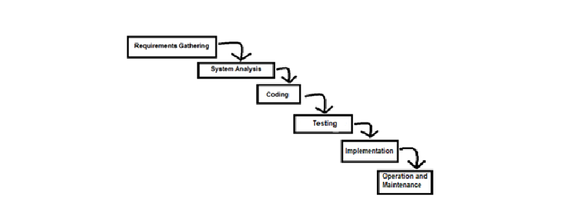1.3.1 Approach and Methodology**

*Figure no. 1.3.1.1: Waterfall Model*

**1.3.1.1 Structured Analysis**

The proponents will undergo a Structured Analysis, which follows the methods of System Development Life Cycle (SDLC).

The project team will do the step-by-step procedure and the five phases of SDLC.

* + - **Requirements Gathering**

Is an essential part of any project and its management. Understanding fully what a project will deliver is critical to its success. Requirements gathering sounds like common sense, but surprisingly, it's an area that is given far too little attention.

* + - **Analysis**

Analyzing of TM system is the next step, in order to analyze the problems and data gathered. On this step, on the lead of the system analyst, the proponents analyze the problems in order to design the interference of our proposed system and generalizing thoughts to give a unified decision for this proposal.

By the gathered data on the interview, the proponents formulate objectives as this was indicated on the deliverables and objectives part of this documentation.

* + - **Coding**

The new system into computer programming language does this. It is an important stage where the defied procedures are transformed into control specifications by the help of a computer language.

* + - **Testing**

In this phase, estimate that 50% of whole software development process should be tested. In this stage physical system specifications are converted into a working and reliable solution.

* + - **Implementation**

Implementing the system will be done after the development of the software. This will test the effectively of the software product if this will work and meet the requirements and needs of the client. When there are problems occurred on the system implementation that is the time that the system must furnish the bugs an error to make the TMS work smoothly.

* + - **Operation and Maintenance**

The system support, maintenance and operation are aiming to incessantly satisfy the needs of the employees by maintaining the operation and the support of the system inside the business. In order to support and operate the Transportation Management activities, the project team must maintain the system for the future errors or sudden supplementary changes of content and features.

**1.3.2 Project Timeline**

|  |  |  |  |  |  |  |  |  |  |
| --- | --- | --- | --- | --- | --- | --- | --- | --- | --- |
| **Task Name** | **Date** | | **Start** | | **Finish** | | | **Duration** | |
| Chapter 1: Project  Charter  August 26, 2017 | August 26-28 | | August 26 | | August 26 | | | 2 days | |
| 1.Project  Background |  | | 7:00pm | | 9:00pm | | | 2 hrs | |
| 1.1.1Problem /  Opportunity  Description | 7:00pm | | 9:00pm | | | 2 hrs | |
| 1.1.2 Benefits | 7:00pm | | 9:00pm | | | 2 hrs | |
| 1.1.3 Goals | 8:30pm | | 9:30pm | | | 2½ hrs | |
| 1.1.4  Stakeholders and  Clients |  | | 9:30 pm | | 10:30pm | | | 1hr | |
| Encoding of  Project  Background | 10:30pm | | 11:30pm | | | 1hr | |
| 1.2.Project Scope |  | | 11:30pm | | 12:30am | | | 1hr | |
| 1.2.1. Objective | 1:00am | | 2:00am | | | 1hr | |
| 1.2.2. Deliverables | 2:00am | | 2:45am | | | 45 mins. | |
| 1.2.3. Out of  Scope | 2:45am | | | 3:15am | | | 30 mins. |
| Encoding of  August 29, 2017  Project Scope | August 27, 2017 | | 08:30am | | 9:00am | | | 1hr | |
| 1.3.Project Plan | 10:00am | | 11:00am | | | 1hr | |
| 1.3.1 Approach  and  Methodology | 11:00am | | 12:30pm | | | 1 ½ hrs | |
| 1.3.2 Project  Timeline | 1:00pm | | 2:30pm | | | 1 ½ hrs | |
| 1.3.3 Success  Criteria | 3:00pm | | 4:15pm | | | 1hr  15mins | |
| 1.3.4 Risk Management Plan | 8:30am | | 9:00am | | | 30mins | |
| 1.3.4 Service  Transition | 9:15am | | 10:00am | | | 45mins | |
| 1.3.5 Option  Analysis | 11:00am | | 12:00nn | | | 1hr | |
| Encoding of |  | |  | | |  | |
| Project Scope | 12:00nn | | 12:30pm | | | 30mins | |
| 1.4 Technical Features | 1:00pm | | 1:45pm | | | 45mins | |
| 1.5 Project |  | |  | | |  | |
| Organization  and Staffing | 2:00pm | | 2:25pm | | | 25mins. | |
| 1.6 Project |  | |  | | |  | |
| Budget | 3:00pm | | 3:45pm | | | 45mins. | |
| Chapter 2: Review of Related Studies | September 1, 2017 | | Sep. 1 | | Sept. 2 | | | 2 days | |
| 2.1Foreign Studies |  | | 5:00pm | | 9:00pm | | | 3 hrs | |
|  |  | | | | | | |
| 2.2 Local Studies | 9:00pm | | 11:00pm | | | 2 hrs | |
| 2. 3 Synthesis and  Relevance of the  Study | September 2, 2017 | | 2:00pm | | 5:30pm | | | 3 hrs 30mins. | |
| Chapter 3: Project Development  October 9, 2017 |  | October 9 | | October 10 | | | 2 days | | |
| 3.1 Business Process Integration Model | 10:50pm | | 11:50pm | | | 1hr | | |
| 3.2 Dataflow Diagram (Level 1) | 12:00am | | 1:15am | | | 1hr 15mins. | | |
| 3.3 Entity Relationship Diagram | 1:30am | | 2:50am | | | 1hr 20mins. | | |
| 3.4 Use Case Diagram  October 10, 2017 |  | 9:00am | | 10:30am | | | 1hr 30mins | | |
| 3.5 Activity Diagram | 11:00am | | 12:00nn | | | 1hr | | |
| 3.6 Graphical User Interface | 12:00nn | | 12:45pm | | | 45 mins. | | |

**1.3.3 Success Criteria**

The development of Transportation Management System is still working on progress. But when the Transportation Management System is Complete develop the Transportation Management Department can achieve the following success:

* Well manage Administrative function
* Generate report can report and can print data from the system.
* Security access for admin and staff.
* Information about incoming appointment and activities that needs a facility.

**1.3.4 Risk Management Plan**

|  |  |  |  |
| --- | --- | --- | --- |
| **Risk Factor** | **Durability**  **L-M-H** | **Impact**  **L-M-H** | **Risk Mgt. Plan** |
| TECHNICAL RISK | **H** | **H** | The laptop may be damaged and because it may not be usable. Accidentally unplugging of the power supply which causes the unit to shut down, VGA cable for the monitor to turn off the computer, Mouse and keyboard might also be unplugged but all of these can be considered as minor problem only and can be immediately configured .if computer might not work on the user’s own computer unit, it can also be test into another unit.  But something might be happened that if these not really work in other computer, another option can be the procurement of the said defected files.  Accidental power interruption or brownouts might happen and the proponents suggest the use of Uninterruptible  Power Supply which can make your computer unit alive at least ten minutes until the power comes back likewise to the generator, if supplies power not only to the computer until but also the operation of the company that can last up to more or less 8 hours until the operation adjourned. |

**1.3.5 Service Transition**

If this project will change or otherwise impact a previously defined ITS service, describe your plan for transitioning project deliverables into service operations. It is the best way to easily adjust and be familiarizing to the scope and features that they can and can’t access.

It includes the following activities such as:

* Seminars and Training
* User Manual
* Maintenance
* Upgrading

**1.4 Technical Features**

**1.4.1 Recommended System Requirements**

|  |  |
| --- | --- |
| **Hardware Requirements** | **Specification** |
| **RAM** | 4Gb |
| **PROCESSOR** | Core i3 |
| **HDD** | 1TB |

|  |  |
| --- | --- |
| **Software Requirements** | **Specification** |
| **OS** | Windows 10 Professional |
| **Programming Language** | Java Netbeans 8.1 |
| **Database** | MySql |
| **Application Software** | Paint  Ms Word |

**1.4.2 Minimum System Requirements**

|  |  |
| --- | --- |
| **Hardware Requirements** | **Specification** |
| **RAM** | 2Gb |
| **Processor** | Intel Celeron |
| **HDD** | 250gb |

|  |  |
| --- | --- |
| **Software Requirements** | **Specification** |
| **OS** | Windows 7 Professional |
| **P.L** | Java Netbeans 7.1 |
| **Database** | Mysql |
| **Application Software** | Paint  Ms Word |

**1.5 Project Organization and Staffing**

The project will be possible by the enlisted organization and staff below

|  |  |  |
| --- | --- | --- |
| **Name** | **Role** | **Responsibilities** |
| Ruanes, Erick P. | Project Manager | * Managing and leading the project team members and motivate to do their jobs. * Ensuring that all members will do their job and can do the project properly. |
| Olalo, Victor Jr. T. | Business Analyst | * Responsible for gathering and understanding the business needs of the members within specific projects. * Elicit requirements using interviews, document analysis, surveys, site visits, business process description, use cases, scenarios, business analysis, task and workflow analysis. * Critically evaluate information gathered from the sources, decompose general idea into details and distinguish user requests from underlying true needs. * Acts as the liaison between, business units and project team. * Collaborates with the system developer to establish the technical vision of the analyzed problem and needs of the business. |
| Panes, Riza C. | System Analyst | * Preparing and submitting comprehensive the feasibility studies and personnel utilization with recommendations. * Identifying specific computer application areas. * Studying and documenting present workflow and procedures. * Identifying the potential computer application areas. * Preparing the system flow diagrams. * Designing the forms and specifications. * Developing system procedures. * Preparing, coordinating and supervising the systems. |
| Bermudez, Jimmel | Lead Programmer | * Working with project manager on the definition of development requirements and priorities. * Data migration. * Interfaces or integration with other systems. * Reporting configuration and deployment. * Set up and maintenance of security rights and access permissions. |
| * Develops the systems interface in accordance with the translation of the system analyst of the problem and needs of the business. * Database management and support including normalizations. |
| Galleza, Jesus O. | Document Specialist | * Performing evaluations and document audits * Effectively follow the standard operating procedures in submission of documents. * Ensures that all documents are error-free in filenames, submissions, etc. before submitting. * Preparation of all document compiled consisting of all details of the project development like graphics, research studies, information documents, etc. |

**1.6 Project Budget**

|  |  |  |
| --- | --- | --- |
| **Budget Item** | **Description** | **Budget Cost** |
| **Food** | Food for the whole Project team | Php 526 |
| **Transportation** | Expense for the transportation. | Php 500 |
| **External Devices** | This expense is used for  Transmitting data at very fast rates with limited distance | Php 830 |

**Chapter 2: Review of Related Studies**

**2.1 Review of Foreign Studies**

**2.1.1 Clio**

**Introduction**

Clio is the world’s leading cloud-based legal practice management software. Clio is an invaluable tool for all sizes of law firms. from basic features such as matter and document management, time tracking and billing to helpful enhancement such as credit card processing, market analysis, and over 50 integration partners, Clio has everything you need to optimize your firm.

**Objectives**

Clio helps you organize your entire firm: structure workflows with dynamic tasks, schedule meetings, and share documents with your clients. Operating quickly and efficiently is easy when everything’s accessible in one software. Easy-to-use product even for non-tech savvy lawyers and staff. The on-demand educational tools are excellent and the customer support is the best I've encountered in dealing with online providers. Clio has saved me a great deal of time and aggravation in practice management, making the practice of law more enjoyable.

**Scope of the Study**

* Keep your legal files all in one place and search and organize your documents efficiently.
* Eliminate the security risk of emailing sensitive documents by using Clio’s private portal to share and collaborate with only the right contacts.
* Instantly streamline and populate new documents using Clio’s automated document templates.
* Powerful features to manage cases, clients, documents, bills, appointments, time tracking, reporting, and accounting.

*Reference:* [*https://www.clio.com/blog/*](https://www.clio.com/blog/)

**2.1.2** **CaseFox, Rakesh Sharma, September 20, 2012**

**Introduction**

Casefox offers a cloud based easy to use multi-user software that is designed for attorneys, CPA’s and other professionals with their practices management billing, invoicing, trust fund management, case document management, client management, tracking billable time, expenses, payments, etc.

**Objectives**

References slide. The body of your presentation should include summary information from your three case files and should follow this outline: Title Slide that includes your name, course, date Objectives slide that gives the purpose of the presentation. Identify the organization and its core business SWOT Analysis Summary, relative to the change initiative Strengths, including core competency Weaknesses Opportunities Threats Organization’s leadership and vision.

Identify the change the company faces and why this change is significant. Your recommendations for a successful change initiative Conclusion Slide References Slide.

You will find information on APA in the Course Materials and Resources section.

**Scope of the Study**

* You can enable access management and restrict users to selected cases.
* Each case is associated with a workflow based on information and artifacts.
* Each client is associated with specific terms and payments.
* CaseFox specifically designed with the legal industry in mind.

*Reference:* [*http://www.casefox.com/web/features.html*](http://www.casefox.com/web/features.html)

**2.1.3 Sutter County Facility Reservation**

**Introduction**

The Sutter Country Facility reservation is a Web Based Reservation Software in California that is created for the benefit of their citizen. This reservation software is design for the reservation of places in California.

**Objectives**

To make an online software system that will create a reservation of facility for its citizens.

**Scope of the Study**

* It has a drop-down list where you can choose your Renter type and the facility to be reserved.
* You can select the day(s) on the calendar.
* In addition, press “continue” to proceed to next step.

*Reference:https://apps.suttercountry.org/apps/Reservations/PublicReserve.aspx*

**2.1.4 GRANVISTA Online Facility Reservation/Booking System**

**Introduction**

GRANVISTA Hotels & Resorts manages a wide variety of facilities, ranging from city hotels and restaurants to a marine facility and a golf resort. Users may freely make online reservations at the facilities of GRANVISTA Hotels & Resorts (hereinafter referred to as “the Company”) and hotels under its outsourced management (hereinafter referred to as “the GRANVISTA Group”), except for Kumamoto Hotel Castle, for which a different reservation system is used (the same shall apply below). However, only individuals registered with the GRANVISTA Membership Club (hereinafter referred to as “Club members”) are eligible to make member reservations and receive e-mail newsletters.

**Objective**

To create an Online Facility Reservation System (FRS) that will handle all customers to easily have their reservation in Granvista facilities.

**Scope of the Study**

* Facility reservation requests are sent when the form on the website's facility reservation screen is filled out and submitted.
* Reservation is complete when the facility concerned receives notification. The contract formed is based on the provisions of the facility concerned within the GRANVISTA Group, and a confirmation e-mail will be sent to the e-mail address provided.
* The contract is concluded between the customer and the facility concerned within the GRANVISTA Group.
* The rates displayed on the website’s facility reservation system are subject to change without notice. However, the rates prevailing the time of contract formation (i.e., reservation completion) shall continue to apply.

*References:http://www.granvista.co.jp/english/company/reservation/index.html*

**2.1.5 Krystal Mumbai, India (DMS), Primeleaf Consulting (P) Ltd, 2013**

**Introduction**

Krystal Mumbai, India DMS is a completely web browser based (web based Document Management System which is easy to install and easy to use. KRYSTAL - Document Management System (DMS) the award-winning document management software solution from Primeleaf Consulting, allows you to spend more time on customer facing activities– instead of on tedious administrative and paper-based chores.

**Objectives**

Schools, Colleges, Universities, public or private, have large volumes of student records and educational files that must be carefully managed. KRYSTAL DMS helps education administrators take control of paper and electronic documents to improve efficiency, lower cost, and speed operations with education document management.

**Scope of the Study**

* KRYSTAL DMS helps education administrators take control of paper and electronic documents to improve efficiency, lower cost, and speed operations with education document management.
* KRYSTAL DMS is electronic document control and automation software for insurance, banking, wealth management, mortgage, and other financial services firms. Paper documents are converted to digital files, joining electronic documents in a single, unified and secure document management system. Everything is searchable and immediately retrievable.
* KRYSTAL DMS can cater to all big and small document management needs within the legal industry, allowing legal firms to operate at an optimum level.

*Reference: https://www.krystaldms.in/*

**2.1.6 Saudi Softech DMS,**

**Introduction**

Saudi Softech DMS is ensuring the highest degree of productivity, efficiency and cost savings. Saudi Softech is one of the leading [document management system](http://www.saudisoftech.com/) and solutions provider in Saudi Arabia. Keeping in mind the enterprise-level need for complete control over documents/information flow, Saudi Softech has also developed a highly collaborative and fully automated [Document Management System](http://www.saudisoftech.com/) (DMS).

**Objectives**

According to researchers, between 50% and 80% of company information lies scattered in documents, e-mail messages and attachments. In order to ensure the highest degree of operational efficiency, businesses need a comprehensive document management system that will store critical information; help update data; track changes and implement role-based access.

**Scope of the Study**

* Saudi Softech DMS is a web-based application using secured SQL server database.
* Saudi Softech DMS is a seamless exchange of documents
* Saudi Softech DMS is a personal arena to each individual user in the network
* Saudi Softech DMS have security to each section
* Saudi Softech DMS is embedded e-mail and document sharing features.

*Reference: http://www.saudisoftech.com*

**2.1.7 Kounta,** **Nick Cloete, 2012**

**Introduction**

Kounta is an Australian software company founded in 2012.  The company is best known for its [flagship product](https://en.wikipedia.org/wiki/Flagship_product), Kounta, which comprises a cloud-based [point of sale](https://en.wikipedia.org/wiki/Point_of_sale) [mobile app](https://en.wikipedia.org/wiki/Mobile_app). Released in 2012, Kounta became the first [hospitality](https://en.wikipedia.org/wiki/Hospitality)-focused point of sale (POS) [mobile app](https://en.wikipedia.org/wiki/Mobile_app) for [iPad](https://en.wikipedia.org/wiki/IPad), [Android](https://en.wikipedia.org/wiki/Android_(operating_system)), [Mac](https://en.wikipedia.org/wiki/MacOS), and [Windows](https://en.wikipedia.org/wiki/Windows). In 2012 [Epson](https://en.wikipedia.org/wiki/Epson) announced a partnership with Kounta, which led to the integration of Kounta's cloud-based POS platforms in Epson printers. In 2013 Kounta launched a partnership with [PayPal](https://en.wikipedia.org/wiki/PayPal) to integrate cashless and cardless transactions via PayPal's [mobile app](https://en.wikipedia.org/wiki/Mobile_app).

**Objectives**

Thousands of stores around the world rely on Kounta’s flexible and scalable cloud-based Point of Sale System. Quick to get started, Kounta is easy to use, yet powerful enough to run any store. Kounta can be securely used in both on and offline modes on smartphones, tablets, laptops and even the traditional POS equipment stores already have, while seamlessly connecting to popular online and mobile [add-ons](https://www.kounta.com/add-ons/) like accounting, loyalty, e-commerce and more.

**Scope of the Study**

* Kounta will run on Macs and iOS devices, as well as PCs, Albert, Android and even legacy POS equipment. It also supports a wide array of printers, barcode scanners, credit card swipers, PIN pads, and cash drawers.
* Kounta works fast, and is responsive to your input.  Beyond its efficient code, Kounta’s intuitive design makes using it quick and efficient, minimizing “user latency.”
* With access to reporting, analytics, and, well, all your data in Kounta available from a web browser, shop owners will never be caught unaware again.
* If your internet connection goes down, Kounta keeps right on going without a hitch.  You can keep selling, and when you are back online, your data is sync back to the cloud.

*Reference: https://www.kounta.com/*

**2.1.8 iVend POS**

**Introduction**

iVend POS powers brick-and-mortar stores as a full service point of sale. Available on terminal and mobile devices, its multi-store, multi-user, e-commerce integrated, loyalty-ready capabilities make it easy to sell to your customers, and more importantly, keep them coming back. Customizable UI empowers you to reflect your retail brand consistently across all shopping channels.

**Objective**

Vend POS is the feature-rich core of the iVend Retail management suite and allows centralized management of all inventory, customer profiles and configurations, including pricing, discounts, promotions, tender types, layaways, and returns, from one place. The intuitive UI can be operated using a touch screen or keyboard, on iOS, Android, Mac or PC, online or offline, and connects to all the latest hardware – barcode scanners, receipt printers, cash drawers.

**Scope of the Study**

* Improved Customer Experience
* Integrated Reporting & Analytics
* Consistent Service Across All Channels
* A Single Stock Pool for Better Inventory Management
* Integrated Reporting & Analytics
* Enhanced Loyalty
* Safe & Secure

*Reference: https://ivend.com/ivend-pos/*

**2.1.9 Lobby Track,** **Brian Solomon, Nov 12, 2015**

**Introduction**

Lobby Track, created by Jolly Technologies. Lobby Track makes it speedy and simple to check people in and out, reducing the complexity of the situation to nothing more than a few mouse-clicks.

Lookup host information via your existing Active Directory system, auto email hosts, create badges generated from scanning driver's licenses, and, if needed, even activate badges into your existing access control system. ID Flow, included with Lobby Track, makes design and formatting a snap.

It is important to know who is coming in and going out, it is essential to identify not only your staff, but also visitors, contractors, maintenance workers, everyone that walks through the door.

**Objectives**

Lobby Track implementation will help organization to track visitor information, analyzed and maintain digital records.

It will help to avoid manual human writing errors and keeping physical visitor logbooks. The System architecture will cover major areas of visitor.

**Scope**

* Use visitor management software designed to fully automate every step of the process.
* Link visitor passes to your existing access control software  
  scan a license, passport or business card to pull visitor information into our software.
* Save time by pre-registering visitors and assigning arrival and departure information. Manage and automatically send host notifications when a visitor arrives.

*Reference:[http://­www.jollytech.com/­software-and-systems/­visitor-management-so­ftware.php](https://free.facebook.com/l.php?u=http%3A%2F%2Fwww.jollytech.com%2Fsoftware-and-systems%2Fvisitor-management-software.php&h=ATO6DKIzfyq0S1s0cEmWOFVb_N0kSVlV3R2d3MK0DDc2oFIpMJMFqFKb-tjcqMLY5dMSbVIbox-j53S3-NX_vLssQVCrFgaD3q-FogbYoa_Am0mrjwE7V0Y2ZImAomPeEXfUi55oOWnhPWll&s=1" \t "_blank)*

**2.1.10 PeopleTrackVM, Paul Arthur, May 19 2014**

**Introduction**

People Track VM software gives the capability of Paul Arthur, Published May 19 2014 of IEEE to quickly and easily track everyone entering and leaving a building or facility and then run report that document visitor activity. The software is easy to set up and provides an ideal replacement for outdated handwritten logbooks. People Track VM is being used in a wide variety of applications including businesses, schools, colleges and universities, and hospitals. The software easily integrates with driver’s license scanners, bar code readers and scanners as well as label and card printers to create a complete visitor management system.

**Objectives**

People Track VM (Visitor Management) solution is designed to quickly and easily track visitors entering or leaving your facility. The software provides all the core features of an effective visitor management system used by companies or organizations in any industry. Identify all individuals who visit your facility. Streamline the visitor check-in process by electronically scanning a driver's license. Identify the location of entry and the reason for the visit. Screen against unwanted visitors by performing a background check in the U.S. Analyze reports of visit history and time and attendance. Instantly print badges for all visitors. Badges can be paper adhesive labels or plastic cards. Capture a photo of the visitor and add it to the badge you print. Checkout of visitors can be done manually or automatically (after a certain time and period or at a specific time).

**Scope**

* Even for the most inexperienced user, People Track VM lets you quickly and easily:
* Scan and capture visitor information from driver’s license or business card at check-in.
* Instantly create a visitor badge with photo.  
  Run a background check.
* Classify each visitor.
* Catalog who has been visited
* Note reason for is it.  
  Close the visit at check-out
* Provide a complete visit history report.
* Activity and visitor tracking  
  Background checks Barcode, magstripe and biometric scanning.

*Reference:*[*https://pcs-i.com/­People-Track-VM.html*](https://pcs-i.com/People-Track-VM.html)

**2.2 Review of Local Studies**

**2.2.1 Case Master Pro**

**Introduction**

Case Master Pro is a Law Firm Management and Debt. Collection Software. Case Master, Inc. that is being use in different city all over the world included the city in the Philippines, Muntinlupa City, Provides complete systems that will meet the needs of law firms in terms of case management software that will also allow for remote offices on one centralized database system.

**Objectives**

Case Master Pro delivers all the functionalities and tools law firms need to help them manage their cases, clients, time, collectibles, and more. With the Case Management feature, users can track their case files as well as that of their opponents. The tool also helps them organize, store, and access crucial information such as account, litigation and judgment details. With ready access to all the relevant details pertaining to a case, lawyers and their staff can devise and implement effective steps of action.

**Scope of the Study**

* The document management feature makes creation and management of legal documents a breeze.
* Accounting and billing are two critical elements in any business endeavor, including legal practice.
* Enables firms to customize the software to better suit their administrative workflows.
* Users can modify many areas of the platform, such as case types, debt types, terminology, user designations and permissions, documents, and security.

*Reference:<http://www.casemasterpro.com/case-management-software/>*

**2.2.2 Pathlegal**

**Introduction**

Pathlegal is simple, safe, powerful and free software tool developed by PathLegal, which can be useful to any lawyer or law firm to manage their lawyers, clients, cases and events. There is always a support service offered with this tool over phone and email, you can contact our support staff if you need any help about the legal case management software. We have a dedicated team working on the enhancement of this software as per your requirement. This legal case management software is integrated with your PathLegal login and your data is safe and protected using your login.

**Objectives**

To make a significant contribution with my core competencies, to the organization. I work with and to help achieve its corporate objectives.

**Scope of the Study**

* Efficient way to manage the lawyers, clients, cases and events.
* Lawyers can share their client's detail and case history to other in a click.
* Lawyers can build virtual law firms and share clients among each other

*Reference:<http://www.ph.pathlegal.com/lcm/legalcasemanagementsoftware.php>*

**2.2.3 Online Reservation Form - UP Engineering Library**

**Introduction**

It is web reservation software in University of the Philippines that is created for students to reserve online and your email & phone number will be used regarding your request for reservation.

**Objectives**

To make a website that will help the students to reserve for facility easily through online.

**Scope**

* You can input the date of your reservation and informed which day is available and which is not.
* It has the input for the user information including name, school department, email, etc.
* It has also the input for the reservation details such as date, time purpose, and the facility that would you like to reserve.

*Reference:http://www.engglib.upd.edu.ph/index.php/web-forms/facility-reservation-form*

**2.2.4 School Facility Reservation System – University of Mindanao** **Bonn Rj De Guzman, October 10, 2013**

**Introduction**

The school reservation system defines the reservation system in University of Mindanao. Among the facilities that the University has, some are yet needed to be improved in terms of procedural servicing which may be referred into manual process. With this, we decided to look among those facilities that needed automated system. Among those facilities, we chose the Facility Reservation. This project will handle reservations of the facilities of a certain school.

**Objectives**

To make a facility reservation system that can minimize the time in reserving by making a system/program that can reserve an event with less time, and without all of the paper works. The aim is to offer a hand in terms of giving an innovative view towards the school and towards the student, to make an operative and automated system that can help not only to the school but also to the students when it comes to reservation. To make the process of facility reservation that is reliable and automated. We aimed and required to create a project/system that is capable of easy encoding, recording and storing.

**Scope**

* The project consists of automated forms that will accept basic information about the student and what he/she are reserving and the time of when he/she will use the facility.
* The information given of the student can also be updated.
* The system can provide a secure field for the information and files that is stored in the database.
* The system is only capable of listing the time when the student will use the facility and what time will the student stop. The system is not capable of listing when the student made the reservation did.

*Reference:https://prezi.com/doi64d7kdulw/school-facility-reservation-system/*

**2.2.5 Paperless Trail, IT Company, 2003**

**Introduction**

Paperless Trail Inc. (PTI) is a privately owned IT company. They provide products that make emerging business **better**.

They focus on scanning and digitization, document management, business mapping, and integration. Founded in 2003, Paperless Trail has grown to a staff of nearly 100 professionals comprised of software designers, developers, technical support, mappers, imaging production staff, and management. They are based here in the Philippines, with their head office, which is located in Makati City Metro Manila. The Paperless Trail Inc. also have a development team in Davao and a Document Management Services facility in Batino. We are strategically located and highly qualified to provide our clients with practical, innovative, and cost effective IT solutions.

**Objectives**

Paperless Trail focuses on the scanning and digitization, document management, business mapping, and integration.

**Scope**

* **Mapping Products & Services** – Location and tracking-based software that is designed to empower users with the intelligence their business or service needs to function effectively and efficiently.
* **Imaging & Document Management Solutions** – A scanning and archiving service that creates, manages and secures digital copies of your hard files in one place for quick and easy future reference.
* **Business Solutions** – Intelligent tools and programs geared towards improving overall productivity in virtually every type of business and industry.

*Reference: http://www.paperlesstrail.net/*

**2.2.6 Archive One**

**Introduction**

Archive One is a document management system which is design to help the document administration classify, store & secure, search for and retrieve essential company records. The centralization of a company document

Repository helps save time, reduce costs, improve operational efficiency and provide security for physical and electronic documents.

**Objectives**

A document management system design to help documents classify, store, secure, search and retrieve essential company records.

**Scope**

* Multiple organized files in a single repository
* Improved search capabilities
* Enhanced security and compliance
* Faster access and retrieval of [document](http://www.archive-one.net/document-management-system-philippines)s
* Protect your [document](http://www.archive-one.net/document-management-system-philippines)s from unauthorized access
* Advanced search features
* Standalone or networked solution

*Reference:http://www.archive-one.net/document-management-system-philippines*

**2.2.7 iRipple**

**Introduction**

iRipple, Inc. is an international premier retail technology company with headquarters in Manila, and subsidiaries in Thailand and Malaysia. iRipple has developed, marketed and successfully deployed a Retail Management Solution named, “Barter”, to a growing number of retail businesses in the Philippines.  iRipple’s flagship product has proven to be a viable retail solution to progressive small and medium enterprise (SME) businesses.  From its initial focus on the supermarket industry, iRipple has moved to servicing a broader range of business operations like boutique, specialty stores, pharmaceutical, convenience store, distribution and the food and beverage retail industry as well.

**Objectives**

Fully integrated Point-of Sale (POS) software, [retail management system](http://www.iripple.com/)s (RMS) and [inventory management](http://www.iripple.com/) that keep clients moving through and profits moving up. Our automated, cost-effective point-of-sale systems will put you in charge and will make way for insights and opportunities to make your retail business more than a thriving enterprise but a success story.

**Scope**

* Adapts very well to local requirements
* Accredited by the Philippine government
* Boasts a strong application development team, capable and efficient local support and a well-established project implementation methodology.

*Reference: http://www.iripple.com/*

**2.2.8 EasyPOS**

**Introduction**

EasyPOS Solutions Inc. is a local company based on a very successful company which was formed in 1992 to address the needs of the bar, hotel, resort and restaurant businesses.  The product is based on the successful DPos software system, being used in more than 300 outlets, and is now being introduced to the Philippines.  The original software was initially DOS based; in 2005, EasyPOS Solutions further developed the system and released a Windows® version called DPos.  DPos is EasyPOS’ flagship software and is continually being improved and upgraded to cater for the ever growing needs of the bar, hotel, restaurant and resort industries.

**Objectives**

EasyPOS Solutions offers a professional, easy to use Point of Sale system along with a fully integrated ordering system for the resort, bar, hotel and restaurant industries. DPos comes with a full range of services including installation, support, training, upgrades and hardware.

**Scope**

* Over 300 installations worldwide with full local and remote support
* Cut your order taking time by up to 75% and increase revenue by up to 10%
* Security features to ensure your business is not losing money
* Printed receipts with full order detail saving money on order Books.
* Monitor staff start/finish with auto calculation of all commissions/fines/salary.

*Reference:* [*http://easypos.com.ph/*](http://easypos.com.ph/)

**2.2.9 EasyLobby Secure Inc.**, **Bryan MClane, July 15, 2013**

**Introduction**

EasyLobby automated visitor management system. EH Media on for both large and small organizations seeking a more professional image, while enhancing security and meeting compliance mandates for the collection and auditing of visitor data. The EasyLobby SVM software is the primary application for implementing an automated visitor management system to process visitors – including scanning a government-issued ID, record creation, badge printing, check-in and check-out and watch list screening. This comprehensive, enterprise-class visitor registration can quickly scale to a network of hundreds of stations and additional capabilities such as web based pre-registration can be added as needed.

**Objectives**

With EasyLobby Visitor Management System, you can identify exactly who is in your facility at all times and why by scanning each visitor ID automatically and printing a customized badge in seconds. It is easy to install and integrates with leading access control systems to provide temporary card access for guests.

**Scope**

* Enhance the professionalism of the enrollment process and visitor check-in
* Streamline enrollment with pre-registration or self-registration options.
* Provide additional safeguards by screening against felony and sex offender watch lists.
* Improve security by identifying who is in a facility quickly and accurately, especially in emergency situations
* Conduct analysis/reporting on visitor data, quickly and easily

*Reference:[https://­www.hidglobal.com/­products/software/­easylobby/svm](https://www.hidglobal.com/products/software/easylobby/svm)*

**2.2.10 Visitor Management System- ELID Technology International Online, May 8, 2013**

**Introduction**

ELID is a reputable leading manufacturer of Matthew Reitan. ELID is an acronym for Electronic Identification. ELID's vision is to be a worlf renowned manufacturer of Electronic Identification System. E.VID is a user-friendly visitor management system. It enhances corporate security through the identification of unwanted or suspicious visitors with the help of the MyKAD technology. Visitor registration and management is a paramount concern for intelligent building or facility. Each day scores of visitor pass through the entrances to your facility

**Objectives**

Using ELID's Visitor Management System helps you in automating this operation quickly, easily and accurately. E.VIS is designed to keep track of visitor traffic details. It also enables instantaneous background checks to be done easily. It minimizes processing time and generates visitor badges in seconds.

**Scope**

* Automatic login of visitor information within seconds through the MyKAD reader.
* Incorporated with touch screen monitor to key-in the information via the virtual keyboard.
* Incorporated with a web camera to capture a visitor's image

business card.

* Visitor card can be assigned within seconds.
* Control visitor's accessibility through an assigned visitor card.
* Real-time visitor information provides comprehensive reports.

*Reference:*[*http://­www.elid.com.ph/­index.php/products/­visitor-management-sy­stem/77-elid/­114-evis.htm*](http://www.elid.com.ph/index.php/products/visitor-management-system/77-elid/114-evis.htm)

**2.3 Synthesis and Relevance to the Study (Matrix Comparative Analysis)**

**2.3.1 Foreign Synthesis and Comparative Analysis**

|  |  |  |  |  |  |  |  |  |  |  |  |
| --- | --- | --- | --- | --- | --- | --- | --- | --- | --- | --- | --- |
| Features | Clio | Casefox | Krystal Mumbai | Saudi software | Sutter country facility Reservation | GRANVISTA Online Reservation System | Kounta(Software company) | Ivend POS | Software | Lobby Track | People Track VM | Proposed System |
| Complains |  |  |  |  |  |  |  |  |  |  |  |
| Legal Cases |  |  |  |  |  |  |  |  |  |  |  |
| Legal Document |  |  |  |  |  |  |  |  |  |  |  |
| Documents |  |  |  |  |  |  |  |  |  |  |  |
| Request |  |  |  |  |  |  |  |  |  |  |  |
| Registration |  |  |  |  |  |  |  |  |  |  |  |
| Amenities |  |  |  |  |  |  |  |  |  |  |  |
| Reservation |  |  |  |  |  |  |  |  |  |  |  |
| Monitoring |  |  |  |  |  |  |  |  |  |  |  |
| Log in &  Log out |  |  |  |  |  |  |  |  |  |  |  |
| Schedule of Visitation |  |  |  |  |  |  |  |  |  |  |  |
| Deposit |  |  |  |  |  |  |  |  |  |  |  |
| Reports |  |  |  |  |  |  |  |  |  |  |  |

**2.3.2 Local Synthesis and Comparative Analysis**

|  |  |  |  |  |  |  |  |  |  |  |  |
| --- | --- | --- | --- | --- | --- | --- | --- | --- | --- | --- | --- |
| Features | Case Master Pro | Pathlegal | Paperless Trail | Archive One | Online Reservation Form - UP Engineering Library | Univ. of Mindanao Facility Reservation System | iRipple | EasyPOS. | HID EasyLobby Secure | ELID Technology International | Proposed System |
| Complains |  |  |  |  |  |  |  |  |  |  |  |
| Legal Cases |  |  |  |  |  |  |  |  |  |  |  |
| Legal Document |  |  |  |  |  |  |  |  |  |  |  |
| Document |  |  |  |  |  |  |  |  |  |  |  |
| Request |  |  |  |  |  |  |  |  |  |  |  |
| Registration |  |  |  |  |  |  |  |  |  |  |  |
| Amenities |  |  |  |  |  |  |  |  |  |  |  |
| Reservation |  |  |  |  |  |  |  |  |  |  |  |
| Monitoring |  |  |  |  |  |  |  |  |  |  |  |
| Log in &  Log out |  |  |  |  |  |  |  |  |  |  |  |
| Schedule of Visitation |  |  |  |  |  |  |  |  |  |  |  |
| Deposit |  |  |  |  |  |  |  |  |  |  |  |
| Reports |  |  |  |  |  |  |  |  |  |  |  |

**2.3.3 Synthesis**

Proponent will illustrate the proposed system. Administrative features from local and foreign will compare the difference between of the current system from proposed system by features and functionalities.

The proponent gets the other features from local and foreign to produce modules to become unique product. Those features are helping the clients’ satisfaction. The studies and literature give us a necessary idea and information, which is needed for the creation of our proposed system.

**Chapter 3: Project Development**

**3.1 Business Process Integration Model**

**Document Management**

**Approval & Document**

**Legal Management**

**Request for Documents/Permits**

**Reservation Details**

**Visitor Management**

**Facility Reservation**

**Reservation Request**

**Point Of Sale**

**3.2 Dataflow Diagram (Level 1)**

**Legal Management**

**COMPLAINTS**

**LEGALCASES&DOCU.**

**Facility Reservation**

**RES. REQUEST**

**RES. DETAILS**

**ADMINISTRATIVE**

**Visitor Management**

**VERIFICATION OF VISITORS**

**ADMINISTRATIVE**

**REQUEST**

**APPROVAL**

**Point Of Sale**

**Document**

**Management**

**3.3 Entity Relationship Diagram**

**3.3.1 Legal Management, Document Management, Facility Reservation and Visitor Management**

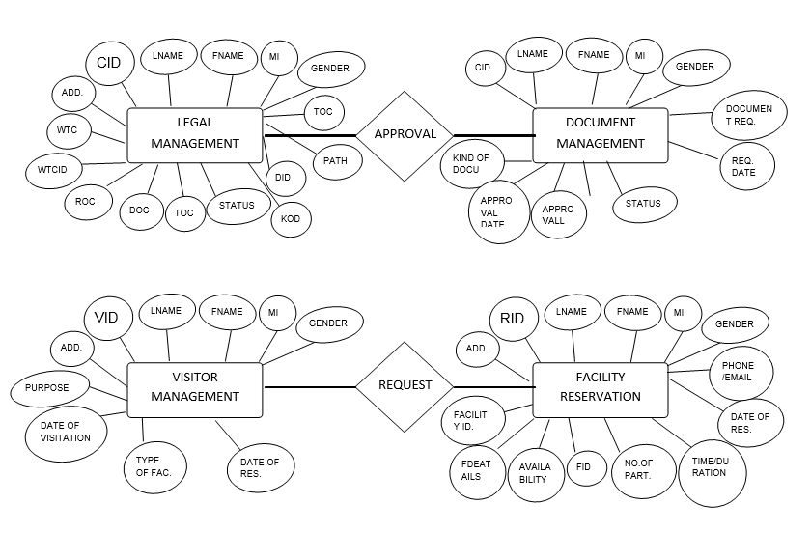

**3.3.2 Point Of Sale**

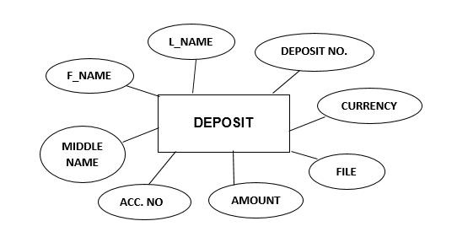

**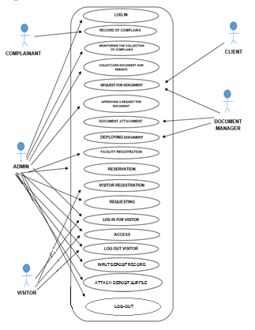3.4 Use Case Diagram**

**3.5 Activity Diagram**

**3.5.1 Legal Management**

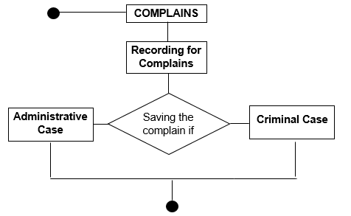**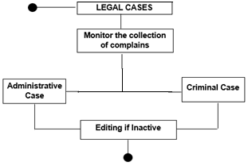**

**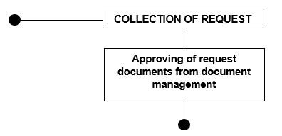**

**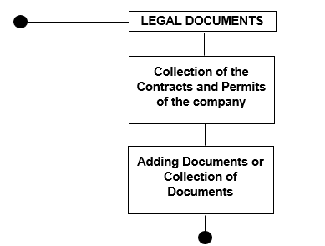**

**3.5.2 Document Management**

**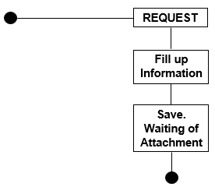**

**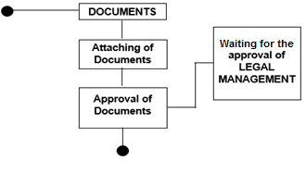**

**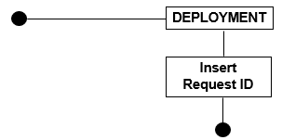**

**3.5.3 Facility Reservation**

**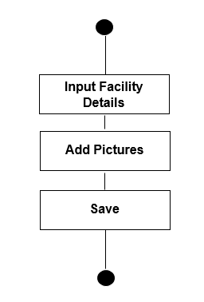**

**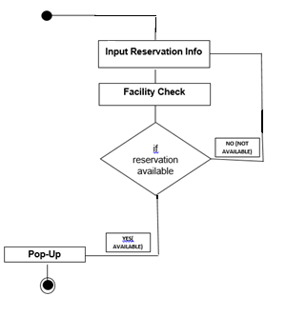**

**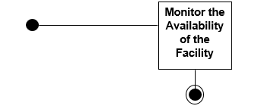**

**3.5.4 Visitor Management**

**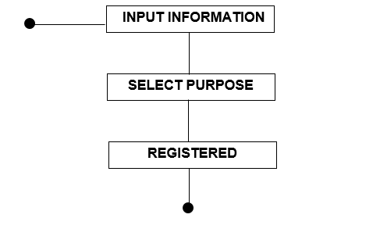**

**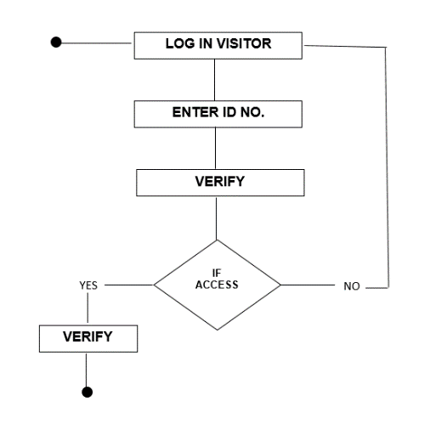**

**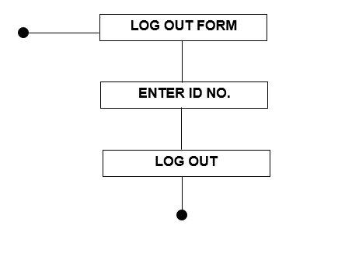**

**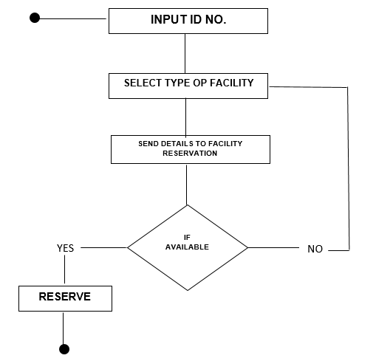**

**3.5.4 Point of Sale**

**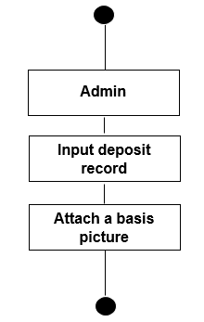**

**3.6 Graphical User Interface**

**3.6.1 Log-In**

**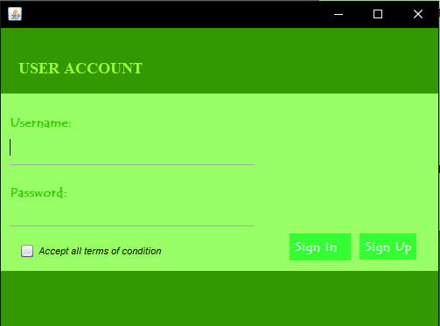**

*Figure no. 3.6.1.1: Login*

Shows the Login form for the security of system.

**3.6.2 Legal Management**

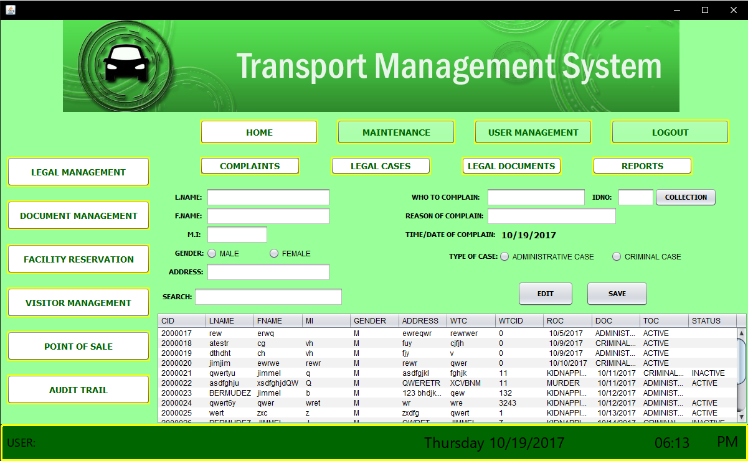

*Figure no. 3.6.2.1: Complaints*

Fill up complains for employees/driver etc.

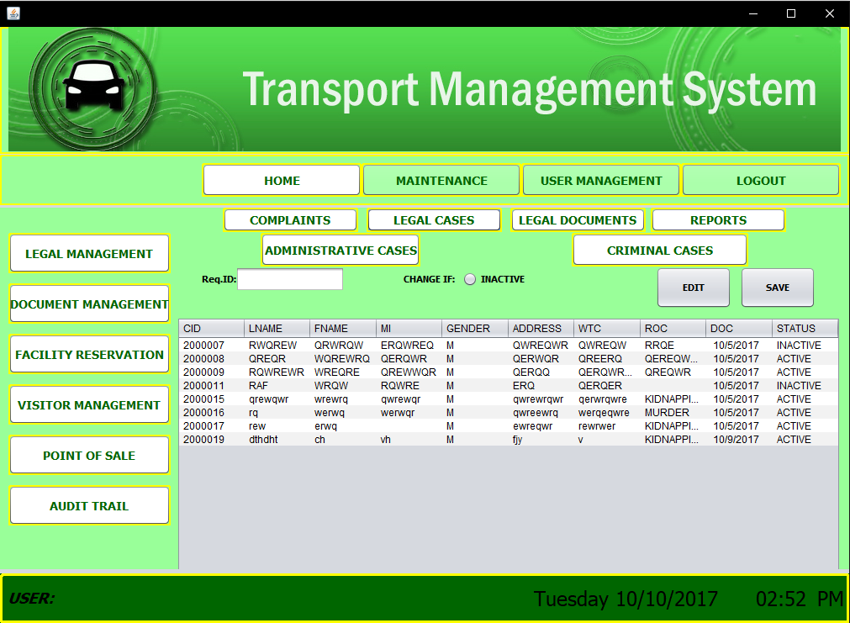

*Figure no. 3.6.2.2: Legal Cases*

Monitoring the cases in Administrative Case and Criminal Case.

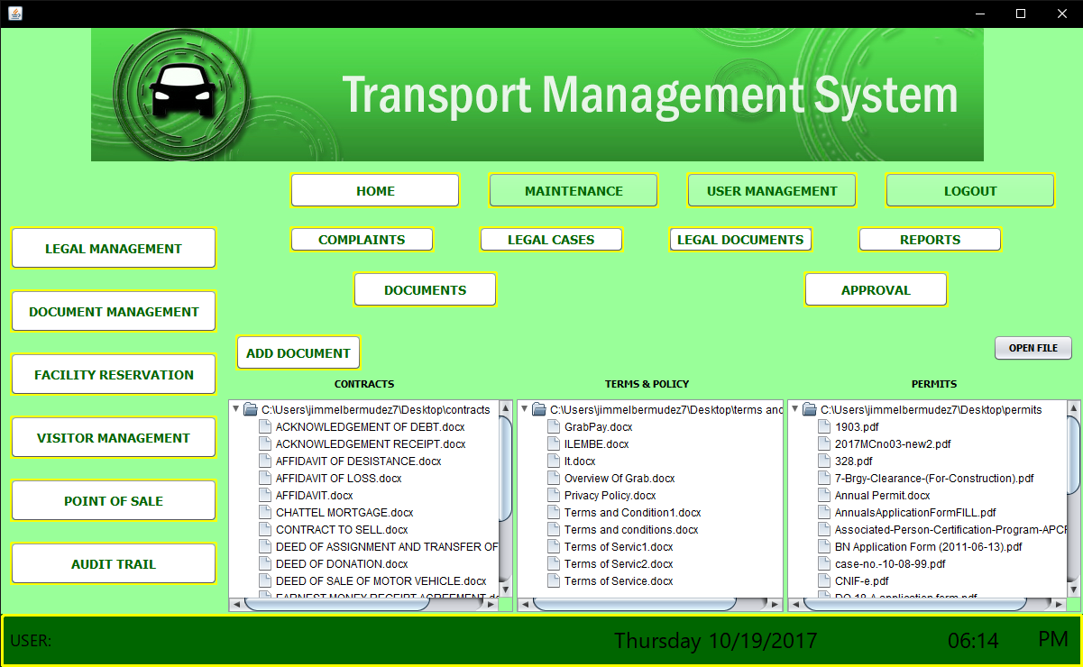

*Figure no. 3.6.2.3: Legal Document*

Storing the legal/important documents, permits and adding document/permits, and approving the request from Document management.

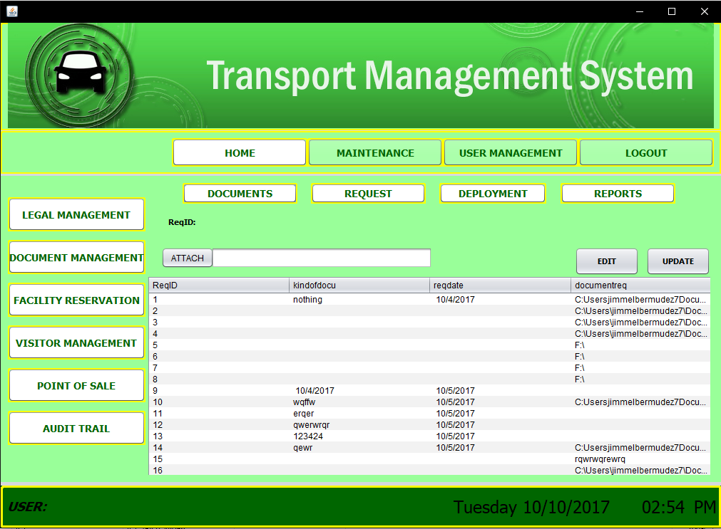**3.6.3 Document Management**

*Figure no. 3.6.3.1: Documents*

Attaching for type of Document and the request

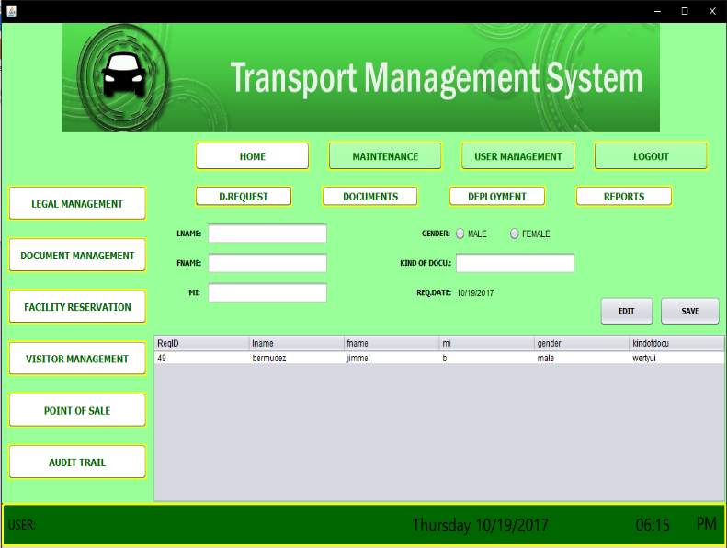

*Figure no. 3.6.3.2: Request*

Requesting for documents needed.

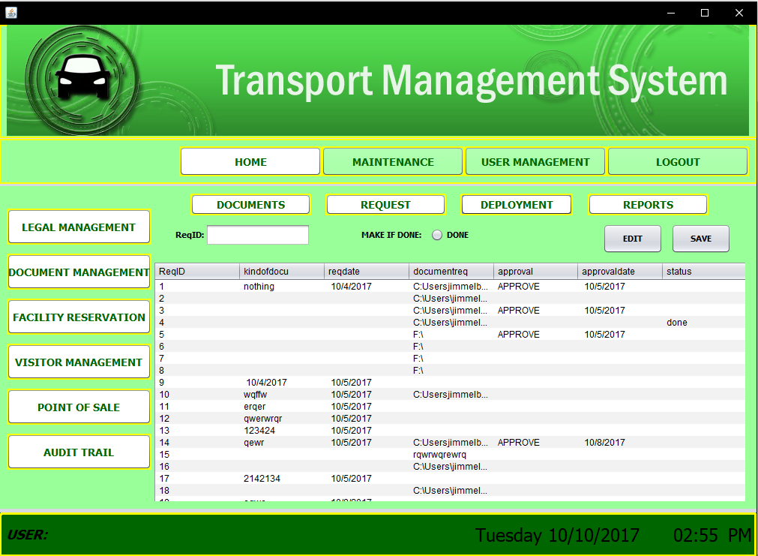

*Figure no. 3.6.3.3: Deployment*

Releasing the Document and approved by the Legal Documents.

**3.6.4 Facility Reservation**

**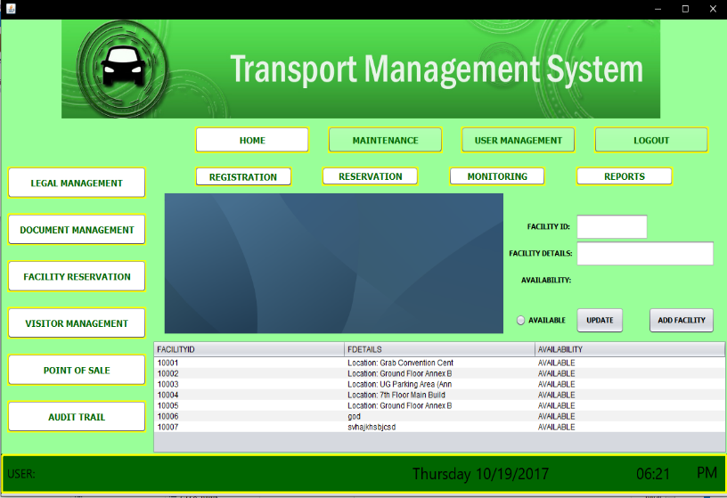**

*Figure no. 3.6.4.1: Registration*

This will show all facilities and their amenities for the reservation of facilities.

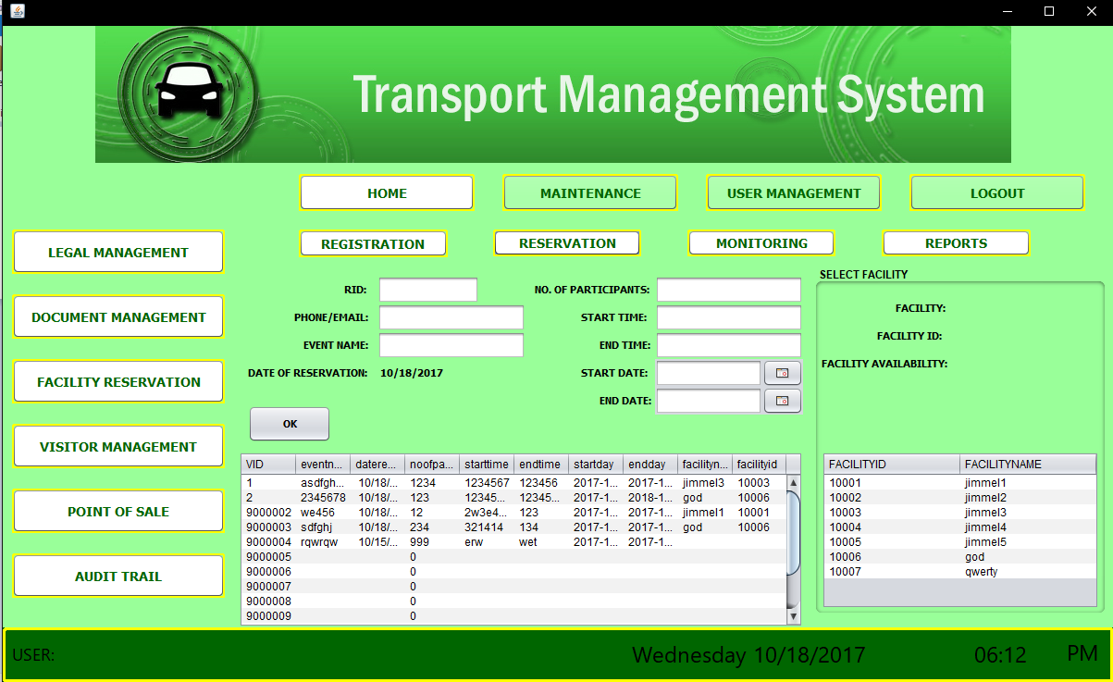

*Figure no. 3.6.4.2: Reservation*

This is where you input all reservation details needed.

**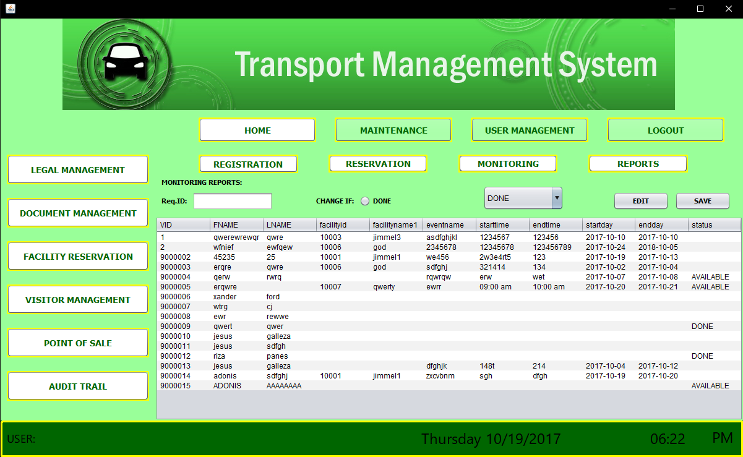**

*Figure no. 3.6.4.3: Monitoring*

Show all facility schedules and status of equipment inside the facility.

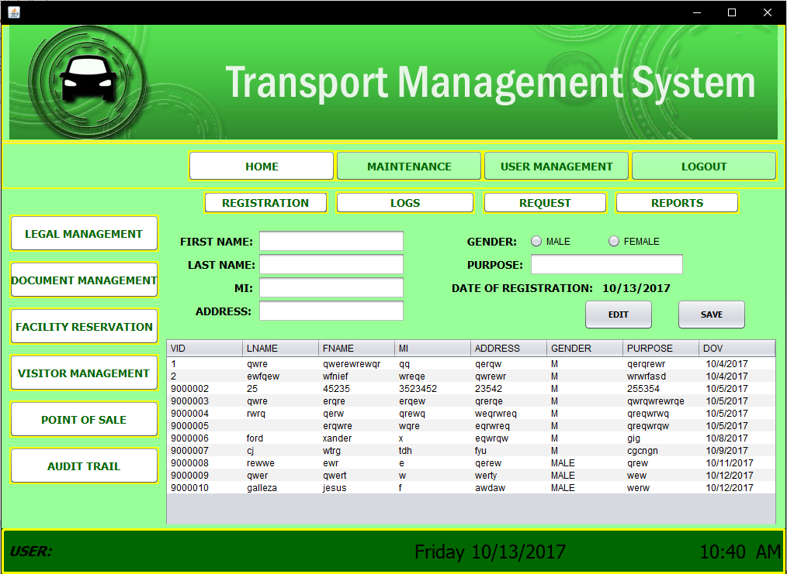**3.6.5 Visitor Management**

*Figure no. 3.6.5.1: Registration*

Show all the certain Information.

*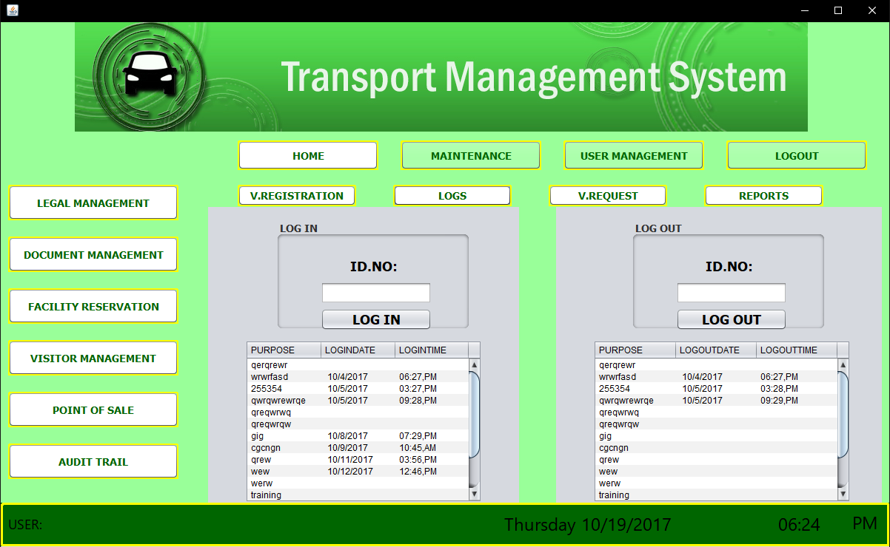*

*Figure no. 3.6.5.2: Logs*

This is for the Login and Log-Out of visitors

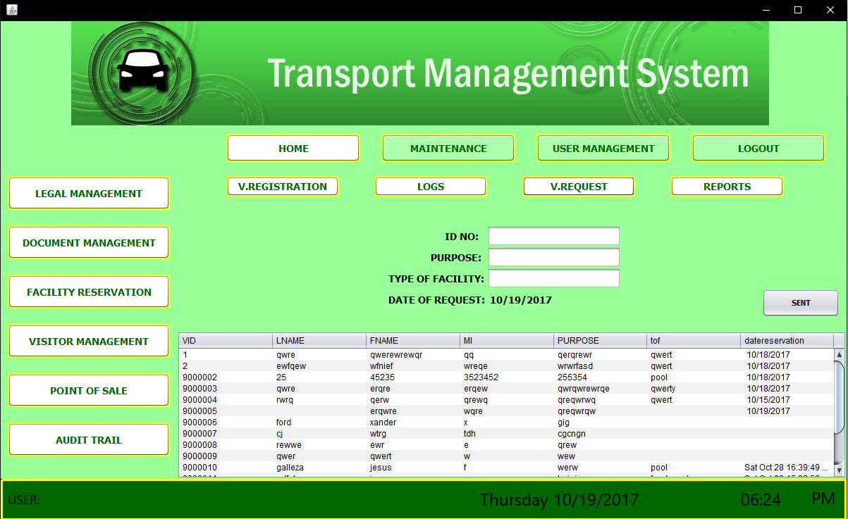

*Figure no. 3.6.5.3: Request*

Sending the reservation request to Facility Reservation

**3.6.6 Point of Sale**

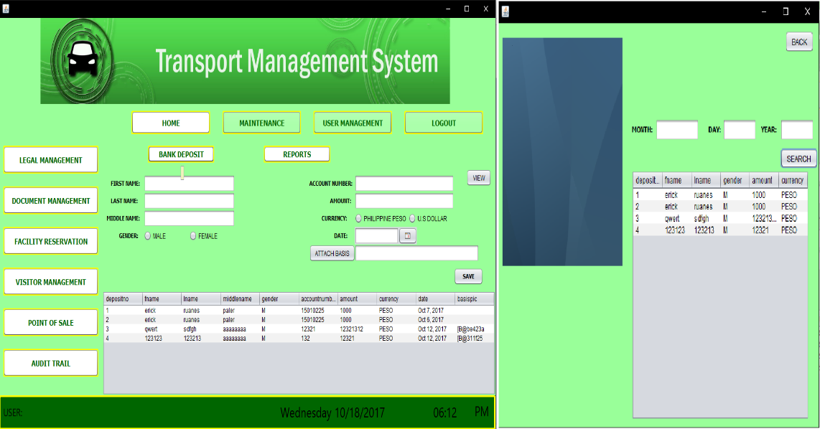

*Figure no. 3.6.6.1: Deposit*

It will record the amount of deposit

**3.6.7 Reports**

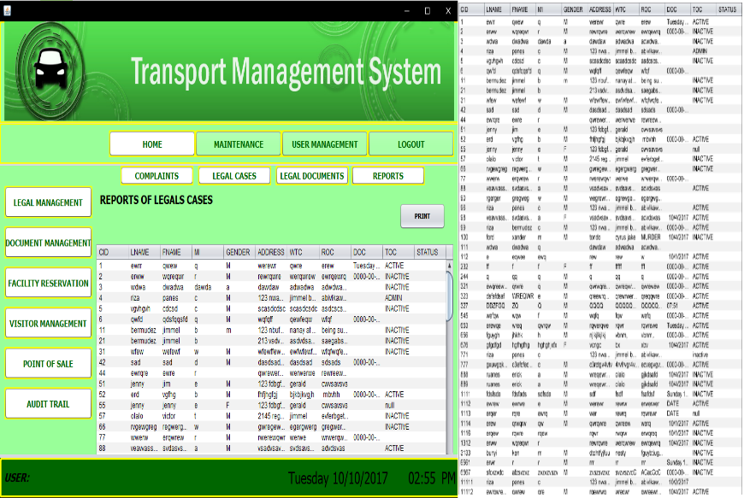

*Figure no. 3.6.7.1: Reports*

This is the collection of all data of the Administrative.