Example Programs

Program 1

{

DO A FROM 1 TO 800 {

SET C := A 0.00000000001 \* ;

FD C

RT 213

SET D := A 0.00000000015 \* ;

FD D

RT 13

SET E := C D + ;

SET F := C D - ;

SET G := E F / ;

LT G

}

}



Program 2.

{

FD 30

LT 45

FD 30

LT 45

FD 30

LT 45

FD 30

LT 45

FD 30

LT 45

FD 30

LT 45

FD 30

LT 45

FD 30

LT 45

}

Program 3.

{

DO A FROM 1 TO 100 {

SET C := A 1.5 \* ;

FD C

RT 62

}

}

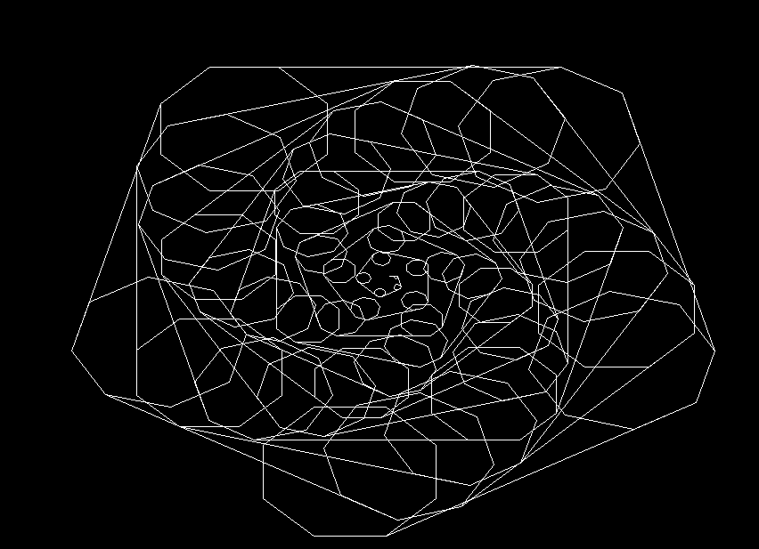

Program 4.

{

DO A FROM 1 TO 50 {

FD A

RT 30

DO B FROM 1 TO 8 {

SET C := A 5 / ;

FD C

RT 45

}

}

}

Program 5.

{

DO A FROM 1 TO 5000 {

FD A

RT 217

FD 20

DO B FROM 1 TO 8 {

SET C := A 5 / ;

FD B

RT 41

}

FD A

}

}

