Assignment 5
Title: Deep Q-Network (DQN) Hyperparameters Analysis
Name: Brennen Cramp
Date: 12/2/2025

Introduction
Deep Q-Network (DQN) learning is a reinforcement learning technique that uses deep neural-networks to calculate the optimal action-value function in complex environments which will allow agents to learn directly from inputs such as hyperparameters. For the experimentation of hyperparameters in a DQN, the car-in-a-grid code (car_dqn_visualizer.py) will be leveraged to examine the effects of changing the values for the hyperparameters. The key hyperparameters will be adjusted to observe their impact on the learning process and final policy. The goal is to develop an understanding of the critical aspects of DQN such as the exploration-exploitation trade-off (epsilon; ε) and the planning horizon (gamma; γ).
Epsilon Decay Analysis
The epsilon decay value controls how quickly the agent switches from choosing actions randomly in a more explorative manor versus choosing actions based on the maximum Q-value calculated, in a more exploitative manor. The rate should be experimented at which the agent shifts from random exploration to exploiting using its learned knowledge and how that affects the optimum path found. For this section of the experiment, other hyperparameters will be the control variables and will not change from their default values (seen in Table 1) while the epsilon decay, which can be seen in Table 2, will be adjusted from high (5000) to medium (2500) to low (1000).

Parameter | Value | Note
Discount Factor (γ) | 0.9 (Lock) | Must be constant for all Part 1 runs.
Learning Rate (α) | 0.0005 (Baseline Value) | Must be constant for all Part 1 runs.
Epsilon Start (ε-start) | 1 | Starts fully exploring.
Epsilon End (ε-end) | 0.05 | Ends with 5% chance of random action.
Table 1: Control Hyperparameter Values for Epsilon Decay
Case | Epsilon Decay Rate | Strategy | Expected Outcome
1A | High (5000) | Rapidly favors exploitation. | Settles quickly, but potentially sub-optimally.
1B | Medium (10000) | Balanced. | Finds a solid path relatively efficiently.
1C | Low (15000) | Slowly favors exploitation. | Takes the longest to stabilize, but finds the optimal path.
Table 2: Epsilon Decay Experimental Values
After running the simulations, the high epsilon decay rate of 5000 (seen in Figure 1) illustrates the expected outcome that the decay plateaus relatively quickly and maintains that average reward with small fluctuations. The general curve for the medium epsilon decay rate of 10000 (seen in Figure 2) shows relatively typical and consistent fluctuation of the average reward time per episode throughout the entire run; also finishing in fewer episodes than the high epsilon decay rate where the medium decay rate finished in 574 episodes versus the high decay rate of 600 episodes. The low epsilon decay rate of 15000 (seen in Figure 3) also illustrates the expected outcome since it is supposed to take the longest to stabilize but finds the optimal path. The low epsilon decay rate also took the longest to complete with 1523 episodes as seen in Figure 4 which contains all the decay rates for comparison, illustrating just how long it took to train itself to find the most optimal path.
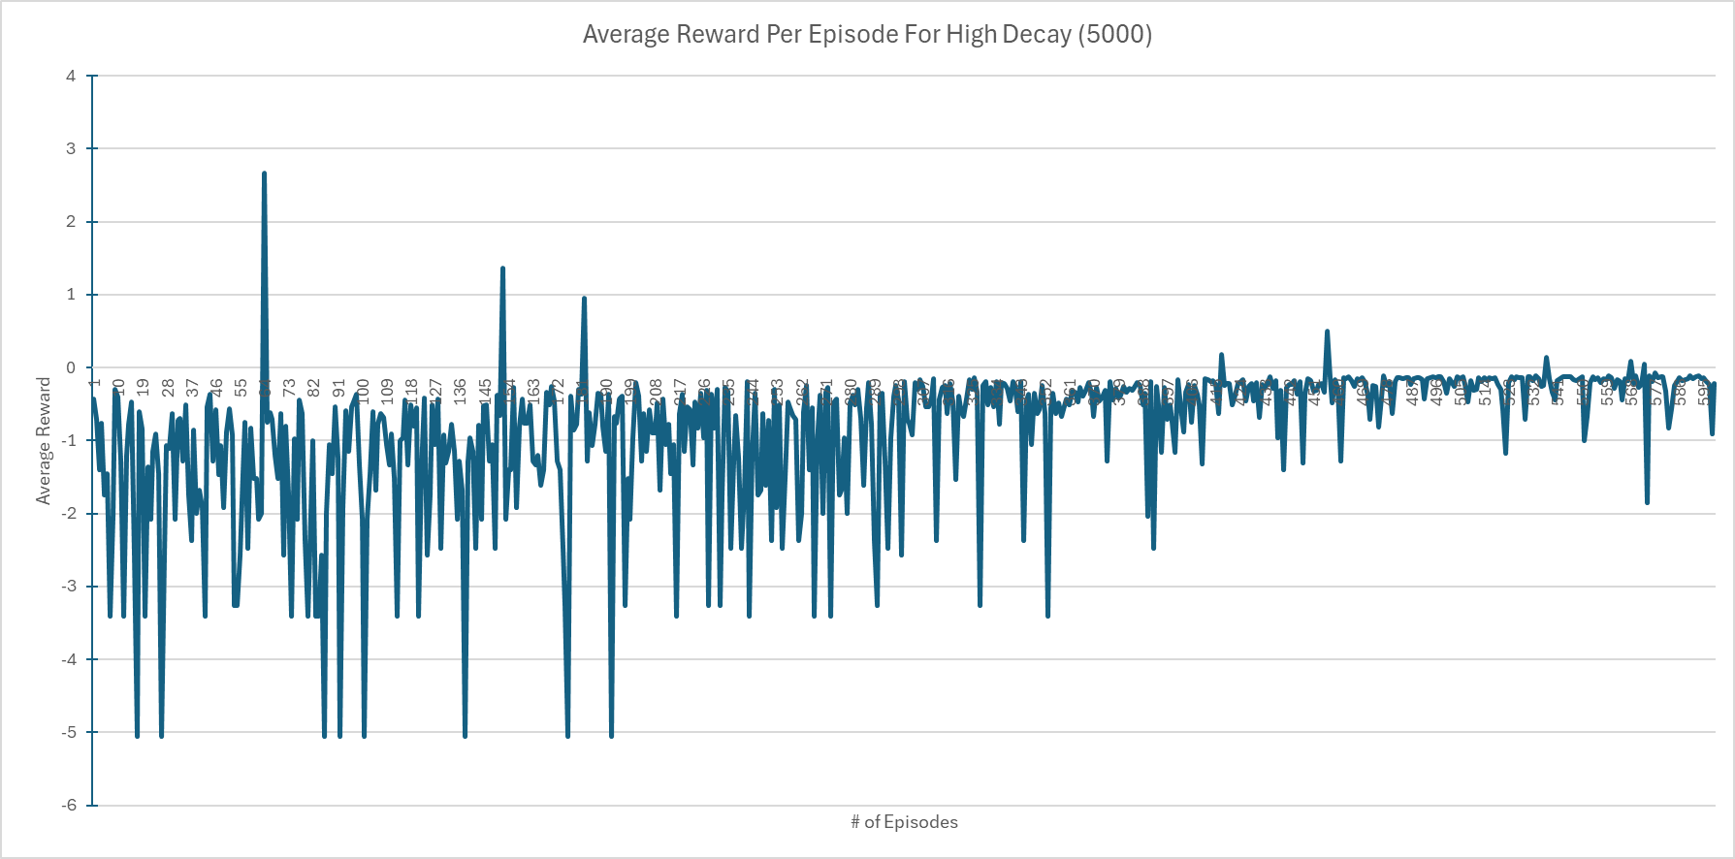
Figure 1: Average Reward Per Episode for High Decay (5000)
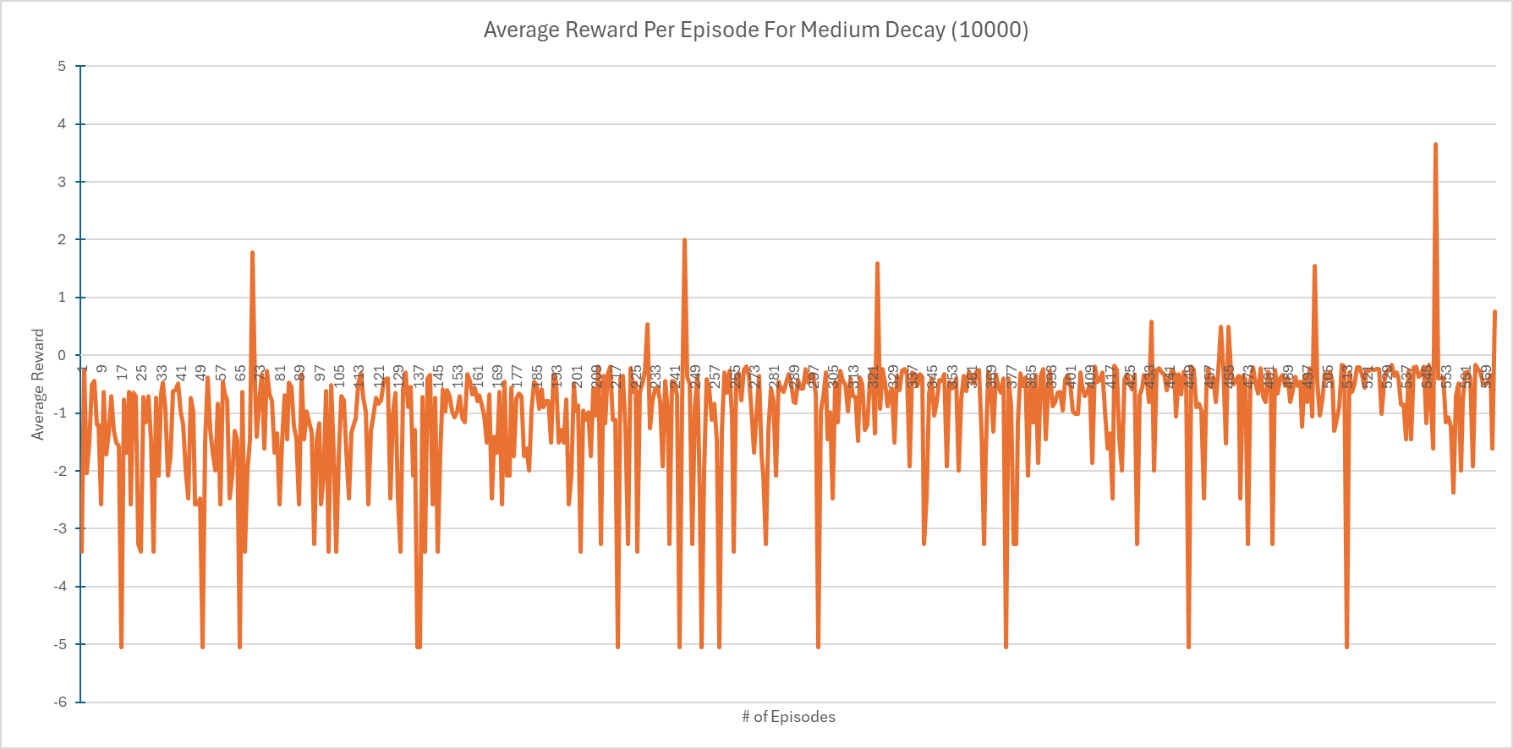
Figure 2: Average Reward Per Episode for Medium Decay (10000)
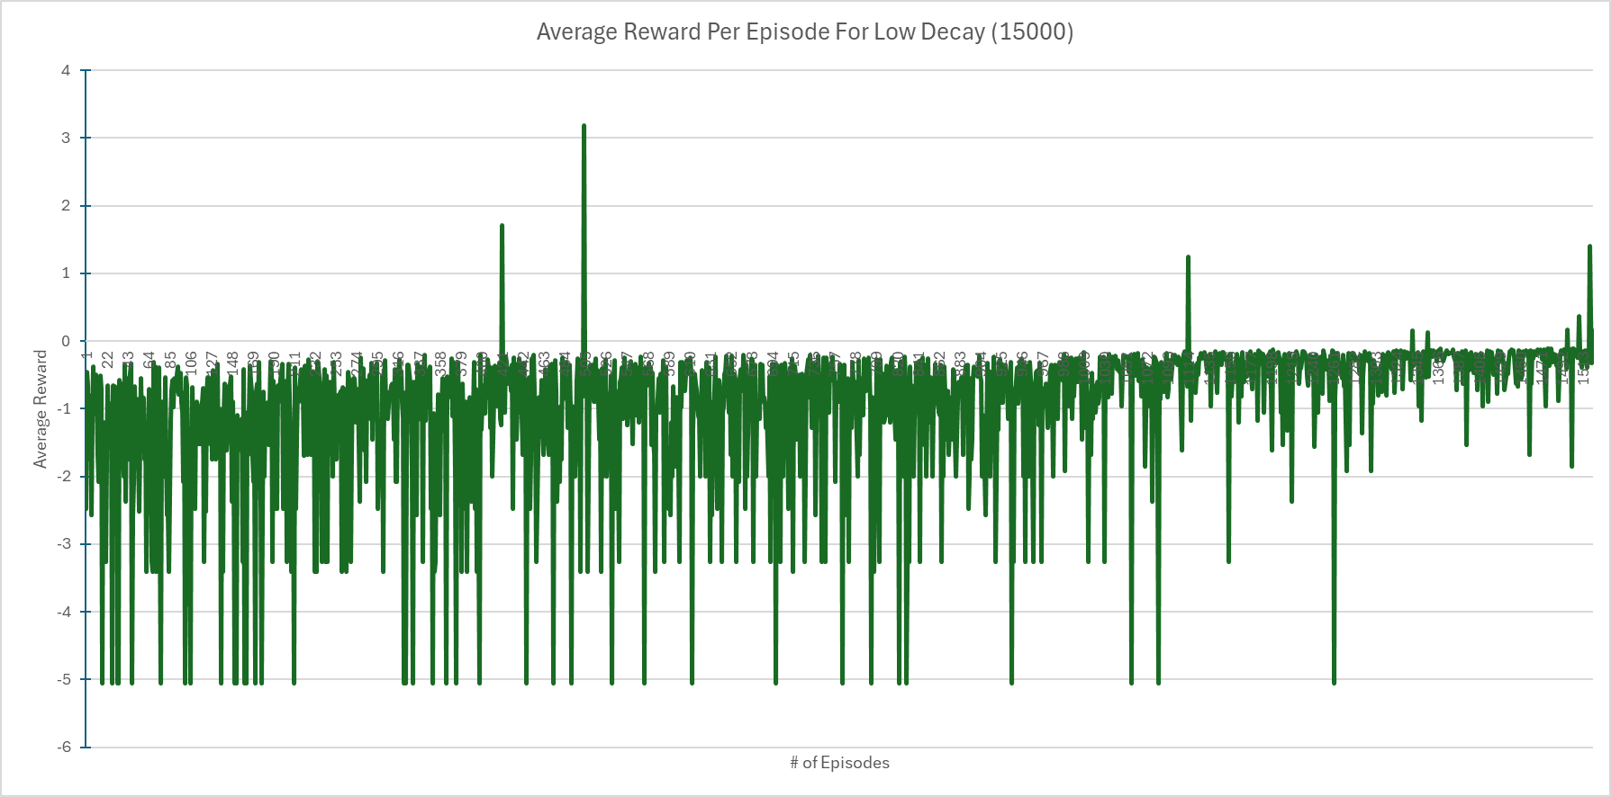
Figure 3: Average Reward Per Episode for Low Decay (15000)
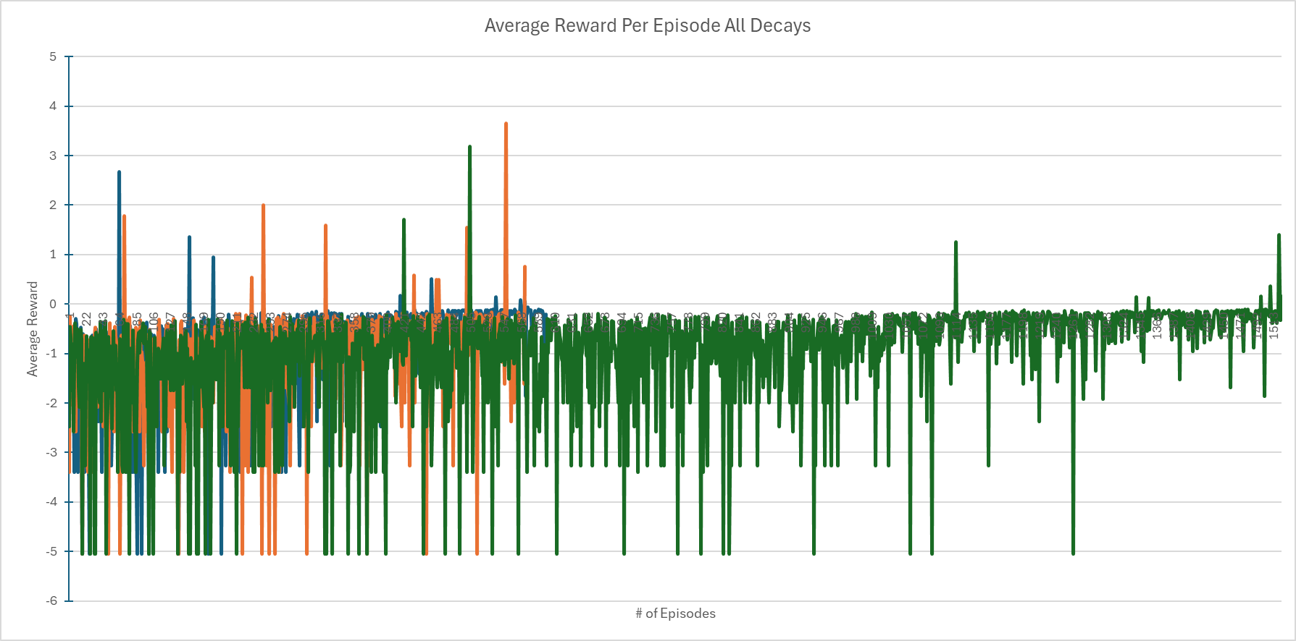
Figure 4: Average Reward Per Episode for All Decays
The Planning Horizon
For this experiment, gamma is sought as the next hyperparameter to adjust while keeping the other values stagnant as the control group.
This part explores how the agent weighs immediate costs (R=-1) against the distant Goal reward (R=+10) by adjusting Gamma.
Lock all parameters at their default values except for Gamma. Use the successful epsilon_decay value found in Part 1.
Run your DQN code once for each of the following Gamma values:
Parameter | Value | Note
Epsilon Decay Rate (ε) | 5000 (Lock) | Must be constant for all Part 2 runs.
Learning Rate (α) | 0.0005 (Baseline Value) | Must be constant for all Part 2 runs.
Epsilon Start (ε-start) | 1 | Starts fully exploring.
Epsilon End (ε-end) | 0.2 | Ends with 20% chance of random action.
Table 3: Control Hyperparameters for Gamma
Case | Gamma | Interpretation of Gama | Expected Outcome
2A | Low (0.1) | Short-sighted. | Finds a longer than optimal path.
2B | Medium (0.5) | Balanced. | Good performance.
2C | High (0.99) | Farsighted. | Finds the shortest path.
Table 4: Gamma Discount Factor Experimental Values
Conclusion
In essence, the use of alpha-beta pruning proves to be more effective than the minimax algorithm and if a well-designed heuristic was implemented for the Nim game tree alongside alpha-beta pruning, it would greatly improve computational time. Alpha-beta pruning is an optimization that significantly decreases the computational time for the search by pruning routes of the game tree that will not be travelled, while still finding the optimal move as opposed to minimax’s exploration of the entire game tree, leading to longer computational times and less performance.

