Quintets Engineering

October 24, 2017

Technical Document

Implementation of iOS Application

Implementing iOS App

1. Google Drive>Shared with me>Quintet Engineering>(Right Click) IOS APP XCode Project>Download locally
2. Then delete all the exe. Files like .DOS_Store, Podfile, and Podfile.lock, and Pods files
3. Open up terminal and locate the files in the terminal
4. Type “pod init”
5. Open up the Podfile in file system
6. Maneuver to below #Pods for Project_Textbook
7. Add the following lines to the Podfile
   1. pod 'Firebase/Core'
   2. pod 'Firebase/Database'
   3. pod 'Firebase/Auth'

Should Look like this:

# Uncomment the next line to define a global platform for your project

# platform :ios, '9.0'

target 'Project_Textbook' do

# Comment the next line if you're not using Swift and don't want to use dynamic frameworks

use_frameworks!

# Pods for Project_Textbook

pod 'Firebase/Core'

pod 'Firebase/Database'

pod 'Firebase/Auth'

end

1. Go to terminal and type pod install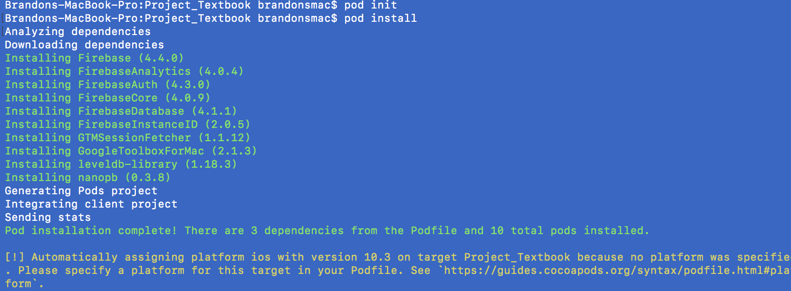
2. Double click Project_Textbook.xcworkspace to open up in XCode
3. Delete the GoogleFirebase.lis file, it should pop up red. Once deleted just add it again to workspace
4. Delete Main.storyboard from the workspace, then add a new file with the same name
5. Now find the file from within your files, Should be within your Bases.lprog file
6. Copy the XML from this location, and then go navigate to the file of the same name in your workspace
7. Repeat this process for LaunchScreen.storyboard
8. Build