Raghav Jhavar

raghav@jhavar.net

Abstract

The following document informs about the MODS XML Uploader program. This includes understanding the UI, how the program works and potential problems.

mods xml uploader

User Documentation



**Part 1: User interface and logic**

# a quick glance

The user interface for the Uploader looks like the following:

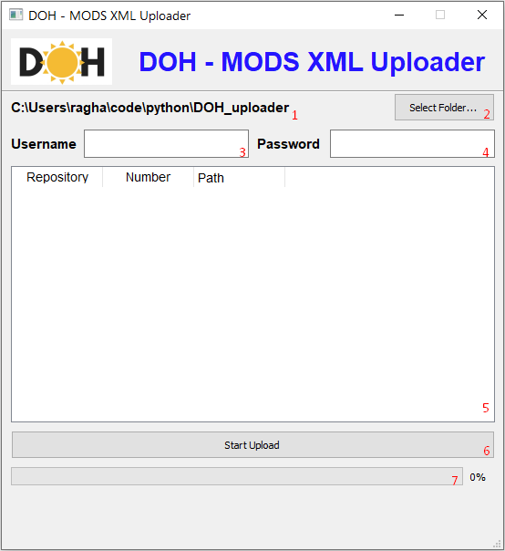

The red numbers in the image are added labels and are **not** part of the UI. Each of these labelled elements play an important role in the program. The following documentation will address each labelled element and clarify its purpose.

# element 1

When the program is first started, this element will indicate the location of the program on the system it is running on. The purpose of this element is to keep track of the folder selected using element 2.

# ELEMENT 2

This element allows you to select a folder on your system. When you select a folder using this element, the program will traverse that folder and all of its sub-folders, picking up all XML files. These XML files, if valid MODS XML files, will be populated into the table (element 5) The validity of a MODS XML file is determined by its name: the name *must* follow the format repository_number.xml. An example would be: arms_7683.xml (for which the PID is arms:7683, or arms%3A7683 when using the website) Note that this element will also update element 1 to the location of the folder selected.

# Element 3

This element allows you to enter your username. This username is the same you use to login to the website.

# element 4

This element allows you to enter your password. This password it eh same you use to login to the website.

# element 5

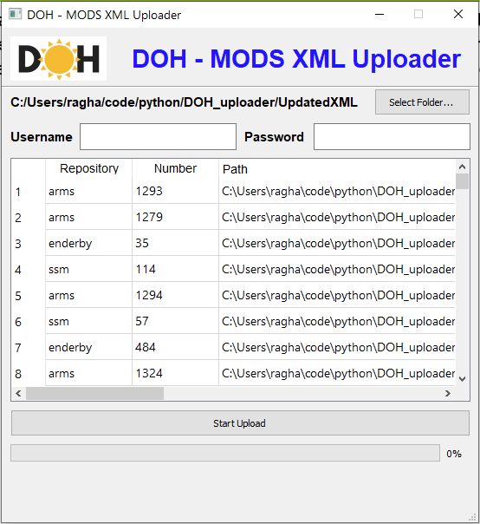This element is a table that is populated when you select a folder that has valid MODS XML files at some depth (i.e. depth in the folder, could be any number of folders deep) The following is an image that indicates the table when a folder with valid MODS XML files is selected:

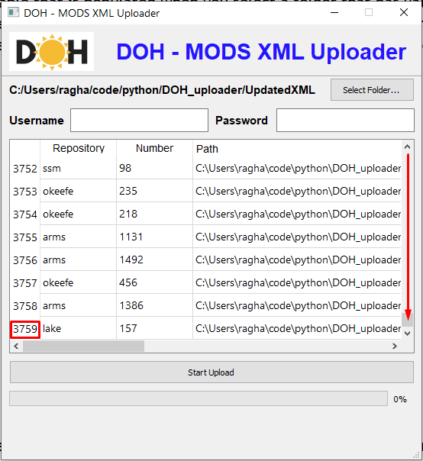Note that the table will **not necessarily** maintain the order of the files in your folder. A useful feature of this table is also the first, undeclared column, which indicates the numerical position on the table. By scrolling down to the end, you can see how many files were found in total:

# element 6

This element is essentially the big-red-button. Clicking this will start uploading the MODS XML files you have loaded, but will do a few checks before it starts:

1. Have any valid MODS XML files been loaded (technically, does element 5, the table, have any rows?)
2. Has a username been entered?
3. Has a password been entered?
4. Are the username and password valid? (i.e. it will try to login using the credentials you provide and throw an error message if invalid)

If the checks successfully pass, the uploading process will begin. There are several indicators for you to keep track of progress. Firstly, there is a progress bar and label, which will be addressed later in the documentation. However, there are also color indicators that can help you keep track. These color indicators will appear in the table, highlighting rows to suggest different things about them:

* A yellow row suggests that the MODS XML file is currently being processed. Processed means opening the object on the website, acquiring the lock, updating the MODS XML and then releasing the lock.
* A green row suggests that the MODS XML file was successfully uploaded.
* 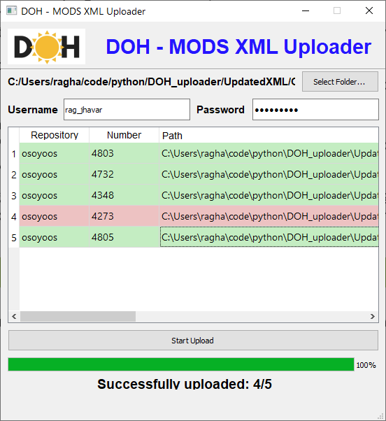A red row suggests that the MODS XML file failed to upload. There are several reasons for why a MODS XML file might fail, which will be discussed later in the documentation.

*The error was triggered purposefully by acquiring the lock beforehand so the program would give a red row*

You may notice that several rows go yellow at once. This is because the program is processing them in parallel, which greatly speeds up the process of uploading (the program will upload a maximum of 10 MODS XML files at a time)

# Element 7

This element is a progress bar that indicates the aggregate uploading progress. That is, it will go up as rows are processed, not taking into account whether it was successful or not:

*The error was triggered purposefully by acquiring the lock beforehand so the program would give a red row*

In this case, the progress bar reached 100% as all rows were processed.  
  
**Note: The successfully uploaded text has been removed from the program as it was not accurate some of the time, which can lead to confusion.**

**part 2: solving issues / errors**

# No files have been loaded…

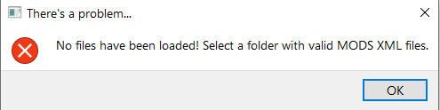

When this error occurs, it usually means you have not picked a folder with MODS XML files. Technically, this error occurs because the table has no rows in it. Go ahead and click element 2, the select folder button, and pick a folder with valid MODS XML files.

# you must enter a username / password

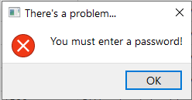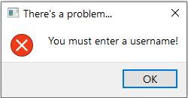

This error occurs when you leave element 3, the username textbox or element 4, the password textbox empty. Simply enter your username and password (same as website) and proceed.

# ensure your username and password are correct!

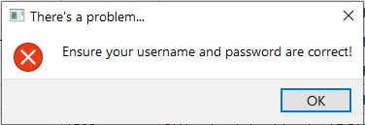

This error occurs when the program tries to authenticate you with the credentials you provided in element 3 and 4 (username and password textboxes) and fails. It is most likely due to an error in your username or password. Ensure you type the correct credentials. If you have forgotten your password, reset it by [clicking here](https://doh.arcabc.ca/user/password). If the error persists, there is an issue with the program which needs to be reported.

# A red row

A red row occurs during the upload process, when a MODS XML file cannot be updated:

*The error was triggered purposefully by acquiring the lock beforehand so the program would give a red row*

The red row can occur for several reasons listed below (ordered by most likely):

* Someone else is modifying the object (and has thus acquired the lock) so you cannot acquire the lock.
* You do not have permission to modify the object. Try and manually update an object and see if you can successfully do it.
* A networking issue occurred:
  + You lost connection to the internet
  + The website crashed and is offline and not serving clients (very unlikely)
* Your user session expired. This can occur if the program signed you in too long ago, or the website dropped your session for another reason. Looking at the DOH website, sessions last up to 23 days. As long as your upload does not exceed 23 days OR your session is not destroyed, you should be okay.
* The program is not working correctly. This can occur if the DOH website’s structure is changed and the program no longer works with the new structure. Report this issue to get the program fixed.

At extremely rare occasions, the red row occurs, but becomes green again. However, the MODS XML file seems to still upload fine. This issue occurs for a reason that nobody including myself will ever know, and that will be that. Oh, the beauty of programming.

# UNDERSIZED WINDOW

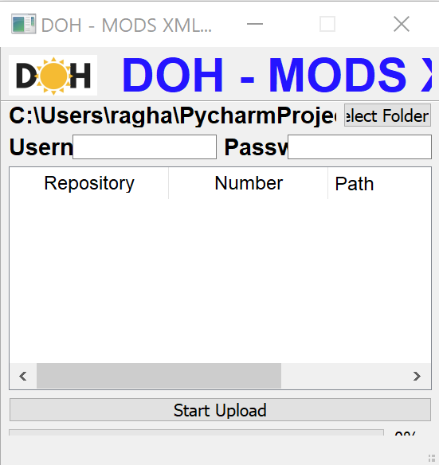When using the program on a laptop, the window will seem too small and the elements will not be properly visible:

To fix this, you will have to change the high DPI settings on your system for this application using the following steps:

1. Right click the application file
2. Select “Properties”
3. Select the “Compatibility” tab
4. Select “Change high DPI settings”
5. Tick “Override high DPI scaling behavior.”
6. Then, in the selection box where it says “Scaling performed by:”, select “System”
7. Click Ok, then Apply to apply these settings. The program should now be normally sized.

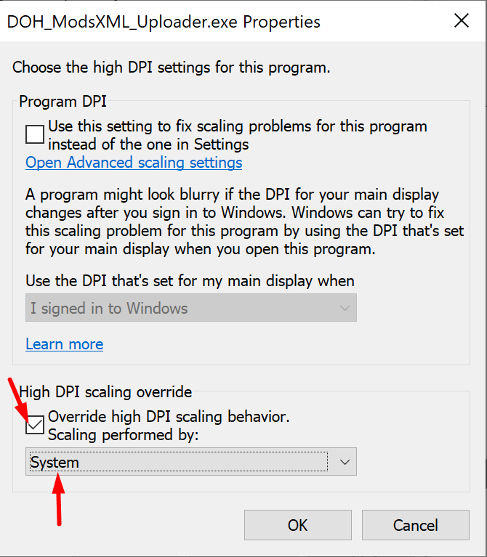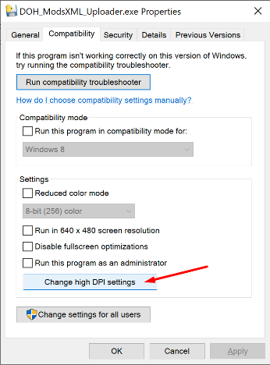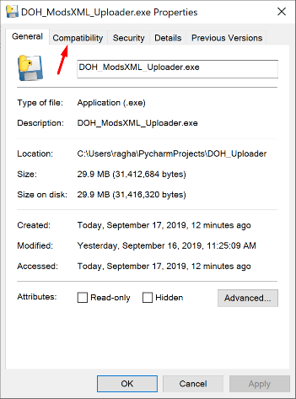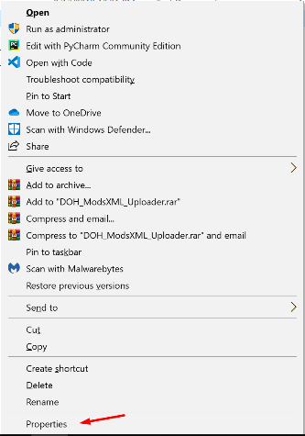Here are images to help you with these steps:

**Part 3: improving the program**

The program and its documentation are subject to improvement, which is determined by the users. Examples of improvements are:

* Adding a timer to indicate total time elapsed
* Creating a new folder called “failed” which contains all the XML files that did not successfully upload.
* Add more screenshots that clarify issues
* Add a page of contents for quicker navigation of the documentation

# suggesting an improvement

A Google Sheet by the name “DOH_tech_improvement” should have been shared with you via Google Drive. If not, you should request that it be shared. In this sheet, you can add improvements.