NAME:E.M.SHESHAN

REG.NO:23MIS1095

QUESTION1:

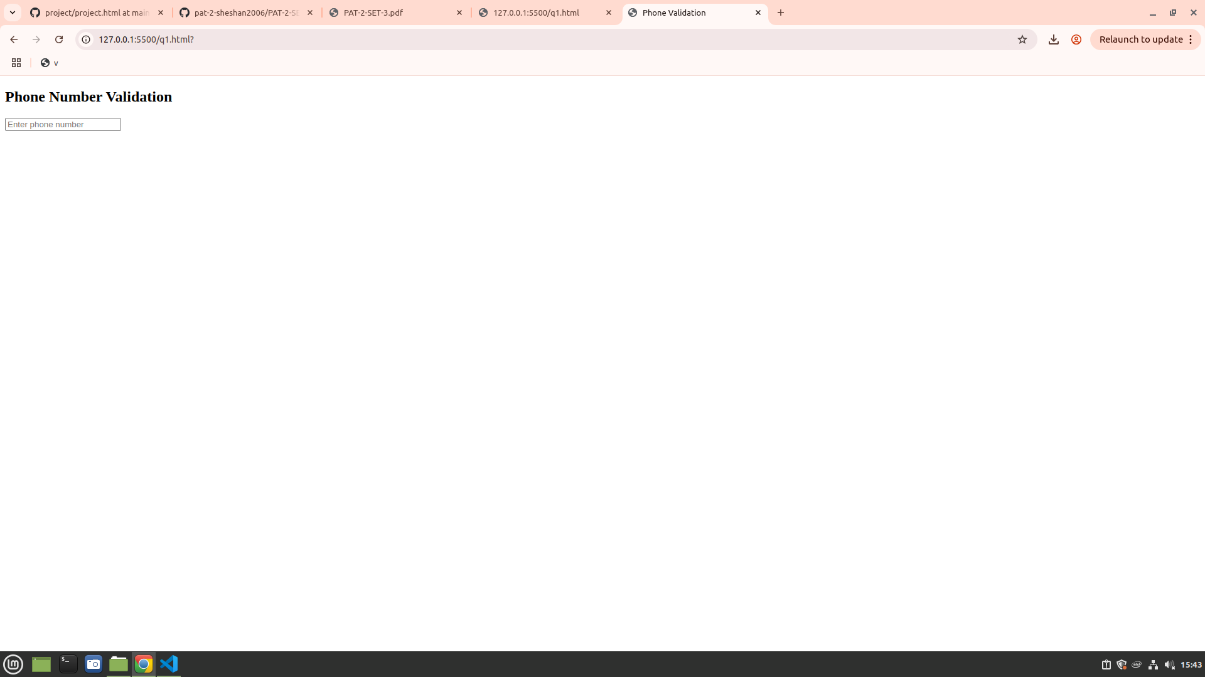

QUESTION2:

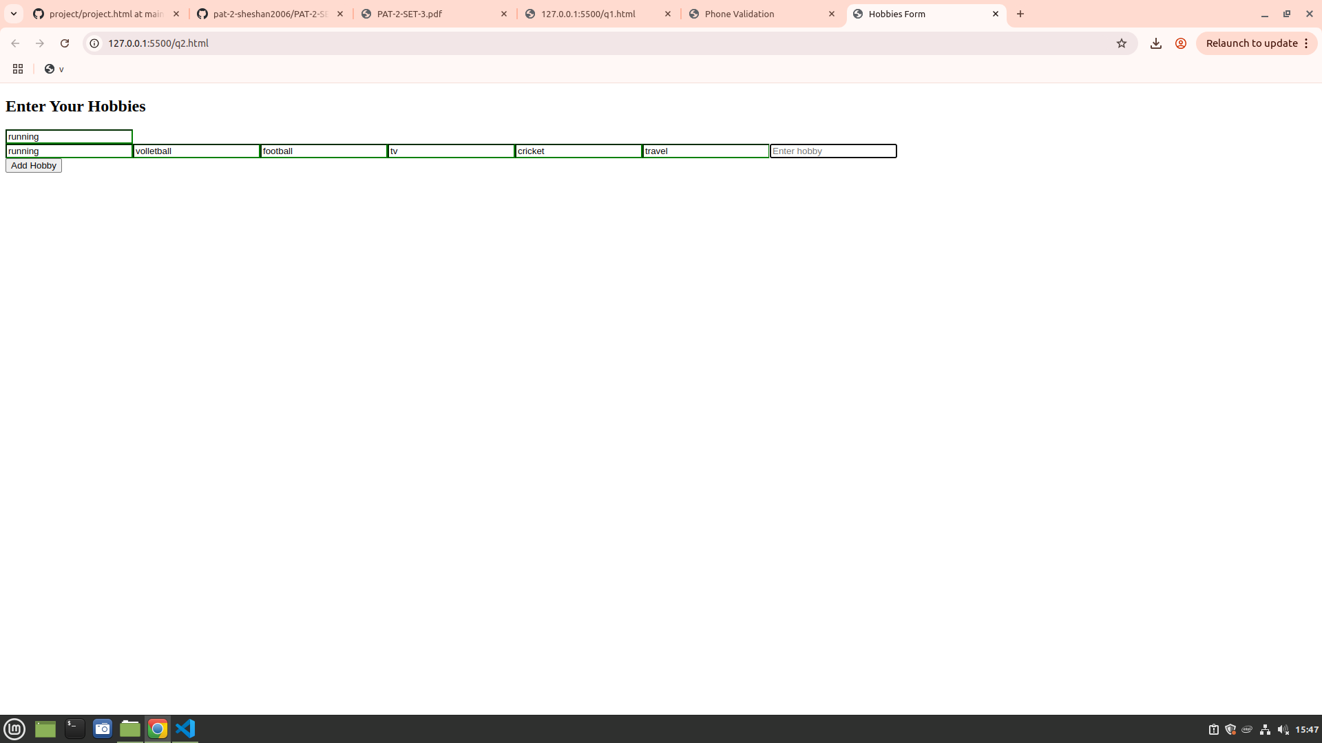
QUESTION 3:

