WEB PAT-03
Name :Tanguturi Uma Maheswari
Reg.No:23MIS1127
1. Write a PHP script that has an array of email addresses, some valid and some invalid (e.g., ["john@example.com", "wrong-email@", "me@site", "user123@gmail.com"]). Using regular expressions, check each email address and print only the valid ones
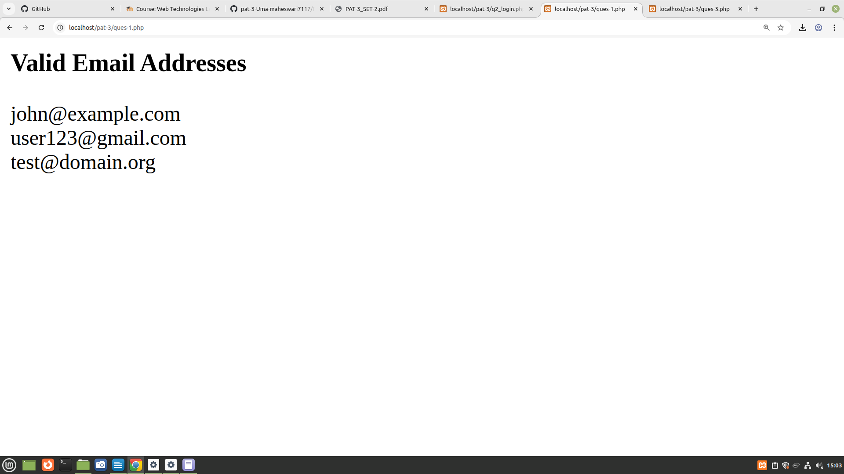
2. Create a login system using sessions. Redirect to a welcome page upon successful login.
Login.php
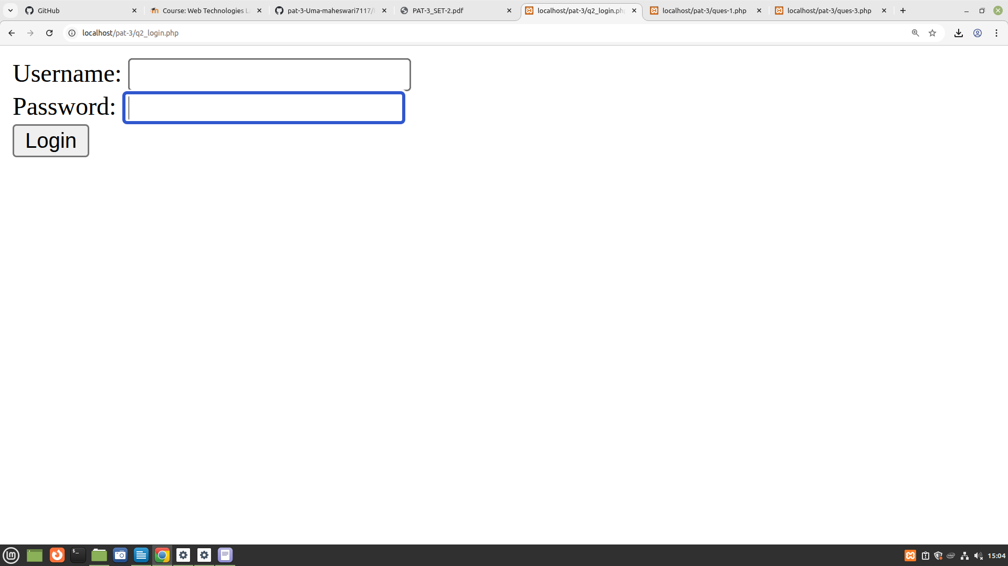
Welcome .php
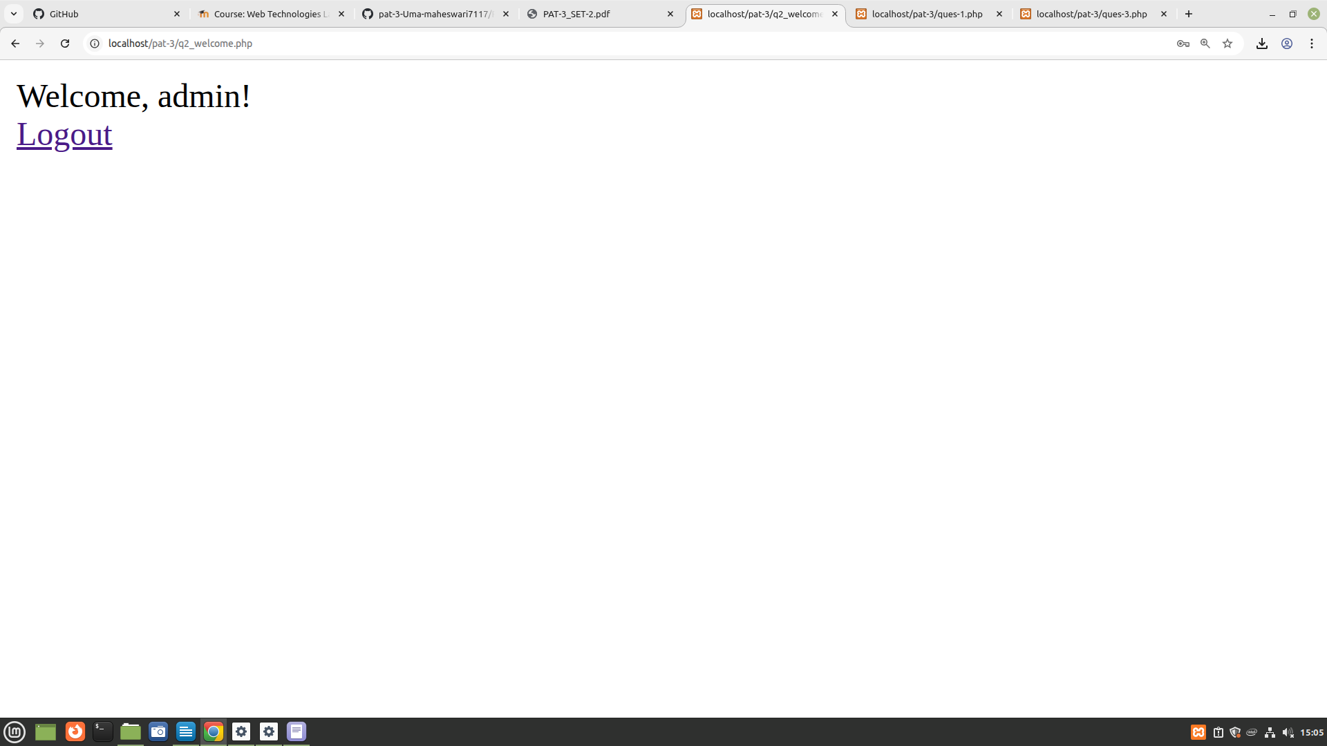
credentials
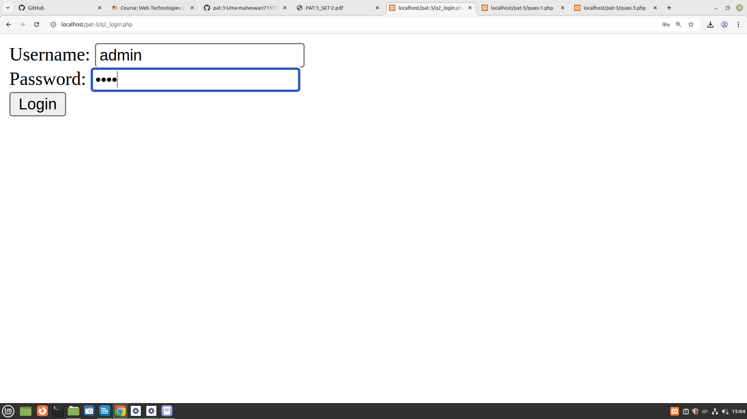
3.Write a PHP script to calculate and display average temperature, five lowest and highest temperatures. Recorded temperatures: 78, 60, 62, 68, 71, 68, 73, 85, 66, 64, 76, 63, 75, 76, 73, 68, 62, 73, 72, 65, 74, 62, 62, 65, 64, 68, 73, 75, 79, 73
