WEB TECHNOLOGIES – PAT3

Reg No: 23MIS1107
Name: Prashanth Guptha

Question 1:
Write a PHP function to change the following array's all values to upper or lower case. Sample arrays : $Color = array('A' => 'Blue', 'B' => 'Green', 'c' => 'Red'); Expected Output : Values are in lower case. Array ( [A] => blue [B] => green [c] => red ) Values are in upper case. Array ( [A] => BLUE [B] => GREEN [c] => RED )

Output:
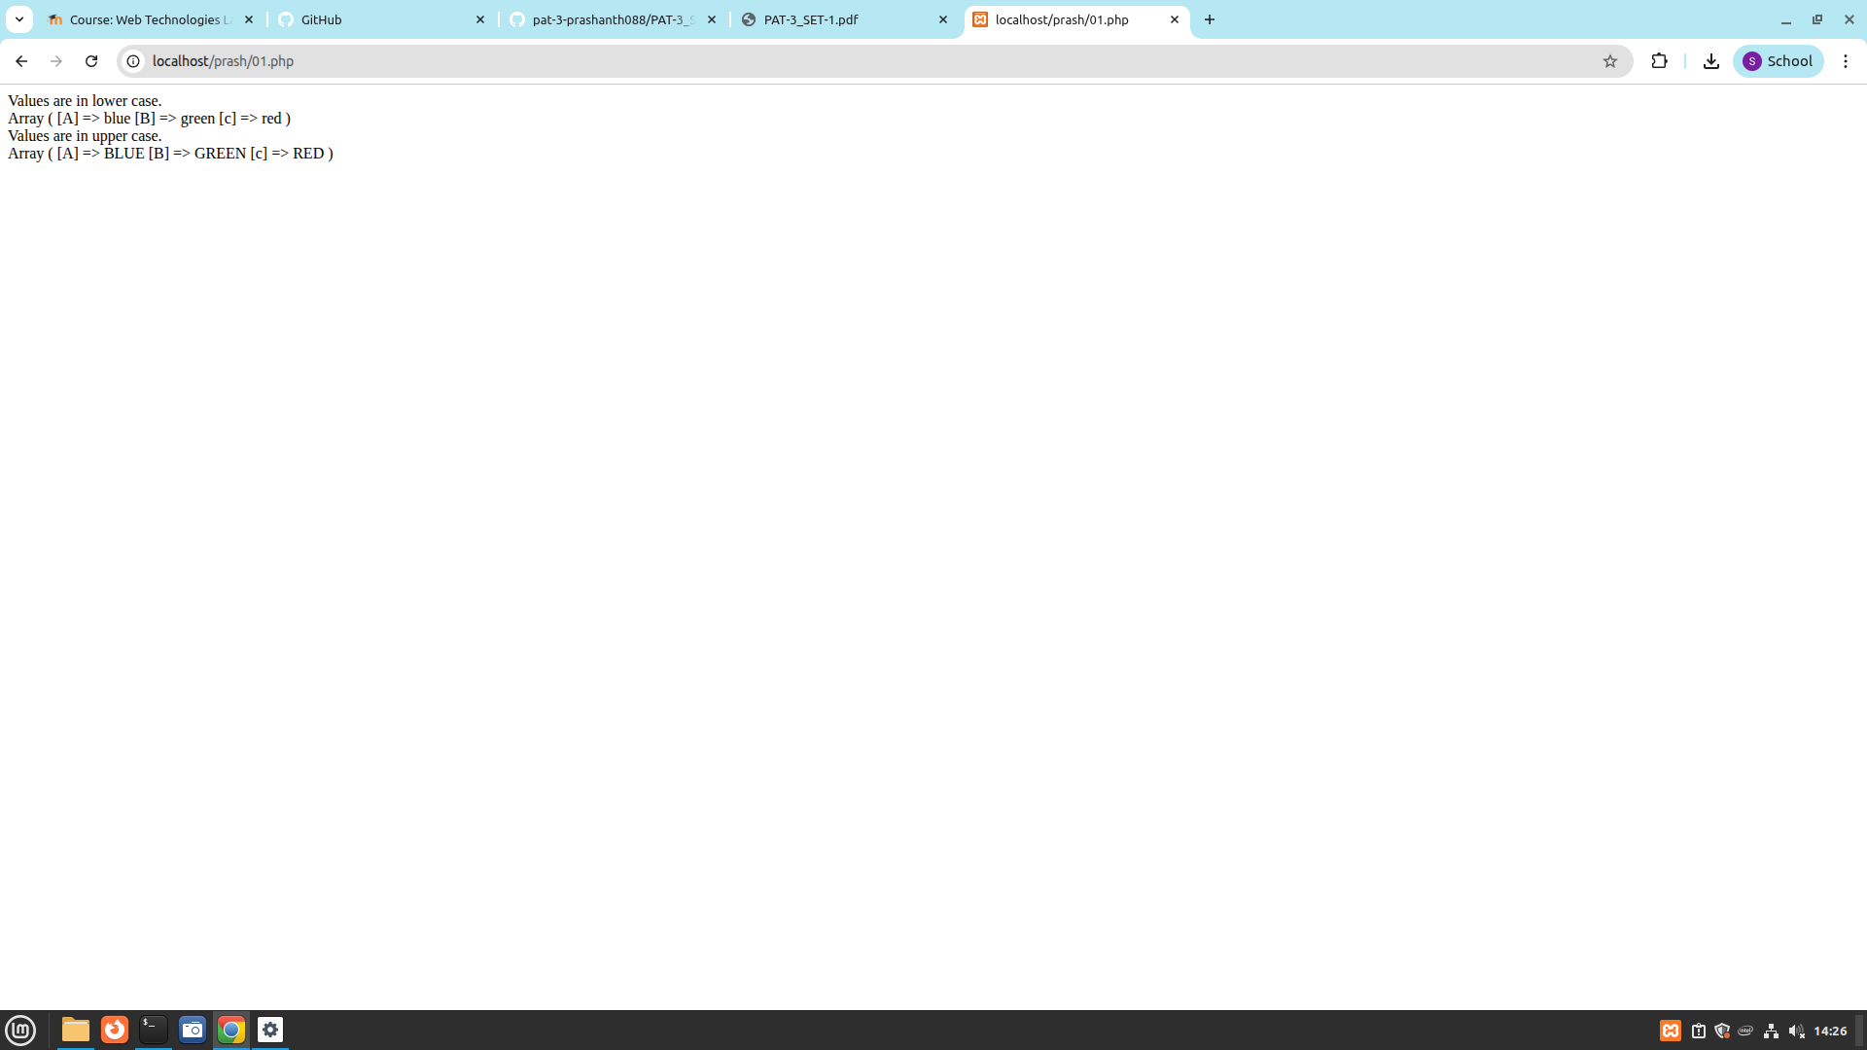
Question 2:
Create a text file products.txt with product names and prices (e.g., Laptop,55000, Mouse,500). Write a PHP program to: • Read the file contents into an array. • Sort the products based on price (ascending). • Display the sorted product list in an HTML table with two columns: Product Name and Price.

Output:

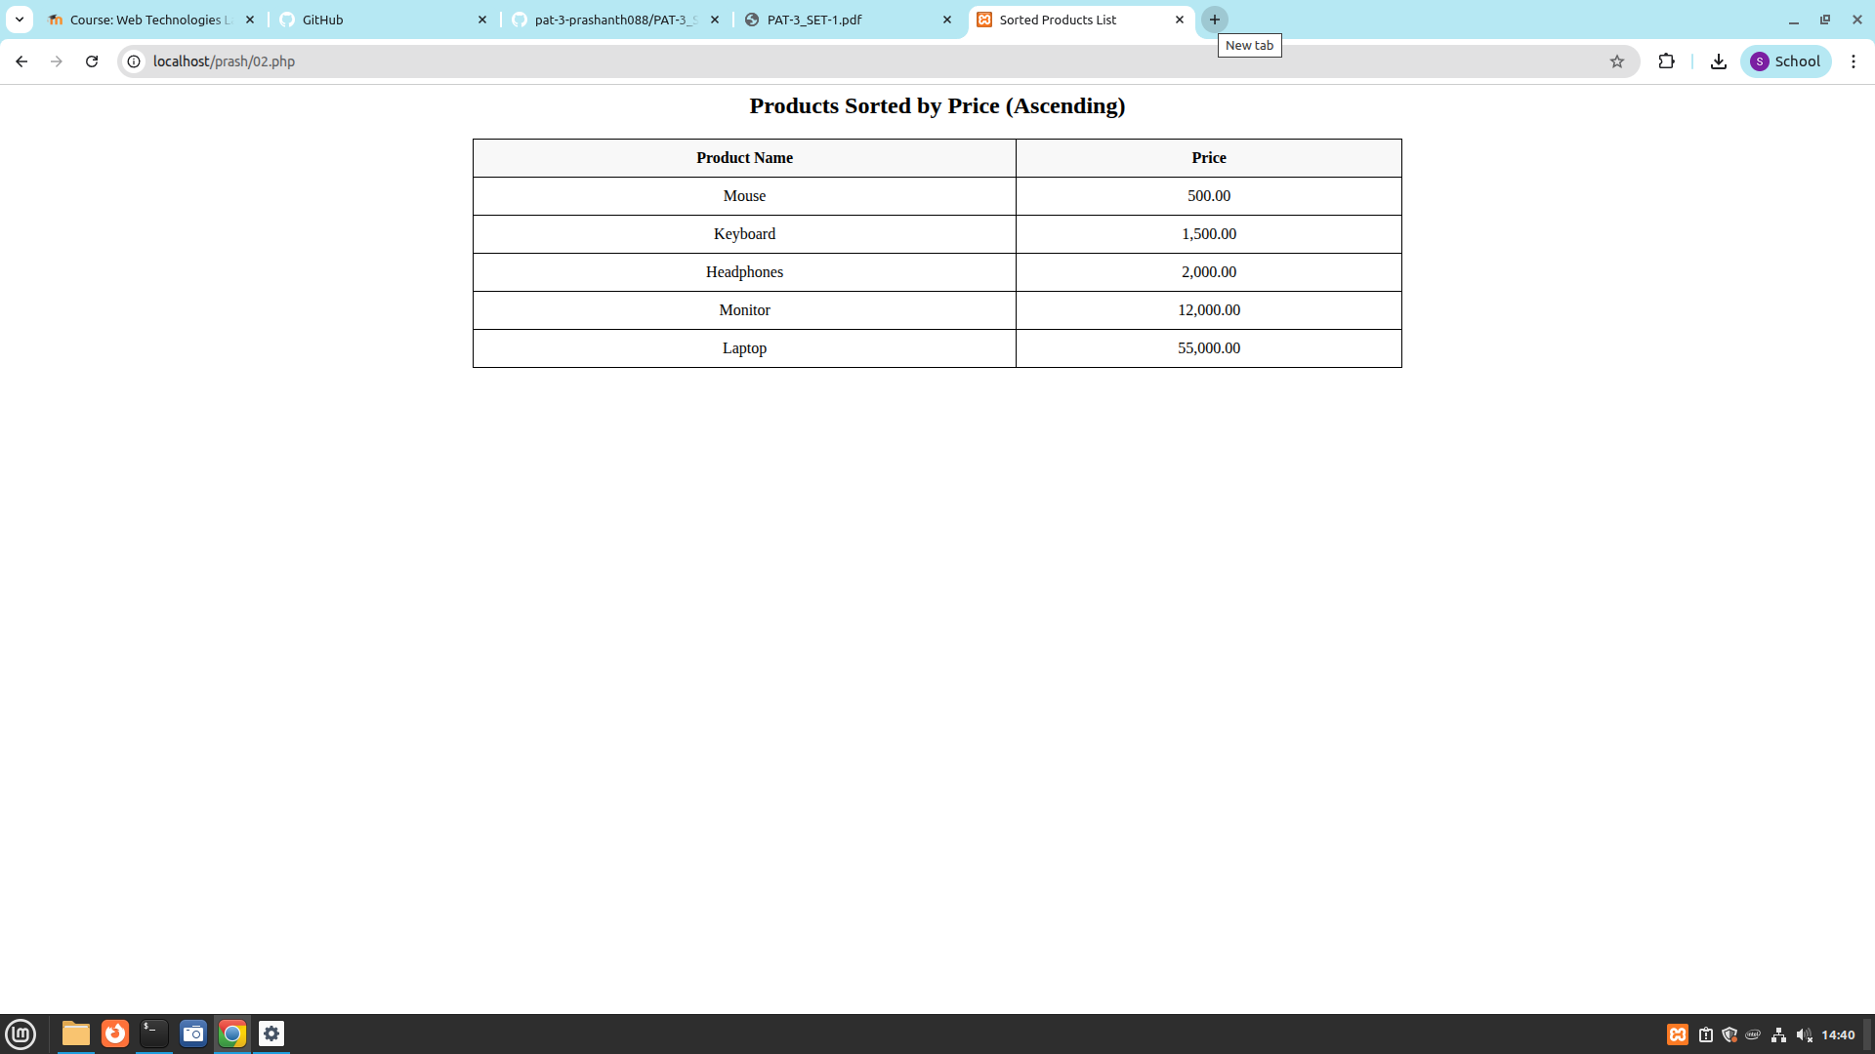

Question 3:
Write a PHP program that uses cookies to count how many times a user has visited your webpage. Display a message showing the visit count.

Output:
