PAT3-SET2

Name : Rahul Krishnamoorthy
Reg no: 23mis1066

1. Write a PHP script that has an array of email addresses, some valid and some invalid (e.g., ["john@example.com", "wrong-email@", "me@site", "user123@gmail.com"]). Using regular expressions, check each email address and print only the valid ones.

CODE:
<?php
$emails = ["john@example.com", "wrong-email@", "me@site", "user123@gmail.com"];
echo "List of emails: ". implode(", ", $emails) . "<br>";

foreach ($emails as $email) {
if (preg_match("/^[a-zA-Z0-9._%+-]+@[a-z0-9.-]+\.[a-z]{2,}$/", $email)) {
echo "Valid Email: $email<br>";
}
}
?>

Screenshot:
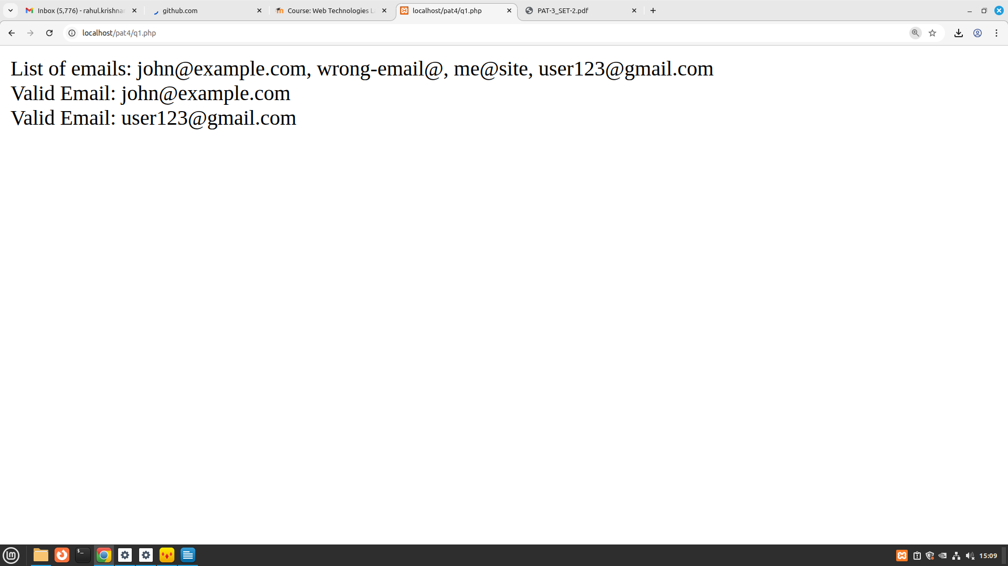
2. Create a login system using sessions. Redirect to a welcome page upon successful login.

CODE:

<?php

session_start();

if (isset($_GET['logout'])) {
session_unset();
session_destroy();
header("Location: " . $_SERVER['PHP_SELF']);
exit();
}

if ($_SERVER['REQUEST_METHOD'] == 'POST') {
$username = $_POST['user'];
$password = $_POST['pass'];

if ($username === "admin" && $password === "1234") {
$_SESSION['user'] = $username;
} else {
$error = "Invalid username or password!";
}
}

if (isset($_SESSION['user'])) {
?>
<!DOCTYPE html>
<html>
<head><title>Welcome</title></head>
<body>
<h2>Welcome, <?php echo $_SESSION['user']; ?>!</h2>
<p>You are logged in successfully using session.</p>
<a href="?logout=true">Logout</a>
</body>
</html>
<?php
} else {
?>
<!DOCTYPE html>
<html>
<head><title>Login</title></head>
<body>
<h2>Login</h2>
<?php if (!empty($error)) echo "<p style='color:red'>$error</p>"; ?>
<form method="POST" action="">
Username: <input type="text" name="user" required><br><br>
Password: <input type="password" name="pass" required><br><br>
<button type="submit">Login</button>
</form>
</body>
</html>
<?php
}
?>

ScreenShot:
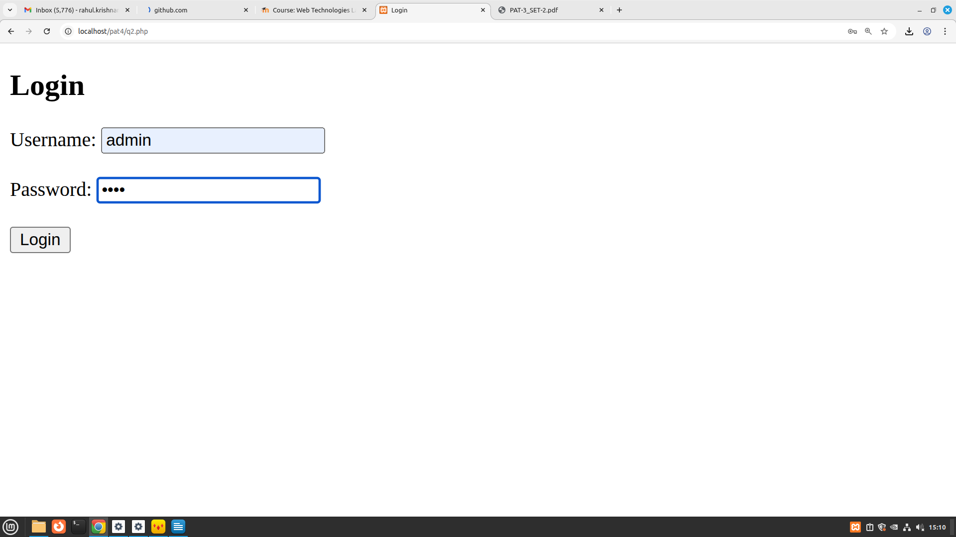

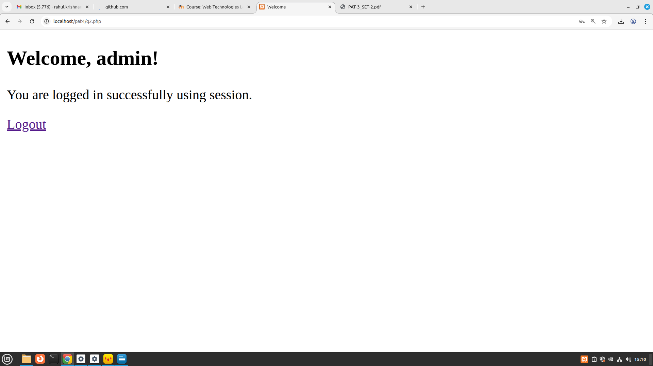

3. Write a PHP script to calculate and display average temperature, five lowest and highest temperatures. Recorded temperatures: 78, 60, 62, 68, 71, 68, 73, 85, 66, 64, 76, 63, 75, 76, 73, 68, 62, 73, 72, 65, 74, 62, 62, 65, 64, 68, 73, 75, 79, 73 Expected Output: Average Temperature is : 70.6 List of seven lowest temperatures : 60, 62, 63, 63, 64, List of seven highest temperatures : 76, 78, 79, 81, 85,

CODE:
<?php
$temperatures = array(78, 60, 62, 68, 71, 68, 73, 85, 66, 64, 76, 63, 75, 76, 73, 68, 62, 73,72, 65, 74, 62, 62, 65, 64, 68, 73, 75, 79, 73);
echo "<h4>List of Temperatures: 78, 60, 62, 68, 71, 68, 73, 85, 66, 64, 76, 63, 75, 76, 73, 68, 62, 73,72, 65, 74, 62, 62, 65, 64, 68, 73, 75, 79, 73</h4>";
$average = array_sum($temperatures) / count($temperatures);
echo "<h2>Average Temperature is : " . round($average, 1) . "<br></h2>";
$unique_temps = array_unique($temperatures);
sort($unique_temps);
$lowest = array_slice($unique_temps, 0, 5);
$highest = array_slice($unique_temps, -5);

echo "<h2>List of five lowest temperatures : " . implode(", ", $lowest) . "<br></h2>";
echo "<h2>List of five highest temperatures : " . implode(", ", $highest) . "<br></h2>";
?>

