ReactJS Part – 3 – Lab Assignment

# Create a React Component using JSX that Displays a Greeting Message

⬛ **Concepts Covered**: JSX, Props

# Task:

* + - Create a Greeting component that accepts a name prop and displays a greeting message like

# "Hello, John!".

* + - Render this component inside App.js with different names.

# Hint:

## Use JSX to return elements dynamically based on props:

function Greeting({ name }) { return <h1>Hello, {name}!</h1>;

*}*

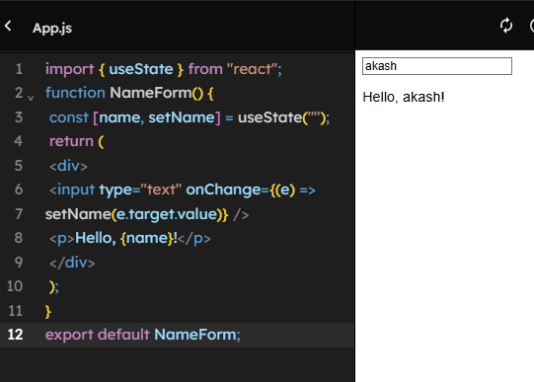

# Build a Counter Component using a Constructor in a Class Component

⬛ **Concepts Covered**: React Constructors, setState

# Task:

* + - Create a **class component** Counter that initializes count = 0.
    - Provide + and - buttons to increase/decrease the count.

# Hint:

* + - Use a **constructor** to initialize the state:

constructor(props) { super(props); this.state = { count: 0 };

*}*

* + - Use this.setState() to update the count.
    - 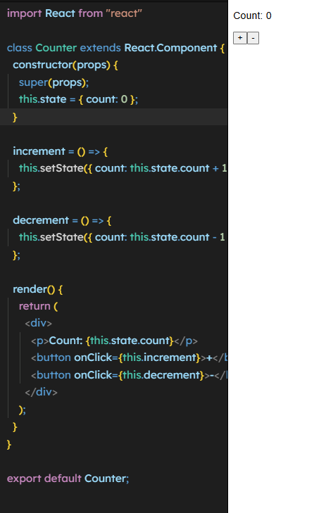

# Convert a Class Component into a Functional Component using Hooks

⬛ **Concepts Covered**: useState, Functional Components

# Task:

* + - Take an existing **class-based counter component** and rewrite it using a functional component with useState.

# Hint:

## Replace this.state with:

## 

const [count, setCount] = useState(0);

## Replace this.setState() with:

setCount(count + 1);

# Create a Dynamic List Rendering Component using .map()

⬛ **Concepts Covered**: JSX, Lists, Props

# Task:

* + - Create a UserList component that takes an array of names as a prop and **renders each name as a list item** (<li>).

# Hint:

## Use .map() inside JSX:

<ul>

{users.map((user, index) => <li key={index}>{user}</li>)}

</ul>

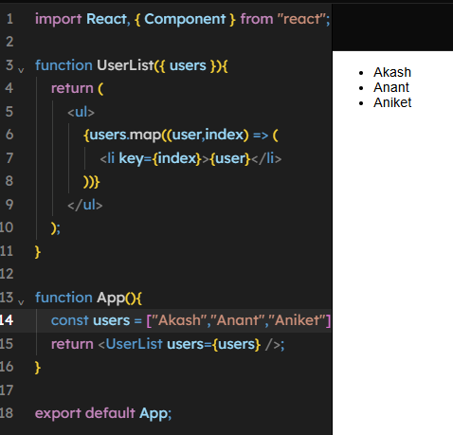

# Implement a Simple Theme Switcher using useState

⬛ **Concepts Covered**: Hooks, State Management

# Task:

* + - Create a **dark/light mode toggle** using a button.
    - Store the theme (light or dark) in a state variable and update styles dynamically.

# Hint:

Use a **boolean state** and toggle it:

const [theme, setTheme] = useState("light");

const toggleTheme = () => setTheme(theme === "light" ? "dark" : "light");

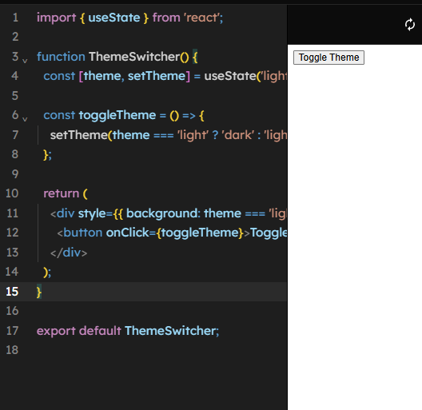

# Use useEffect to Fetch and Display Data from an API

⬛ **Concepts Covered**: useEffect, Fetch API, Lifecycle Hooks

# Task:

## Fetch **user data** from https://jsonplaceholder.typicode.com/users when the component mounts.

* + - Display **name, email, and website** of users.

# Hint:

## Use useEffect to fetch data only **on mount**:

useEffect(() => {

fetch("https://jsonplaceholder.typicode.com/users")

.then(response => response.json())

.then(data => setUsers(data));

*}, []);*

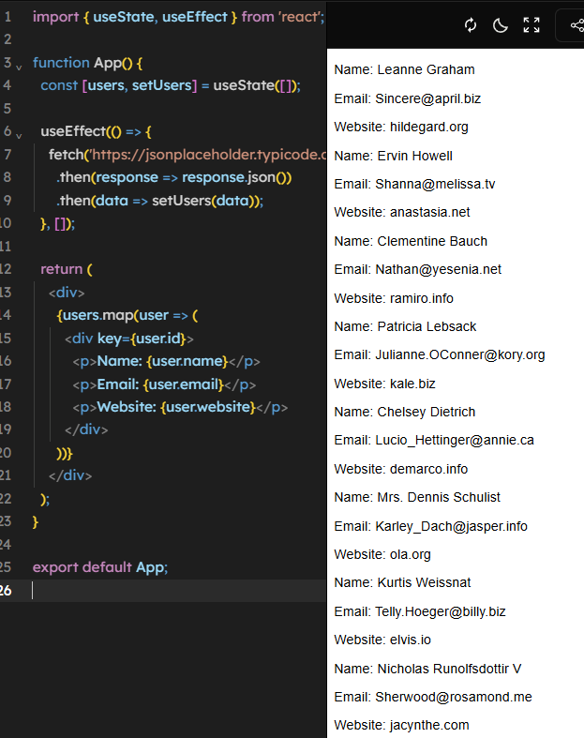

# Implement a Simple Form Handling Component using useState

⬛ **Concepts Covered**: Form Handling, State Management

# Task:

* + - Create a form with **name and email inputs**.
    - On form submission, display the entered data.

# Hint:

## Use controlled inputs:

const [name, setName] = useState("");

<input type="text" value={name} onChange={(e) => setName(e.target.value)} />

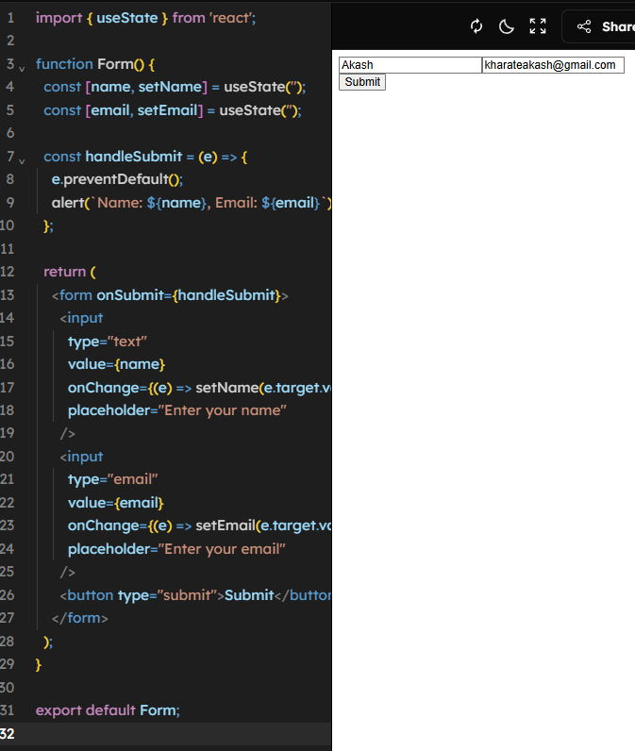

# Create a Component that Uses useEffect to Track Window Resize

⬛ **Concepts Covered**: Hooks, Event Listeners

# Task:

* + - Track **window width** and display it in the component.
    - Update width dynamically when resized.

# Hint:

## Use useEffect with an event listener:

useEffect(() => {

const handleResize = () => setWidth(window.innerWidth); window.addEventListener("resize", handleResize);

return () => window.removeEventListener("resize", handleResize);

*}, []);*

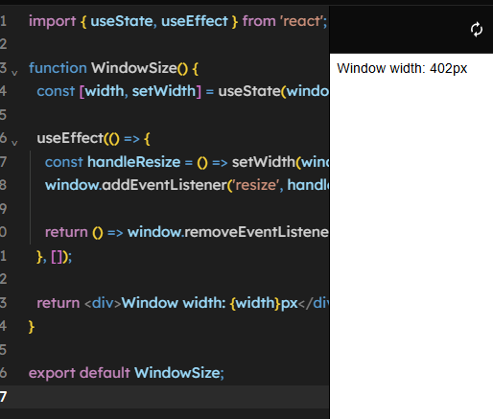

# Create a Parent-Child Component Communication using Props and Callbacks

⬛ **Concepts Covered**: Props, Callback Functions

# Task:

## Create a Parent component that has a button.

* + - The button should **update the state in the Child component**.

# Hint:

## Pass a function as a prop:

function Parent() {

const [message, setMessage] = useState("Hello");

return <Child updateMessage={() => setMessage("Updated!")} />;

*}*

function Child({ updateMessage }) {

return <button onClick={updateMessage}>Change Parent Message</button>;

*}*

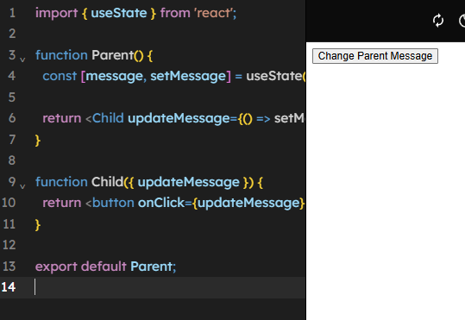

# Implement a StopWatch Using useState and useEffect

⬛ **Concepts Covered**: State, useEffect, Timers

# Task:

* + - Create a **StopWatch** with **Start, Stop, and Reset** buttons.
    - The stopwatch should count **seconds and minutes**.

# Hint:

## Use setInterval() inside useEffect:

useEffect(() => { if (isRunning) {

const interval = setInterval(() => setTime(time + 1), 1000); return () => clearInterval(interval);

*}*

}, [isRunning, time]);

