Add customer
National ID, Nationality, Phone number, driving license details should be mandatory. If user click “X” nothing should be saved.
New Company
TAX ID, contact person, Number, Email Address should be mandatory fields

New Contract.
A contract should not be created with previous date. Presently user can select past date while creating the contract.
When staff creates contract, there is no option to confirm contract. In admin login all options are working
The contract display for admin user should list the staff name who created the contract.
Time in should be removed from new contract page. Add time in when client returns vehicle.
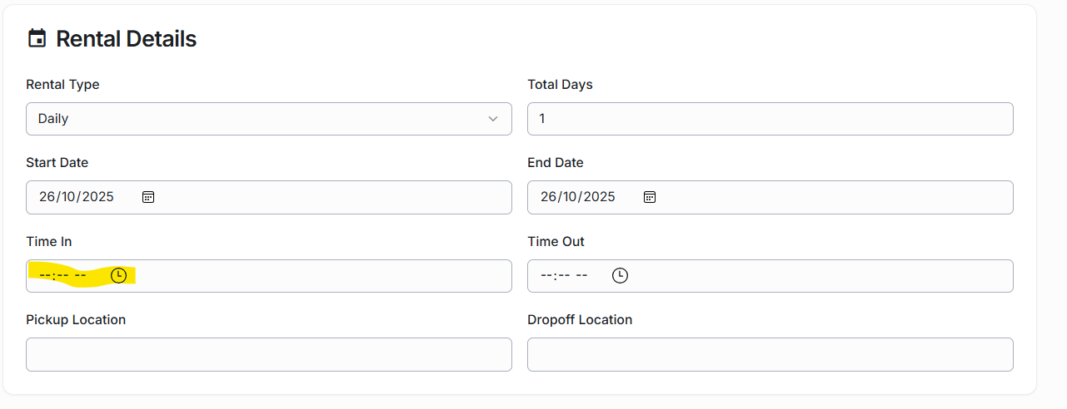
Complete contract –
If customer returned the vehicle earlier than the contract end date. User can complete the contract. But it will be better if a window pops up for entering the reason for early contract closure.

After completing the contract Payment details shows as below

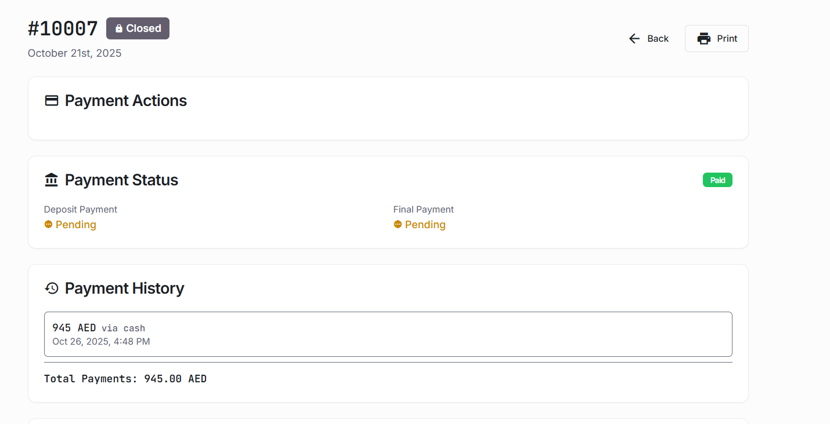

When vehicle is returned user changes the contract status to completed. After entering the rental payment, next option available is close contract. A close contract should only appear if the final payment is recorded

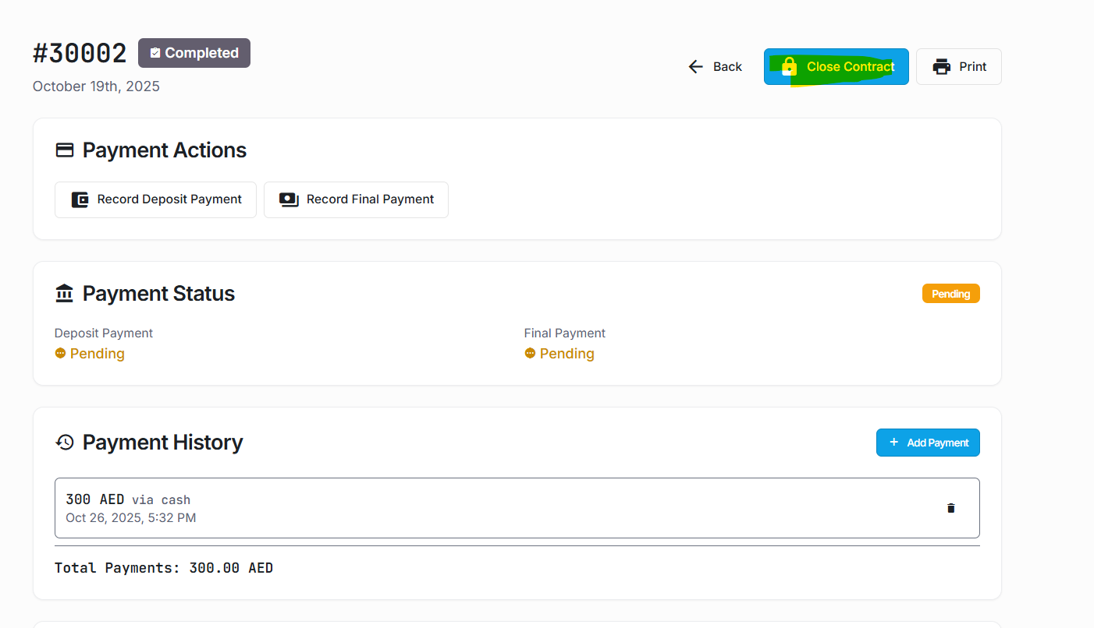

Rental company should verify about any fines and violations and record the amount in the contract before completing the contract.

Reports.

When report is exported, for example form operations Reports, All the menu reports like vehicle, operations and Extra charge are consolidated in to one report.
User should be able to generate report based on contract only. For example,
- All Contract report based on Date form and Date To
- Contract reports based on customers and company.
When generating the reports , report should display on the screen with an option to print.

