***Electoral integrity and International threat***

**By Miguel Angel Martin Tortabu**

**Democracy:**

**i.** Theword **Democracy** comes from the Greek word **"Democratia",** which is composed of the terms ***δῆμος*** **(démos),** which means **'people',** and **'(krátos),'** meaning **'power',** hence the essence of democracy, understood as **"The government of the people".**

**ii.**  In this form of government, the participation of the people in political decision-making is conceived as a human right, where citizens participate in the public destiny, directly or through their elected representatives. They have the right to vote and be elected in elections based on democratic processes that guarantee their will. [1]

**iii.**  Democracy as a pillar of society guarantees the well-being of people. It is based on the values of freedom, equality, justice, respect, tolerance, pluralism and participation; for this reason, the civilized world promotes the systems of democratic governments that guarantee the fulfilment of human rights and fundamental freedoms.

The core of democracy is the voice of the people and the consequence of electing translates into an expression of freedom, as Fernando Sabater says.[2]

**Elections; an element of democracy:**

**iv.** The principle of holding genuine elections through universal suffrage is an essential element of democracy. Its consolidation relates to other elements that are linked to each other, such as independence and separation of powers; transparency and accountability of the administrative function; independence of the judiciary. It's about complying with and enforcing the law.[3]

**Crisis of democracy:**

**v.** There are countries in America that have decades suffering in their democracies. In Cuba, Nicaragua, Venezuela and Bolivia there is no vestige of democracy, as an ideology is imposed by violence in order to control and remain in power occupying all the stages of society (public and private institutions, universities, companies, workers, academies, churches). At the order are systematic violations of human rights and serious crimes against humanity, keeping peoples subdued and prevented from liberating themselves precisely because they are traditional regimes that act as partners, **leaving a vacuum of democracy,** and the irony is that they access power using the institutions and processes built by democracy, through lies, advantage and subjugation to citizens.[4]

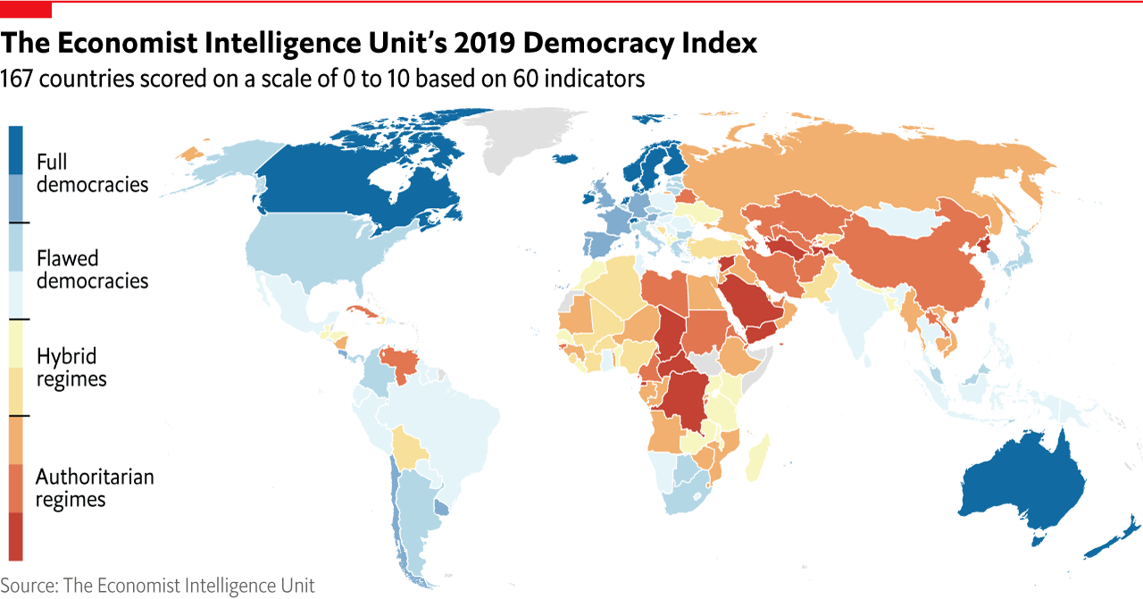

**vi.** These regimes have the characteristic of creating an appearance of legality, modifying constitutions and laws, controlling all public authorities as executing arms of the absolutism they impose. They use measures dictated by the courts and bodies of the administration.

**vii.** Election processes are carried out in these countries by circumventing internationally established standards of free and democratic elections, with artifices ranging from the abolition of political parties, disqualification of people, arrests and torture, theft of property, use of public resources in campaigns and in the act of voting, mass and forced mobilization of voters, a manipulated electoral pattern, and the use of electronic voting processes full of fallacies, which do not represent credibility. **The will of the citizens does not exist.**

**It is a transnational organized crime:**

**viii.** "Transnational" offences refer not only to offenses committed in more than one State, but also to offenses that take place in one State but are carried out by groups operating in more than one State, as well as crimes committed in one State, but which have a substantial impact on another State. "Transnational organized crime" includes virtually all serious for-profit criminal activities that have international implications. This broad definition considers the overall complexity of the problem and gives rise to cooperation to address the broader range of common concerns.[5]

**ix.** Transnational organized crime does not remain motionless; it is an industry that always changes, adapting to markets and leading to new forms of crime. It is an illicit business that transcends cultural, social, linguistic and geographical barriers, as well as having no limits or rules.

**x.** Its normal activities are in drug trafficking, migrant smuggling, arms trafficking, human trafficking, sexual and child exploitation, trafficking in exotic animals, intellectual property crimes, capital legitimization or whitening, and those related to cybercrime.

**The use of financial vehicles from several countries:**

**xi.** Organized crime in its mutation is positioned in several countries, precisely through election processes, managing to control several states, and from the government apparatus facilitate financial vehicles with business contracts between countries, using suspicious money from the "Chinese Fund" and the "Syrian Fund", circumventing US sanctions, allowing money to be moved in several countries, for control tasks in global geopolitics.[6]

**xii.** There are situations that set alerts to the international community, because their purpose goes beyond profit; these are geopolitical purposes in several countries, where they promote candidates for presidents, senators, deputies, positions at the OAS, at the United Nations, in the European Parliament.

**xiii.** Transnational organized crime of the 21st century is made up of countries with socialist ideology whose main enemy is the United States of America, generating destabilization in countries that have maintained minimum standards of democracy and rule of law, as has happened recently in Chile, Brazil, Colombia and the United States of America.

It is no coincidence that unrest is fought in these countries where a communication war is waged by investing large capitals; beginning to recover spaces they had lost (Argentina, Bolivia and Mexico) and join forces to gain power (Chile, Peru and Ecuador). The crown jewels are Colombia, Brazil and of course the United States of America.

**Review of the standards of democracy:**

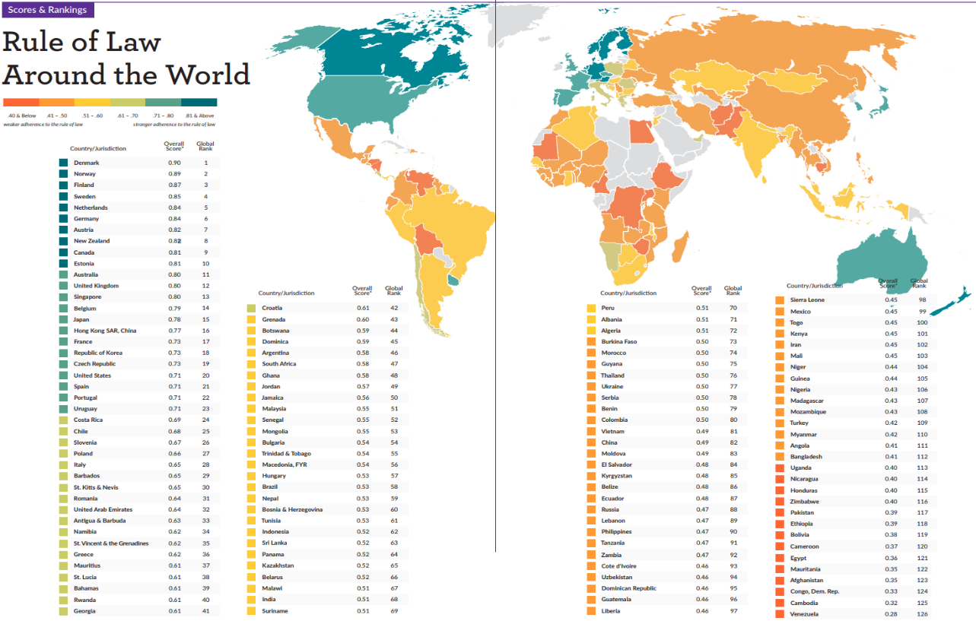

**xiv.** Deficits of democracy, rule of law problems, weak institutions and poor governance impose enormous and persistent challenges, forcing us to revise the legal rules of democracy as a system of a government.

**xv.** Rule of law scores in 2019 show a deterioration relative to 2018 where 61 countries increase in the "limits of government power" factor, 21 countries remain and only 29 improved, opening way to authoritarianism. The top three places in the *2019* Rule of Law Index are Denmark (position 1 of 126 countries), Norway (2) and Finland (3); the last three are Democratic Republic of the Congo (124), Cambodia (125) and Venezuela (126). At the regional level, in Latin America and the Caribbean, the best-placed country was Uruguay (23), followed by Costa Rica (24) and Chile (25). The three countries with the highest score in the region are Honduras (115), Bolivia (119) and Venezuela (126).[7]

**The danger is near:**

**xvi.** There is an international organization that is surprising America and Europe, using all economic and media resources to impose an ideology that is harming our peoples. They do so openly, taking advantage of the that some societies are still in a comfort zone and do not think it can reach them.

**xvii.** It is the Sao Paulo Forum, an articulation of Latin American and Caribbean political parties and movements, which now has 123 member parties in 27 countries, which meet at an annual meeting, and a Working Group composed of representations from 16 countries, which meets regularly. The annual meetings bring together, in addition to the member parties, guests of social movements and political organizations from other continents, building common agendas and actions, such as World Day against Imperialism, Continental Day for Democracy and Against Neoliberalism. [8]

This organization creates on July 12, 2019 the new Grupo Puebla[9], in the Mexican city of Puebla, as a political and academic front made up of representatives of the Ibero-American political left, its main objective being to articulate ideas, productive models, development programs and progressive state policies. It is made up of presidents, former presidents, political and social references within the socialist movement and academics from twelve Latin American countries, including Spain, whose profiles speak for themselves, executing actions where they grow spatially and achieve important conquests in international geopolitics.

**Conclusion:**

**xviii.** Dear Friends, it is with great sadness that I must express that the analysis contained in the video reproduced and my words today are derived from research that reached conclusive facts and reliably demonstrate the existence of an international plot that seeks to empty democracy in the civilized world. You just have to review the creation of the *Podemos* party in Spain with money delivered by several countries and financing of electoral campaigns, with achievements after one year of its creation, winning the elections for the Madrid and Barcelona city councils; in the following years they obtained seats in the European Parliament and representatives in the Spanish Parliament. Let us remember that Spain has a parliamentary government where the members of parliament appoint the prime minister. Today one of his accomplices is vice president in Spain.

There is evidence of the case of the construction company Odebrecht paying campaigns with money diverted from the Dominican Republic and other countries, so that Chavez, Lula, Ortega, Evo, Correa, Maduro and others, take power. The illicit financing of electoral campaigns through different channels has been a vehicle that has reached Ecuador, Nicaragua, Argentina, Bolivia and other countries.

Now they present themselves strong, with total impudence before the world, gathered in the Sao Paolo Forum, taking advantage of the weaknesses and errors of democracy. Cuba has been the laboratory and we know that they have partially achieved their goals. It is urgent to close ranks against this organization that acts with "the banality of evil."

**"Freedom is achieved when peoples are determined to live under the Rule of Law"**

**Twitter: @martin_tortabu**

**Parler: @Miguelangelmartint**

1. **Universal Declaration of Human Rights:**

   **Article 21:** 1. Everyone has the right to participate in the government of his country, directly or through freely chosen representatives. 2. Everyone has the right of equal access to the public functions of his country. 3. The will of the people is the basis of the authority of the public authority; this will be expressed through genuine elections to be held periodically, by universal and equal suffrage and by secret ballot or other equivalent procedure guaranteeing freedom of voting.

   **International Covenant on Civil and Political Rights:**

   **Article 25:** All citizens shall enjoy, without any of the distinctions referred to in Article 2, and without undue restrictions, the following rights and opportunities:

   (a) Participate in the direction of public affairs, directly or through freely elected representatives.

   (b) Voting and being elected in regular, authentic elections held by universal and equal suffrage and by secret ballot guaranteeing the free expression of the will of voters.

   c) Have access, on a general level playing field, to the public functions of your country.
2. **Fernando Sabater: *The Value of Choosing***. Ariel, Barcelona. Spain. 2003.
3. **The** [**United Nations Human**](https://www.ohchr.org/SP/HRBodies/HRC/Pages/Home.aspx) Rights Council adopted a series of **resolutions** highlighting the interdependence and mutual relationship that is reinforcing between democracy and human rights. Resolutions 19/36 and 28/14 on 'Human rights, democracy and the rule of law'.
4. [**Democracy Index 2020 - Economist Intelligence Unit (eiu.com)**](https://www.eiu.com/n/campaigns/democracy-index-2020/)**: The state of democracy around the world.**

   The EIU Democracy Index provides a snapshot of the state of world democracy for 165 independent states and two territories. The Democracy Index is based on five categories: electoral process and pluralism, civil liberties, the functioning of government, political participation, and political culture. Based on their scores on 60 indicators within these categories, each country is then itself classified as one of four types of regime: full democracy, flawed democracy, hybrid regime or authoritarian regime.
5. **United Nations Convention against Transnational Organized Crime and its Protocols (2000):**

   **Article 3.**  Application scope.

   2. For the purposes of paragraph 1 of this Article, the offence shall be transnational in nature if:

   (a) It is committed in more than one State.

   b) It is committed within a single State, but a substantial part of its preparation, planning, direction or control is carried out in another State.

   (c) It is committed within a single State but involves the participation of an organized criminal group engaged in criminal activities in more than one State.

   d) It is committed in one State but has substantial effects on another State.
6. **Serious situations:**

   (a) In the case of the company *Constructora Odebrecht*, serious investigations have determined the linkage of money used in Brazil, Venezuela, Peru, Bolivia, Ecuador, Spain, Mexico, in election campaigns of presidencies.

   b) The provision of food and medicine in several countries that make up the Sao Paolo Forum.

   c) The trafficking of gold, coltan and other minerals in the Amazon mining arc.

   d) The creation of professorships such as Neurona, Prometheus and Miranda in Ecuador, Bolivia and Venezuela, which served to create the Podemos party in Spain.

   (e) Venezuela's link with terrorist groups such as the FARC, ELN and HESBOLLAH, which not only have their bases in Venezuelan territory, but also leverage resources for their political and terrorist objectives.

   (f) Venezuela's oil subsidy operations to several countries, which have consolidated the Cuba and Nicaraguan regime, also paying the consciences of small countries in Central America, securing votes in the OAS and UN.

   (g) The relations of non-democracy countries with drug trafficking.
7. [**WJP Rule of Law Index 2019 | World Justice Project**](https://worldjusticeproject.org/our-work/research-and-data/wjp-rule-law-index-2019)**:** The *World Justice Project Rule of Law Index®* is the world’s leading source for original, independent data on the rule of law. Covering 126 countries and jurisdictions, the Index relies on more than 120,000 household surveys and 3,800 legal practitioner and expert surveys to measure how the rule of law is experienced and perceived worldwide. Featuring primary data, the *WJP Rule of Law Index* measures countries’ rule of law performance across eight factors: Constraints on Government Powers, Absence of Corruption, Open Government, Fundamental Rights, Order and Security, Regulatory Enforcement, Civil Justice, and Criminal Justice.
8. [**Brief history and foundations - Foro de SP (forodesaopaulo.org)**](https://forodesaopaulo.org/brief-history-and-foundations/)**:** The São Paulo Forum’s origin can be traced back to a call made by former presidents Lula and Fidel Castro to all leftist parties, movements and organizations in July 1990 to reflect upon the events in the aftermath of the fall of the Berlin Wall and upon alternative and autonomous paths from the standpoint of the Latin American and Caribbean left that would go beyond the traditional responses.

   The first meeting was held in the city of São Paulo, in July 1990, and brought together 48 parties and organizations representing the multiple experiences from all across the Latin American and Caribbean political and ideological spectrum. From that meeting came the São Paulo Declaration ***(Declaration***), a historical document that expresses the aspirations, principles, and goals of every party and movement present then. Highlights of the Declaration are the **following goals:** **“*Push forward with consensus proposals for unity of action in the anti-imperialist and people’s struggle; “We shall promote specialized exchanges focused on economic, political, social, and cultural issues; “[…] in opposition to the proposal for integration under imperialist domination, [ to define] the cornerstones for a new concept of continental unity and integration.***

   At the following meeting, held in Mexico City in 1991, the name “São Paulo Forum” was adopted, setting in motion a coordination of Latin American and Caribbean political parties and movements opposing neoliberalism and imperialism and committed to the regional integration, sovereignty, and self-determination of Latin America and the Caribbean and of our nations.

   The following meetings reaffirmed the political will to continue on that path of dialogue and exchange among a number of political parties and movements of Latin America and the Caribbean (…) Between the late 1990s and the mid-2000s, many of those parties reached for the first time the national governments of their countries with a series of landmark regional electoral victories.

   At the Forum’s annual meetings, as well as at the subregional and sectoral meetings, were consolidated the anti-neoliberal platforms that would become the blueprint for the victorious tactical and electoral programs of leftist parties and progressive coalitions, allowing the São Paulo Forum to call for regional and international political backing for the Latin American and Caribbean progressive administrations. In a context of a strong neoliberal counteroffensive in the continent that began in 2015, the Working Group of the São Paulo Forum submitted, in January 2017, to the Forum’s member parties a new document – the Our America Consensus ***(Consensus)***– analyzing our trajectory that far and proposing new debates and courses.
9. [**www.grupodepuebla.org**](http://www.grupodepuebla.org)**:** The objective of the GP is the articulation of progressive leaders with a vocation for change and political action, committed to the integration and development of the region. When Latin America comes together it goes further.