Should you have any questions, please feel free to contact me.

Email: [bctanner305@gmail.com](mailto:bctanner305@gmail.com)

Phone: [613-700-2839](mailto:bctanner305@gmail.com)

1. Obtain Code **climate.zip** from GitHub <https://github.com/bctanner305/BofC-Climate-Summary>

Unzip **climate.zip**

1. From GitHub obtain file **eng-climate-summary.csv** and save it locally. (i.e., on C Drive somewhere)
2. Modify c**onfig.propertie**s located in **\climate\src\main\resources**. Set the filename to the location of the csv file, to be used. (i.e, the file you downloaded in step 2

NOTE: Full Path is required.



1. From the “/climate” directory perform **mvn clean install**

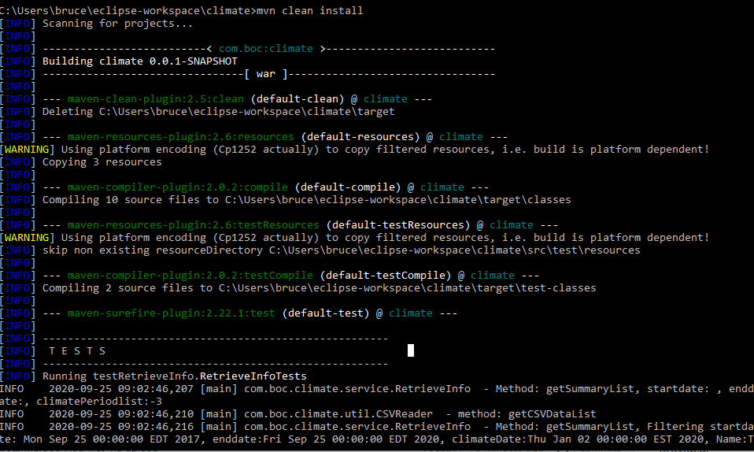

1. Deploy on a Server. I deployed on Tomcat version 7

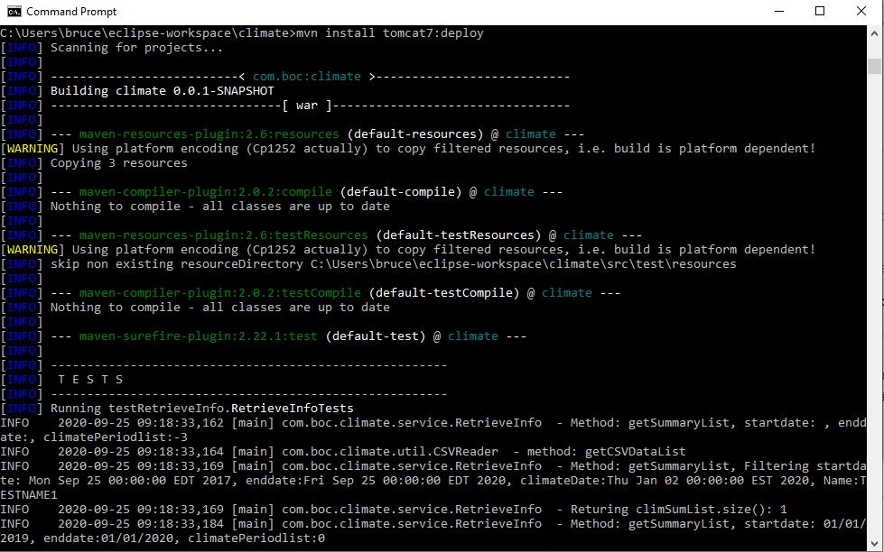

1. From Browser run [**http://localhost:8080/climate/**](http://localhost:8080/climate/)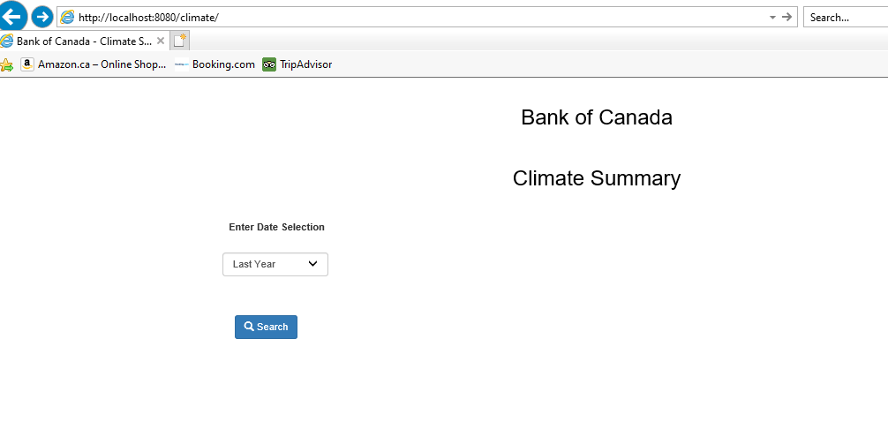
2. Enter Date selection (for example “Last 2 Years” )and click on the Search Button

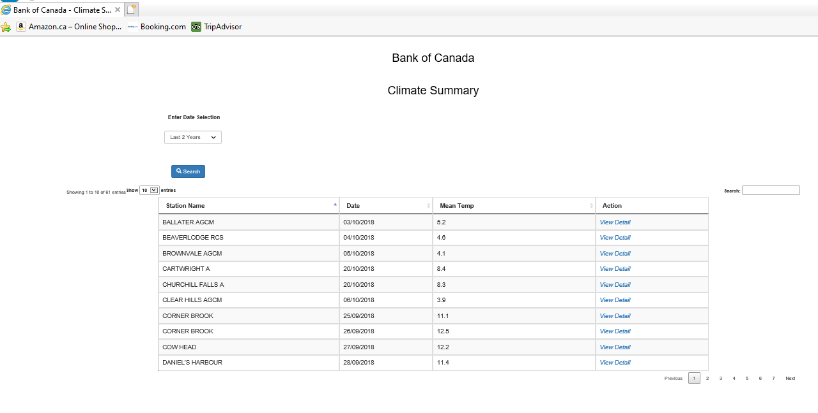

1. Select a Custom Range (i.e., a Start and End date) to perform a Search

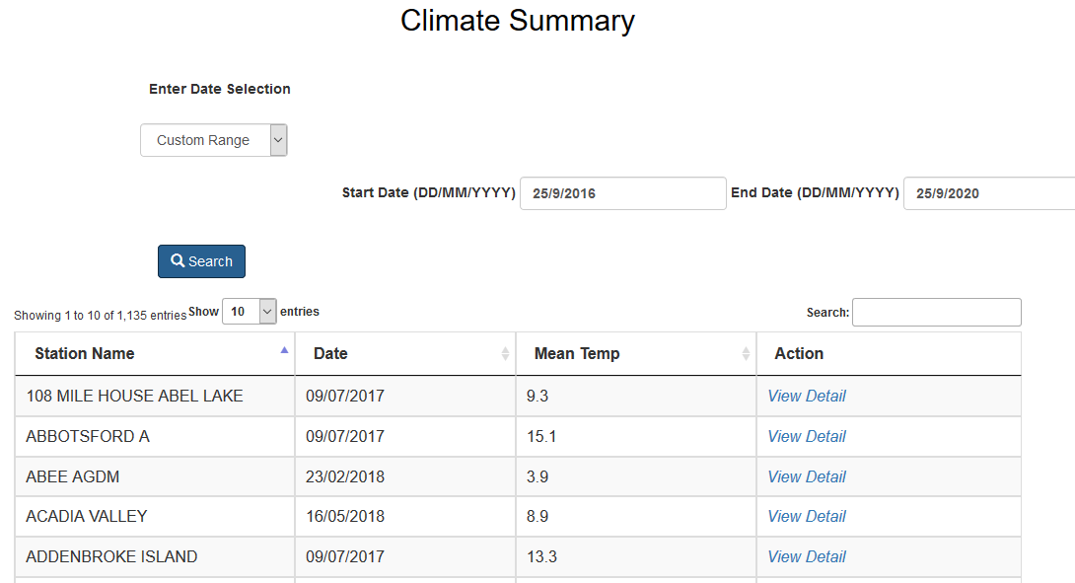

1. Click on “View Detail” to view the Individual Climate Station Details

