Should you have any questions, please feel free to contact me.
Email: bctanner305@gmail.com
Phone: 613-700-2839

- Obtain Code climate.zip from GitHub https://github.com/bctanner305/BofC-Climate-Summary

Unzip climate.zip

- From GitHub obtain file eng-climate-summary.csv and save it locally. (i.e., on C Drive somewhere)

- Modify config.properties located in \climate\src\main\resources. Set the filename to the location of the csv file, to be used. (i.e, the file you downloaded in step 2

NOTE: Full Path is required.

- From the “/climate” directory perform mvn clean install

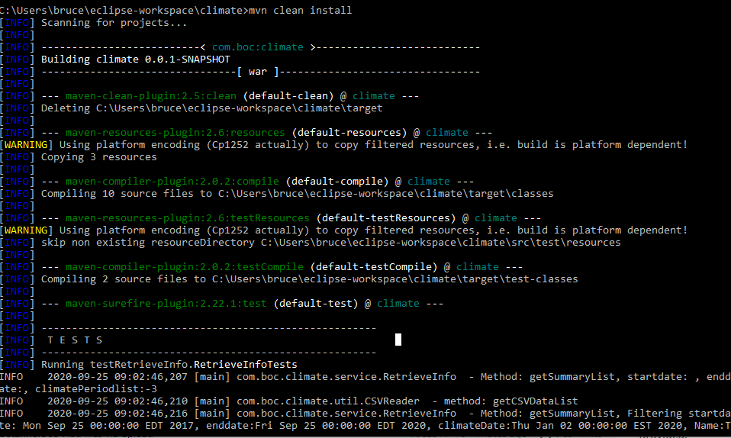

- Deploy on a Server. I deployed on Tomcat version 7

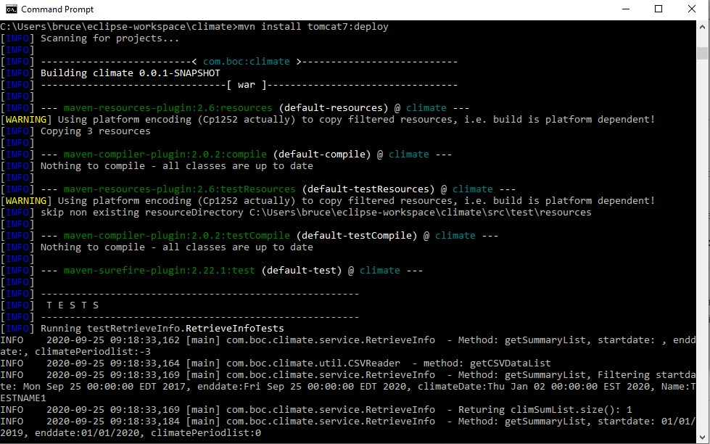
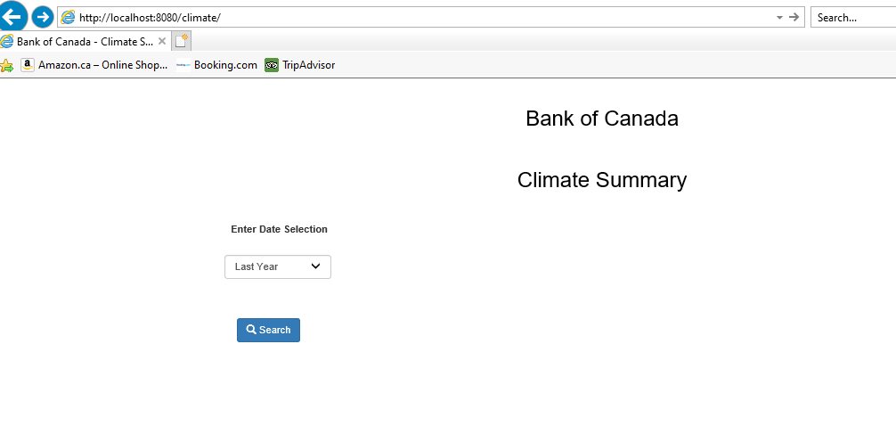
- From Browser run http://localhost:8080/climate/

- Enter Date selection (for example “Last 2 Years” )and click on the Search Button
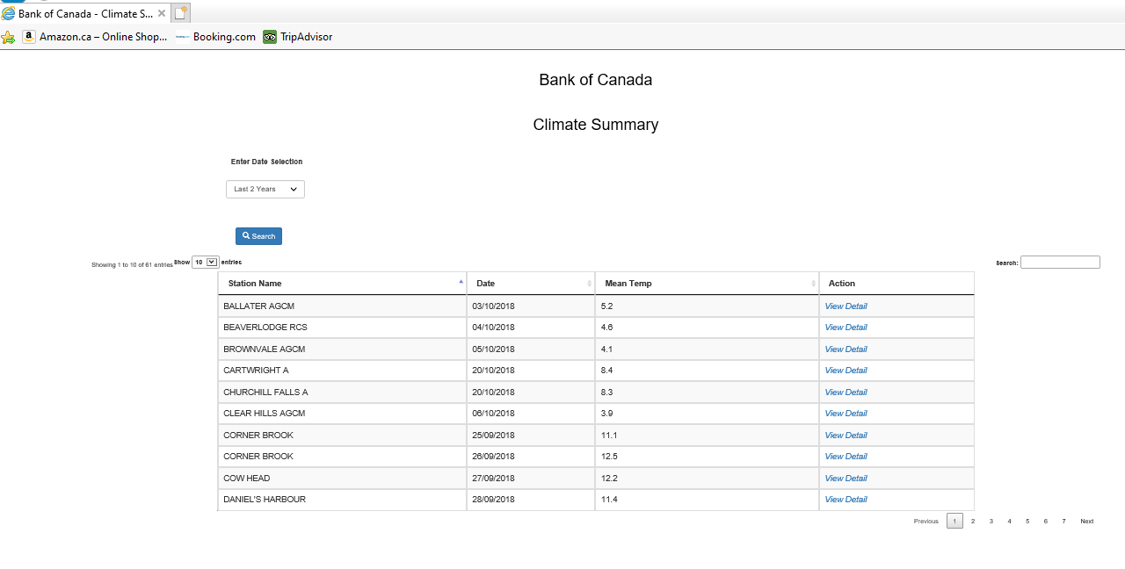

- Select a Custom Range (i.e., a Start and End date) to perform a Search

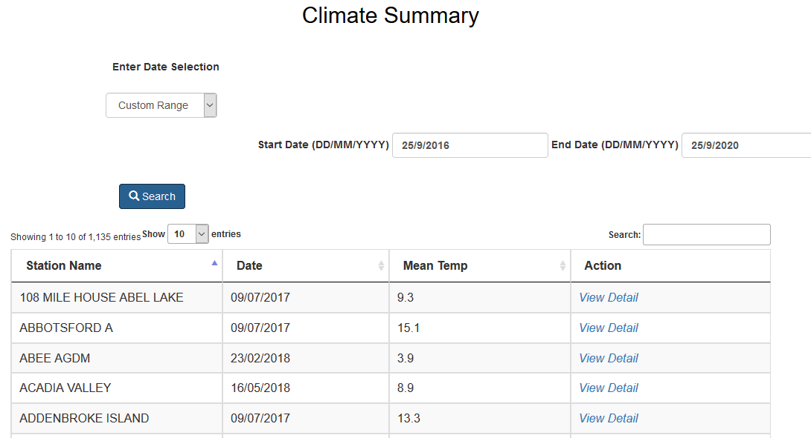
- Click on “View Detail” to view the Individual Climate Station Details

