LabAssist

User Documentation

Initial Setup

1. To start using LabAssist, go to labassist.wvutech.edu. This will display the following page  
   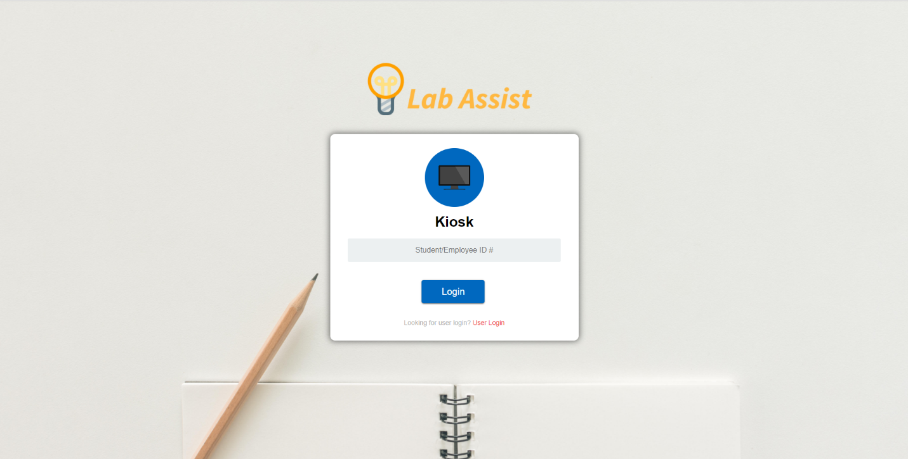
2. To clock in or out, enter in your student ID number and press the login button.
3. If this is your first time using the system, you will see the following screen.  
   <Insert Screen Here>
4. <Insert registration steps>
5. After you are registered into system, you will instead arrive at the following page.

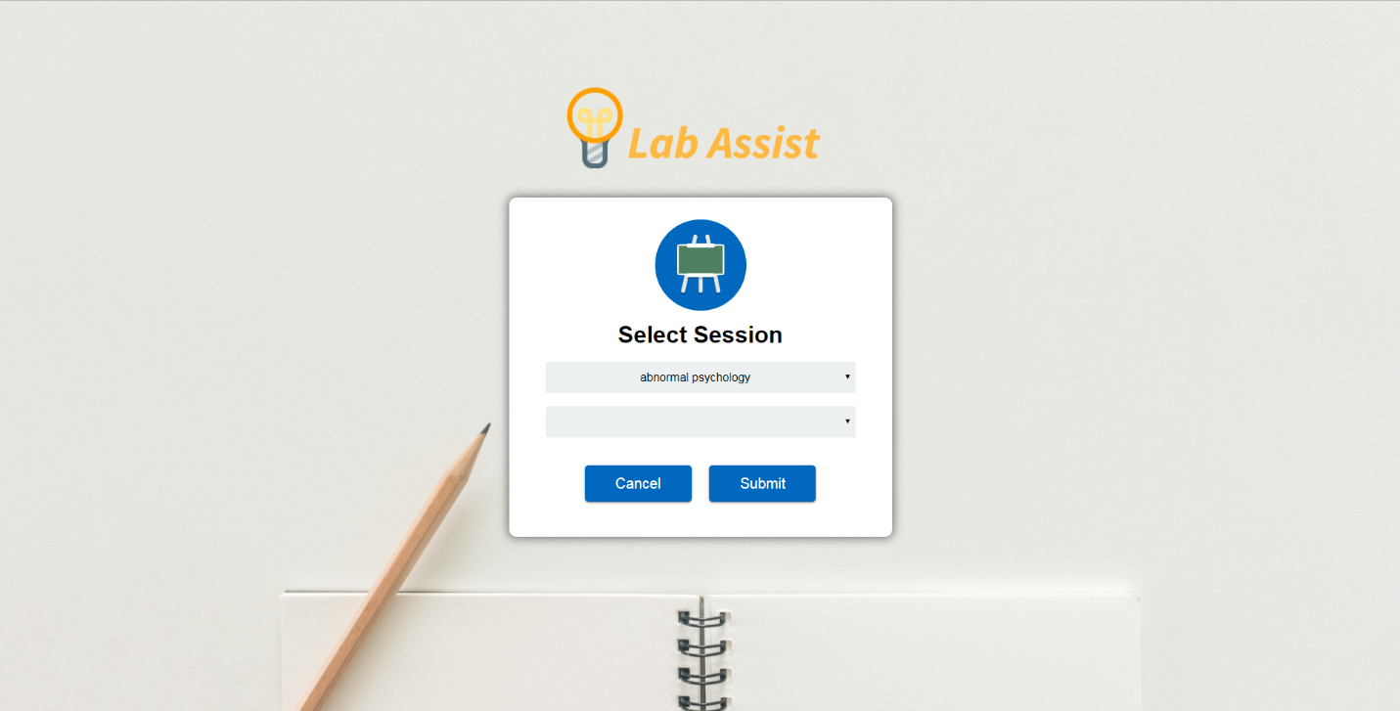

1. Here, you will select the department the class you are here for is in in the first dropdown menu, then select the class from the second one and click the submit button.
2. Once you’ve done this, you will be notified that you have been clocked in, and redirected back to the home page.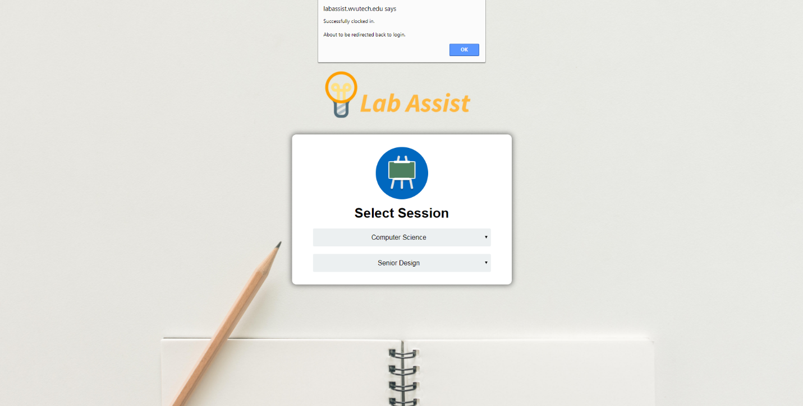
3. To clock out, simply enter your ID again, and you will see the following screen instead.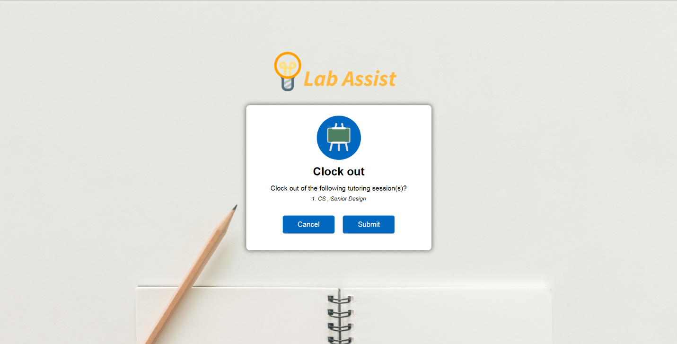
4. Simply click the submit button, and you will be clocked out.