**problem**

**problem** **1**

1. Write the equivalent governing equation in the domain

the equivalent governing equation is:



2. Programming

get the mesh from triangulation mesh generator:

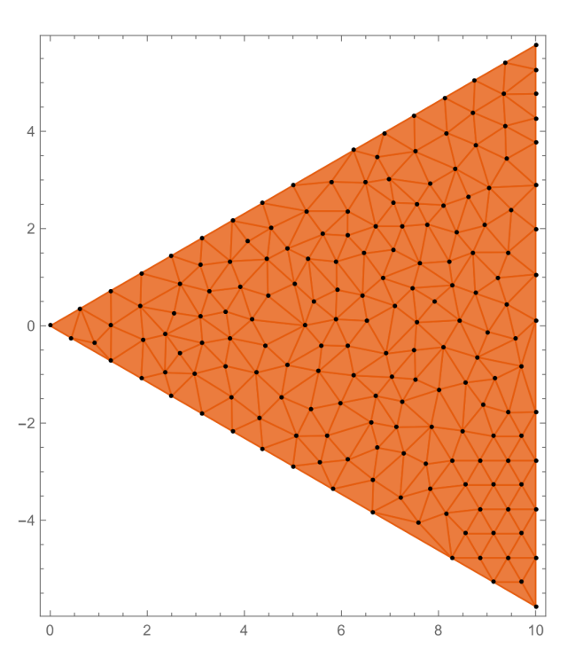

use matlab to solve problem 1

read mesh information and set b as 10:

|  |
| --- |
| clear;clc;close all;  NE = textread ( 'mesh.txt', '%d', 2);  N = NE (1);  E = NE (2);  data = readmatrix ( 'mesh.txt');  position = data (1:N, 1:2);  connect = round (data (N+1:N+E, 2:4)) + 1;  b = 10;  alpha = 30*pi/180; |

the position of node to solve is as below:

|  |
| --- |
| NI = [];  toler = 1e-5;  for i = 1: N  x = position (i, 1);  y = position (i, 2);  a1 = abs (x - b);  a2 = abs (y - tan (alpha) * x);  a3 = abs (y + tan (alpha) * x);  if a1 > toler && a2 > toler && a3 > toler  NI = [NI, i];  end  end |

the core codes of FEM:

|  |
| --- |
| K = zeros (N, N);  F = zeros (1, N);  u = zeros (1, N);  for k = 1: E  node1 = connect (k, 1);  node2 = connect (k, 2);  node3 = connect (k, 3);  x1 = position (node1, 1);  y1 = position (node1, 2);  x2 = position (node2, 1);  y2 = position (node2, 2);  x3 = position (node3, 1);  y3 = position (node3, 2);  A2 = 2*det ([1 x1 y1; 1 x2 y2; 1 x3 y3]);  k11 = (x2 - x3)^2 + (y2 - y3)^2;  k12 = (x1 - x3) * (-x2 + x3) + (y1 - y3) * (-y2 + y3);  k13 = (x1 - x2) * (x2 - x3) + (y1 - y2) * (y2 - y3);  k22 = (x1 - x3)^2 + (y1 - y3)^2;  k23 = - (x1^2 + x2 * x3 - x1 * (x2 + x3) + (y1 - y2) * (y1 - y3)); k33 = (x1 - x2)^2 + (y1 - y2)^2;  F1 = (x3 * (y1 - y2) + x1 * (y2 - y3) + x2 * (-y1 + y3)) / 6; F2 = (x3 * (y1 - y2) + x1 * (y2 - y3) + x2 * (-y1+y3)) / 6; F3 = (x3 * (y1 - y2) + x1 * (y2 - y3) + x2 * (-y1+y3)) / 6;  K (node1, node1) = K (node1, node1) + k11 / A2;  K (node1, node2) = K (node1, node2) + k12 / A2;  K (node1, node3) = K (node1, node3) + k13 / A2;  K (node2, node1) = K (node2, node1) + k12 / A2;  K (node2, node2) = K (node2, node2) + k22 / A2;  K (node2, node3) = K (node2, node3) + k23 / A2;  K (node3, node1) = K (node3, node1) + k13 / A2;  K (node3, node2) = K (node3, node2) + k23 / A2;  K (node3, node3) = K (node3, node3) + k33 / A2;  F (node1) = F (node1) + F1;  F (node2) = F (node2) + F2;  F (node3) = F (node3) + F3; |

solve by inverse of matrix and draw the 3D result:

|  |
| --- |
| u (NI) = K (NI, NI) \ F (NI). ';  trisurf (connect, position (:, 1), position (:, 2), u)  view ([-62.63 75.27])  exportgraphics (gca, 'res1.png')  view ([-0.44 90.00])  exportgraphics (gca, 'res2.png')  view ([55.41 66.95])  exportgraphics (gca, 'res3.png') |

the 3 views of ：

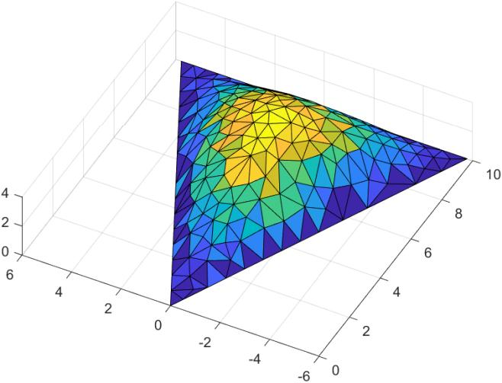

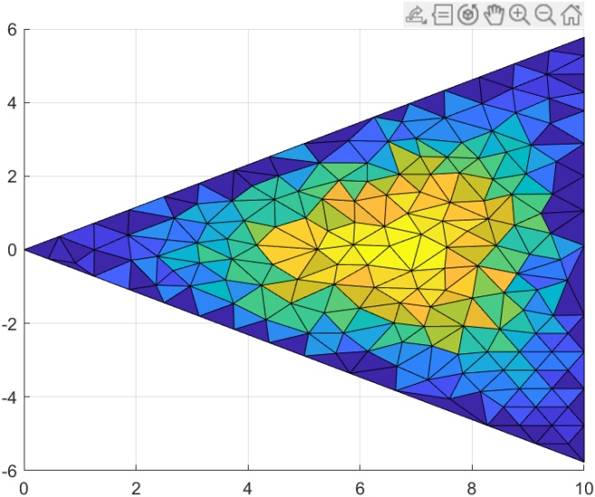

[](af://n29)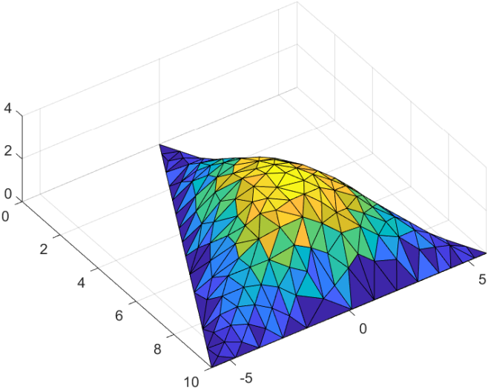

**problem** **2**

Lagrange equation:



for this system, we have



the velocity:





thus we have kietic energy of the system:



and the potential energy is:



thus we will have:



**problem** **3**

governing equation:





local stiffness relationship:





the matlab code and result are as below:

set the calculation parameters







|  |
| --- |
| clear;clc;close all;  q_ = -200;  F_ = -1000;  M_ = 2000;  L = 0.12;  d1 = 0.03;  d2 = 0.02;  Es = 200e9;  I1 = pi * d1^4 / 64;  I2 = pi * d2^4 / 64;  N = 51;  x = linspace (0, 2*L, N);  h = x (2) - x (1); |

get the stiffness matrix (core code):

|  |
| --- |
| K = zeros (2*N, 2*N);  b = zeros (2*N);  localk = [12/h^3, 6/h^2, -12/h^3, 6/h^2;  6/h^2, 4/h, -6/h^2, 2/h;  -12/h^3, -6/h^2, 12/h^3, -6/h^2;  6/h^2, 2/h, -6/h^2, 4/h]; |

|  |
| --- |
| localb = h * [1/2, h/12, 1/2, -h/12];  not_boundary = [3:2*N-2, 2*N];  for k = 1:N-1  if k <= (N-1)/2  K (2*k-1:2*k+2, 2*k-1:2*k+2) = K (2*k-1:2*k+2, 2*k-1:2*k+2) + Es * I1 * localk;  b (2*k-1:2*k+2) = b (2*k-1:2*k+2) + q_ * localb;  else  K (2*k-1:2*k+2, 2*k-1:2*k+2) = K (2*k-1:2*k+2, 2*k-1:2*k+2) + Es * I2 * localk;  end  end  b (N) = b (N) + F_;  b (2*N) = b (2*N) - M_; |

solve:

|  |
| --- |
| bm = b (not_boundary);  Km = K (not_boundary, not_boundary);  solution = zeros (2*N);  solution (not_boundary) = Km \ bm. ';  w = solution (1:2:2*N);  theta = solution (2:2:2*N); |

draw the deflection picture:

|  |
| --- |
| plot (x, w)  xlabel ( 'x')  ylabel ( 'w')  title ( 'w(x)-x')  exportgraphics (gca, 'w.png')  hold off; |

draw the torsion angle deflection:

|  |
| --- |
| plot (x, theta*180/pi)  xlabel ( 'x')  ylabel ( '\theta')  title ( '\theta\circ(x)-x')  exportgraphics (gca, 'theta.png') |

the solution result is as below, where the deflection of the beam is:

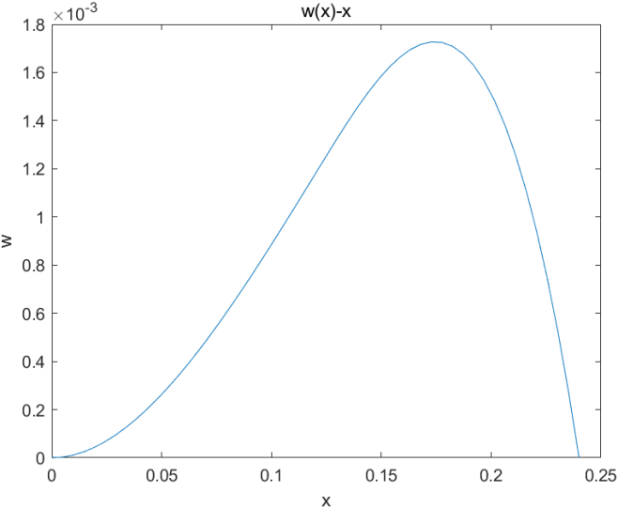

the torsion angle is:

