Homework

taskl

the equivalent governing equation is:

V2« +1=0

below is the matlab code. This document is generated by matlab's script first read the triangulation mesh and draw the reigion, A equals to 4.

clearjclc;

b = 4;

alpha = 30*pi/180;

node_elem = textread('hwl.txt'3 '%d', *2);*

node_num = node_elem(l);

elem_num = node_elem(2);

data = readmatrix(1hwl.txt1);

xy = data(l:node_numj 1:2);

Tri = round(data(node_num+l:node_num+elem_num2:4)) + *1;*

triplotCTri, xy(:, 1), xy(:, 2))

-0.5

-2

-2.5

2.5

2

1.5

1

0.5

0

0.5

1

1.5

2

2.5

3

3.5

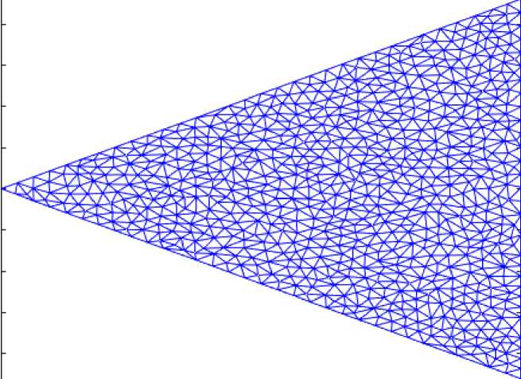

nodes at the boundary should be excluded, thus: node_inside =[];

err = le-5;

for i = 1: node_num

x = xy(i, 1)；

y = xy(i, 2);

errl = abs(x - b);

err2 = abs(y - tan(alpha) * x);

err3 = abs(y + tan(alpha) * x);

if errl > err && err2 > err && err3 > err node_inside = [node_insidej i];

end

end

node_boundary = setdiff([1:node_num], node_inside);

node_boundary

node_boundary =

1 2 3 4 5 6 8 15 20 24 28 34 44 63 65 66

scatter(xy(node_boundary, 1), xy(node_boundapy, 2))

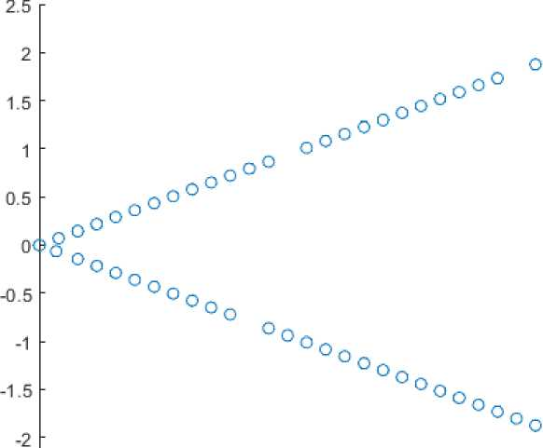

*5*

3.

oo

OOOOOOOOOOOOOQOOO o 000008 0008

nl : n2 : n3 : xl : yi : x2 y2 x3 ■ y3 : A2 : kll kl2 kl3 k22 k23 k33

*1)；*

1. ；
2. ；

1)；

2)；

1)；

*2)；*

1)；

2)；

-x3)A2

-x3) *

-x2) *

-x3)A2 -(xl人2 + x2 (xl - x2)A2

now insert the local stiffness relationship into the total stiffness relationship to get a larger matrix:

K = zeros(node_numj node_num); F = zeros(lj node_num);

u = zeros(lj node_num); for k = 1: elem_num

=Tri(k,

=Tri(k,

=Tri(k,

=xy(nl,

=xy(nl,

=xy(n2,

=xy(n2,

=xy(n3,

=xy(n3,

=2*det([l xl y]; 1 x2 *y2;* 1 x3 y3]);

+ (y2 - y3)”;

(-x2 + x3) + (yl - y3) * (-y2 + y3);

(x2 - x3) + (yl - y2) * (y2 - y3);

+ (yl - y3)人2;

* x3 - xl * (x2 + x3) + (yl - y2) * (yl - y3)); + (yl - y2)A2;

|  |  |  |  |  |  |  |  |  |
| --- | --- | --- | --- | --- | --- | --- | --- | --- |
| Fl = | (x3 * | (yi - y2) + ) | <1 * | (y2 - | y3) | + x2 * | (-yl + y3)) | / 6； |
| F2 = | (x3 * | (yi - y2) + ) | <1 * | (y2 - | y3) | + x2 * | (-yl+y3)) / | 6； |
| F3 = | (x3 * | (yl - y2) + 】 | <1 * | (y2 - | y3) | + x2 * | (-yl+y3)) / | 6； |
| K(nl, | nl) | K(nl, nl) + | kll | / A2； |  |  |  |  |
| K(nl, | n2) | K(nl, n2) + | kl2 | / A2； |  |  |  |  |
| K(nl, | n3) | K(nlj n3) + | kl3 | / A2； |  |  |  |  |
| K(n2, | nl) | K(n2, nl) + | kl2 | / A2； |  |  |  |  |
| K(n2, | n2) | K(n2, n2) + | k22 | / A2； |  |  |  |  |
| K(n2, | n3) | K(n2, n3) + | k23 | / A2； |  |  |  |  |
| K(n3, | nl) | K(n3, nl) + | kl3 | / A2; |  |  |  |  |
| K(n3, | n2) | K(n3, n2) + | k23 | / A2； |  |  |  |  |
| K(n3, | n3) | K(n3j n3) + | k33 | / A2； |  |  |  |  |
| F(nl) | =F(nl) + Fl; | |  |  |  |  |  |  |
| F(n2) | =F(n2) + *F2;* | |  |  |  |  |  |  |
| F(n3) | =F(n3) + F3； | |  |  |  |  |  |  |
| end |  |  |  |  |  |  |  |  |
| K |  |  |  |  |  |  |  |  |

K = 767g767

|  |  |  |  |  |  |  |  |  |
| --- | --- | --- | --- | --- | --- | --- | --- | --- |
| 0.5893 | 0 | 0 | 0 | 0 | 0 | 0 | 0 | 0 |
| 0 0.5893 | | 0 | 0 | 0 | 0 | 0 | 0 | 0 |
| 0 | 0 | 0.6195 | 0 | 0 | 0 | 0 | 0 | 0 |
| 0 | 0 | 0 | 1.7773 | 0 | 0 | 0 | 0 | 0 |
| 0 | 0 | 0 | 0 | 2.2396 | 0 | 0 | 0 | 0 |
| 0 | 0 | 0 | 0 | 0 | 1.7700 | 0 | 0 | 0 |
| 0 | 0 | 0 | 0 | 0 | 0 | 3.6042 | 0 | 0 |
| 0 | 0 | 0 | 0 | *0* | 0 | *0* | 1.8412 | 0 |
| 0 | 0 | 0 | 0 | *0* | 0 | *0* | 0 | 3.7771 |
| 0 | 0 | 0 | 0 | *0* | 0 | *0* | 0 | 0 4.214 |
| isdiag(K) | | | | | | | | |
| ans = logical |  |  |  |  |  |  |  |  |
| 0 |  |  |  |  |  |  |  |  |
| F | | | | | | | | |
| F = 1X767 |  |  |  |  |  |  |  |  |
| 0.0026 0.0026 | | 0.0030 | 0.0084 | 0.0137 | 0.0072 | 0.0168 | 0.0057 | 0.0149 0.013 |
| inverse the #to get the result: | | |  |  |  |  |  |  |
| u(node_inside)= trisurf(Trij xy( colormap hot; | K(node_insideJ node_inside) :,1), xy(:, *2),* u) | | | | \ F(node_inside). | | 1 . j |  |

view([-48.300 40.800])

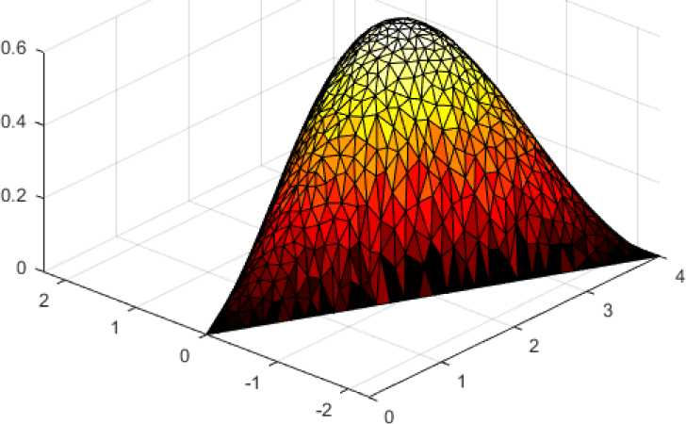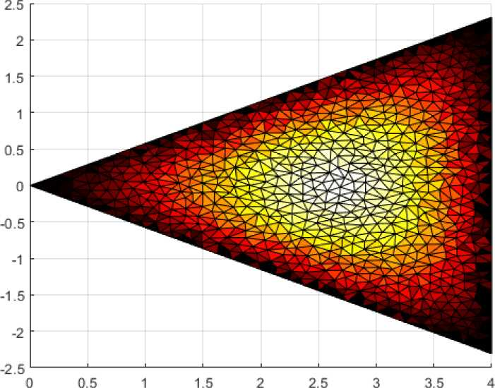

*±dL_dL=Q i=* 1,2,3... *dt dq^* 翊

*L = T-V*

view([-0.600 90.000])

task2

the Lagrange equation is as below: where *L* equals to:

in which *Tis* the kinetic energy and /is potenial energy. In this case, let =幻 *02* -冬2 W

*u* ] — (/]S cos 0] + *f) i* +/[0] sin *0^ j*

*U 2 —* (，1S COS 0] +，2‘2 COS *02* + «/*)，+ H]S sinsin。2)*j*

kietic energy *T.*

*T = ^mi\\ui\\2 + ^m2\\u2\\2*

potential energy *V.*

V = (1 — cos。]) + (1 — cos。[) +，2( 1 — cos 的)]

use Lagrange equation we will have the result:

*d dL _ dL _ dtd0x* 泌 i

(也]+ *f* cos+ g sin 0] + ) +，2小20： sin(劣一勿)+，2川2务 cos (劣—魚)二0

*d dL _ dL  
dtdO2* 泌2

*f* cos *02* + g sin。2 —sin *(0】—*四)+，i 咨 cos(。]—勿)+，2咨2 = °

**task3**

for this problem, use hermite interpolation to finish the job:

denote that:

*X2 = Xi+ h*

x = jq + /

clearjclc;

syms x xl x2 h t;

mat =[

1 xl xlA2 xlA3;

0 1 2*xl 3*xlA2;

1 x2 x2A2 x2A3;

0 1 2*x2 3*x2A2;

]；

phi = simplify([1 x xA2 xA3] * inv(mat));

phi_local = subs(subs(phi, x2, xl+h), x, xl+t);

phi_local

phi_local =

*f {h —* f)2 統 + 2 £)*t (h — t)2 P* (3 *h* — 2 f) ，*(h —*

*\ 总 律* k丿

simplify(diff(ph^local, t))

ans =

*也一 >* 龙2 - 4 /i r + 3 “ 6 f (内 一 f) *_ t* (2 /i - 3 f)\

*h3 h1 h3 ~ h2 J* thus we have when *0 <t < h'.*

w(x) = ~~I普+ ")~~咬+光尹*M +* ~~%2t)~~财]_丝特缶+1 *n(* — 6/(。一 r) *{h — t)(h —* 3t) n *6t(h — t) t(2h — 3t) n* 贝 — *兩- k + 律 毒* + -^3- *wk+*1 ^2 *"k+*1

below is the caculation parameters:

clear;clc;

q = -200;

F = -1000；

M = 2000；

L = 0.12；

dl = 0.03;

d2 = 0.02;

Es = 200e9;

JI = pi * dlA4 / 64;

32 = pi * d2A4 / 64；

N = 101;

x = linspace(0, 2*L? N);

h = 2*L / N;

the local stiffness matrix *Klocal* and *biocai* are shown as below:

K = zeros(2*N, 2*N);

b = zeros(2*N);

stiffness_K = [12/hA3, 6/hA2, -12/hA3, 6/hA2;

6/hA2, 4/h, -6/hA2, 2/h;

-12/hA3> -6/hA2, 12/hA3, -6/hA2;

6/hA2, 2/h, -6/hA2, 4/h];

stiffness_b = h * [1/2, h/12, 1/2, -h/12];

to_solve = [3:2*N-2, 2*N];

stiffness_K

|  |  |  |  |
| --- | --- | --- | --- |
| stiffness_K | =4©©4 | | |
| 108 g |  |  |  |
| 8.9436 | 0.0106 | -8.9436 | 0.0106 |
| 0.0106 | 0.0000 | -0.0106 | 0.0000 |
| -8.9436 | -0.0106 | 8.9436 | -0.0106 |
| 0.0106 | 0.0000 | -0.0106 | 0.0000 |

stiffness_b

|  |  |  |  |
| --- | --- | --- | --- |
| stiffness_b | = |  |  |
| 0.0012 | 0.0000 | 0.0012 | -0.0000 |

put them together:

for k = 1: N-l

if k <= (N-l)/2

K(2*k-l:2*k+2, 2*k-l:2*k+2) = K(2*k-l:2*k+2, 2*k-l:2*k+2) + Es * 01 * stiffness_K; b(2*k-l:2*k+2) = b(2*k-l:2*k+2) + q * stiffness_b;

else

K(2*k-l:2*k+2, 2*k-l:2*k+2) = K(2*k-l:2*k+2, 2*k-l:2*k+2) + Es * 02 * stiffness_K; end

end

b(N) = b(N) + F;

b(2*N) = b(2*N) - M;

solve the *Ku = b* and get *wb*

bm = b(to_solve);

Km = K(to_solve, to_solve);

solution = zeros(2*N);

solution(to_solve) = Km \ bm.';

w = solution(l:2:2*N);

theta = solution(2:2:2*N);

w

w = 1^^101

0 0.0000 0.0000 0.0000 0.0000 0.0000 0.0000 0.0000 0.0000 0.000

theta

theta = 1^101

0 0.0006 0.0011 0.0017 0.0022 0.0028 0.0033 0.0038 0.0043 0.004

here's the torsion angle *0{x)* 一 x

plot(Xj theta*180/pi)

xlabelCx')

ylabel('\theta1)

title('\theta\circ(x)-x')

ax = gca;

chart = ax.Children(l);

datatip(chartj0.1248j0.8415);

俨(x)小

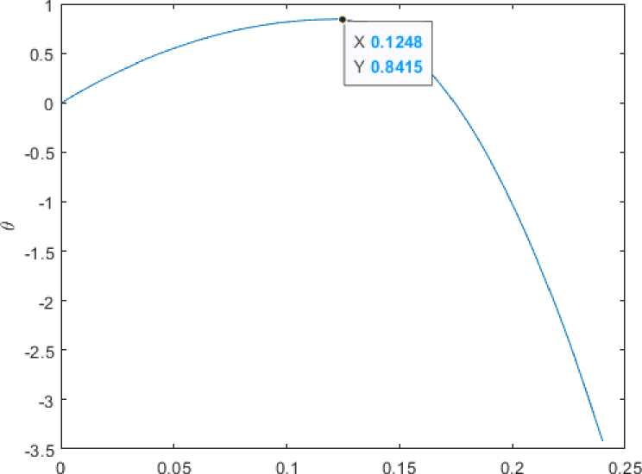

below is the deflection:

plot(x, w) xlabel('x') ylabel('w')

ax = gca;

chart = ax.Children(l);

datatip(chart,0.1728,0.001693);

