**[1] Interpret AICc selected model from my nhlreg lasso. Just tell some stories about what the model tells you.**

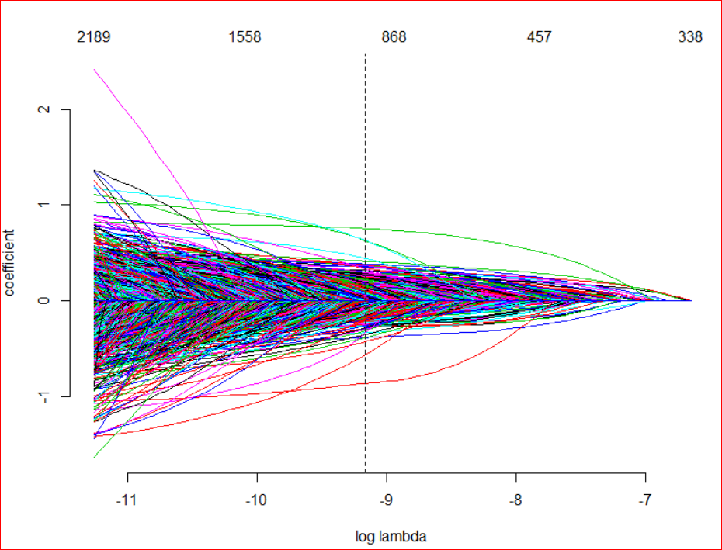

In general the AICc approximates for OOS deviance while controlling for data sets where df is large because AIC does not control for this and thus is susceptible to overfitting.

The AICc selected model from nhlreg lasso

Min max

Out of sample deviance

SNG S5v3

-1.726057 3.274932

Overall the model states that the strongest predictor of a goal is the configuration of 5v3. This accounts for situations one team has 5 players on the ice where the other team has 3 players on the ice. Oddly, this is actually stronger than the strength of the predictive power of S6v3 which you’d think would have more predictive power. The lowest predictive power was that of SNG

**[2] The gamlr run for nhlreg uses standardize=FALSE. Why did I do this? What happens if you do standardize?**

Standardize standardizes the lasso because scale matters when applying a penalty to predictive factors of different scales. You didn’t standardize in this instance because everything (config, team, player) is already on the same scale and is essentially logical.

**[3] Compare model selection methods for the nhlreg lasso. Consider both IC and CV (you’ll want to create cv.nhlreg).**

**[4] We’ve controlled our estimates for confounding information from team effects and special play configuration. How do things change if we ignored this info (i.e., fit a player-only model)? Which scheme is better (interpretability, CV, and IC)?**

**[+] Can you translate player Bk effects into something comparable to classic Plus-Minus? How do things compare?**