Instructions for Incorporating 3rd Party libraries to you Visual Studio project.

You must add the library in Visual Studio by right-clicking on the project, then select Properties, and then Linker, Input as shown below. Note the Additional Dependencies box. The easiest thing to do is to copy the library (.lib file) into your Visual Studio Project directory, then there will not need to be a relative path given with the name. If your library is located elsewhere, then the path given is relative to the project directory.

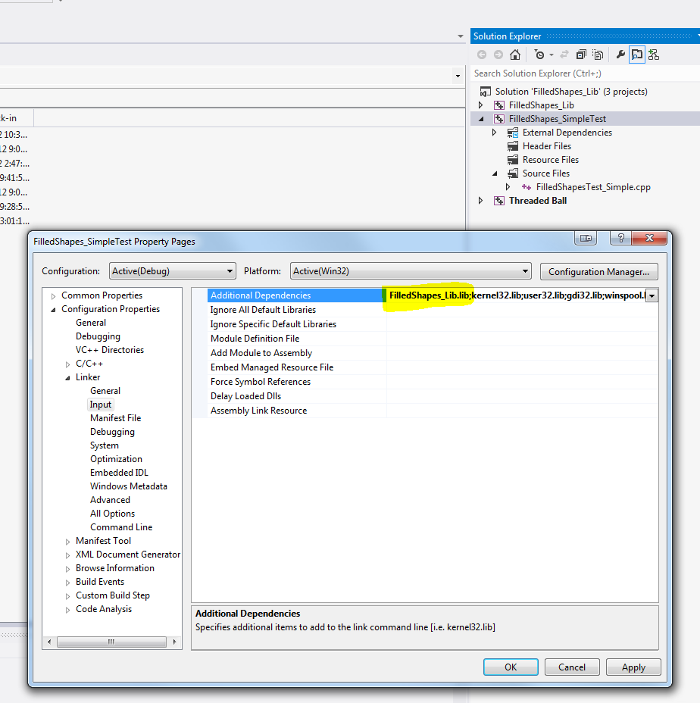

I have provided a simple test program for you to test to make sure it works. Create a simple project, and copy FilledShapesTest_Simple.cpp and FilledShapes.h to the project directory. Then, Add FilledShapesTest_Simple.cpp to your project. Finally, build it (AFTER you have updated the Linker properties to include FilledShapes_Lib.lib).

