**First-Time User Exploration Guide [Hexabeta -Engineering Platform]**

**🔐 Step 1: Logging In**

When I landed on the Hexabeta site, I saw a friendly welcome screen that said:

**“Welcome back Buddy!”**

I had two choices to log in:

* I could Sign in with Google (quick and easy), or
* Enter my email and password manually.

Since it was my first time, I clicked on “Create an account”.

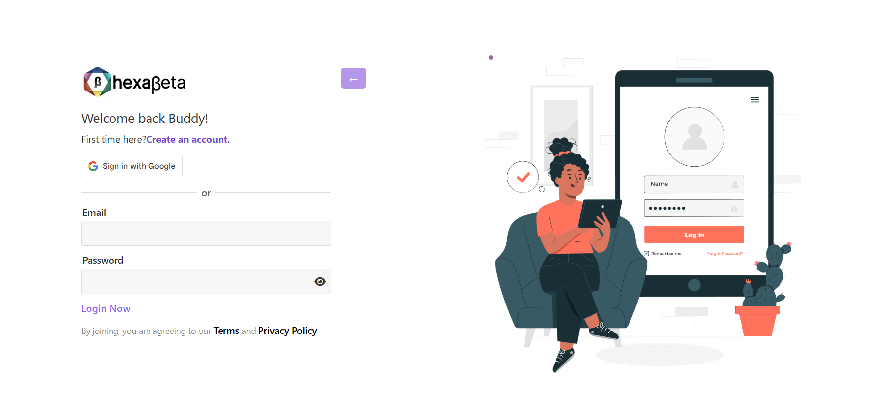

**📝 Step 2: Creating My Account**

The sign-up form asked me to fill in:

* My **First Name** and **Last Name**
* **Email address**
* **Phone number**
* **A password** (and confirm it)

Once I entered everything, I clicked **“Continue to Step 2”**.

This completed my registration, and now I had access to the platform.

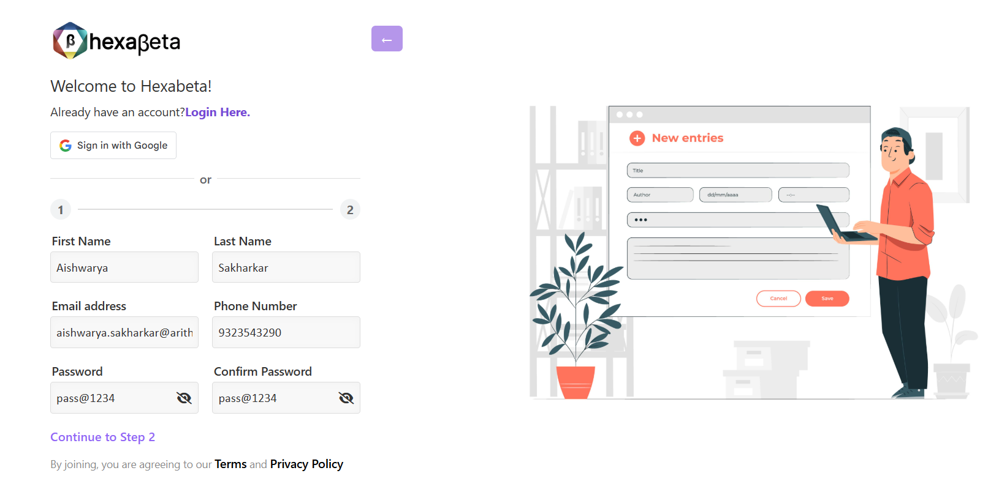

**👤 Step 3: Setting Up My Profile (This Screen)**

This screen said: **“Almost there!”**

Here I did the final setup:

* Chose a **username** from the options suggested (I picked @aishwaryasakharkar)
* (Optional) Uploaded a **profile picture**
* Reviewed all the info: name, email, phone

It even gave a **preview of my profile** — I liked that touch!

Once I confirmed everything, I clicked **“Complete Registration.”**

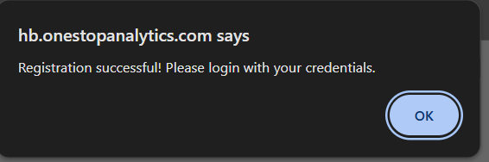

**🏠 Step 4: Landing on My Dashboard (This Screen)**

After completing registration, I was taken to my **main dashboard**.

It greeted me with:  
**“Welcome to Your hexabeta”**

The dashboard is beautifully organized into sections:

**🔹 Compete**

* **Quiz** – Test my knowledge with interactive quizzes
* **Competition** – Join coding competitions
* **Hackathons** – Work on time-based project challenges

**🔹 Games**

* **Code Puzzle** – Practice logic through puzzles
* **HexaBot Simulator** – Drag, drop, and learn to build logic
* **Debug Master** – Fix buggy code snippets

**🔹 Continue Learning**

This section shows progress and lets me resume where I left off.

**🔝 Top-Right Corner Tools**

Located at the top right of the dashboard:

🌓 **Theme Switch** – Toggle between light and dark modes  
🔔 **Notifications** – See new alerts or interview updates  
✉️ **Messages** – Access direct messages or platform updates  
🙋‍♀️ **Profile**  – Your account identity  
🧠 **Activity Center** – Track your actions, progress, or events

This area is your personal control center — everything important is just a click away!