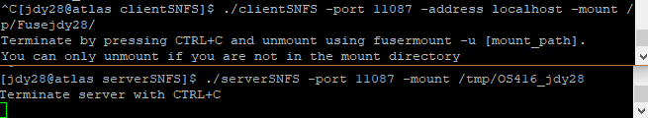

Fuse directory: /tmp/Fusejdy28/

Server directory: /tmp/OS416_jdy28/

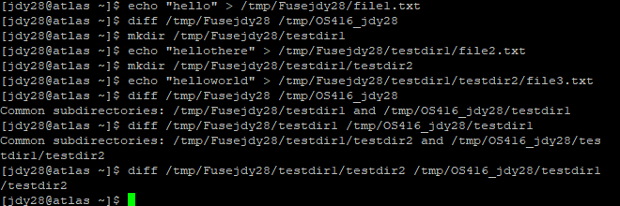

By the third file creation, there is a file “testfile1” in fuse directory, directory “testdir1” with file “testfile2” and directory “testdir2”, and directory “testdir2” has file “testfile3”. When we look at differences between each step, we see that all files are the same and all directories are the same.

On server and client termination, we see:



This indicates that when the programs are terminated, the fuse directory does not store the files and directories, but the server program maintains its changes in disk.

Another case we tested is if we had two instances of the client running at the same time and making changes to their respective directories.

Client 1 fuse directory: /tmp/Fusejdy28/

Client 2 fuse directory: /tmp/OS416_NFS/Fuseks1141/

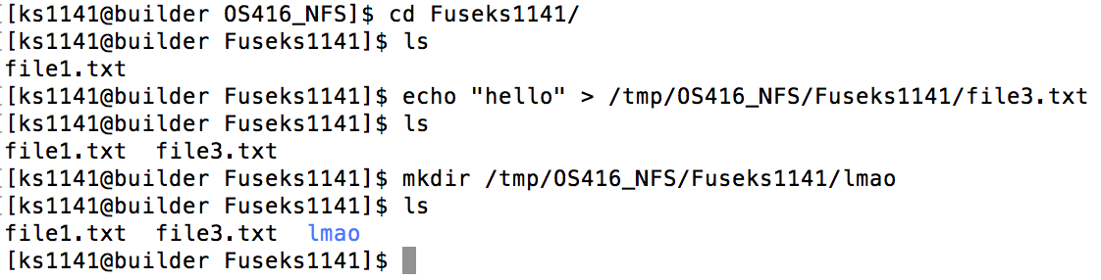

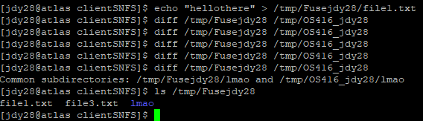

We both put in text files into our respective directories as well as a new folder in one of the directories. The results synched up within our directories.

We also implemented directory removal.

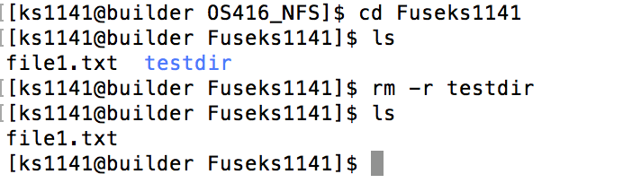

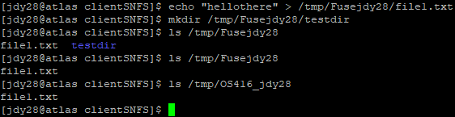

In this case, removing the directory from one client reflected in being removed from another client as well.