AI Report

**Name:** Zainab abd elhamed Mohamed

**B.N:** 1

**Topic:** Artificial Intelligence

**No. Sitting:** 342

**Group:** 3

**Application Brief:**

Artificial intelligence (AI) refers to the simulation of human intelligence in machines that are programmed to think like humans and mimic their actions. The term may also be applied to any machine that exhibits traits associated with a human mind such as learning and problem-solving.

As machines become increasingly capable, tasks considered to require "intelligence" are often removed from the definition of AI, a phenomenon known as the [AI effect](https://en.wikipedia.org/wiki/AI_effect).

A quip in Tesler's Theorem says "AI is whatever hasn't been done yet.

" For instance, [optical character recognition](https://en.wikipedia.org/wiki/Optical_character_recognition) is frequently excluded from things considered to be AI, having become a routine technology

Artificial intelligence forms the basis for all computer learning and is the future of all complex decision making. As an example, most humans can figure out how to not lose at tic-tac-toe (noughts and crosses), even though there are 255,168 unique moves, of which 46,080 end in a draw.

**Application Screenshots:**

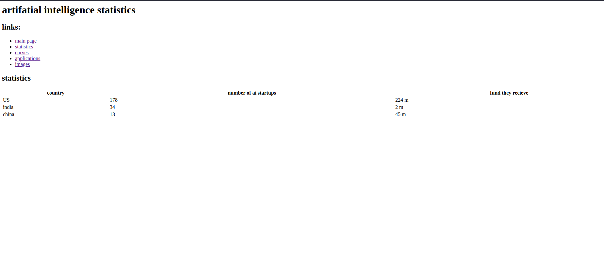

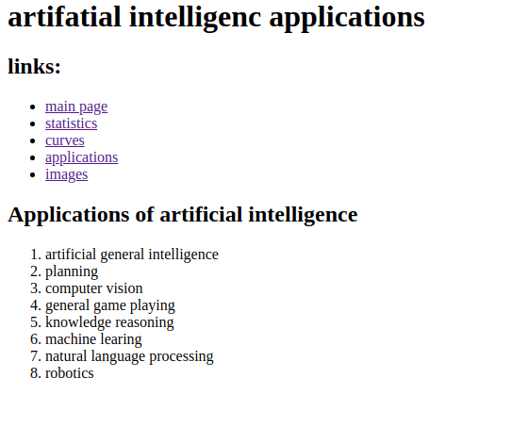

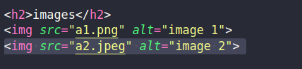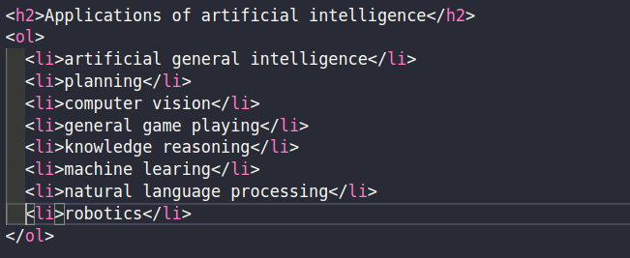**Source Code Screenshots:**