**Big Data Analytics and Applications**

**Lab-3 Report**

**N. Ayyappa Kumar(16157522)**

First step we have to install glassfish server on virtual machine. So login into clodera.

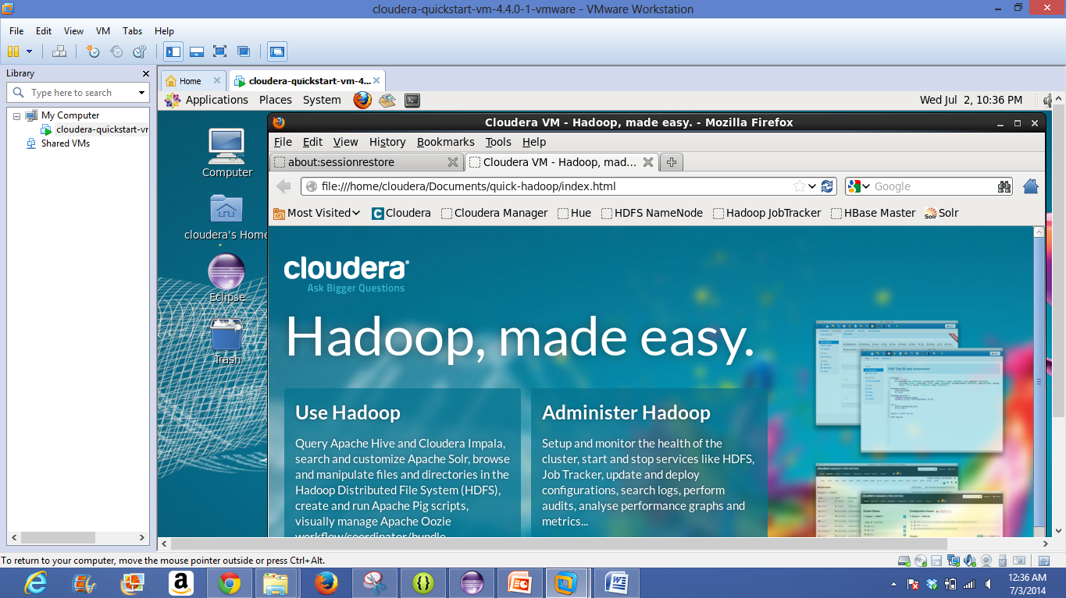

Install Glassfish server on cloudera.

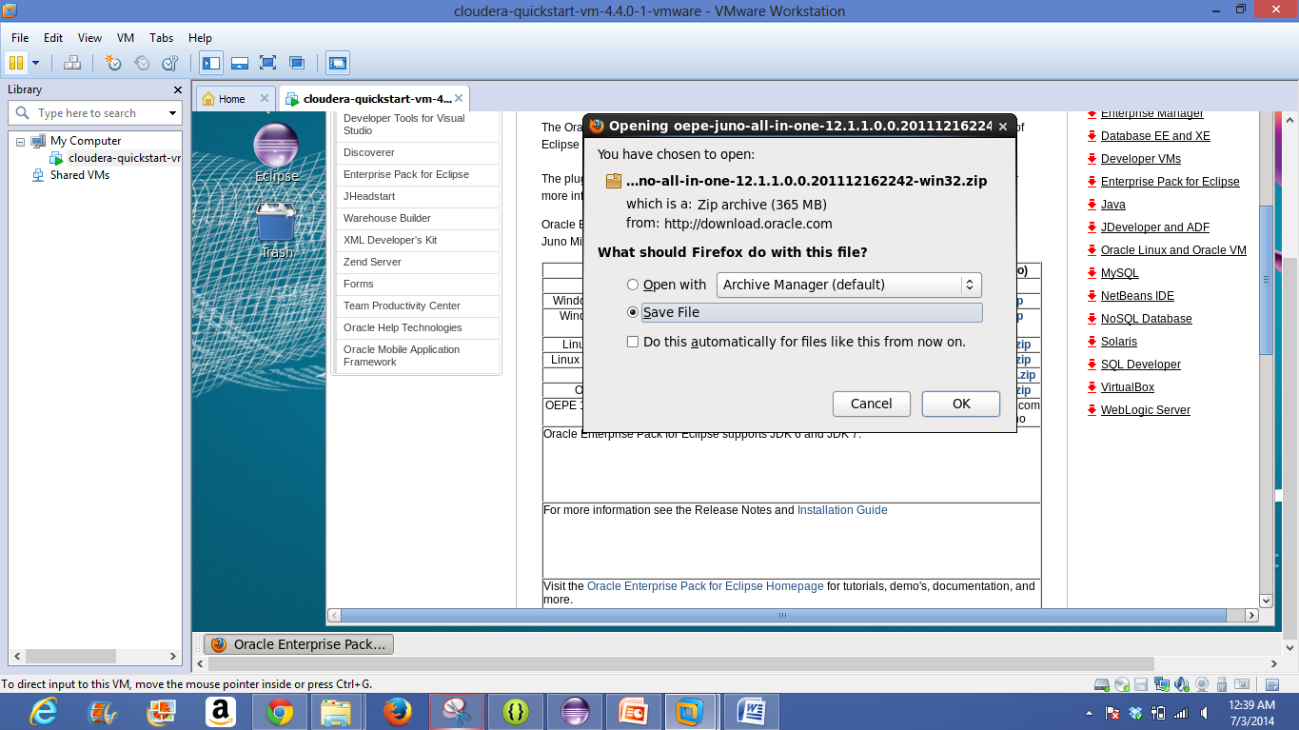

Open the code and make changes as of required

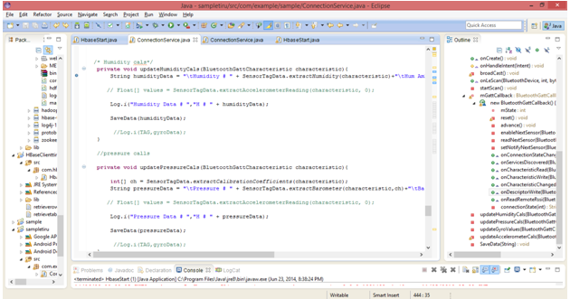

I had successfully written the Humidity and Temperature data along with the old data services as below.

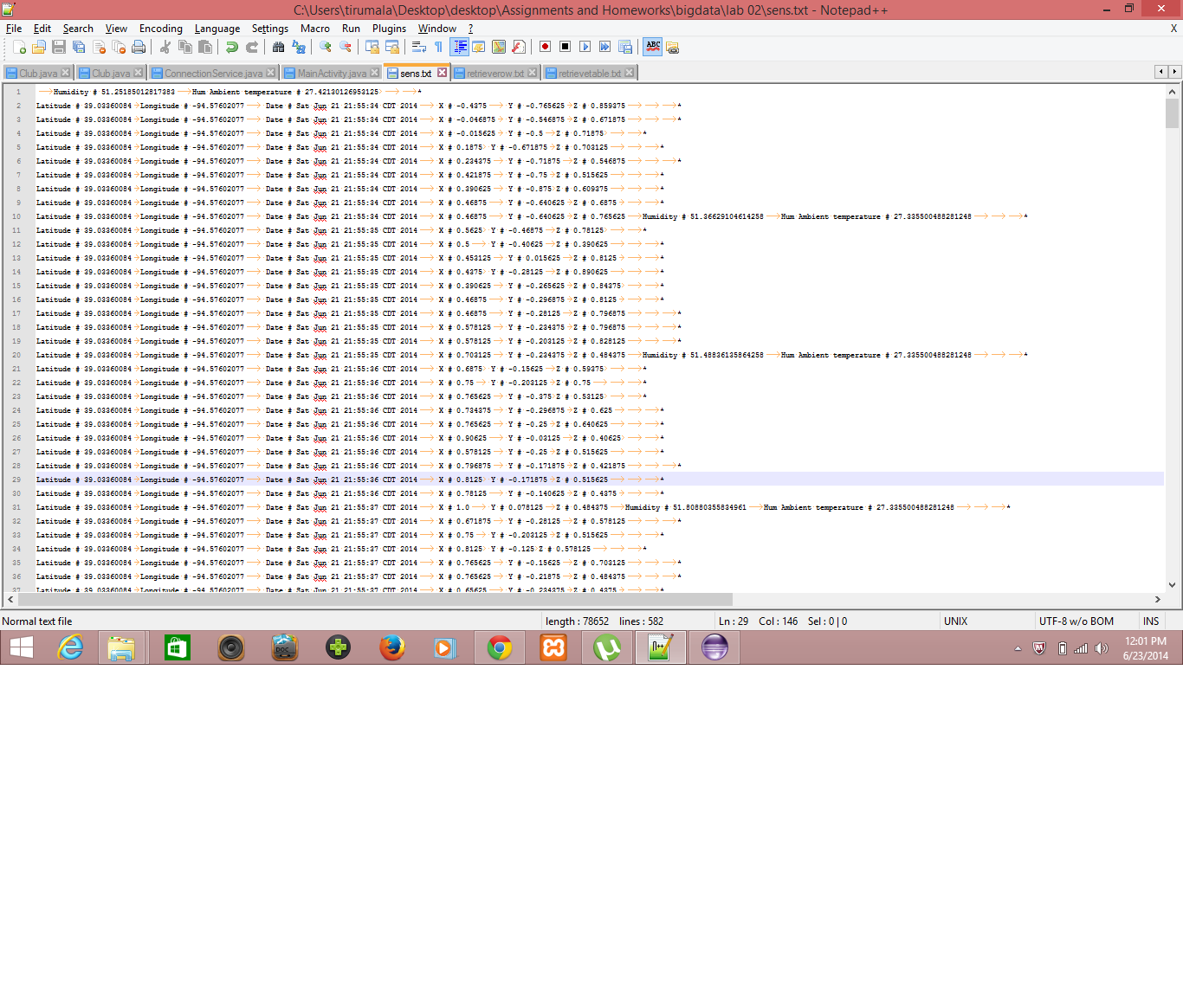

**Uploading data to HBase using web service:**

I had developed a web service to upload all this data into HBASE server for using this data to train gestures as follows.

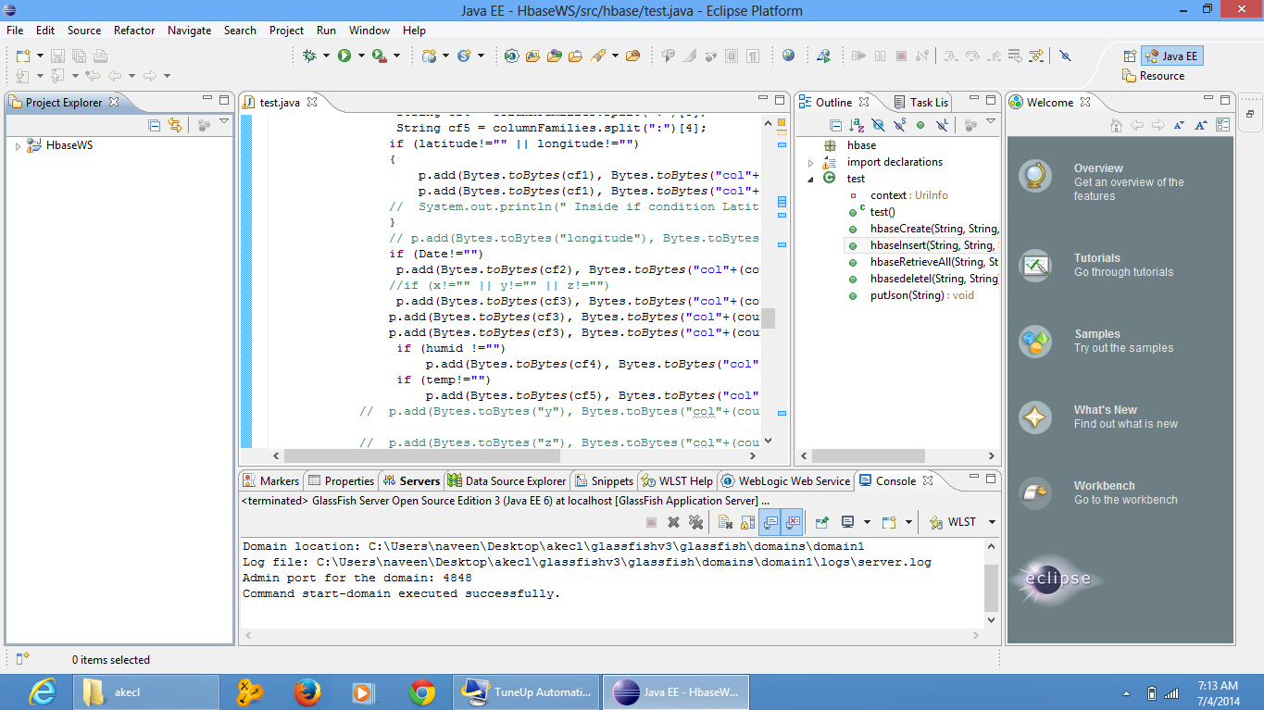

Executing the code on server.

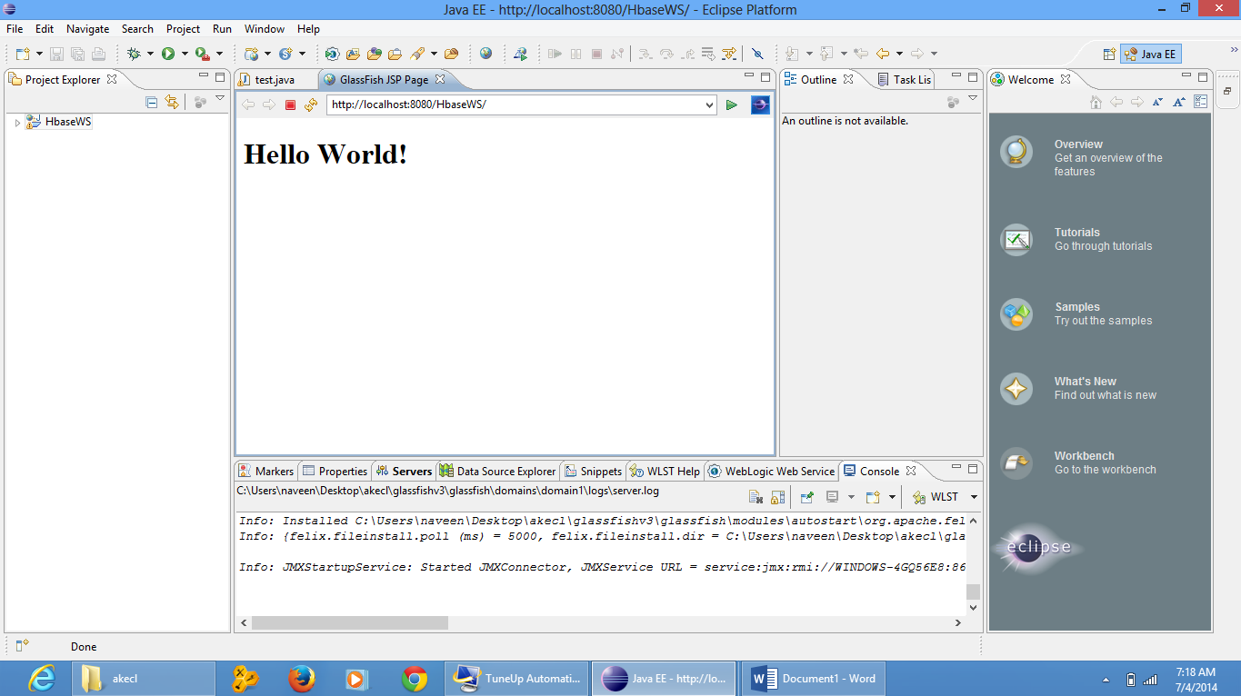

Creating table kumar1 is success.

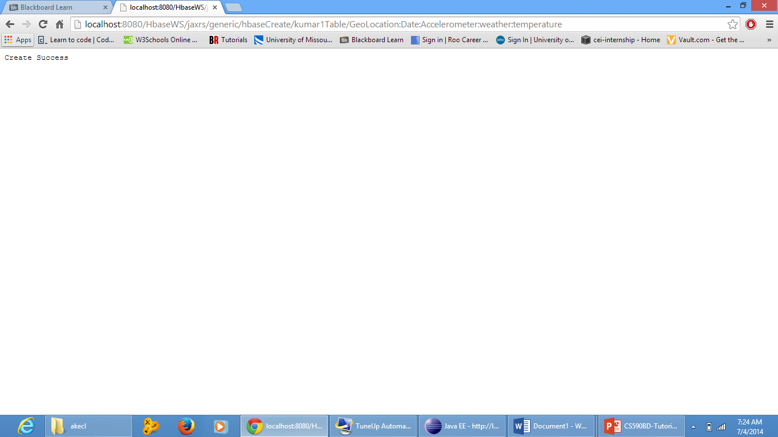

login in order to see the created table.

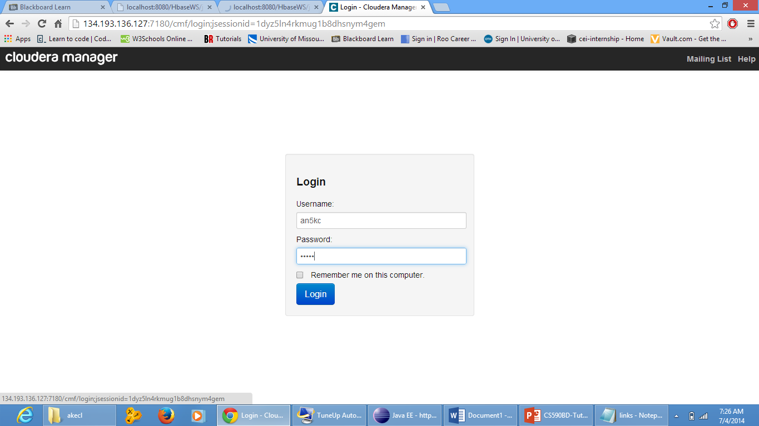

Inserting the table kumar1

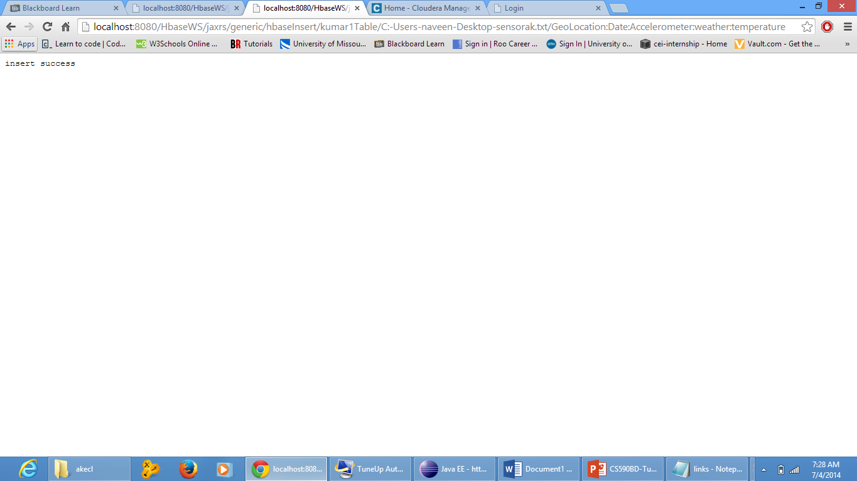

retrieving the table.

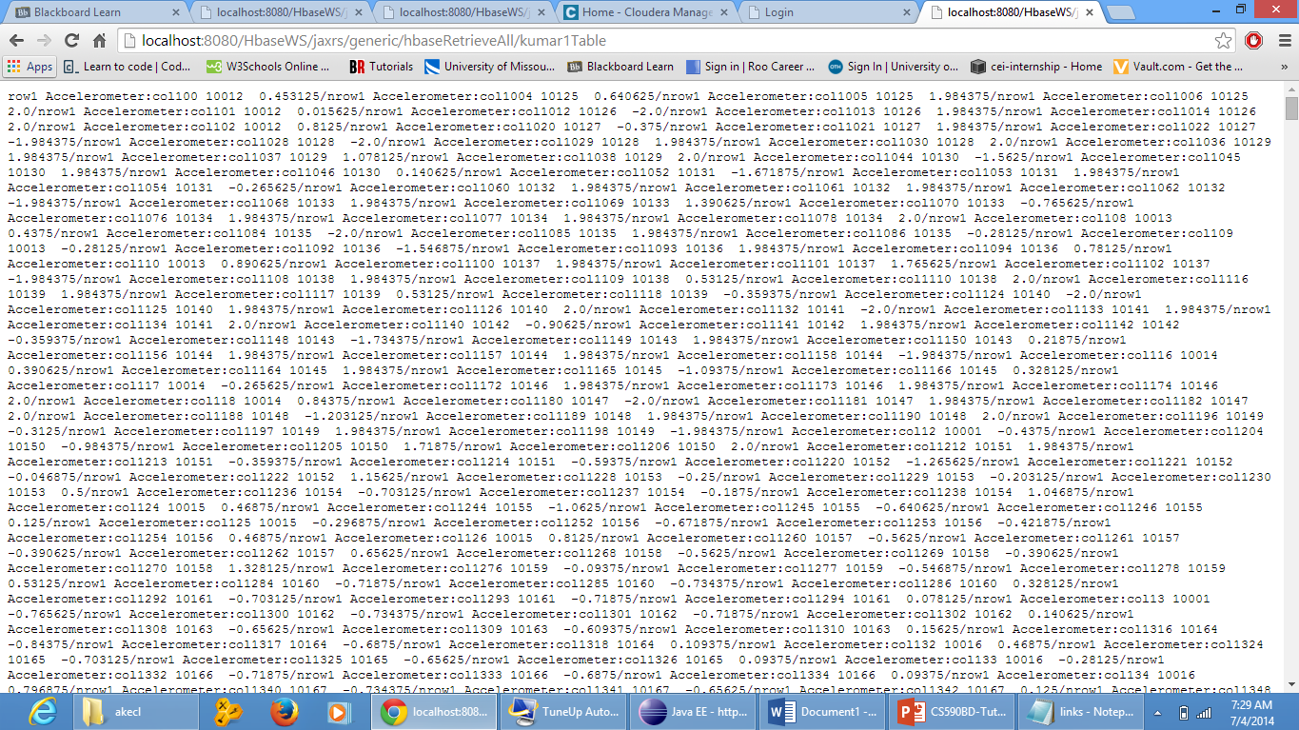

Deleting the table.

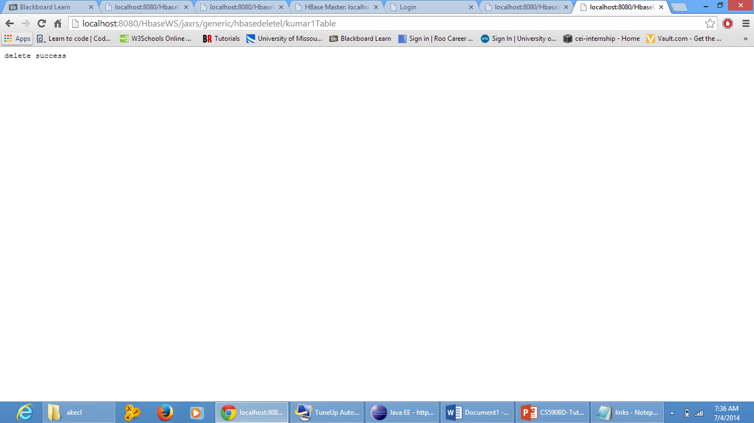

**Android App:**

The front end of android app is shown in below screen shot.

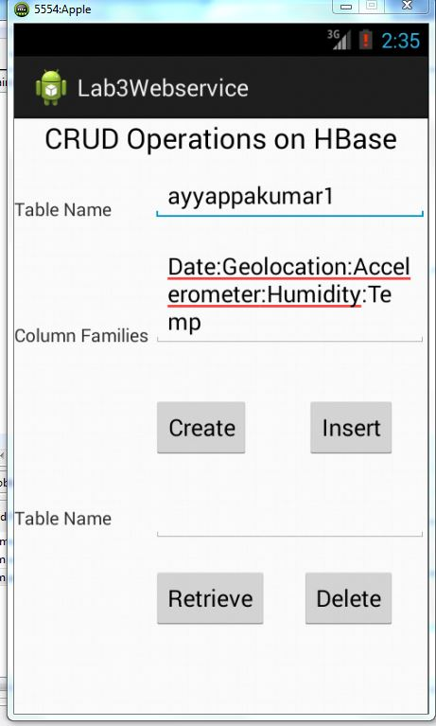

After specifying required fields like table name table columns if we click on create button it will show the confirmation of table created.

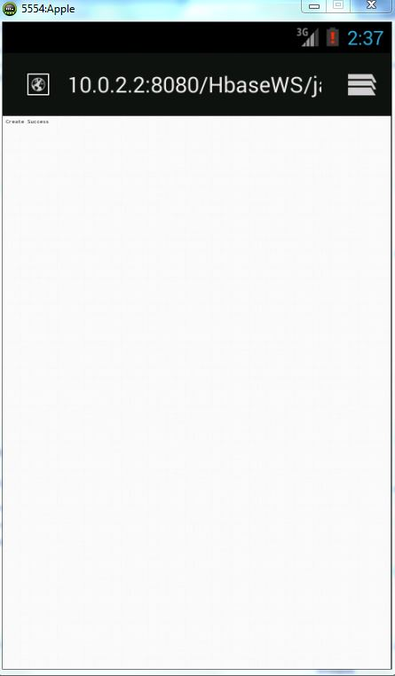

Below screen shot shows the inserting table.

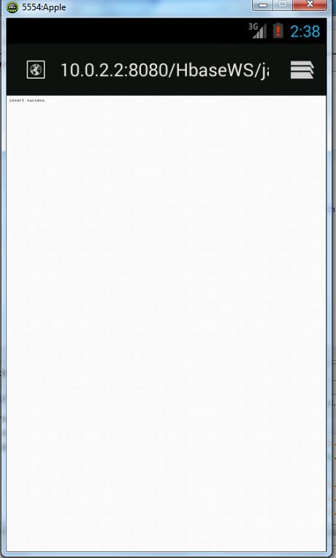

Below screen shot represents the data retrieved after performing retrieving option.

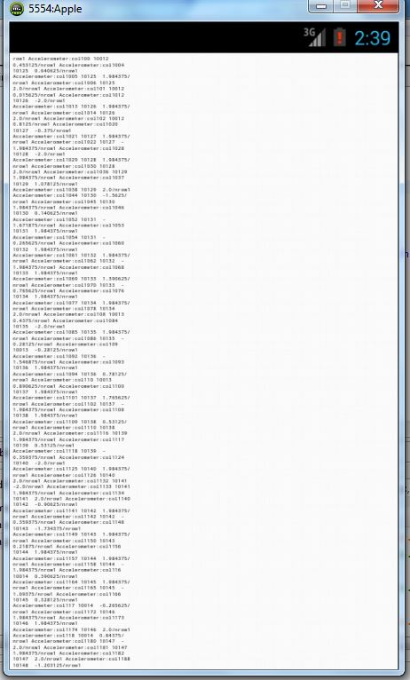

Below screen shot shows the deleting the table.

