**Big Data Analytics and Applications**

**Lab-4 Report**

**N. Ayyappa Kumar(16157522)**

1.I downloaded HMMWS Dynamic web project and imported into Eclipse and Run on Glassfish server to start webserver.

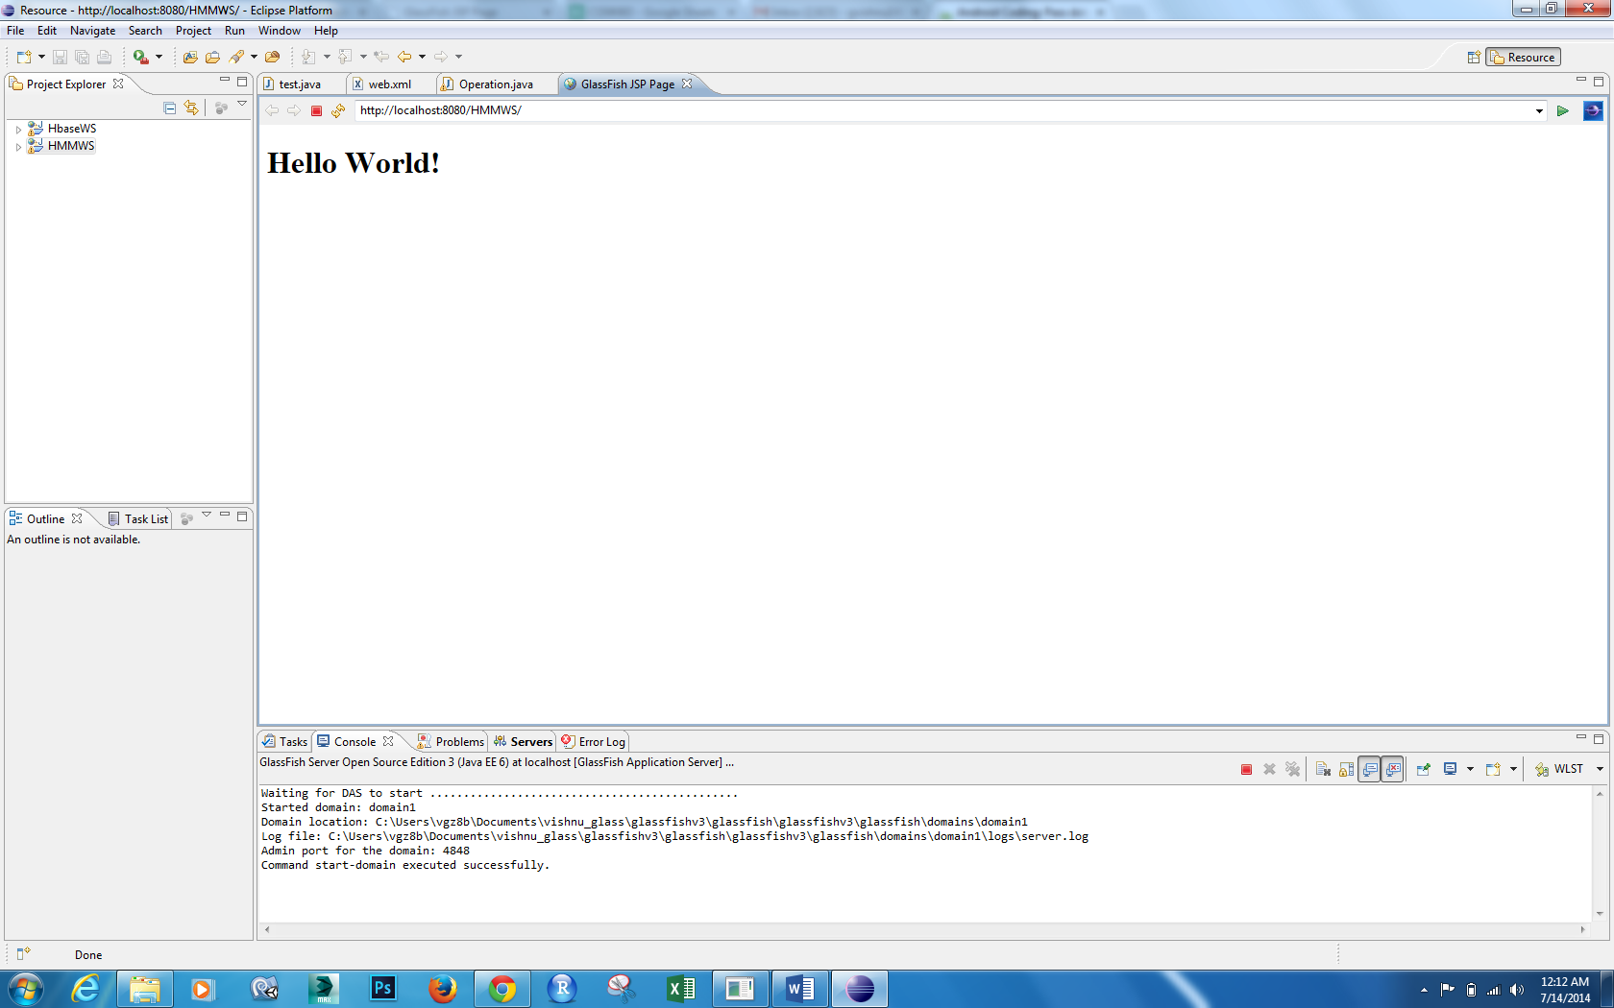

Now We have to train Gestures by collecting and saving data into txt files

Now I collected three types of Gesture data in txt files using my App i.e. Punch, Left to Right, Right to left gestures



Now generate Test Gesture files also for testing

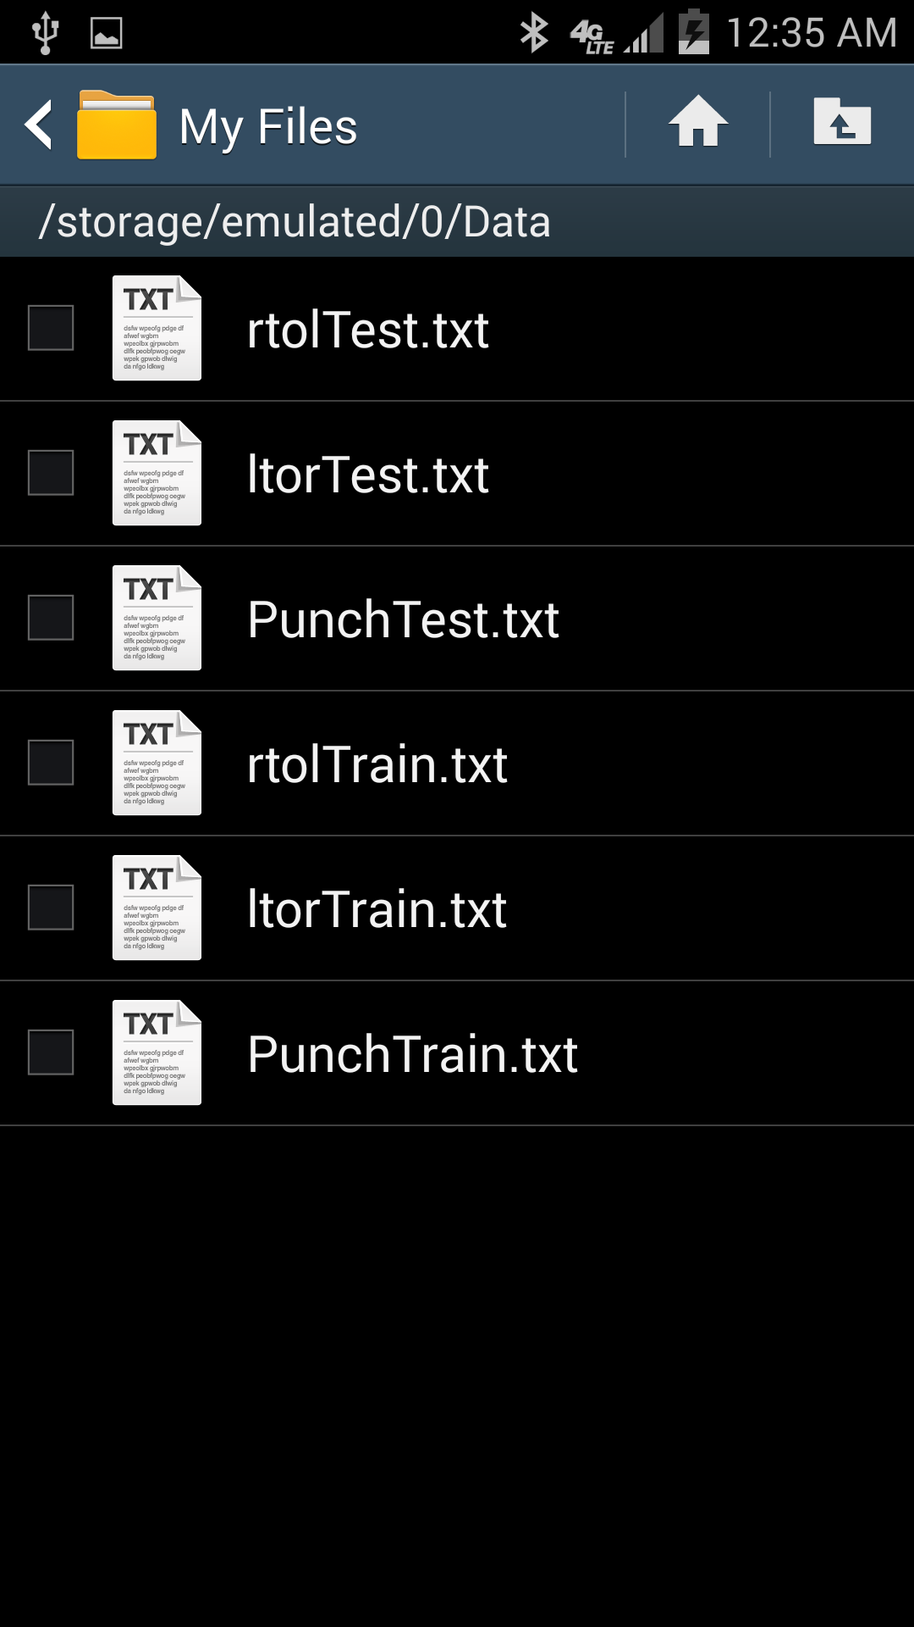

Now copy files into local host and started HMMWS web service in Glassfish

First generate sequence files for training data

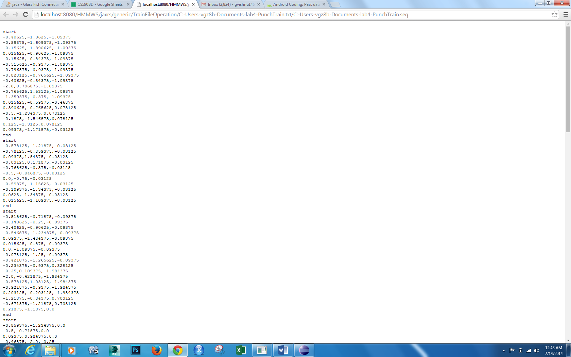

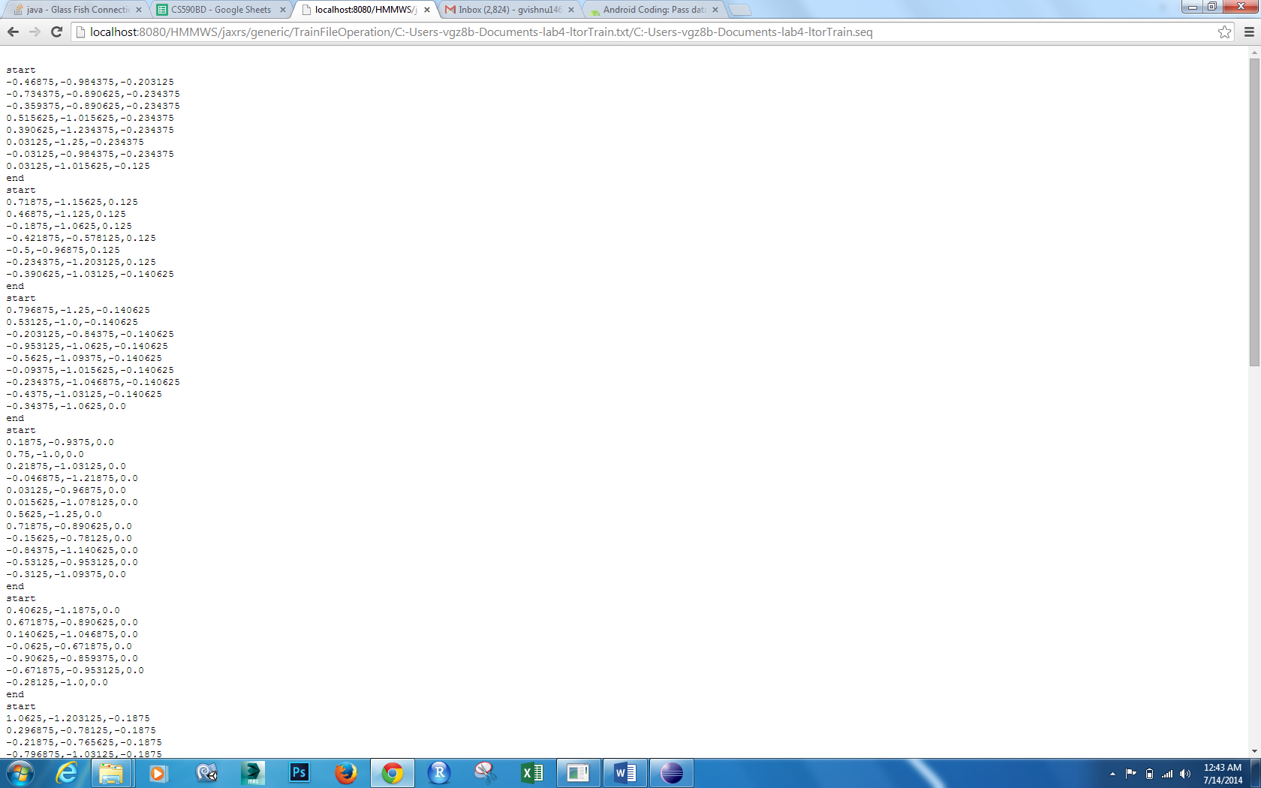

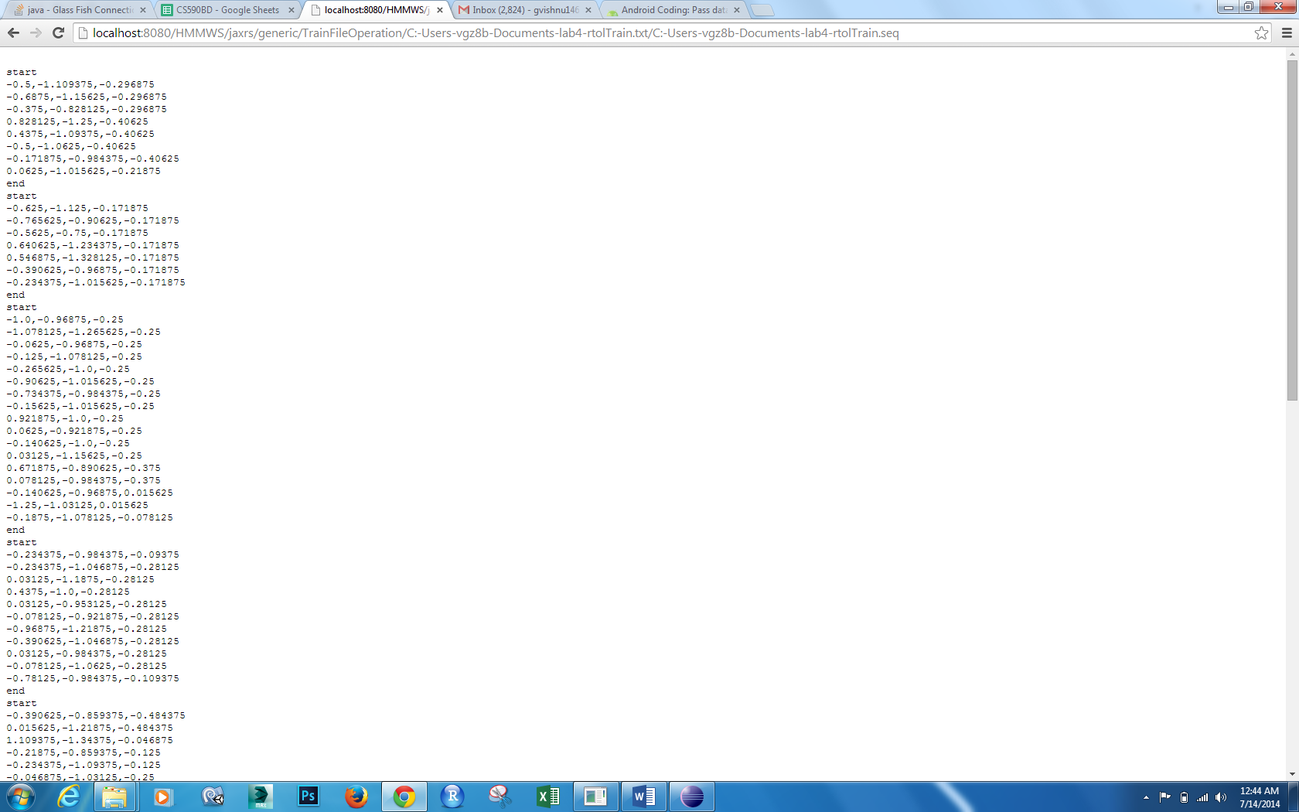

Now Generate Sequence files for Testing Data

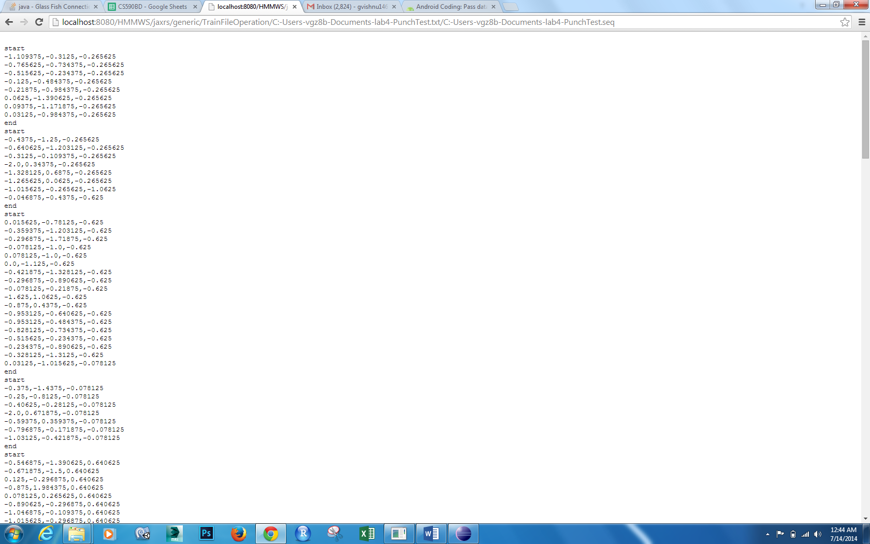

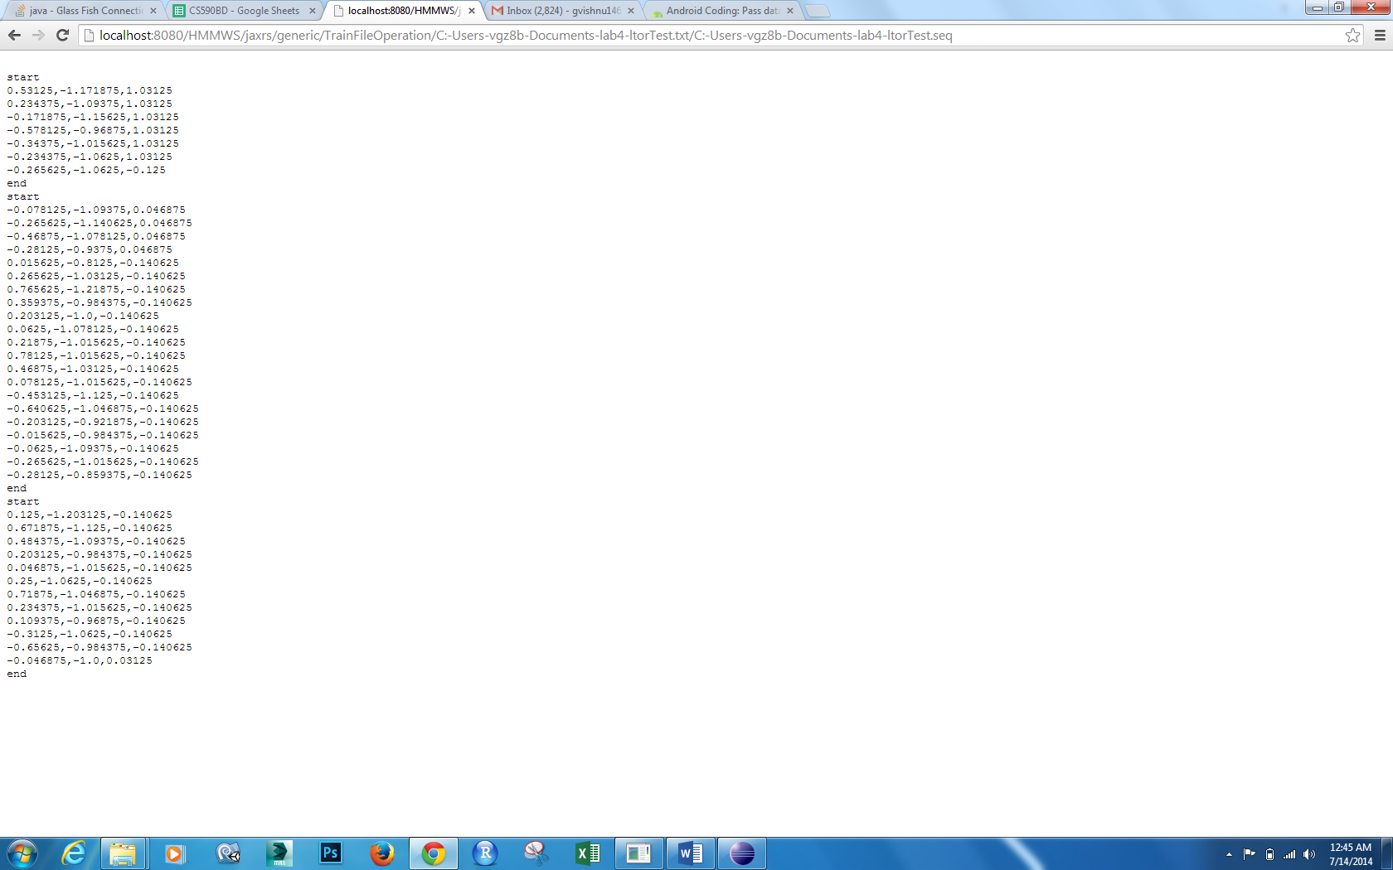

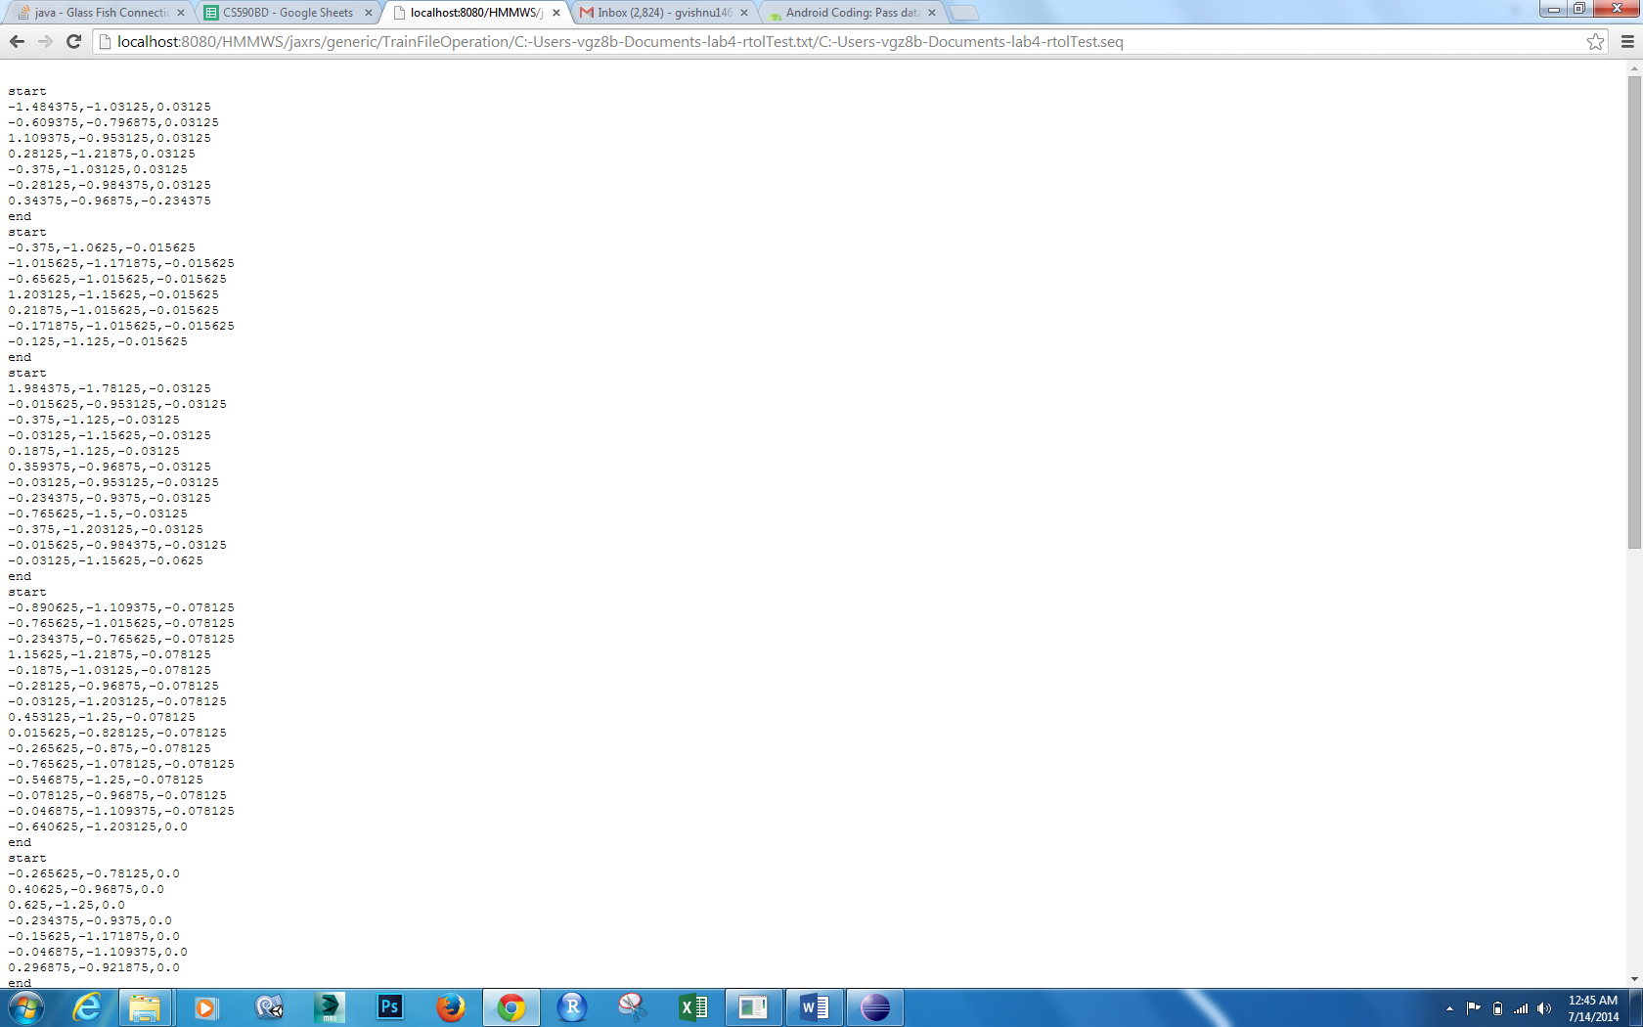

Now Generated a Combination.txt by doing three gestures one after other

Now generated sequence file for Combination.txt

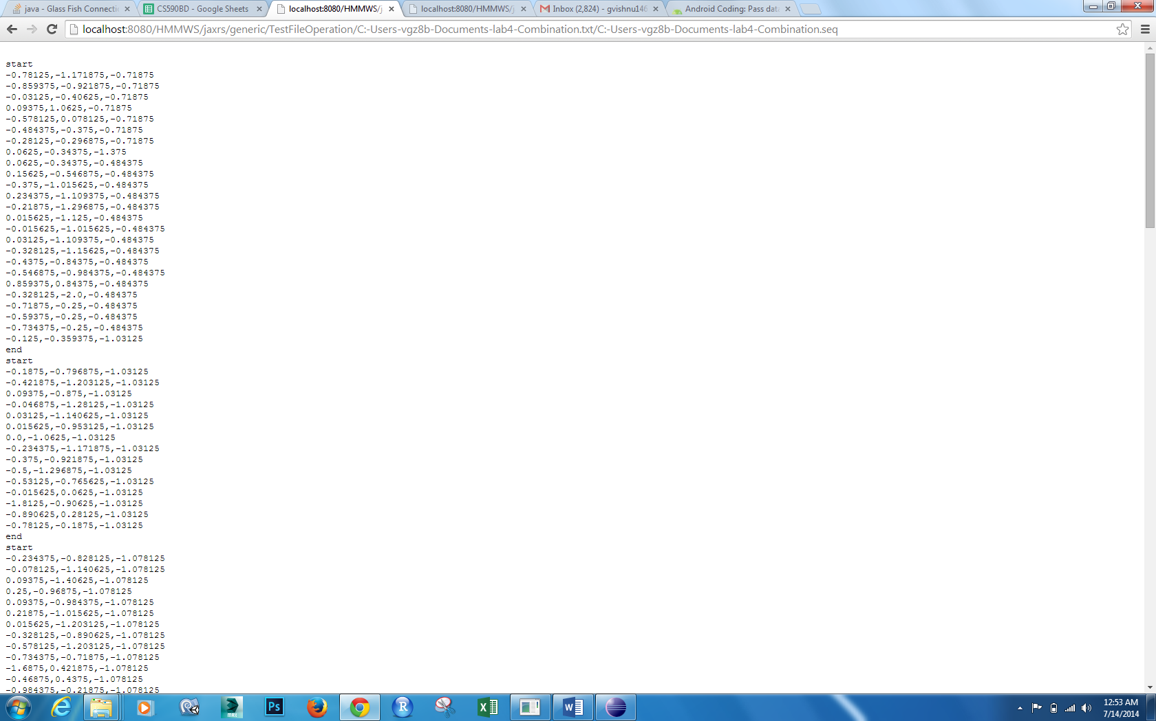

Now test with Webservice **HMMTrainingTestThree**

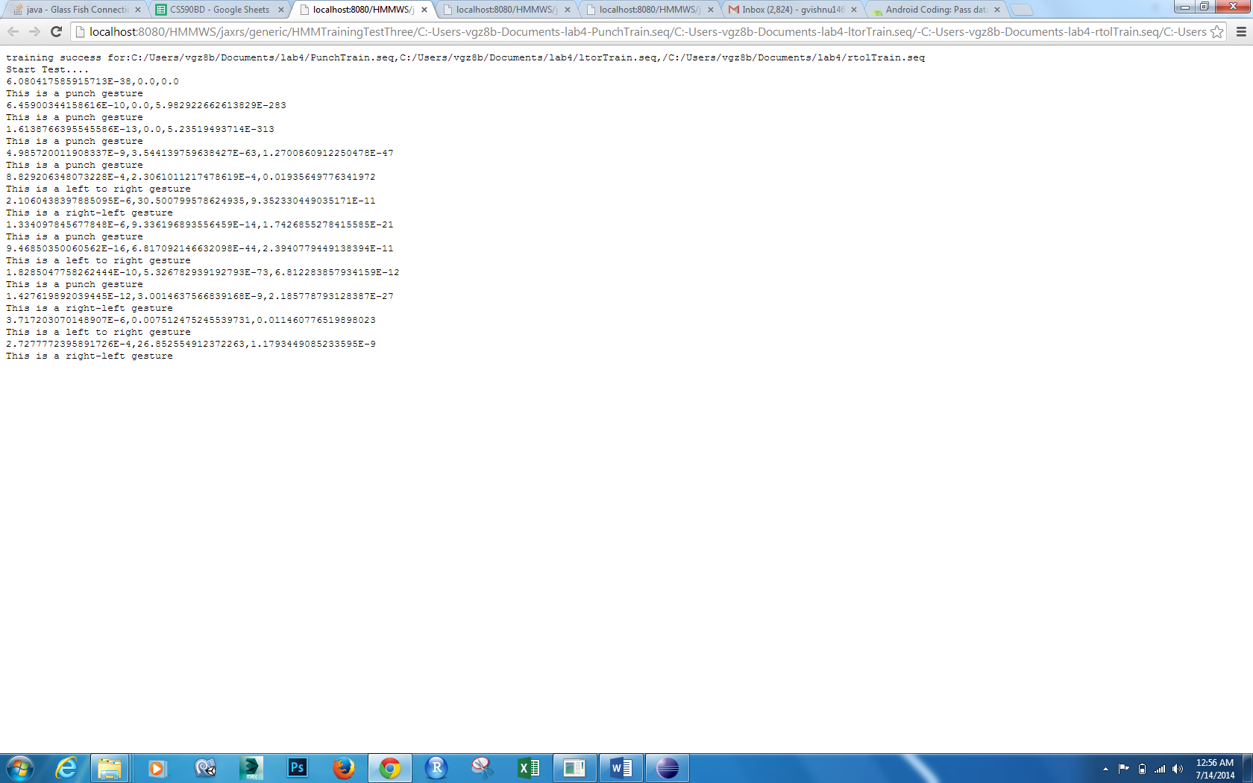

From the output we can see It is detected as punch, left to right and right to left along with probabilities.

Now for the fourth webservice HMMTrainingTest Inside the code changed split eliminator from ‘:’ to ‘::’ because our localhostlink already contains ‘:’

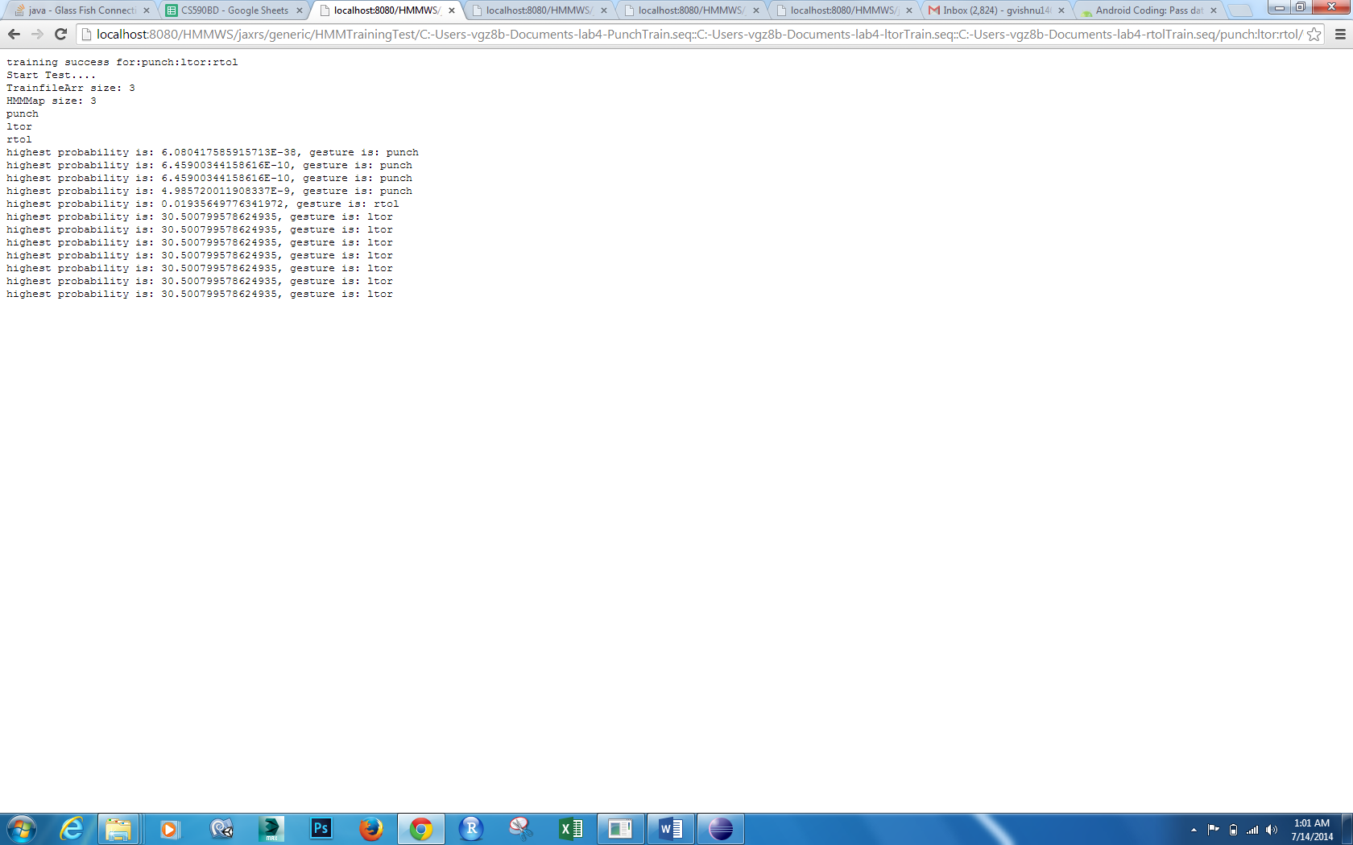

In this way we can detect train gestures and then test them .