**Big Data Analytics and Applications**

**lab-2**

**N.AYYAPPA KUMAR(16157522)**

**TASK:**

Collection of various information like Time, GPS, Accelerometer, Humidity, Temperature and use a client application to push the data file into HBase.

Android Smart Phone and Sensor Tags are the devices used.

Select BLE sensor tag app in your mobile then you will be able to detect the sensor in your device as follows.

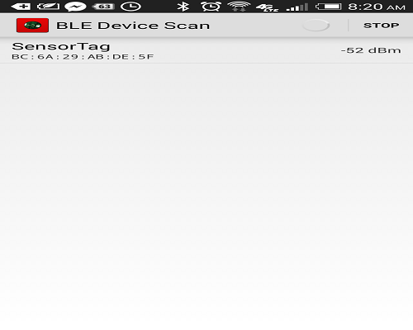

We can see the data available from various applications as follows.

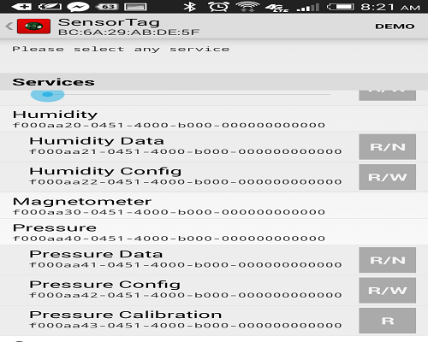

**Applications used for the tasks are:**

**\***  We used the applications App1-sensor tag, App3-Android GPS and combined them to read the data into the file.

* We use Astro file manager to collect the data file in our android device. It is an android application to collect the data from the sensor tag in our mobile.

* Modify the existing application such that it can collect the Humidity and Pressure data along with the GPS, Time, and Accelerometer.

* Then after running the application the data is collected in a file as follows.

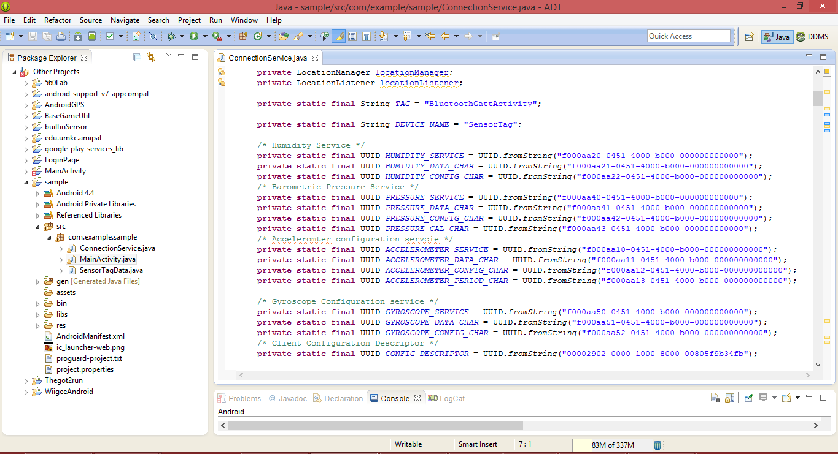

You can see the changes made in the application for the collection of data as follows.

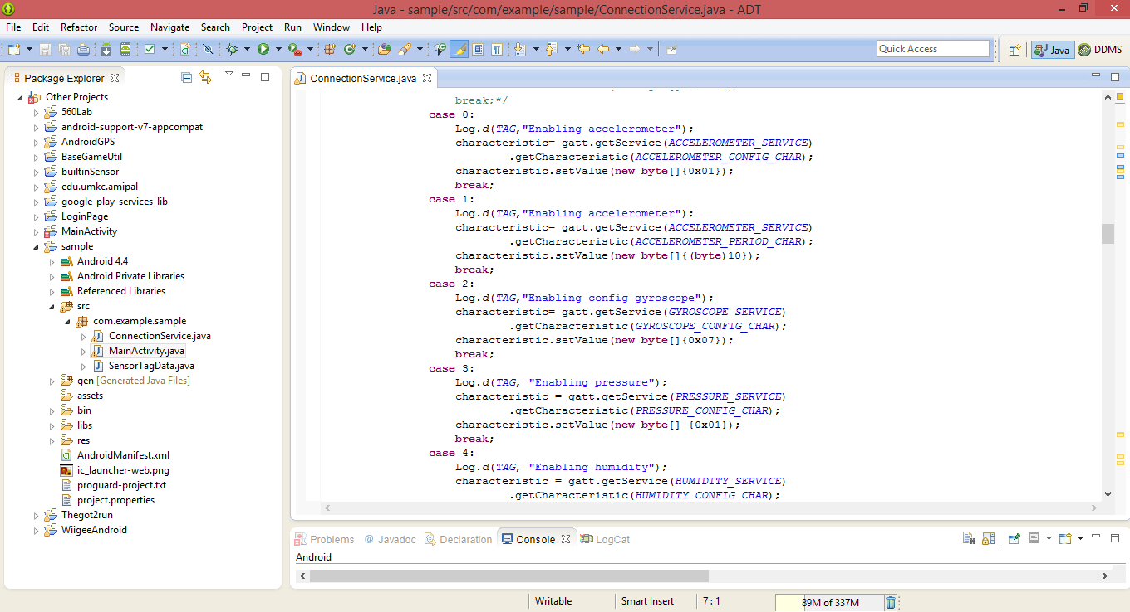

Different types of data is collected as follows in the text file as shown below.

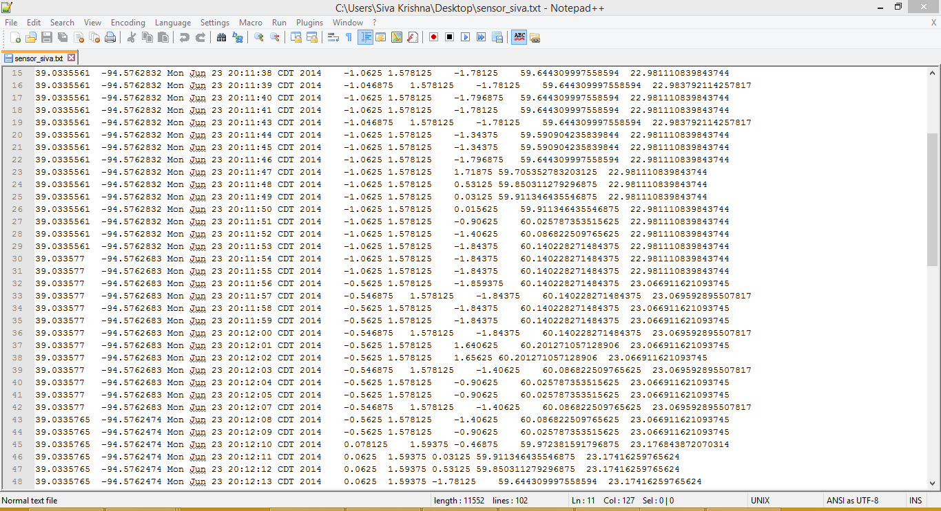

**Inserting into HBase:**

We had written code in java for

* Creating the table in HBase.
* Inserting Collected Data into the created table in HBase.
* Retrieving the collected data from the table.
* Deleting the table Created in the HBase.

By executing the function to create a table the table is created.

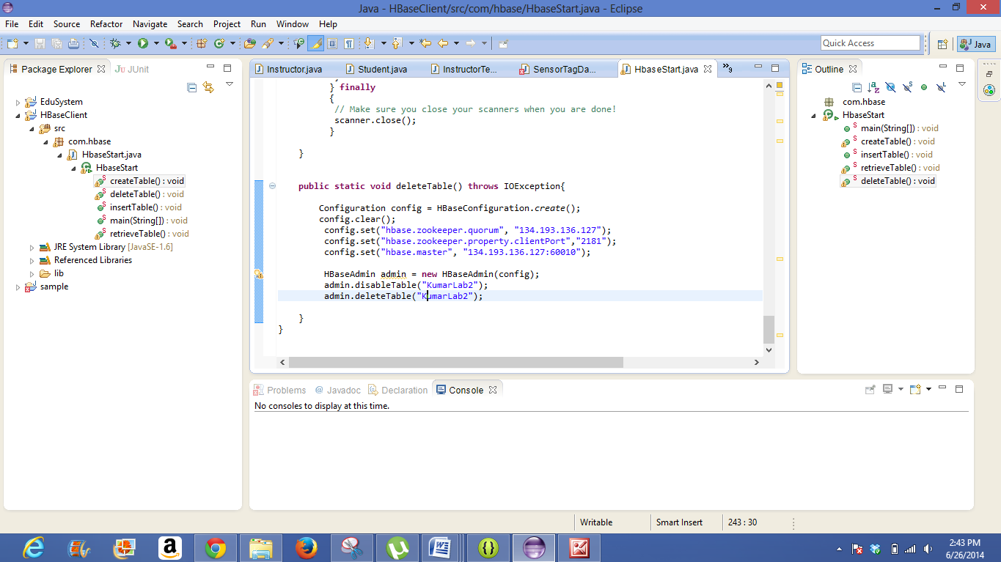

The below screen shot is at the time of creation of table at run time where you can see the message saying creating table.

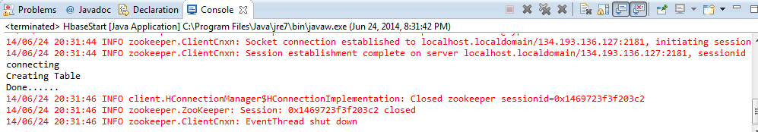

Then we need to remove the code of creating the table and run the insertion function with the same table name. Where the data will be inserted in that particular table

Similarly we can retrieve the data from the table and can also delete the table.

Below is the screen shot of the created table showing in the UI of HBase.

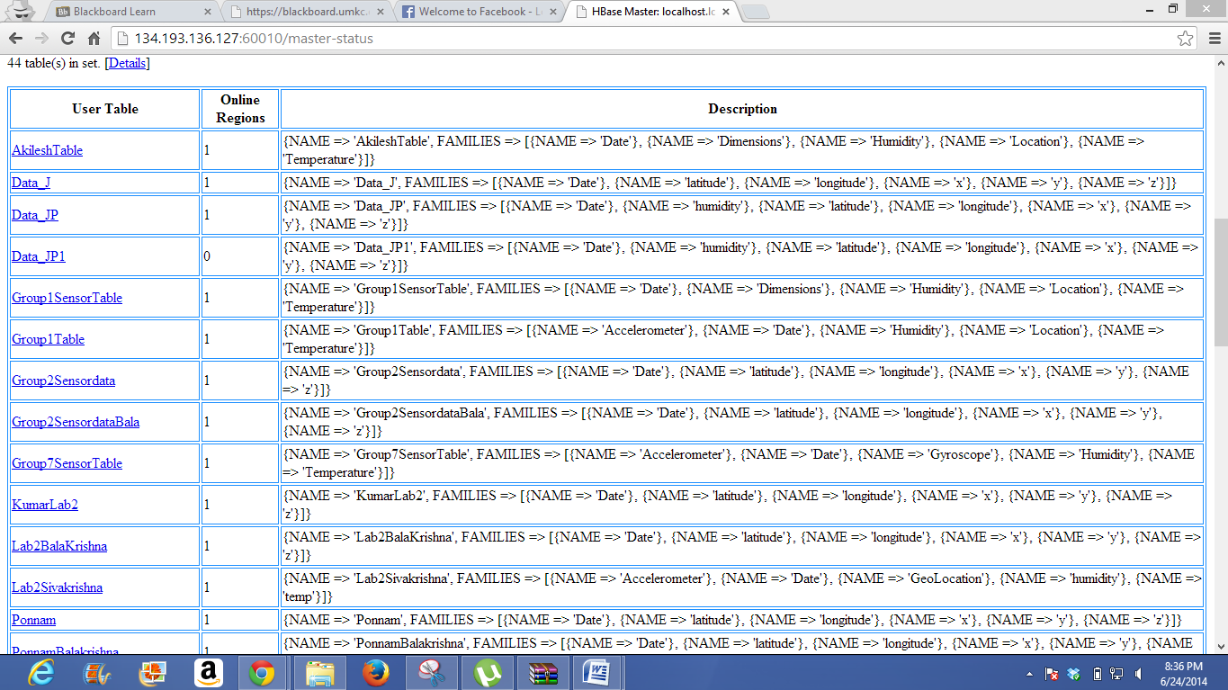

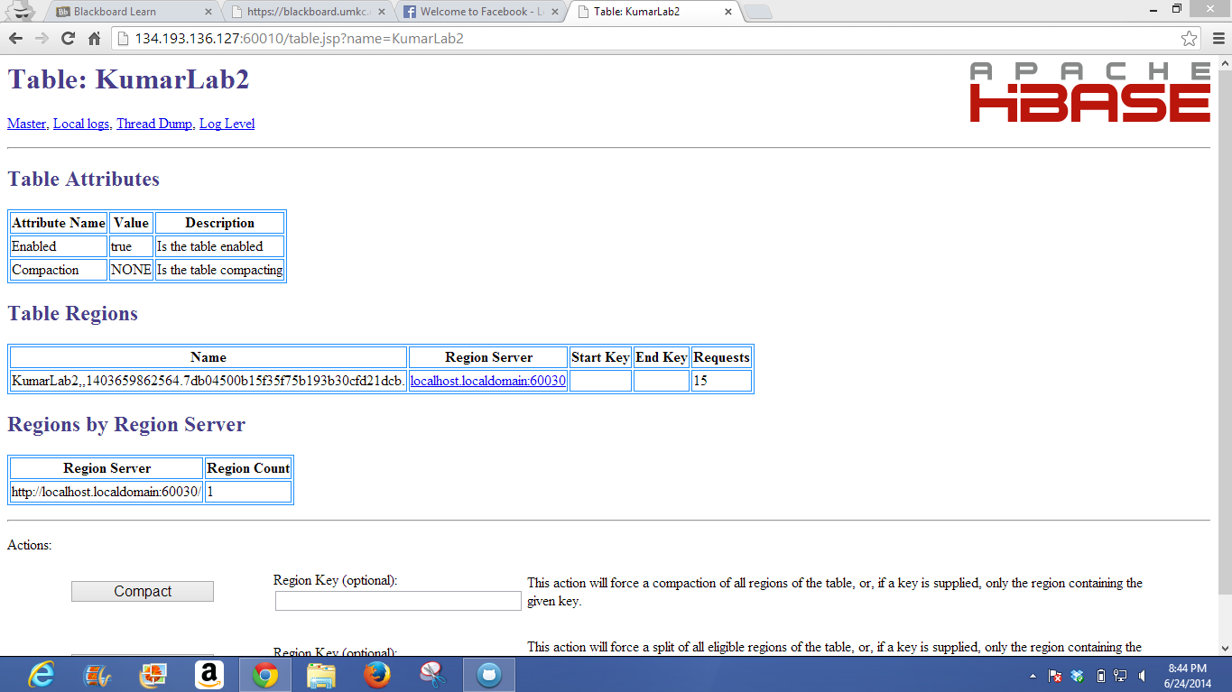

Thus the retrieving of data screen shot is as follows:

