Kriging

variogram_model='gaussian'

variogram_parameters={'range': 10, 'sill': 2, 'nugget': 0.5}  
  
These parameters decide how the kriging is done  
  
**Gaussian Variogram Model**

The Gaussian model is one of the most commonly used variogram models. It is particularly suited for smooth, continuous phenomena where the changes in values between points are gradual and not abrupt.

**Range**

The range is the distance over which spatial correlation exists. Beyond this distance, data points are considered spatially independent (i.e., the value at one point does not influence the value at another point).

**Nugget**

The nugget represents small-scale variability and/or measurement error. It is the variance that exists at very short distances. In the Gaussian model, the nugget value starts the variogram at a small non-zero value instead of zero.

**Sill**

The sill is the maximum variance (or plateau) of the variogram. It represents the point where spatial correlation no longer increases with distance; beyond this point, data points are effectively independent.

SRGAN

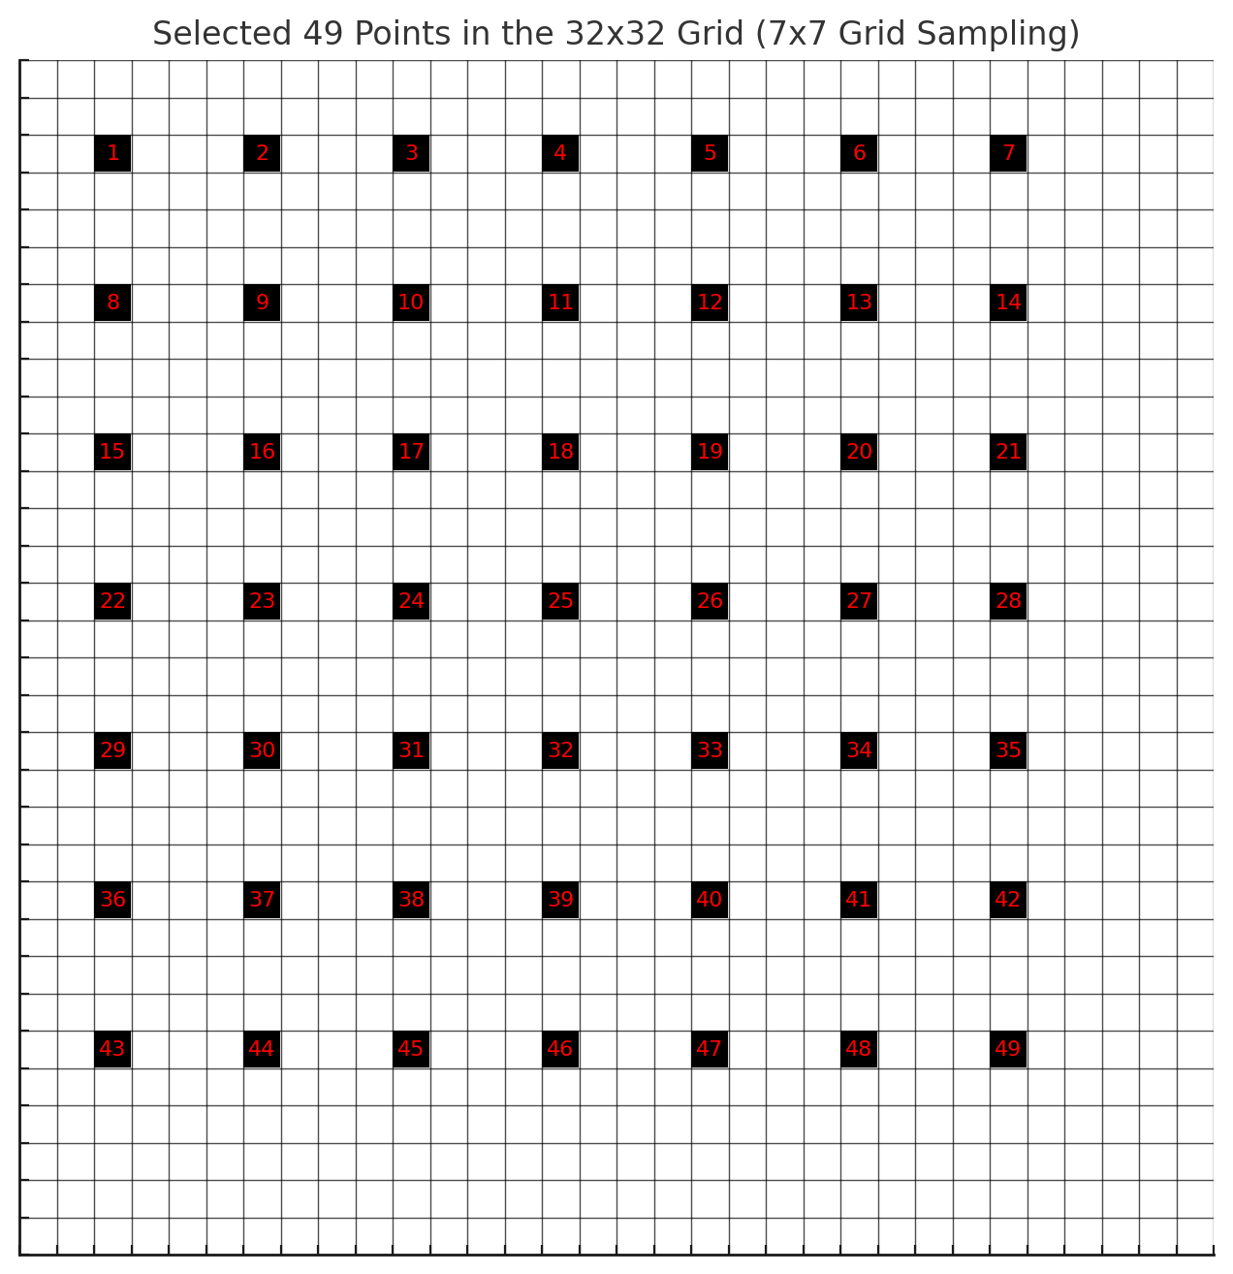**7x7**

**5x5**

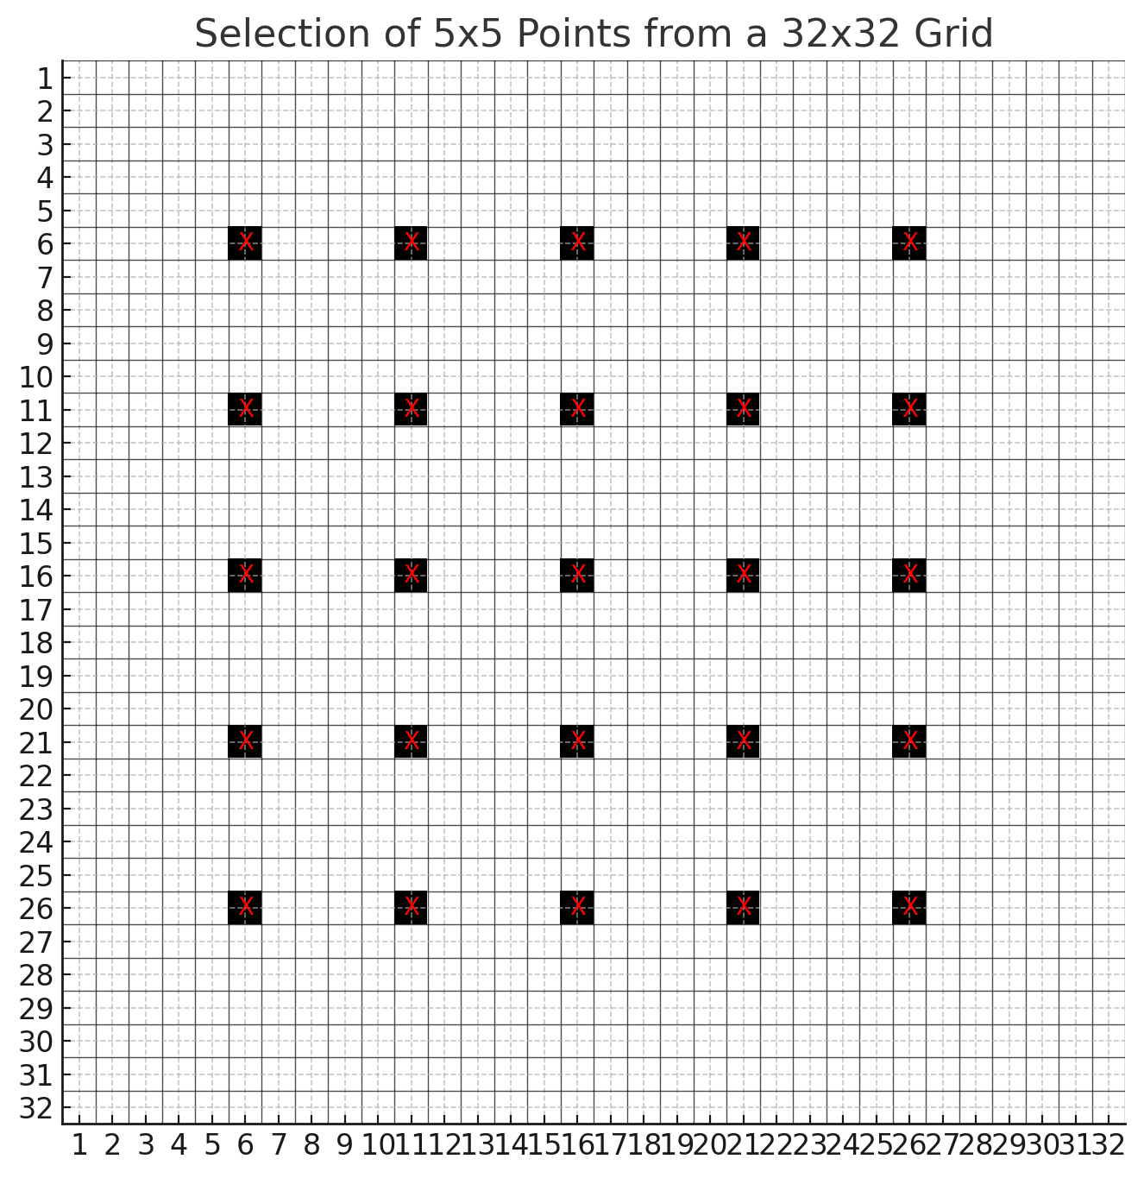

I tried with 2 different settings selecting a 7x7 grid and a 5x5 grid evenly.

**7x7**

PSNR for image 155: 32.94

RMSE for image 155: 0.0225

**5x5**

PSNR for image 155: 32.11

RMSE for image 155: 0.0248

