STAT-FINAL-PROJECT.R

Bhargav Dasari

2024-05-01

# Load required libraries  
library(tidyverse)

## ── Attaching core tidyverse packages ──────────────────────── tidyverse 2.0.0 ──  
## ✔ dplyr 1.1.4 ✔ readr 2.1.5  
## ✔ forcats 1.0.0 ✔ stringr 1.5.1  
## ✔ ggplot2 3.4.4 ✔ tibble 3.2.1  
## ✔ lubridate 1.9.3 ✔ tidyr 1.3.0  
## ✔ purrr 1.0.2   
## ── Conflicts ────────────────────────────────────────── tidyverse_conflicts() ──  
## ✖ dplyr::filter() masks stats::filter()  
## ✖ dplyr::lag() masks stats::lag()  
## ℹ Use the conflicted package (<http://conflicted.r-lib.org/>) to force all conflicts to become errors

# Read the dataset  
airbnb_data <- read.csv("C:/Users/Bhargav Dasari/Documents/SPRING-2024/STAT-515/project/cleaned_data.csv")

# Visualize the relationship between number of listings managed by a host and price variation across different room types  
ggplot(airbnb_data, aes(x = calculated_host_listings_count, y = price, color = room_type)) +  
 geom_point() +  
 facet_wrap(~ room_type) +  
 labs(x = "Number of Listings Managed by Host", y = "Price", title = "Price Variation by Number of Listings and Room Type")

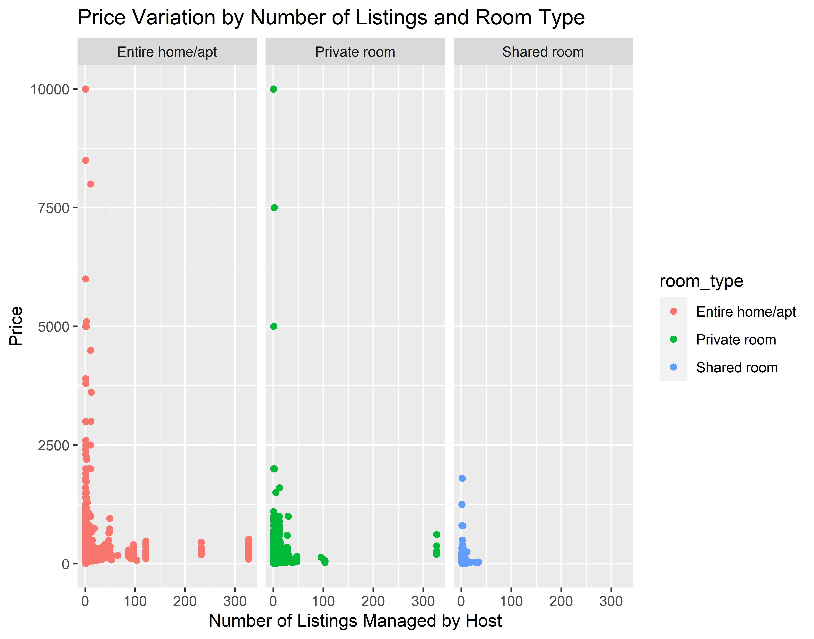

# Linear regression to quantify the relationship  
lm_model <- lm(price ~ calculated_host_listings_count * room_type, data = airbnb_data)  
summary(lm_model)

##   
## Call:  
## lm(formula = price ~ calculated_host_listings_count * room_type,   
## data = airbnb_data)  
##   
## Residuals:  
## Min 1Q Median 3Q Max   
## -194.9 -47.6 -21.6 11.4 9916.7   
##   
## Coefficients:  
## Estimate Std. Error  
## (Intercept) 194.65262 1.34844  
## calculated_host_listings_count 0.23328 0.03769  
## room_typePrivate room -111.74346 2.00683  
## room_typeShared room -122.18015 8.31816  
## calculated_host_listings_count:room_typePrivate room 0.12059 0.15136  
## calculated_host_listings_count:room_typeShared room -2.17688 1.05792  
## t value Pr(>|t|)   
## (Intercept) 144.354 < 2e-16 ***  
## calculated_host_listings_count 6.190 6.09e-10 ***  
## room_typePrivate room -55.682 < 2e-16 ***  
## room_typeShared room -14.688 < 2e-16 ***  
## calculated_host_listings_count:room_typePrivate room 0.797 0.4256   
## calculated_host_listings_count:room_typeShared room -2.058 0.0396 *   
## ---  
## Signif. codes: 0 '***' 0.001 '**' 0.01 '*' 0.05 '.' 0.1 ' ' 1  
##   
## Residual standard error: 188.5 on 38837 degrees of freedom  
## Multiple R-squared: 0.08386, Adjusted R-squared: 0.08374   
## F-statistic: 711 on 5 and 38837 DF, p-value: < 2.2e-16

# Build Poisson regression model  
poisson_model <- glm(number_of_reviews ~ calculated_host_listings_count + room_type, data = airbnb_data, family = poisson)  
  
# Summarize the model  
summary(poisson_model)

##   
## Call:  
## glm(formula = number_of_reviews ~ calculated_host_listings_count +   
## room_type, family = poisson, data = airbnb_data)  
##   
## Coefficients:  
## Estimate Std. Error z value Pr(>|z|)   
## (Intercept) 3.3949421 0.0013482 2518.07 <2e-16 ***  
## calculated_host_listings_count -0.0111227 0.0001199 -92.80 <2e-16 ***  
## room_typePrivate room 0.0522275 0.0018922 27.60 <2e-16 ***  
## room_typeShared room -0.2190670 0.0073282 -29.89 <2e-16 ***  
## ---  
## Signif. codes: 0 '***' 0.001 '**' 0.01 '*' 0.05 '.' 0.1 ' ' 1  
##   
## (Dispersion parameter for poisson family taken to be 1)  
##   
## Null deviance: 1954366 on 38842 degrees of freedom  
## Residual deviance: 1932166 on 38839 degrees of freedom  
## AIC: 2094724  
##   
## Number of Fisher Scoring iterations: 6

# Preprocess the data  
# Encode categorical variables  
airbnb_data <- airbnb_data %>%  
 mutate(location_encoded = as.factor(neighbourhood_group),  
 room_type_encoded = as.factor(room_type))  
  
# Handle missing values if any  
  
# Split the data into train and test sets  
set.seed(123)  
train_indices <- sample(1:nrow(airbnb_data), 0.8 * nrow(airbnb_data))  
train_data <- airbnb_data[train_indices, ]  
test_data <- airbnb_data[-train_indices, ]  
  
# Train regression model  
regression_model <- lm(number_of_reviews ~ location_encoded + room_type_encoded + price, data = train_data)  
summary(regression_model)

##   
## Call:  
## lm(formula = number_of_reviews ~ location_encoded + room_type_encoded +   
## price, data = train_data)  
##   
## Residuals:  
## Min 1Q Median 3Q Max   
## -34.20 -26.08 -19.54 4.12 594.18   
##   
## Coefficients:  
## Estimate Std. Error t value Pr(>|t|)   
## (Intercept) 33.460891 1.880139 17.797 < 2e-16 ***  
## location_encodedBrooklyn -2.777958 1.880566 -1.477 0.140   
## location_encodedManhattan -4.319758 1.885814 -2.291 0.022 *   
## location_encodedQueens 1.401967 1.998881 0.701 0.483   
## location_encodedStaten Island 1.649350 3.559207 0.463 0.643   
## room_type_encodedPrivate room 0.325691 0.587427 0.554 0.579   
## room_type_encodedShared room -7.967898 1.895489 -4.204 2.63e-05 ***  
## price -0.007853 0.001556 -5.046 4.54e-07 ***  
## ---  
## Signif. codes: 0 '***' 0.001 '**' 0.01 '*' 0.05 '.' 0.1 ' ' 1  
##   
## Residual standard error: 48.44 on 31066 degrees of freedom  
## Multiple R-squared: 0.003292, Adjusted R-squared: 0.003067   
## F-statistic: 14.66 on 7 and 31066 DF, p-value: < 2.2e-16

# Predictions on test set  
predictions <- predict(regression_model, newdata = test_data)  
  
# Evaluate model performance  
RMSE <- sqrt(mean((test_data$number_of_reviews - predictions)^2))  
MAE <- mean(abs(test_data$number_of_reviews - predictions))  
  
RMSE

## [1] 46.71403

MAE

## [1] 30.57147

# Load required library  
library(randomForest)

## Warning: package 'randomForest' was built under R version 4.3.3

## randomForest 4.7-1.1

## Type rfNews() to see new features/changes/bug fixes.

##   
## Attaching package: 'randomForest'

## The following object is masked from 'package:dplyr':  
##   
## combine

## The following object is masked from 'package:ggplot2':  
##   
## margin

# Encode categorical variables  
airbnb_data$location_encoded <- as.factor(airbnb_data$neighbourhood_group)  
airbnb_data$room_type_encoded <- as.factor(airbnb_data$room_type)  
  
# Handle missing values if any  
  
# Split the data into train and test sets  
set.seed(123)  
train_indices <- sample(1:nrow(airbnb_data), 0.8 * nrow(airbnb_data))  
train_data <- airbnb_data[train_indices, ]  
test_data <- airbnb_data[-train_indices, ]  
  
# Train Random Forest model  
rf_model <- randomForest(number_of_reviews ~ location_encoded + room_type_encoded + price, data = train_data, ntree = 500)  
print(rf_model)

##   
## Call:  
## randomForest(formula = number_of_reviews ~ location_encoded + room_type_encoded + price, data = train_data, ntree = 500)   
## Type of random forest: regression  
## Number of trees: 500  
## No. of variables tried at each split: 1  
##   
## Mean of squared residuals: 2314.65  
## % Var explained: 1.67

# Predictions on test set  
rf_predictions <- predict(rf_model, newdata = test_data)  
  
# Evaluate model performance  
rf_rmse <- sqrt(mean((test_data$number_of_reviews - rf_predictions)^2))  
rf_mae <- mean(abs(test_data$number_of_reviews - rf_predictions))  
  
print(paste("Random Forest RMSE:", rf_rmse))

## [1] "Random Forest RMSE: 46.5043157596358"

print(paste("Random Forest MAE:", rf_mae))

## [1] "Random Forest MAE: 30.3279656644863"

# Feature Importance  
varImpPlot(rf_model)

