**Marine Ecological Response to the Rise of Land-Plant Weathering Rates in the Late Devonian**

**A dissertation proposal submitted to the Department of Geoscience faculty of the University of Wisconsin-Madison on May 9, 2016**

**Ben Davis Barnes**

**Primary Advisor: Shanan E. Peters**

**Committee members: Andrew A. Zaffos, Jon Husson, Valerie Syverson**

**Abstract**

The rise of rooted vascular plants and forest communities in the Middle Devonian led to a profoundly different terrestrial weathering regime. Increased pedogenic and chemical weathering rates on land allowed for greater riverine transport of nutrient-rich compounds and sediments to the ocean, which is hypothesized to have triggered periods of eutrophication and deep-water anoxia which contributed to mass extinction events throughout the Middle to Late Devonian. These short term pulses would leave characteristic selective impacts on shallow-water marine faunal communities, while a return to steady-state following the Late Devonian Mass Extinctions may allow for greater nutrient availability in a long-term scale.

I propose to use marine fossil diversity data to gauge the biotic response to increased terrestrial chemical weathering and organic materials. I will measure trends in abundance, origination, and extinction of shallow marine invertebrates as terrestrial vascular communities developed, and evaluate the global shifts in niche groups to gain a better understanding of the role terrestrial weathering played in marine diversification and extinction in the Devonian. This study will also incorporate an opportunistic PaleoDeepDive replication of an earlier study, to aid in the development and calibration of the automated language and data processing system.

**Statement of the Problem**

The Late Devonian was an epoch of great environmental turbulence: as life diversified on land in the form of the earliest tetrapods and vascular plant forests, the ocean was experiencing episodes of bottom-water anoxia, climate fluctuations, and rapid sea-level change. These events are recorded in the rock record as organic-rich black shales, and in the isotopic record as a series of positive carbon isotopic excursions. Throughout these perturbations, large-scale biotic crises collectively known as the Late Devonian Mass Extinctions (LDME) devastated marine low-latitude communities. Despite their magnitude, the mechanisms driving the LDME remain uncertain, and hypotheses range from global climate changes to impact events (e.g. McGhee, 1996; Racki, 2005). One hypothesis in particular – the “land-plant weathering rate” hypothesis – proposes that rather than a coincidentally contemporary event, the rise of land plant communities had a causal factor in the LDME, by way of increased continental weathering input and organic material delivery to the ocean (Algeo et al., 1995). Most support for this hypothesis comes from paleobotanical fossils showing contemporary development with the extinctions (Algeo and Scheckler, 1998), analogical studies of modern plant weathering rates (Drever, 1994), paleosols records of weathering (Retallack et al., 1985), and inference by proxy of lowered concentrations of atmospheric carbon dioxide (Berner, 1994).

This research project will test the land-plant weathering hypothesis with evidence from the marine realm, thereby gauging the response to this process instead of inferring its feasibility. Fossil occurrence data drawn from the Paleobiology Database (PBDB) will allow for an assessment of the ecological response to the LDME in coastal-proximal marine units constrained by Macrostrat data. Our methods will comprise two scales of assessment, the short-term and long-term biotic response, as well as a case study for the effectiveness of PaleoDeepDive in the context of paleoecological assessments:

1. Are the pulses of extinction and anoxia prevalent in the Late Devonian (Givetian – Famennian) caused by the development of terrestrial flora communities and their associated increase in weathering regimes? By examining short-term ecological and taxonomical shifts in diversity and abundance, we can test that the biotic marine response to these episodes corresponds characteristically to the “land-plant weathering rate” hypothesis.
2. Over a larger time-scale spanning before and after the pulses of extinction (Middle Devonian – Early Mississippian), do we see a broader ecological or evolutionary response by marine communities to these frequent perturbations? By examining ecological and taxonomical trends, this time over a broader scale, secular trends in marine life in response to the arrival of land-plant communities will be identified.
3. In addition, this study will incorporate a trial of PaleoDeepDive to test the rigor of the machine reading system. Large-scale tests of the program’s accuracy alongside the PBDB have been conducted with great accuracy (≥92%; Peters et al., 2014). However, this study’s utilization of the PBDB for one period and in great detail will provide another opportunity to test PaleoDeepDive’s capacity and showcase its accuracy of database research.

**Background**

*Scientific Significance* –– The Middle to Late Devonian (393.3 – 358.9 Mya) was a period of considerable environmental turbulence: the evolution of terrestrial forest communities and early tetrapods was interspersed by episodes of marine bottom-water anoxia, climate fluctuations, rapid sea-level change, isotopic excursions and a series of biotic crises, the worst of which are known as the Late Devonian mass extinction (LDME) and constitute one of the “Big Five” extinction events during the Phanerozoic. The LDME led to the extinction of approximately 82% of marine species and 50% of genera (McGhee, 1996). The event was unusual in that it comprised at least 8 episodes of extinction spanning 20Ma (starting in the Givetian) and preferentially eliminated tropical, shallow marine species (Algeo et al., 1995). Reef-building organisms and communities were especially affected: the LDME permanently obliterated the dominant reef-forming tabulate corals and stromatoporoids and reduced reef communities by a factor of 5000 (Copper, 1994; Stigall, 2012). Many competing hypotheses for the cause of the LDME exist, ranging from climate warming (van Geldern et al., 2006) to cooling and short-lived glaciations (Joachimski and Buggisch, 2002), eustatic sea-level fluctuations, an impact event, and pulses of anoxia and eutrophication caused by ocean stratification (Murphy, Sageman and Hollander, 2000) or tectonic uplift (Averbuch et al., 2005). Additionally, some propose the LDME be classified as a ‘mass depletion’ owing to a diminished biodiversity origination rate rather than extinction rate (Bambach, Knoll, and Wang, 2004; Stigall, 2012).

The land-plant weathering hypothesis first proposed by Algeo et al. in 1995 and later expanded (Algeo and Scheckler, 1998; Algeo and Scheckler, 2010) is an alternative which seeks to correlate the environmental perturbations present in the Middle- to Late-Devonian with terrestrial plant evolution. Although early plants had existed on land since the Late Ordovician or Silurian (Gensel, 2008), the evolution of higher vascular plants in the Devonian brought about three major adaptations:

1. arborescence, or greater biomass and height of plants, in the Late Givetian allowed for the dominance of archaeopterid trees (~30m high, ~1.5m in diameter) and forests;
2. more complex root systems which yielded deeper soil penetration (from 20cm deep to 80-100cm by the Frasnian-Famennian); and
3. the evolution of seed-bearing plants (mid-to-late Famennian), which enabled plants to be independent on wet lowland habitats and expand into the dryer highlands.

The expansion of forest communities across the continents had a profound impact on the chemical weathering of the continents. Before the Devonian the land surface had been hypothesized to feature only thin microbial soils and barren rock faces (Feakes and Retallack, 1988). The arrival of large vascular plants marked the beginning of extensive pedogenesis and an acceleration of chemical weathering by the release of organic and carbonic acids from increased organic litter decomposition and root processes and the enhanced trapping of moisture by soils. The acid production in conjunction with complex root systems in vascular plants gives a weathering efficiency ratio over non-vascular plants of 7:1 (Berner, 1994). These compounded effects underline the dramatic chemical weathering shift from pre-Devonian to Devonian regimes­. This trend is further evidenced by:

1. the shift by the Early Carboniferous from clay assemblages dominated by illite and chlorite to those dominated by smectite and kaolinite, which are associated with pedogenic chemical weathering;
2. the increased occurrence of pedogenic products such as bauxites and laterites; and
3. the preservation of the first temperate forest paleosols such as alfisols, spodosols, and vertisols starting in the End Devonian (Algeo and Scheckler, 2010).

With the expansion of land plants and pedogenesis, terrestrial influx to the ocean changed from a weathering-limited process to a transport-limited process. The arrival of root systems afforded stabilization of sediment against mass movement and the evolution of meandering streams (Davies and Gibling, 2010), but also increased the residence time of sediments to be exposed to water-rock interactions, which in turn yielded finer, more mature sediments. Furthermore, the stabilizing effect of roots against mass movement is thought to be negated by the degree of flooding and catastrophic mass movement on a geological time scale. While surface runoff is reduced with vegetation, precipitation increases as developing forests support hydrological recirculation via evapotranspiration and increase albedo over the land (Algeo and Scheckler, 2010).

Another negative feedback of pedogenesis is that on the order of 105 to 106 years, a sufficiently thick soil layer is generated to shield fresh bedrock from further chemical weathering. The largest feedback comes from the drawdown and sequestering of atmospheric CO2 when reduced organic carbons are buried in soil or as biomass. This long-term feedback ultimately led to the global reduction of atmospheric CO2 from ~12–16PAL in the mid-Devonian to ~1PAL in the mid-Carboniferous (Berner, 1997), ushering in an icehouse climate which reduced continental chemical weathering dependent on precipitation. Although the development of plant communities had a strong impact on the global biogeochemical cycle, the short-term and long-term effects oppose one another. We thus propose to compare and contrast the transient and dramatic perturbations during the Middle to Late Devonian with the long-term stabilization of ecosystems through the Late Paleozoic.

*Short-Term Terrestrial Forcing of Late Devonian Mass Extinction Events*

The main hypothesized effects of terrestrial plant diversification in the Devonian are the increased delivery of silicate minerals and bio-limiting compounds to the marine realm via riverine transport. Berner (1997) hypothesized the chemical weathering regime created by land plants would accelerate silicate weathering rates by up to a factor of 5 (see also Cawley et al., 1969). While the long-term drawdown of CO2 would provide a long-term negative feedback to this weathering, in the short-term bursts of colonization by vascular plants could yield pulses of sediment influx during the Late Devonian, as per the reaction:

CO2 + 2H2O + CaAl2Si2O8 –> Al2Si2O5(OH)4 + CaCO3

Terrestrial plants also produce large volumes of humus and litter, which leads to the storage of labile organic compounds in soils, and pedogenically weather nutrient-rich minerals such as K-bearing minerals (Algeo and Scheckler, 1998). Increased delivery of these biolimiting nitrogen- and phosphorus-rich compounds to the ocean results in enhanced marine primary production (MPP) and subsequently eutrophication events such as the algal blooms seen in modern-day euxinic environments such as the Black Sea (Lyons et al., 1993). Subsequent die-offs and aerobic decomposition of the primary producers drastically lowers seawater pO2 levels, resulting in basin-wide or global bottom-water anoxia and enhanced organic carbon burial. Episodes of anoxia are a common occurrence in the Late Devonian, as evidenced by the abundance of black shale deposits.

*Long-Term Terrestrial Stabilization of post-Devonian Marine Biota*

The accelerated weathering rates due to land plant colonization during the Devonian was necessarily a temporary trend: with organic matter burial and silicate weathering, CO2 was drawn down, inducing an icehouse climate not conducive to further terrestrial weathering (Algeo and Scheckler, 1998). This is summarized in Fig. 1, in which sediment and nutrient influx, Corg burial, and the associated extinction are categorized short-term effects. Conversely, longer-lasting effects included landscape stabilization and pedogenic processes. In spite of the end of periodic pulses of sediment and organic matter, the presence of land plants would still permanently alter the carbon-silicate weathering cycle.

One secular trend arising from the establishment of terrestrial plants may be an increased availability of nutrients the Phanerozoic oceans, even after steady state carbon cycling is reached. This in turn has implications for long-term evolutionary trends in marine fauna. Cárdenas and Harries (2010) hypothesize that changes in nutrient availability throughout the Phanerozoic have a positive correlation with genus-level origination rates, so long as the increased input doesn’t trigger global eutrophication. This hypothesis was followed up by Boyce and Lee (2011), who suggested that the Cretaceous radiation of angiosperms resulted in an elevated nutrient influx which could have partially supported the Cretaceous marine radiation. Taylor et al. (2009) also hypothesized that the diversification of angiosperms in the Cretaceous – more efficient weathering agents which were accompanied by the rise of mycorrhizal fungal symbionts – played a significant role in increasing chemical weathering and diminishing atmospheric CO2 over the last 120 million years.

Allmon and Martin (2014) proposed that increased trophic resource availability could have fostered trends in the evolution of the marine biosphere. Phosphorus in particular is an important biolimiting nutrient on the geologic time-scale and has variable influx to the ocean controlled by terrestrial runoff. The authors note a secular trend in organisms developing to more “high energy” schemes (such as a change in the Devonian to more planktonic and nektonic taxa

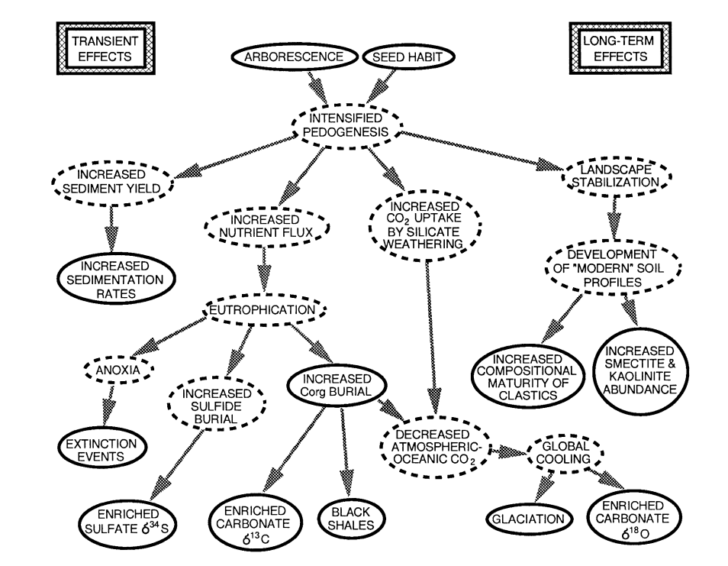

Fig. 1. A flow-chart summary of the short- and long-term effects of the development of vascular land plant communities, particularly the evolution of arborescence and seed habit. Solid lines around factors correspond to directly observed geological proxies; dashed lines correspond to processes that have been inferred from proxies. From Algeo and Scheckler, 1998.

diversity), increasing diversity of predators, and more complex ecologies including greater degrees of bioturbation, tiering, and deposit feeding. They correlate these trends with long-term increases in biolimiting elements in the ocean, and suggest that support from these nutrients may have played a role in Phanerozoic increases in biodiversity.

**Research Plan**

The data for this research will be drawn primarily from the Paleobiology Database ([www.paleobiodb.org)](http://www.paleobiodb.org)). Whereas most previous research on terrestrial input during this time has utilized geochemical proxies (Śliwiński et al., 2011; Whalen et al., 2015), our methods will use a broad data set of marine invertebrates to monitor the ecological responses to the punctuated episodes of eutrophication and anoxia. Choosing prominent taxa with diverse ecological types such as *Brachiopoda*, *Bivalvia*, *Cephalopoda*, *Ostracoda*, *Anthozoa*, and *Annelida*, we will be able to gather information on body sizes, foraging strategy and metabolic efficiency, motility, and habitat among each group from the PBDB occurrence data.

In order to infer data reliability, this study will be limited to North American fossil and rock occurrences. The benefit of this choice is threefold. Firstly, within PBDB, there is far greater thoroughness and confidence in the occurrences derived from North American literature. Secondly, the North American fossil and rock record within the Devonian is exceptional, and rich with epicontinental basins which acted as the site for terrestrial delivery and anoxia, as evidenced by ~341 widespread black shale units from the Frasnian-Famennian epochs. Finally, constraining this study to North America allows for the use of Macrostrat to supplement the fossil record. Currently complete for North America, the Macrostrat database provides comprehensive paleoenvironmental and lithological data on each of the lithostratigraphic units included in PBDB. By taking advantage of this resource, the project will be able to focus on shallow-water and coast-proximal environments with evidence of anoxia for the faunal analyses. Finally, Macrostrat will provide a useful corroboration for community ages: while we are not seeking to create a high-resolution stratigraphic correlation of extinction events across the continent, knowing the approximate timing of fossil die-offs in relation to the development of land plant communities will help control the testing of our hypothesis.

Measuring the short-term faunal response over the 20Myr period of crises – from the Givetian to the end-Famennian – will involve two methods of analysis. The first will rely upon the qualitative ecological and morphological data for each fossil genus in the PBDB. Our hypothesized plant-related eutrophic events will lead to the selective die-offs of genera vulnerable to low-oxygen, eutrophic, sediment-rich waters. In shallow proximal environments where eutrophication takes place, the surface-water productivity spike would decrease water clarity, preferentially extinguishing phototrophic and shallow-water species. Organisms adapted to oligotrophic (low nutrient level), clear-water conditions such as corals would be especially devastated (Murphy, Sageman, and Hollander, 2000). Victims of shallow-water preferential extinction would include sessile benthic suspension-feeders or specialists, whereas generalists would be able to adapt better to stressful conditions (Stigall, 2012). Furthermore, an increased clastic flux would preferentially impact suspension-feeders and grazing organisms adversely affected by the extra energy expenditure needed to expel inorganic particles and unbury their food sources, respectively.

In a study of the End-Permian anoxic and sediment-influx periods, several groups such as brachiopods, ostracods, bivalves, and gastropods were found to have experienced body-size reduction, although larger gastropods occur in between turbulent intervals. This suggests that tracking average body sizes within families and genera will provide another important proxy for these eutrophication and increased sedimentation events. (Pietsch, Petsios, and Bottjer, 2016).

During the Early Triassic following the End-Permian mass extinction, the loss of plants led to a pulse of soil erosion and increased nutrient delivery to the ocean (Algeo and Twitchett, 2010). The influx of sediments inhibited the ability of suspension feeders and grazers to forage, while the reduced clarity of shallow water significantly stunted photosynthetic organisms and may have damaged fishes’ respiration. Nutrient influxes at the time also supported increased particle-attached microorganisms, in turn accelerating settling and benthic organism burial. Selective survival during this interval applied to organisms adapted to soft, unstable substrates; however, all communities experienced a loss of ecological tiering, and development of low-diversity, small body size communities with a dominance of infaunal deposit-feeding organisms such as polychaetes.

With these paleoecological patterns in mind, the PBDB will be utilized to examine trends within clades throughout the Middle to Late Devonian. Occurrence data of shallow marine fossiliferous units will be compiled, and within-community proportions and diversities of life habits will be compared using the ecological data. In this way, we will be able to gauge changes in communities’ proportion of suspension feeders/infaunal burrowers/grazers etc. over the Devonian. We hypothesize a measurable decrease in community proportions of organisms more vulnerable to the pulses of eutrophication and sedimentation, as described above. We will also track diversity within ecological groups, hypothesizing greater rates of origination in life habits well-adapted to the proposed land-plant extinction mechanisms, while conversely higher rates of extinction in vulnerable taxa. By studying dynamics within communities and further controlling by clade, confounding variables for the biotic response will be minimized.

The second line of analysis will entail measuring for a taxonomic response to the eutrophic pulses. Rather than using broad ecological categories within communities, specific genera will be chosen with well-understood environmental tolerances. This approach has been employed in previous studies of anoxic and eutrophic extinctions to infer marine conditions. For example, in the end-Permian anoxia was illustrated by the absence of certain taxa: ostracods are resilient to temperatures shifts but highly sensitive to pO2 fluctuations (Song et al., 2014), and ophiuroids will disintegrate in low-O2 conditions (Twitchett, 1999). In contrast, some energetically opportunistic taxa, such as microgastropods, flourish in the vacated niches during anoxic periods (Pietsch, Petsios, and Bottjer, 2016). See Fig. 2 for an example of these gradients.

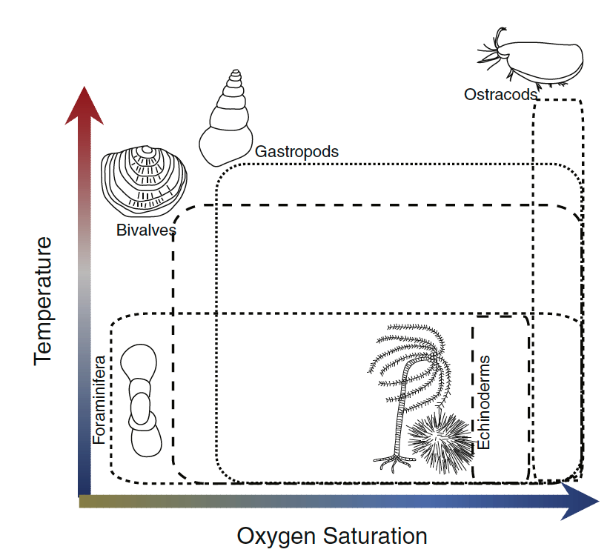

Fig. 2. A schematic for environmental tolerances of benthic marine invertebrates in the Early Triassic. Each clade’s box is plotted to demonstrate its relative range of oxygen and temperature tolerances. From Pietsch, Petsios, and Bottjer, 2016.

The evaluation of a taxon’s environmental tolerances through ordination techniques is well-utilized in Brett et al.’s Middle Devonian analysis of biofacies (2007). While in this study the turbulence and oxygen-level tolerance of taxa was used to infer sequence stratigraphic stages, as seen in Fig. 3, the same information could be used to interpret an extinction which selected against oxic and calm-water species, leaving the better-adapted dysoxic fauna. Some of these latter fossils for the Devonian include brachiopods (*Ambocoeliidae*, *Orbiculoidea*, and *Leiorhynchidae*), mollusks (bivalve families *Nuculidae* and *Praecardiidae*, Orthocerid nautiloids, and Goniatite ammonites), and coral order *Auloporida*. Common throughout the Devonian in deep sea environments, their occurrence in shallower basin formations through the will indicate the turbulent and anoxic environmental pressures we hypothesize for the land-plant weathering pulses. Using PBDB occurrences to monitor the abundance and origination/ extinction rates of these target taxa across basins, a second basis of faunal analysis will be possible.

Following within-Devonian analysis of taxonomic and ecological trends, the long-term analysis will utilize PBDB data for fossil occurrences in North America from the Givetian (Middle Devonian) to the Visean (Middle Mississippian). In order to test for a steady-state increased nutrient availability as hypothesized, we will organize the fossil data by community and environment and analyze the long-term trends in ecological proportions. We will test for increased tiering of communities and increasing proportions and diversities of high-energy modes of life, based on ecological classifications. For example, increased primary producer diversity following the LDME and increased abundance of complex organisms such as fish predators within shallow marine communities will suggest a secular increase in nutrient level

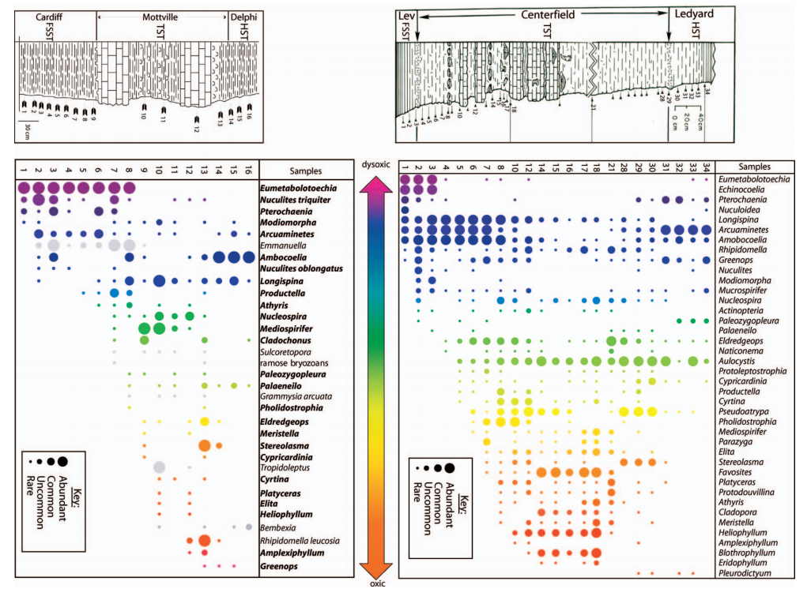

Fig. 3. A plot of relative abundances of different fossil species plotted against stratigraphic position during major third-order regressive cycles in the Hamilton Group. Colors of the fossil occurrences communicate relative tolerance of oxygen levels ranging from dysoxic to oxic, whereas the diameter of circles relates to the relative abundance of the species within that stratigraphic location. From Brett et al., 2007.

into the Late Paleozoic. Furthermore, while periods of environmental stress can depress origination rates (i.e. a mass depletion scenario as proposed by Bambach et al., 2004 for the LDME), increased trophic resources are proposed to have a positive correlation with origination rates (Cárdenas and Harries, 2010); we can thus track origination rates within clades and communities as a potential proxy for nutrient delivery trends. If necessary, analysis will continue through the Carboniferous: however, the Visean has been selected as an intermediate boundary following the LDME, so as not to introduce unnecessary confounding variables such as the dramatic pCO2 and climate changes which have a broad impact throughout the end of the Paleozoic.

Finally, we will test the accuracy of the PaleoDeepDive (PDD) system on our PBDB datasets, in order to replicate under different circumstances a similar study (Peters et al., 2014). PBDB, being derived from a synthesis of published literature, represents a human-compiled database that while comprehensive, is also the product of many hours of human labor. PDD is an exciting prospect for the automation of database compilations and the potential to expand upon our abilities to access data from publications. However, the system still requires calibration as it is developed. PDD will analyze the text of the publications which comprise our PBDB dataset, and seek to extract all marine invertebrate fossil occurrences and ecological characteristics for this time period and compare the results. From this test, we will measure the degree of similarity between the two datasets, and be able to pinpoint the flaws in the PDD’s sampling or conversely, discrepancies in the PBDB’s set.

**Expected Outcomes and Broader Impact**

Given the big-data approach to paleoecological evaluation the PBDB affords this study, a more definitive statistical assessment of community changes through the Devonian and the LDME is possible. The analyses will test the hypothesis that land-plant weathering was the main mechanism responsible for the pulses of extinction and subsequent anoxic events (Algeo et al., 1995), but no matter what support is found for the hypothesis, a quantitative appreciation for paleoecological dynamics during the Late Devonian will be gained. We expect to see selective extinction of anoxia- and eutrophic-sensitive ecotypes and taxa, contrasted with the rise and diversification of generalists and well-adapted organisms. Following the Devonian-Carboniferous boundary, we expect to see a great complexity of communities and increased energetic capacity in organisms, indicating a steady-state secular increase in marine nutrient levels due to stabilized terrestrial plant weathering regimes (Allmon and Martin, 2014).

Beyond deep time, this research project will provide an analog to modern-day processes of eutrophication and anoxia which are well-understood on the ecological time scale, but less understood on the geological time scale. In modern environments human land-use policies, agricultural practices, and artificial introduction of important bio-limiting nutrients such as nitrogen and phosphorus are widespread (Bennett, Carpenter, and Caraco, 2001). Conversely, deforestation and clearing practices threaten to destabilize the root systems on riparian and marine-marginal ecosystems, allowing for a greater erosion rate of organic-rich soils. While nutrient fluxes have been long hypothesized to be the cause behind eutrophication events and subsequent anoxic conditions, such as in the Black and Baltic Seas (Lyons et al., 1993), the long-term ecological impact needs to be better understood to influence policy-makers’ and conservation biologists’ approaches. In providing a geological-scale paleoecological evaluation of the effects of this continental influx, we can shed light on the long-term effects of modern-day practices and help provide context for the ramifications of eutrophic blooms today.

Finally, our project will provide the setting to replicate a test of PaleoDeepDive’s accuracy and functioning, furthering its calibration and development as a reliable Natural Language Processing system. Regardless of our findings, this comparison will yield improvements to PDD’s function and bring us closer to the automation of database construction from published literature.

**References**

Algeo, T. J., Berner, R. A., Maynard, J. B., & Scheckler, S. E. (1995). Late Devonian oceanic anoxic events and biotic crises:“rooted” in the evolution of vascular land plants. *GSA today*, *5*(3), 63-66.

Algeo, T. J., & Scheckler, S. E. (1998). Terrestrial-marine teleconnections in the Devonian: links between the evolution of land plants, weathering processes, and marine anoxic events. *Philosophical Transactions of the Royal Society of London B: Biological Sciences*, *353*(1365), 113-130.

Algeo, T. J., & Scheckler, S. E. (2010). Land plant evolution and weathering rate changes in the Devonian. *Journal of Earth Science*, *21*, 75.

Allmon, W. D., & Martin, R. E. (2014). Seafood through time revisited: the Phanerozoic increase in marine trophic resources and its macroevolutionary consequences. *Paleobiology*, *40*(2), 256-287.

Averbuch, O., Tribovillard, N., Devleeschouwer, X., Riquier, L., Mistiaen, B., & Vliet‐Lanoe, V. (2005). Mountain building‐enhanced continental weathering and organic carbon burial as major causes for climatic cooling at the Frasnian–Famennian boundary (c. 376 Ma)?. *Terra Nova*, *17*(1), 25-34.

Bambach, R. K., Knoll, A. H., & Wang, S. C. (2004). Origination, extinction, and mass depletions of marine diversity. *Paleobiology*, *30*(04), 522-542.

Bennett, E. M., Carpenter, S. R., & Caraco, N. F. (2001). Human impact on erodable phosphorus and eutrophication: a global perspective increasing accumulation of phosphorus in soil threatens rivers, lakes, and coastal oceans with eutrophication. *BioScience*, *51*(3), 227-234.

Berner, R. A. (1994). GEOCARB II: A revised model of atmospheric CO [sub 2] over phanerozoic time. *American Journal of Science;(United States)*,*294*(1).

Berner, R. A. (1997). The rise of plants and their effect on weathering and atmospheric CO2. *Science*, *276*(5312), 544.

Brett, C. E., Bartholomew, A. J., & Baird, G. C. (2007). Biofacies recurrence in the Middle Devonian of New York State: an example with implications for evolutionary paleoecology. *Palaios*, *22*(3), 306-324.

Boyce, C. K., & Lee, J. E. (2011). Could land plant evolution have fed the marine revolution?. *Paleontological research*, *15*(2), 100-105.

Cárdenas, A. L., & Harries, P. J. (2010). Effect of nutrient availability on marine origination rates throughout the Phanerozoic eon. *Nature Geoscience*, *3*(6), 430-434.

Cawley, J. L., Burruss, R. C., & Holland, H. D. (1969). Chemical weathering in central Iceland: an analog of pre-Silurian weathering. *Science*, *165*(3891), 391-392.

Copper, P. (1994). Ancient reef ecosystem expansion and collapse. *Coral reefs*, *13*(1), 3-11.

Davies, N. S., & Gibling, M. R. (2010). Cambrian to Devonian evolution of alluvial systems: the sedimentological impact of the earliest land plants. *Earth-Science Reviews*, *98*(3), 171-200.

Drever, J. I. (1994). The effect of land plants on weathering rates of silicate minerals. *Geochimica et Cosmochimica Acta*, *58*(10), 2325-2332.

Feakes, C. R., & Retallack, G. J. (1988). Recognition and chemical characterization of fossil soils developed on alluvium; a Late Ordovician example. *Geological Society of America Special Papers*, *216*, 35-48.

Gensel, P. G. (2008). The earliest land plants. *Annual Review of Ecology, Evolution, and Systematics*, 459-477

Goddéris, Y., & Joachimski, M. M. (2004). Global change in the Late Devonian: modelling the Frasnian–Famennian short-term carbon isotope excursions. *Palaeogeography, Palaeoclimatology, Palaeoecology*, *202*(3), 309-329.

Joachimski, M. M., & Buggisch, W. (2002). Conodont apatite δ18O signatures indicate climatic cooling as a trigger of the Late Devonian mass extinction. *Geology*, *30*(8), 711-714.

Lyons, M. G., Balls, P. W., & Turrell, W. R. (1993). A preliminary study of the relative importance of riverine nutrient inputs to the Scottish North Sea Coastal Zone. *Marine pollution bulletin*, *26*(11), 620-628.

McGhee, G. R. (1996). *The late Devonian mass extinction: the Frasnian/Famennian crisis*. Columbia

University Press.

Murphy, A. E., Sageman, B. B., & Hollander, D. J. (2000). Eutrophication by decoupling of the marine biogeochemical cycles of C, N, and P: a mechanism for the Late Devonian mass extinction. *Geology*, *28*(5), 427-430.

Peters, S. E., Zhang, C., Livny, M., & Ré, C. (2014). A machine reading system for assembling synthetic paleontological databases. *PloS one*, *9*(12), e113523.

Pietsch, C., Petsios, E., & Bottjer, D. J. (2016). Sudden and extreme hyperthermals, low-oxygen, and sediment influx drove community phase shifts following the end-Permian mass extinction. *Palaeogeography, Palaeoclimatology, Palaeoecology*.

Racki, G. (2005). Toward understanding Late Devonian global events: few answers, many questions. *Developments in Palaeontology and Stratigraphy*,*20*, 5-36.

Retallack, G. J., Catt, J. A., & Chaloner, W. G. (1985). Fossil Soils as Grounds for Interpreting the Advent of Large Plants and Animals on Land [and Discussion]. *Philosophical Transactions of the Royal Society of London B: Biological Sciences*, *309*(1138), 105-142.

Riquier, L., Tribovillard, N., Averbuch, O., Devleeschouwer, X., & Riboulleau, A. (2006). The Late Frasnian Kellwasser horizons of the Harz Mountains (Germany): two oxygen-deficient periods resulting from different mechanisms. *Chemical Geology*, *233*(1), 137-155.

Śliwiński, M. G., Whalen, M. T., Meyer, F. J., & Majs, F. (2012). Constraining clastic input controls on magnetic susceptibility and trace element anomalies during the Late Devonian punctata Event in the Western Canada Sedimentary Basin. *Terra Nova*, *24*(4), 301-309.

Song, H., Wignall, P. B., Chu, D., Tong, J., Sun, Y., Song, H., ... & Tian, L. (2014). Anoxia/high temperature double whammy during the Permian-Triassic marine crisis and its aftermath. *Scientific reports*, *4*.

Stigall, A. L. (2012). Speciation collapse and invasive species dynamics during the Late Devonian “Mass Extinction”. *GSA Today*, *22*(1), 4-9.

Taylor, E. L., Taylor, T. N., & Krings, M. (2009). *Paleobotany: the biology and evolution of fossil plants*. Academic Press.

Twitchett, R. J. (1999). Palaeoenvironments and faunal recovery after the end-Permian mass extinction. *Palaeogeography, Palaeoclimatology, Palaeoecology*, *154*(1), 27-37.

Van Geldern, R., Joachimski, M. M., Day, J., Jansen, U., Alvarez, F., Yolkin, E. A., & Ma, X. P. (2006). Carbon, oxygen and strontium isotope records of Devonian brachiopod shell calcite. *Palaeogeography, Palaeoclimatology, Palaeoecology*, *240*(1), 47-67.

Whalen, M. T., Śliwiński, M. G., Payne, J. H., Day, J. E. J., Chen, D., & Da Silva, A. C. (2015). Chemostratigraphy and magnetic susceptibility of the Late Devonian Frasnian–Famennian transition in western Canada and southern China: implications for carbon and nutrient cycling and mass extinction. *Geological Society, London, Special Publications*, *414*(1), 37-72.