Tender_PI Instructions

Installation
Tender_PI installs like a standard OpenCPN PlugIn..

Requirements:

OpenCPN Version 4.4.0 or later.

http://opencpn.navnux.org/4.4.0/opencpn_4.4.0_setup.exe

HowTo Use

Start OpenCPN normally. To use the tender_pi, be sure that the serial port to be used for the remote radio modem is NOT enabled in options(wrench)->Connections.. This port is controlled exclusively by the PlugIn.

First task is to enable the Tender_PI PlugIn.
Start OpenCPN, go to options tool(Wrench), select PlugIns, and “Enable” the tender_pi PlugIn.

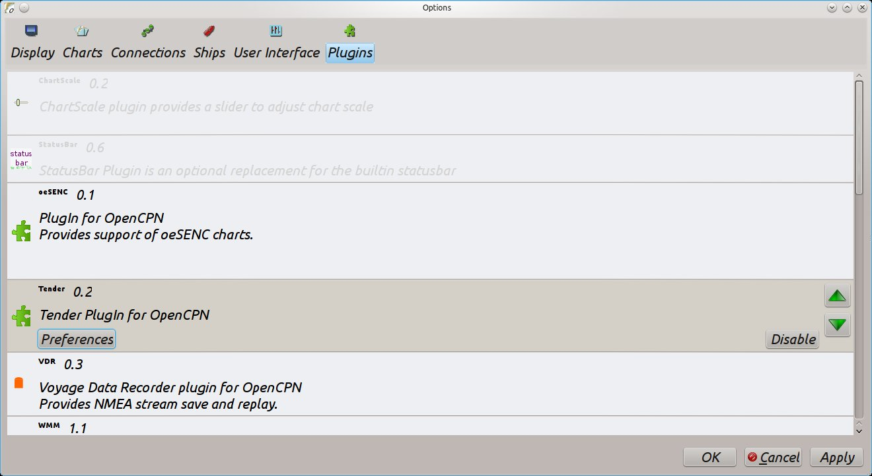

Next, create an OpenCPN waypoint which will be tracked dynamically as the barge position moves. Choose with a memorable name. Here I create a waypoint with the name “BargeTrack1”. Use range rings for the waypoint if you like.

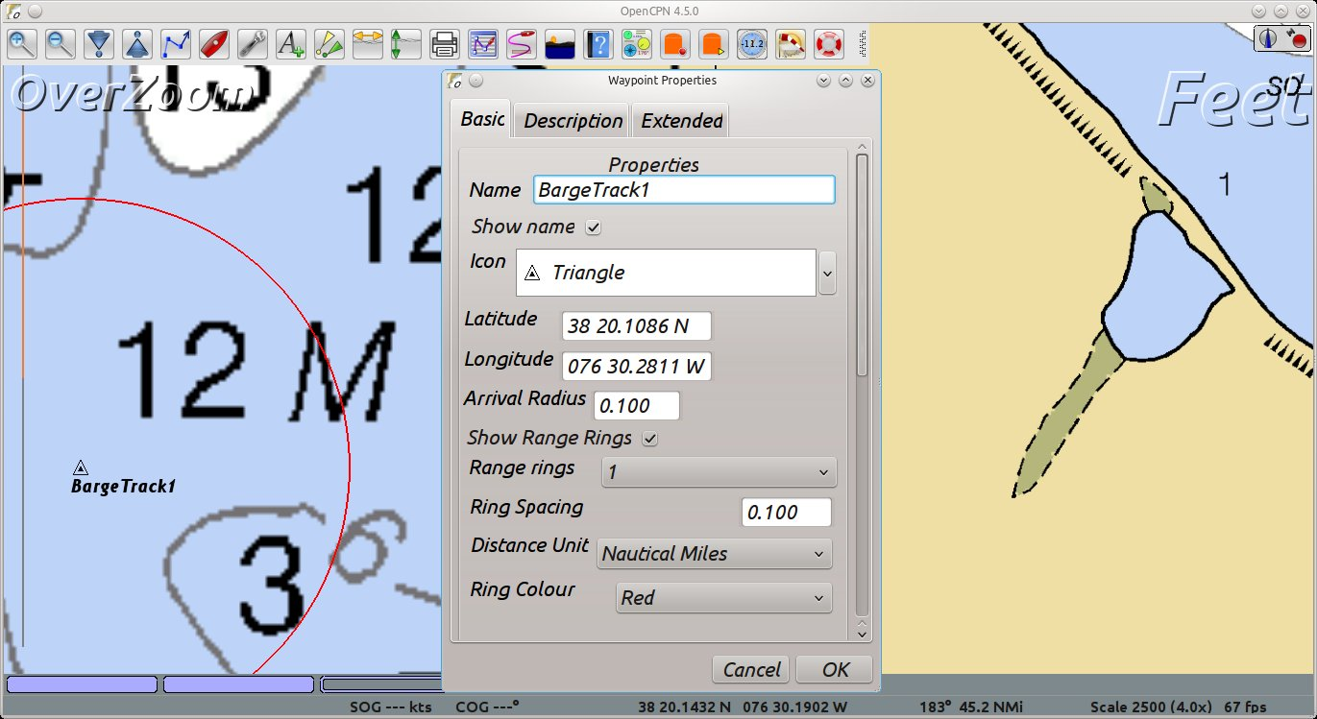

Next task is to set the tracked tender parameters, and choose the waypoint for continuous tracking. Go to toolbar options(Wrench), select PlugIns->Tender PlugIn->Preferences.

Set the serial port on which the barge radio modem is connected.
Set the barge parameters (length, width, GPS offset).
Select the tracked waypoint (by name) in the drop-down box.

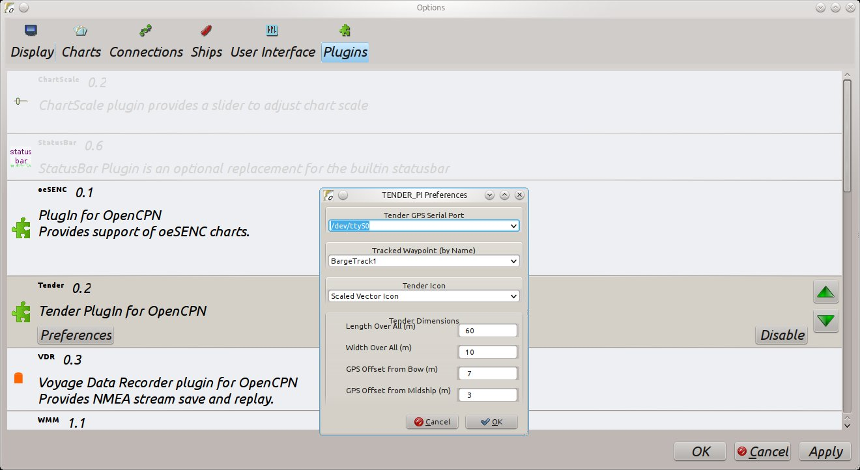

At this point, if the barge radio modem is active, you should see the barge icon rendered at its present location. When the mouse is positioned near the tracked waypoint, a popup message will show the present bearing and range of the barge to that waypoint.

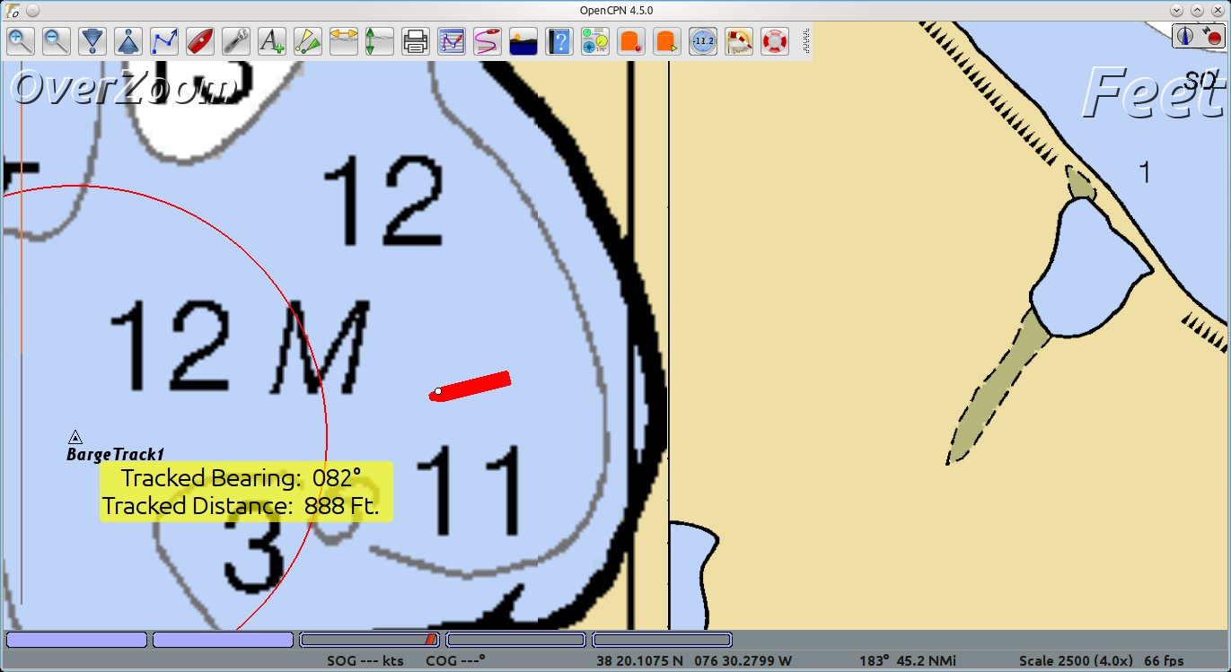

Good Luck
Dave Register

bdbcat@yahoo.com

