**Appendix A. Literature search and screening**

We searched the databases Google Scholar, Web of Science, Figshare, Mendeley, Luquillo Long Term Ecological Research, and Luquillo Critical Zone Observatory between January 10 and July 10 2020 to encompass studies and data sets published between 1970 and 2020. For each included published article, we examined reference lists and performed a citation search using Google Scholar. Search results were restricted to those written in English, Spanish, Portuguese and French. Papers were selected for inclusion by the first author. Our search terms were: Tropical forest* AND (Wind* OR cyclone OR hurricane OR typhoon) AND (recovery OR succession OR dynamics OR resilience OR stability OR productivity) AND (litterfall OR litter OR litter production OR litter deposition) AND (nutrient OR nitrogen OR phosphorus OR stoichiometry OR biogeochemistry OR nutrient cycling). Article and review papers were included in the initial selection, which was refined to exclude studies in fields that are unrelated to Environmental topics.

We retrieved 2341 published articles from the primary searches (Figure 2). A total of 274 published articles were assessed at full-text length, and 27 representing 73 case studies were kept in this systematic map (Figure A1; Table A1 for publications excluded at this stage and the reasons for exclusion). The remainder of the systematic map is primarily grounded on the 27 publications that were kept, which are included in the systematic map database (Appendix B). The analyses were conducted at case-study level (n = 73), which we considered most relevant for each addressed research question (James et al., 2016). Each case study represents a unique combination of cyclone, site and treatment (Table 1), and has a unique effect size ID (Appendix B).

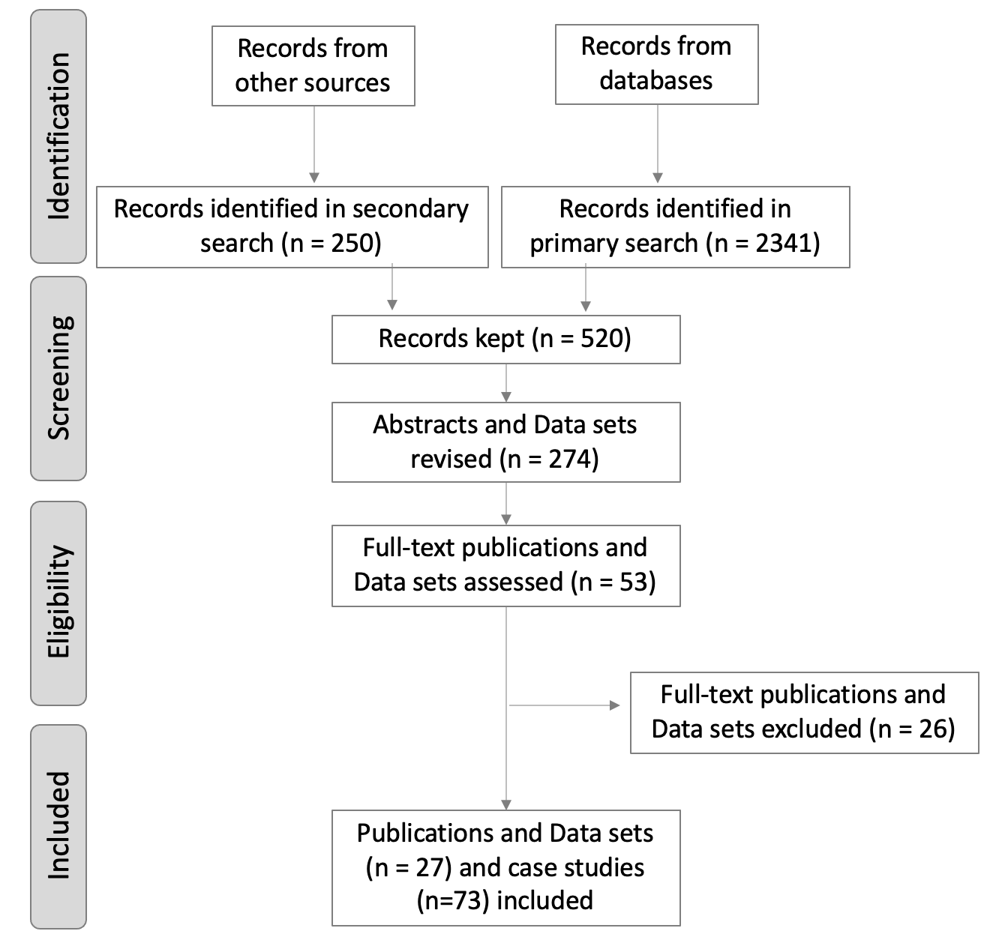

**Figure A1.** Flow of information through the phases of a systematic review. Adapted from (Moher et al., 2009).

**Table A1.** Published articles excluded and reasons for exclusion.

|  |  |  |  |
| --- | --- | --- | --- |
| **N** | **Study citation** | **Region** | **Reason for exclusion** |
| **1** | Mitchell (2013) | Global | Review paper did not report litterfall mass or nutrient data. |
| **2** | Vesk & Westoby (2004) | Global | Results focused on plant sprouting after several disturbances including wind throw. |
| **3** | Cornelissen et al. (2003) | Global | Article focused on protocol for plant trait measurements in response to disturbance and environmental change. |
| **4** | Liu et al. (2018) | Caribbean | Results focused on Canopy Trimming Experiment effects on soil organic carbon. |
| **5** | Scatena et al. (1993) | Caribbean | Reported results on stocks not fluxes or nutrient concentrations. |
| **6** | Shiels & González (2014) | Caribbean | Reported results on nutrient concentration and stocks in the debris added to the soil in the Canopy Trimming Experiment. |
| **7** | Shiels et al. (2014) | Caribbean | Synthesis of the Canopy Trimming Experiment. |
| **8** | Cantrell et al. (2014) | Caribbean | Results focused on responses of forest floor microbial communities to the Canopy Trimming Experiment. |
| **9** | Lodge et al. (2014) | Caribbean | Results focused on phosphorus movement and mass loss in the Canopy Trimming Experiment. |
| **10** | Frangi & Lugo (1991) | Caribbean | Results focused on hurricane impacts on trees and aboveground nutrient stocks. |
| **11** | Steudler et al. (1991) | Caribbean | Results focused on the responses of soil nitrogen and trace gas fluxes to disturbance. |
| **12** | Frangi & Lugo (1998) | Caribbean | Results focused on trees and changes in aboveground biomass. |
| **13** | McDowell et al. (1992) | Caribbean | Results focused on riparian nitrogen dynamics. |
| **14** | Cusack et al. (2009) | Caribbean | Study included litterfall rates but not associated with a cyclone disturbance. |
| **15** | Cusack et al. (2016) | Caribbean | Results focused on soil base cation responses to nitrogen additions. |
| **16** | Heartsill Scalley et al. (2010) | Caribbean | Results focused on changes in tree biomass and floristic composition. |
| **17** | McDowell (2015) | Caribbean | Data set includes Icacos litter stock data. |
| **18** | Lin et al. (2003) | Taiwan | The study site, Fushan, is located outside the tropical region. |
| **19** | Vogt et al. (1996) | Caribbean | Study included litterfall data for sites and hurricane already compiled in the meta-analysis. |
| **20** | Sullivan et al. (1999) | Caribbean | Results focused on litter decomposition and nitrogen dynamics by species as affected by a hurricane. |
| **21** | Lugo et al. (1999) | Caribbean | Study focused on a secondary forest not associated with a hurricane. |
| **22** | Vargas et al. (2010) | Mexico | Study focused on tree aboveground changes after a hurricane. |
| **23** | Chen et al. (2009) | China | Study conducted in non-native tree plantation. |
| **24** | McDonald & Healey (2000) | Jamaica | Study conducted four years after the last recorded hurricane. |

Whenever the published article or data set did not include a pre-disturbance value, a search for published articles and datasets that pre-date the cyclone disturbance was conducted. For instance, the pre-disturbance litterfall data for Milolii, Makaha 1, Halemanu, and Kumuwela sites in Hawaii were obtained from (Scowcroft, 1986). Also, pre-disturbance means and standard deviations for the same site may differ between studies as they reflect a particular patch of forest where the baskets were deployed, and the forest successional status when they were measured.

**References**

Cantrell, S. A., Molina, M., Jean Lodge, D., Rivera-Figueroa, F. J., Ortiz-Hernández, M. L., Marchetti, A. A., Cyterski, M. J., & Pérez-Jiménez, J. R. (2014). Effects of a simulated hurricane disturbance on forest floor microbial communities. *Forest Ecology and Management*, *332*, 22–31. https://doi.org/10.1016/j.foreco.2014.07.010

Chen, L., Zan, Q., Li, M., Shen, J., & Liao, W. (2009). Litter dynamics and forest structure of the introduced Sonneratia caseolaris mangrove forest in Shenzhen, China. *Estuarine, Coastal and Shelf Science*, *85*(2), 241–246. https://doi.org/10.1016/j.ecss.2009.08.007

Cornelissen, J. H. C., Lavorel, S., Garnier, E., Díaz, S., Buchmann, N., Gurvich, D. E., Reich, P. B., Steege, H. ter, Morgan, H. D., Heijden, M. G. A. van der, Pausas, J. G., & Poorter, H. (2003). A handbook of protocols for standardised and easy measurement of plant functional traits worldwide. *Australian Journal of Botany*, *51*(4), 335. https://doi.org/10.1071/BT02124

Cusack, D. F., Chou, W. W., Yang, W. H., Harmon, M. E., Silver, W. L., & The lidet Team. (2009). Controls on long-term root and leaf litter decomposition in neotropical forests. *Global Change Biology*, *15*(5), 1339–1355. https://doi.org/10.1111/j.1365-2486.2008.01781.x

Cusack, D. F., Macy, J., & McDowell, W. H. (2016). Nitrogen additions mobilize soil base cations in two tropical forests. *Biogeochemistry*, *128*(1), 67–88. https://doi.org/10.1007/s10533-016-0195-7

Frangi, J. L., & Lugo, A. E. (1991). Hurricane Damage to a Flood Plain Forest in the Luquillo Mountains of Puerto Rico. *Biotropica*, *23*(4), 324–335. JSTOR. https://doi.org/10.2307/2388248

Frangi, J. L., & Lugo, A. E. (1998). A Flood Plain Palm Forest in the Luquillo Mountains of Puerto Rico Five Years After Hurricane Hugo1. *Biotropica*, *30*(3), 339–348. https://doi.org/10.1111/j.1744-7429.1998.tb00069.x

Heartsill Scalley, T., Scatena, F. N., Lugo, A. E., Moya, S., & Estrada Ruiz, C. R. (2010). Changes in Structure, Composition, and Nutrients During 15 Yr of Hurricane-Induced Succession in a Subtropical Wet Forest in Puerto Rico: Composition and Nutrients During 15 yr. *Biotropica*, *42*(4), 455–463. https://doi.org/10.1111/j.1744-7429.2009.00609.x

Lin, K.-C., Hamburg, S. P., Tang, S., Hsia, Y.-J., & Lin, T.-C. (2003). Typhoon effects on litterfall in a subtropical forest. *Canadian Journal of Forest Research*, *33*(11), 2184–2192. https://doi.org/10.1139/x03-154

Liu, X., Zeng, X., Zou, X., Lodge, D., Stankavich, S., González, G., & Cantrell, S. (2018). Responses of Soil Labile Organic Carbon to a Simulated Hurricane Disturbance in a Tropical Wet Forest. *Forests*, *9*(7), 420. https://doi.org/10.3390/f9070420

Lodge, D. J., Cantrell, S. A., & González, G. (2014). Effects of canopy opening and debris deposition on fungal connectivity, phosphorus movement between litter cohorts and mass loss. *Forest Ecology and Management*, *332*, 11–21. https://doi.org/10.1016/j.foreco.2014.03.002

Lugo, A. E., Cristóbal, C. D., Santos, A., & Morales, E. T. (1999). Nutrient Return and Accumulation in Litter of a Secondary Forest in the Coffee Region of Puerto Rico. *Acta Científica*, *13*(1–3), 43–74.

McDonald, M. A., & Healey, J. R. (2000). Nutrient cycling in secondary forests in the Blue Mountains of Jamaica. *Forest Ecology and Management*, *139*(1), 257–278. https://doi.org/10.1016/S0378-1127(00)00442-4

McDowell, W. H. (2015). *Coarse Woody Debris in Bisley Experimental Forest and the Rio Icacos Basin* [Data set]. Environmental Data Initiative. https://doi.org/10.6073/PASTA/C0A7ABCBD347093A51E9581FED616858

McDowell, W. H., Bowden, W. B., & Asbury, C. E. (1992). Riparian nitrogen dynamics in two geomorphologically distinct tropical rain forest watersheds: Subsurface solute patterns. *Biogeochemistry*, *18*(2), 53–75. https://doi.org/10.1007/BF00002703

Mitchell, S. J. (2013). Wind as a natural disturbance agent in forests: A synthesis. *Forestry: An International Journal of Forest Research*, *86*(2), 147–157. https://doi.org/10.1093/forestry/cps058

Scatena, F. N., Silver, W., Siccama, T., Johnson, A., & Sanchez, M. J. (1993). Biomass and Nutrient Content of the Bisley Experimental Watersheds, Luquillo Experimental Forest, Puerto Rico, Before and After Hurricane Hugo, 1989. *Biotropica*, *25*(1), 15. https://doi.org/10.2307/2388975

Shiels, A. B., & González, G. (2014). Understanding the key mechanisms of tropical forest responses to canopy loss and biomass deposition from experimental hurricane effects. *Tropical Forest Responses to Large-Scale Experimental Hurricane Effects*, *332*, 1–10. https://doi.org/10.1016/j.foreco.2014.04.024

Shiels, A. B., González, G., & Willig, M. R. (2014). Responses to canopy loss and debris deposition in a tropical forest ecosystem: Synthesis from an experimental manipulation simulating effects of hurricane disturbance. *Tropical Forest Responses to Large-Scale Experimental Hurricane Effects*, *332*, 124–133. https://doi.org/10.1016/j.foreco.2014.08.005

Steudler, P. A., Melillo, J. M., Bowden, R. D., Castro, M. S., & Lugo, A. E. (1991). The Effects of Natural and Human Disturbances on Soil Nitrogen Dynamics and Trace Gas Fluxes in a Puerto Rican Wet Forest. *Biotropica*, *23*(4), 356–363. JSTOR. https://doi.org/10.2307/2388252

Sullivan, N. H., Bowden, W. B., & McDowell, W. H. (1999). Short-Term Disappearance of Foliar Litter in Three Species before and after a Hurricane. *Biotropica*, *31*(3), 382–393. JSTOR. http://www.jstor.org/stable/2663933

Vargas, R., Hasselquist, N., Allen, E. B., & Allen, M. F. (2010). Effects of a Hurricane Disturbance on Aboveground Forest Structure, Arbuscular Mycorrhizae and Belowground Carbon in a Restored Tropical Forest. *Ecosystems*, *13*(1), 118–128. https://doi.org/10.1007/s10021-009-9305-x

Vesk, P. A., & Westoby, M. (2004). Sprouting ability across diverse disturbances and vegetation types worldwide. *Journal of Ecology*, *92*(2), 310–320. https://doi.org/10.1111/j.0022-0477.2004.00871.x

Vogt, K. A., Vogt, D. J., Boon, P., Covich, A., Scatena, F. N., Asbjornsen, H., O’Harra, J. L., Perez, J., Siccama, T. g., Bloomfield, J., & Ranciato, J. F. (1996). Litter Dynamics Along Stream, Riparian and Upslope Areas Following Hurricane Hugo, Luquillo Experimental Forest, Puerto Rico. *Biotropica*, *28*(4), 458–470. JSTOR. https://doi.org/10.2307/2389088