GEOSPATIAL ASSESSMENT | KHU-01 | 2024-04-01
Batiaghata Union Coastal Cropland
Baseline Report
Batiaghata, Khulna · Centroid 22.7301°N, 89.4921°E

Report ID | BA-2020-20260817-2D1AD6
Prepared by | BDCrops AgroVision™
Acquisition | 2024-04-01 · SENTINELHUB · cloud <5%
Generated | 2026-08-17
Status | QA PASS | Production Tier | CONFIDENTIAL

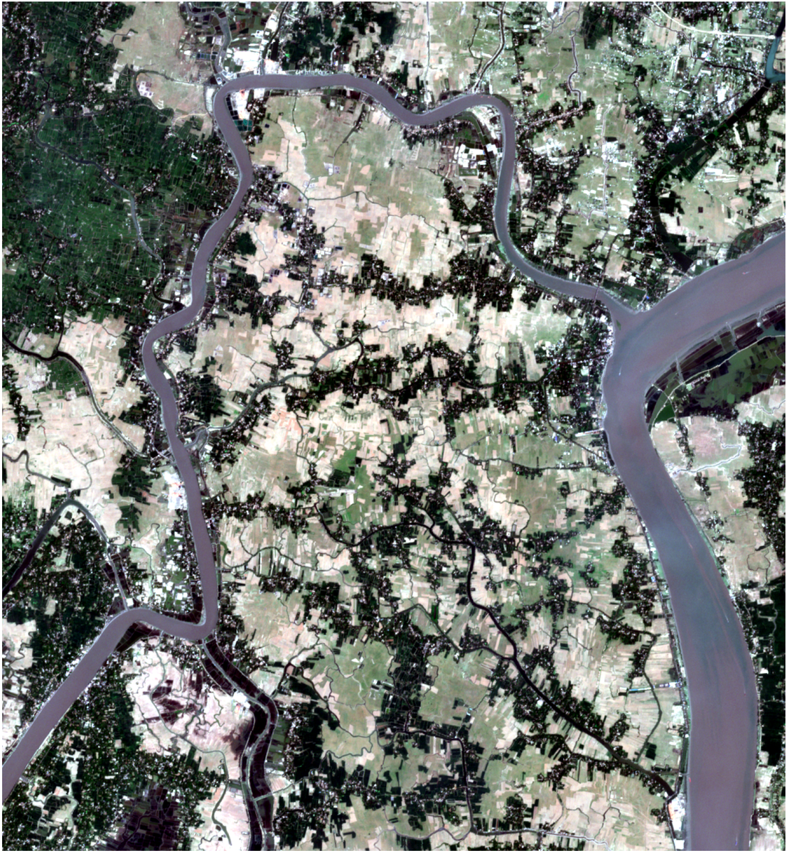
True-colour composite (Sentinel-2 L2A) — Batiaghata Union Coastal Cropland, Khulna — 2024-04-01
AOI | Cloud | Resolution | QA Status
KHU-01 | <5% | 10.0 m | PASS

Scene acquired 2024-04-01 via SENTINELHUB. over Batiaghata Union Coastal Cropland (Batiaghata, Khulna).

1. Report Specifications
AOI / Topic | Batiaghata Union Coastal Cropland | Date | 2024-04-01
AOI Code | KHU-01 | AOI ID | AOI_KH01
Centroid | 22.7301°N, 89.4921°E | AOI Bounds | 89.442147, 22.680075, / 89.542147, 22.780075
EPSG | 4326 | Source File | AOI_Khulna_L2.kmz
Provider | SENTINELHUB (production) | Cloud | <5%
Source Resolution | 10 m | Bands | —
Analysis Resolution | 10.0 m | QA Status | ■ PASS (Production Tier)
Report ID | BA-2020-20260817-2D1AD6

1.1 AOI Footprint Summary
Bounding Box (WGS84) | minLon 89.442147, minLat 22.680075 / maxLon 89.542147, maxLat 22.780075
Centroid (lat, lon) | 22.7301°N, 89.4921°E
CRS / EPSG | EPSG:4326
Source | AOI_Khulna_L2.kmz

1.2 Executive Summary
• Scene Sentinel-2 L2A acquired 2024-04-01 via SENTINELHUB, cloud <5%, QA PASS.
• Dominant land cover: Agriculture 42.2%, Vegetation 22.0%, Fallow 16.6%.
• Detailed analytics for water, LULC, change detection, drainage, soil carbon, and crop residue follow on subsequent pages.

2. Compliance Matrix
Verifies scene-level compliance with thresholds — resolution, cloud cover, projection, bit depth, band availability and orthorectification. PASS indicates all minimum requirements met.
Tier | Status | Resolution | Cloud | Bands | Projection
FAIL | ■ PASS | 10.0 m | <5% | 0 | EPSG:4326

# | Check | Threshold | Actual | Status
1 | Cloud Cover | ≤ 5 % | <5% | PASS
2 | Resolution (spectral preferred) | ≤ 10 m | 10.0 m | PASS
3 | Resolution (multispectral preferred) | ≤ 1.5 m | 10.0 m | FAIL
4 | Bands acquired | 4 required (Blue, Green, Red, NIR) | 0 acquired | FAIL
5 | Projection | EPSG:4326 / UTM | EPSG:4326 | PASS
6 | Bit Depth | 16-bit | 16-bit | PASS
7 | Orthorectified | Required | Yes | PASS
8 | QA Overall | PASS | PASS | PASS

3. Spectral Indices
Per-pixel ratios of satellite bands that highlight specific land conditions: vegetation health (NDVI / EVI / SAVI / NDRE), surface water (NDWI / MNDWI), and tillage / residue proxies. Each index is summarised over the valid (non-cloud) pixel area.
NDVI | NDWI | NDBI | EVI | SAVI | NBR
0.367 | -0.361 | -0.087 | 0.270 | 0.240 | 0.237

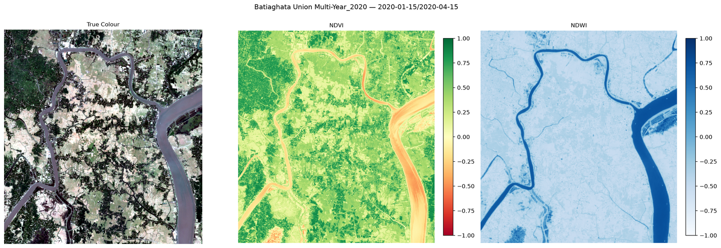
Spectral indices dashboard — NDVI, NDWI, EVI, SAVI
Index | Mean | Std Dev | Min | Max
NDVI | 0.3672 | 0.2803 | -0.7448 | 0.8953
NDWI | -0.3609 | 0.2522 | -0.8205 | 0.7782
NDBI | -0.0874 | 0.1994 | -0.7430 | 0.7603
EVI | 0.2700 | 0.1928 | -0.1559 | 1.0000
SAVI | 0.2404 | 0.1679 | -0.1442 | 0.7116
NBR | 0.2370 | 0.2239 | -0.7224 | 0.8197
MNDWI | -0.2947 | 0.3201 | -0.7074 | 0.7739
NBR2 | 0.1619 | 0.0728 | -0.1513 | 0.3914

4. Water & Waterlogging Analysis
Detects open water and inundated cropland using NDWI (Green / NIR) and MNDWI (Green / SWIR) spectral indices. Permanent Water = pixels consistently water-covered. Flood Risk = low-lying areas with elevated water signatures relative to dry-season baseline.
Permanent Water | Flood Risk | Enhanced Water | MNDWI Used
2.43% | 8.49% | 9.22% | Yes

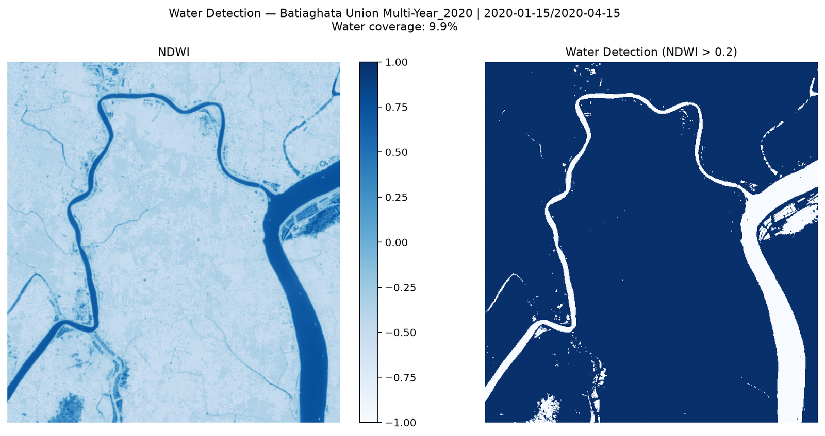  Water Detection Map | 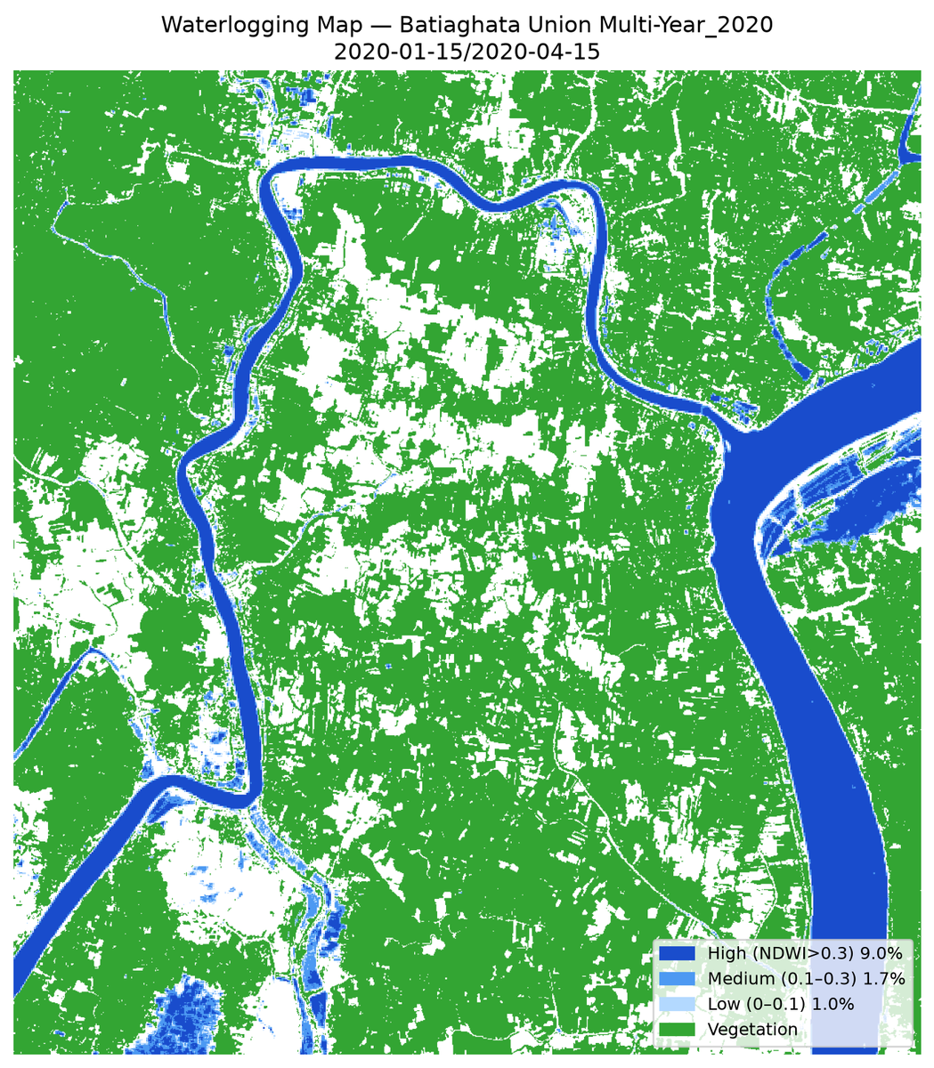  Waterlogging Risk Map

Metric | Value
Permanent Water (NDWI > 0.3) | 2.43%
Flood Risk Zone | 8.49%
Enhanced Water (MNDWI / fused) | 9.22%
MNDWI Index Available | Yes

5. Land Use / Land Cover (LULC)
Pixel-level classification of the AOI into thematic classes (water, vegetation, agriculture, bare soil, fallow). Built from spectral signatures using the available band stack; SWIR-required Built-up class merges into Bare Soil when SWIR is unavailable.
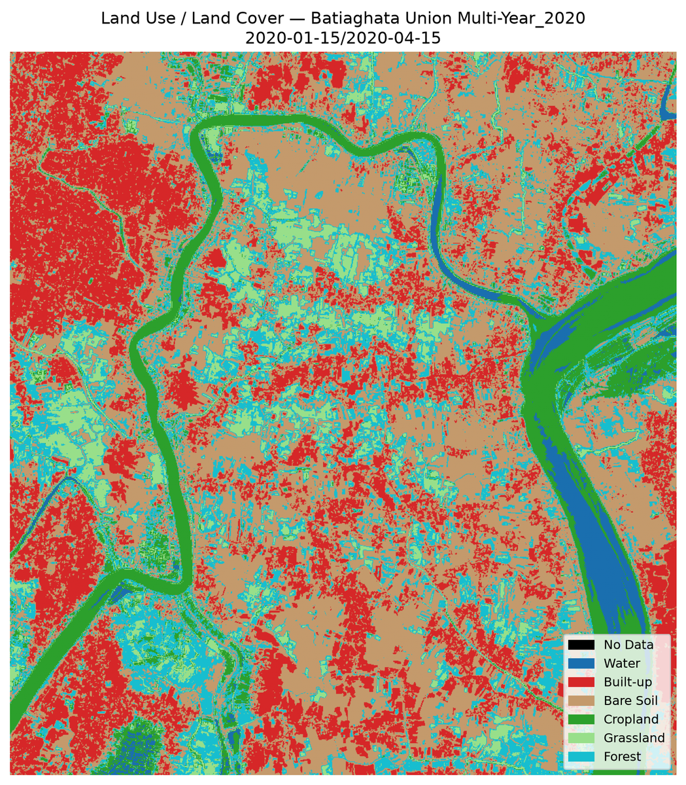
LULC Classification Map
Swatch | Class | Area % | Hex
■ | Water | 2.43% | #1F77B4
■ | Vegetation | 22.00% | #2CA02C
■ | Agriculture | 42.19% | #FFEB3B
■ | BareSoil | 9.99% | #8C564B
■ | BuiltUp | 6.83% | #D62728
■ | Fallow | 16.57% | #9467BD

6. Change Detection
Compares NDVI between two acquisition dates to quantify vegetation gain, loss and stability. Synthetic-baseline mode flags single-date runs where no real prior-date scene was supplied — results are indicative only.
Mode | Gain | Loss | Stable | Mean Δ
Synthetic (single date) | 31.54% | 12.66% | 55.80% | 0.0672

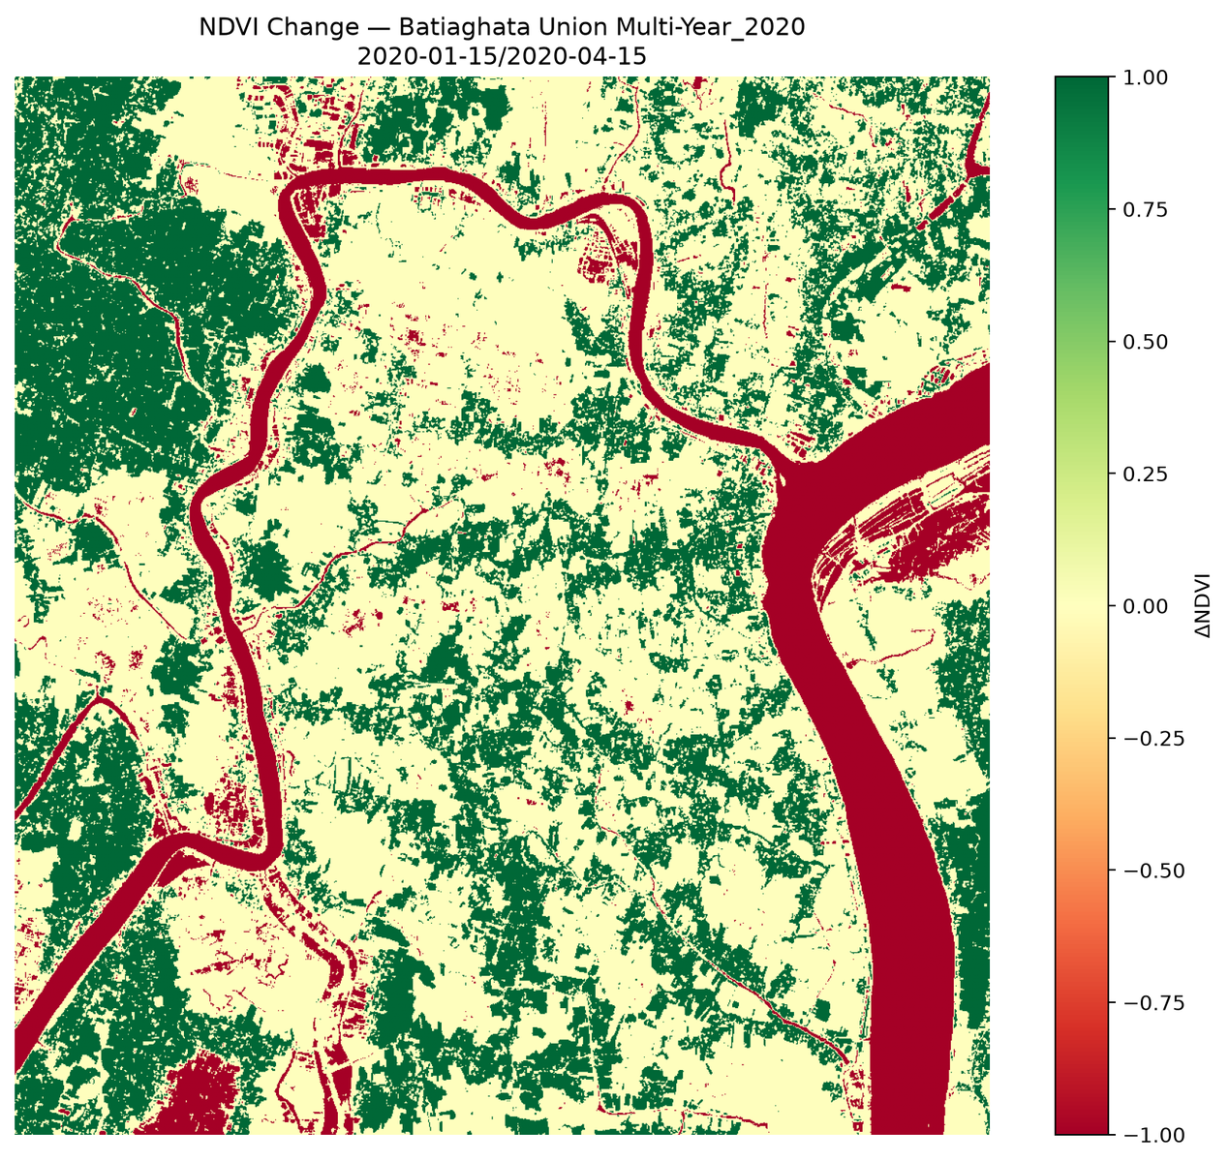
NDVI Change Map
Mode | Gain % | Loss % | Stable % | Mean Δ | Gain Thresh | Loss Thresh | Synthetic Baseline
Synthetic (single date) | 31.54% | 12.66% | 55.80% | 0.0672 | 0.200 | 0.200 | 0.3

Synthetic baseline used — no dual-date imagery provided; results are indicative only.

7. Drainage Analysis
Identifies areas of persistent surface-water accumulation that indicate poor drainage. Congestion score combines NDWI persistence with terrain proxies; full Topographic Wetness Index requires a DEM.
Congestion % | Persistence | Threshold | TWI Used
9.87% | 0.080 | — | No

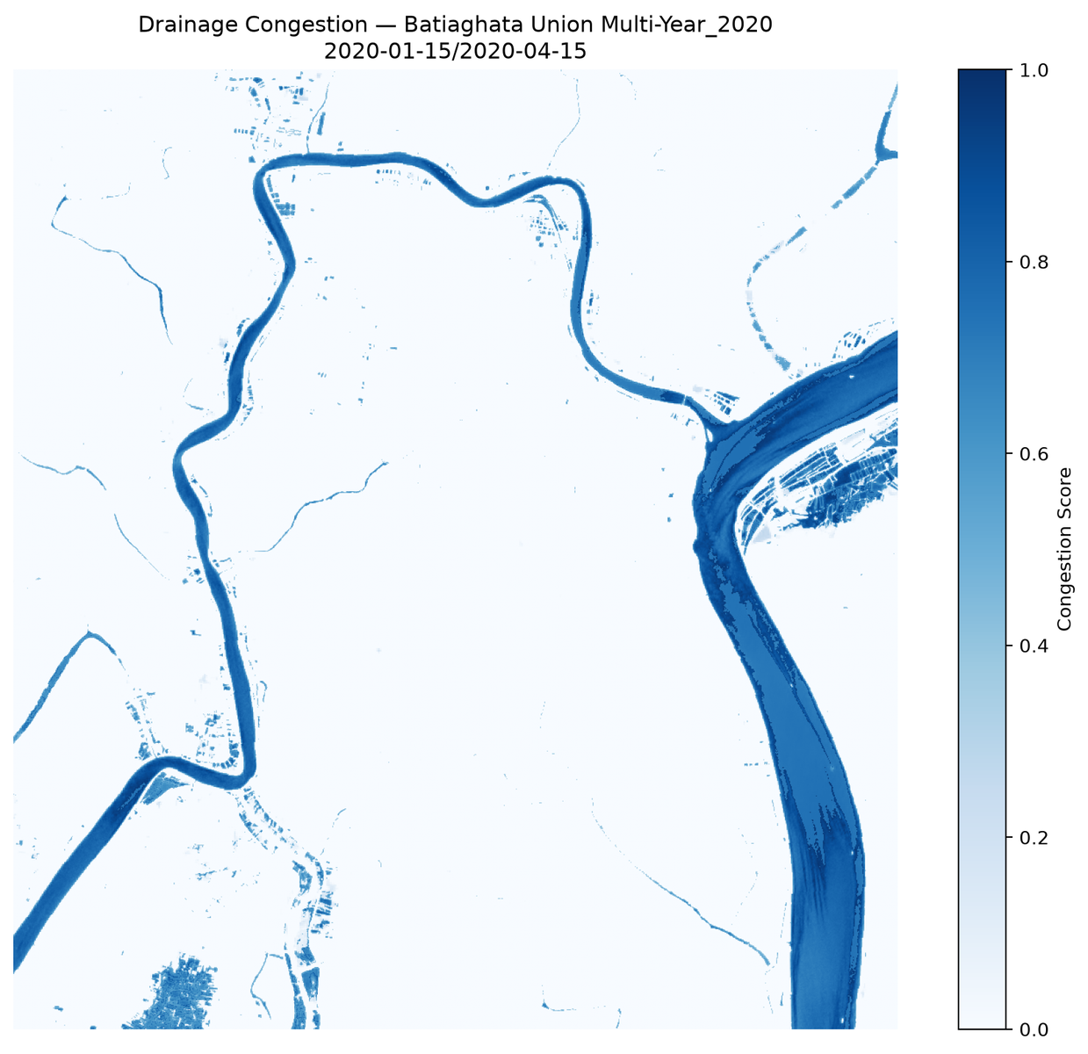
Drainage congestion map — blues scale, persistence proxy (no DEM)
Zone | Class | Congestion % | Persistence | Pixels
LULC | Water | 99.05% | 0.707 | 27702
LULC | Vegetation | 0.00% | 0.000 | 251178
LULC | Agriculture | 0.00% | 0.000 | 481744
LULC | BareSoil | 72.53% | 0.595 | 114102
LULC | BuiltUp | 2.98% | 0.043 | 77993
LULC | Fallow | 8.00% | 0.003 | 189219

No DEM supplied — TWI deferred; congestion score uses persistence-only weighting.

8. Soil Organic Carbon
Estimates Soil Organic Carbon content (g/kg) over bare-soil pixels via regional spectral calibration. Regional mode uses a fixed national/regional model; field mode would use ground-truth samples.
SOC Mean | SOC Std | Uncertainty | Bare-soil | Mode
26.24 g/kg | 7.00 g/kg | — | 351821 | regional

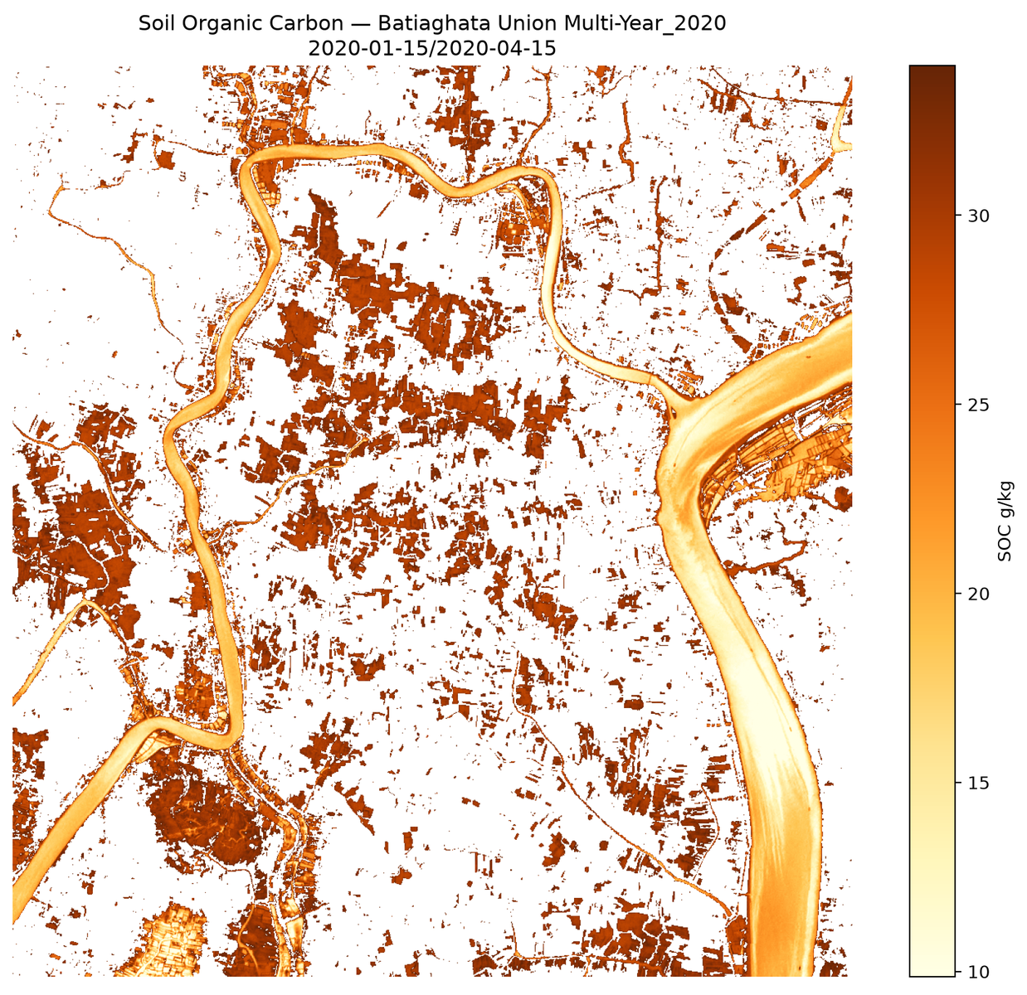
Soil Organic Carbon Density Map
Zone | Class | SOC Mean (g/kg) | SOC Std (g/kg) | Calib Mode | R²
ALL_BARE | bare_soil | 26.244 | 7.004 | regional | —
LULC | Water | 11.658 | 2.770 | regional | —
LULC | BareSoil | 21.233 | 4.798 | regional | —
LULC | BuiltUp | 28.739 | 2.254 | regional | —
LULC | Fallow | 32.162 | 1.087 | regional | —

9. Crop Residue
Estimates fractional residue cover over agricultural pixels. NIR/Red ratio is used as a proxy when SWIR bands are unavailable; high-accuracy NDTI / STI requires SWIR (Sentinel-2 B11 / B12 or Landsat-9).
Index Used | Mean Cover | High Cover >30% | Valid Pixels
NDTI | 40.49% | 70.36% | 1,141,938

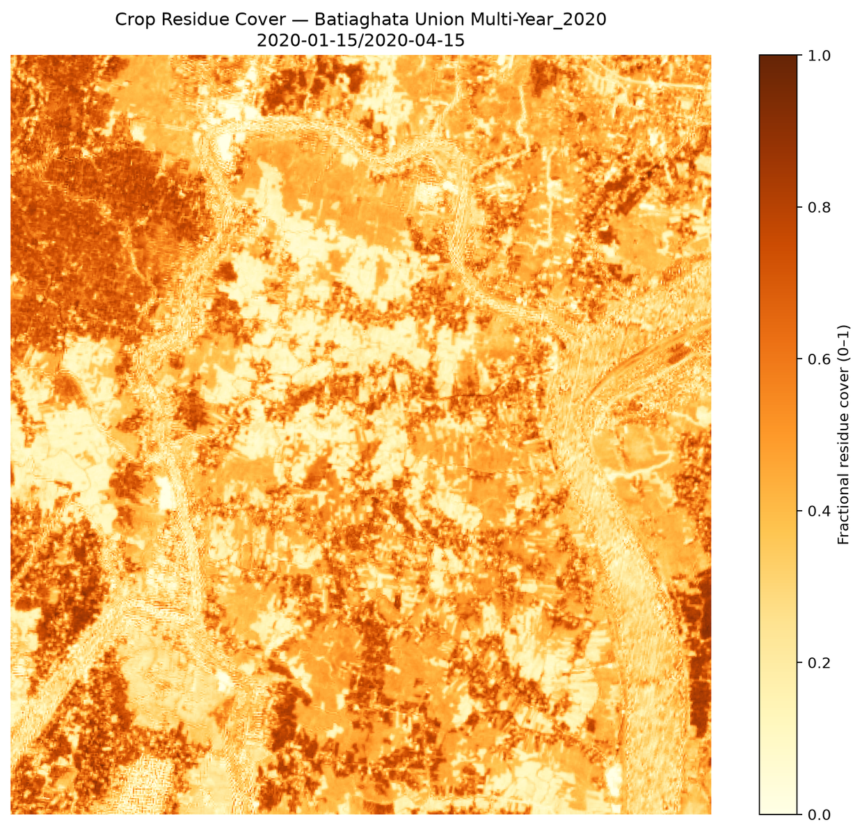
Crop Residue Cover Map
Zone | Class | Mean Residue Cover | High Cover % | Valid Pixels | Index Used
ALL | all_valid | 0.4049 | 70.36% | 1,141,938 | NDTI
LULC | Water | 0.2727 | 36.90% | 27,702 | NDTI
LULC | Vegetation | 0.6452 | 99.79% | 251,178 | NDTI
LULC | Agriculture | 0.4182 | 90.35% | 481,744 | NDTI
LULC | BareSoil | 0.2842 | 44.20% | 114,102 | NDTI
LULC | BuiltUp | 0.1521 | 8.29% | 77,993 | NDTI
LULC | Fallow | 0.2483 | 26.66% | 189,219 | NDTI

Residue estimated via NIR/Red ratio — SWIR bands unavailable; interpret with caution.

10. Key Findings
Auto-generated narrative summarising the most significant metrics, exceedances and data caveats from the preceding analytics. The full machine-readable trace is preserved in geodata_run_result.json.

GeoData Findings — Batiaghata Union Multi-Year_2020
Generated by Unit-GeoData

1. Acquisition Summary
• Status: success ✅
• Provider: sentinelhub
• Satellite: —
• Scene ID: —
• Acquisition window: —
• Cloud cover: —
• Resolution: 10.0 m
• Bit depth (delivered): —-bit
• Projection: — / —
• Bands acquired: 6/6 ['B02', 'B03', 'B04', 'B08', 'B11', 'B12']

2. Quality Assurance
Check | Result
`bands_ok` | ✅
`bit_depth_ok` | ✅
`cloud_ok` | ❌
`files_ok` | ✅
`ortho_ok` | ✅
`projection_ok` | ✅
`resolution_ok` | ✅
`resolution_preferred_ok` | ✅
**PASS** | ✅

Warnings (1):
• ⚠️ cloud_cover_pct not reported by provider

4. Spectral Indices (Stage 3)
• Status: success ✅
• Provider: sentinelhub
• Computed: 8 indices
• Skipped: 1 (provider missing required bands)

4a. Generic Indices
Index | Min | Max | Mean | Range | Note
`NDVI` | -0.745 | 0.895 | 0.367 | ✅ | Vegetation health
`NDWI` | -0.821 | 0.778 | -0.361 | ✅ | Surface water / vegetation moisture
`NDBI` | -0.743 | 0.760 | -0.087 | ✅ | Built-up area (needs SWIR)
`EVI` | -0.156 | 1.000 | 0.270 | ✅ | Enhanced vegetation index (atmosphere-corrected)
`SAVI` | -0.144 | 0.712 | 0.240 | ✅ | Soil-adjusted vegetation (sparse cover)
`NBR` | -0.722 | 0.820 | 0.237 | ✅ | Normalized burn ratio
`MNDWI` | -0.707 | 0.774 | -0.295 | ✅ | Modified NDWI (water discrimination)
`NBR2` | -0.151 | 0.391 | 0.162 | ✅

4b. WV-3-specific Indices
(not computed — provider is sentinelhub. NDRE/CRI/NMDI/NBAI require WorldView-3 8-band imagery.)

5. Compliance Matrix
Requirement | Spec | Actual | Status | Ref
Resolution | ≤ 0.5 m | 10.0 m | ❌ | §4.1
Cloud cover | ≤ 5.0% | — | ⚠️ | §4.2
Projection | UTM / WGS84 | — | ✅ | §4.3
Bit depth (final) | 16-bit | None-bit | ✅ | §4.4
Bands present | 0 () | 6 | ✅ | §4.5
Orthorectified | required | yes | ✅ | §4.3
**Overall** | passed_qa | PASS | ✅ | —

6. §5 Deliverables — Gap Analysis
Section | Deliverable | Tool | Status | Tender Ref | Next Steps
§5.1 | Soil Organic Carbon | `soil_carbon` | ⏭ disabled in profile | §5.1 | Enable in `geodata_tools` to surface gap
§5.1 | Crop Residue Cover | `crop_residue` | ⏭ disabled in profile | §5.1 | Enable in `geodata_tools` to surface gap
§5.2 | Drainage Congestion | `drainage` | ⏭ disabled in profile | §5.2 | Enable in `geodata_tools` to surface gap

7. Generated Visualizations
PNG outputs (11):
• png/change_map.png
• png/dashboard.png
• png/drainage_map.png
• png/false_color.png
• png/lulc_map.png
• png/qa_overlay.png
• png/residue_map.png
• png/soc_map.png
• png/true_color.png
• png/water_detection.png
• png/waterlogging_map.png

Report generated by CF2 Unit-GeoData · 2026-08-17T23:05:16 _Full machine-readable trace: geodata_run_result.json (14,523 bytes)_

11. Glossary of Terms
Reference definitions for every acronym and technical term used across this report. Terms appear in the order they are first encountered above; entries are alphabetical within this glossary. Region: Bangladesh.
Term | Definition
8FYP | Eighth Five-Year Plan (2020-2025). GoB development framework with dedicated Agriculture, Water and Climate chapters.
ADB | Asian Development Bank. Multilateral lender co-financing climate, irrigation and coastal-embankment projects.
AEZ | Agro-Ecological Zone. Land classification dividing Bangladesh into 30 zones based on physiography, soils, hydrology and climate.
AEZ-13 | Ganges Tidal Floodplain. Coastal saline zone covering greater Khulna, Satkhira, Bagerhat. Rice-shrimp mosaic dominates.
AIS | Agriculture Information Service. MoA public communications wing producing farmer advisories, print and broadcast content.
Aman | Bangladesh monsoon rice season. Transplanted Jul-Aug, harvested Nov-Dec. Rain-fed, largest cropped area.
AOI | Area of Interest. The geographic region delimited by the bounding box for which all analytics in this report are computed.
Aus | Bangladesh pre-monsoon rice season. Direct-seeded or transplanted Mar-Apr, harvested Jun-Aug. Rain-fed, drought-prone.
BADC | Bangladesh Agricultural Development Corporation. State agency for seed multiplication, irrigation infrastructure and input distribution.
BARI | Bangladesh Agricultural Research Institute. National institute for non-rice crops — wheat, maize, pulses, oilseeds, vegetables.
Barind | Elevated Pleistocene terrace in NW Bangladesh. Drought-prone; managed by BMDA.
BBS | Bangladesh Bureau of Statistics. Official statistical agency; publishes crop area, production estimates and agricultural census.
BCCSAP | Bangladesh Climate Change Strategy and Action Plan. National framework for food security, agricultural adaptation and DRR.
Beel | Perennial or seasonal freshwater lake in low-lying floodplain. Important for fisheries and dry-season boro paddy.
BINA | Bangladesh Institute of Nuclear Agriculture. Develops crop varieties via induced mutation and biotechnology.
Bit depth | Number of bits per pixel per band in the source imagery. Higher bit depth (e.g. 16-bit) preserves finer reflectance gradations.
BJRI | Bangladesh Jute Research Institute. National centre for jute, kenaf and allied fibre research.
BMDA | Barind Multipurpose Development Authority. Development agency for the Barind Tract; groundwater irrigation and afforestation.
Boro | Bangladesh dry-season rice. Transplanted Dec-Feb, harvested Apr-Jun. Irrigated, highest yielding season.
BRAC | Largest NGO in Bangladesh. Extensive rural livelihood, microfinance and agriculture programmes reaching millions of smallholders.
BRRI | Bangladesh Rice Research Institute. Develops BRRI dhan varieties (e.g. dhan28, dhan29, dhan47, dhan52, dhan89, dhan100).
BRRI dhan100 | Zinc-enriched Boro rice variety (2021). Biofortified with ~25 mg/kg zinc addressing micronutrient deficiency.
BRRI dhan29 | High-yielding Boro rice variety. 160-day duration, yield potential 7.0-7.5 t/ha under optimal irrigation.
BRRI dhan47 | Salinity-tolerant Boro rice variety (2007). Tolerates soil salinity up to 12-14 dS/m; suited to coastal saline zones.
BRRI dhan52 | Submergence-tolerant Aman rice variety carrying the SUB1 gene. Survives 14+ days of complete submergence.
BRRI dhan89 | Modern Boro rice variety (2018). Yield potential 8.0-8.5 t/ha, 158-day duration, superior grain quality.
BSRI | Bangladesh Sugarcane Research Institute. Research and variety development for sugarcane.
BWDB | Bangladesh Water Development Board. Manages coastal polders, embankments, drainage sluices and river-training works.
CEGIS | Center for Environmental and Geographic Information Services. Semi-autonomous body providing GIS/RS services on water, land, agriculture.
Char | River island or emerging sand-silt land formed by riverine deposition. Highly productive but flood-prone.
CIMMYT | International Maize and Wheat Improvement Center. CGIAR centre supporting Bangladesh wheat, maize and conservation-agriculture research.
CIP-BD | Country Investment Plan of Bangladesh. Government-endorsed 5-year framework aligning agriculture, food security and nutrition investments.
Cloud cover % | Estimated fraction of the AOI obscured by cloud at acquisition time, as reported by the provider or computed from the scene quality mask.
Congestion score | Drainage-section metric combining NDWI persistence with terrain proxies. Higher values indicate areas prone to standing water.
DAE | Department of Agricultural Extension. MoA field-level extension arm delivering advisory services via Upazila and Union offices.
EPSG | EPSG Geodetic Parameter Dataset code identifying the coordinate reference system. EPSG:4326 = WGS-84 geographic (lat / lon).
EVI | Enhanced Vegetation Index. Atmosphere-corrected variant of NDVI; less prone to saturation in dense canopy. Range -1 to +1.
FAO-BD | Food and Agriculture Organization of the UN, Bangladesh Country Office. Technical support to MoA on statistics, crop monitoring and food security.
Flood Risk | Pixels with elevated water signatures relative to dry-baseline; indicates seasonal inundation or low-lying areas vulnerable to flooding.
GCF | Green Climate Fund. UNFCCC financing mechanism; funds Bangladesh coastal adaptation and climate-resilient agriculture.
Haor | Bowl-shaped tectonic depression in NE Bangladesh (Sylhet, Sunamganj). Deeply flooded during monsoon; single Boro crop annually.
HYV | High-Yielding Variety. Modern improved cultivars requiring irrigation and fertiliser inputs.
iDE | International Development Enterprises. Market-based NGO active in Bangladesh irrigation, vegetables and rural entrepreneurship.
IFAD | International Fund for Agricultural Development. UN agency financing smallholder agriculture; major char and coastal portfolio in Bangladesh.
IRRI | International Rice Research Institute. CGIAR centre with long-standing Bangladesh programme on rice varieties, stress-tolerance and mechanisation.
L2A | Sentinel-2 Level-2A product — bottom-of-atmosphere surface reflectance, atmospherically and topographically corrected.
LGED | Local Government Engineering Department. Rural infrastructure — farm-to-market roads, small-scale irrigation, drainage.
LULC | Land Use / Land Cover. Pixel-level classification into thematic classes (water, vegetation, agriculture, bare soil, fallow, etc.).
MNDWI | Modified NDWI. Uses SWIR instead of NIR; better separation of water from built-up surfaces. Requires SWIR band (B11 / B12).
MoA | Ministry of Agriculture, Government of Bangladesh. Umbrella ministry over DAE, BADC, BARI, BRRI, SRDI, and related institutions.
MoDMR | Ministry of Disaster Management and Relief. Coordinates flood, cyclone and drought response; overlaps with agricultural risk management.
NAEP | National Agricultural Extension Policy. GoB framework for DAE service delivery, farmer-field-schools, and PPP extension linkages.
NAP-BD | National Adaptation Plan of Bangladesh (2023-2050). UNFCCC-registered plan with agriculture-sector adaptation priorities.
NDRE | Normalized Difference Red-Edge. Uses the Red-Edge band (B05); sensitive to canopy chlorophyll content — useful for crop-stress detection.
NDTI | Normalized Difference Tillage Index. Detects crop residue using SWIR1 / SWIR2 bands. High accuracy; SWIR-required.
NDVI | Normalized Difference Vegetation Index. Ratio of NIR and Red bands; sensitive to live green vegetation. Range -1 to +1.
NDWI | Normalized Difference Water Index. Detects open water using Green and NIR bands. Range -1 to +1 (positive = water).
NIR / Red ratio | Near-Infrared / Red reflectance ratio. Fallback proxy for crop residue when SWIR bands are unavailable. Indicative accuracy only.
Permanent Water | Pixels consistently water-covered across the analysis window — distinct from seasonal flood-risk zones.
PKSF | Palli Karma-Sahayak Foundation. Bangladesh government wholesaling microfinance to NGO-MFIs for rural livelihoods.
Polder | Embanked coastal land parcel managed by BWDB. Bangladesh has 139 polders totalling ~1.2M ha reclaimed from tidal floodplain.
Preview Tier | Lower-resolution / lower-cost imagery tier used for preliminary scoping. Field-level decisions typically require Tasked tier.
QA | Quality Assurance. Per-scene compliance checks (cloud cover, bit depth, band availability, projection, orthorectification).
Resolution | Ground sample distance (pixel size) of the source imagery. Sentinel-2 native: 10 m (visible/NIR), 20 m (SWIR/RE), 60 m (atmospheric).
SAVI | Soil-Adjusted Vegetation Index. NDVI variant correcting for soil-brightness; useful when vegetation cover is sparse (<40%).
Sentinel-2 | ESA optical Earth-observation mission providing 13-band multispectral imagery at 10-60 m resolution with 5-day global revisit.
SOC | Soil Organic Carbon (g/kg). Carbon stored in soil organic matter; indicator of soil health, fertility and water-retention capacity.
SPARRSO | Space Research and Remote Sensing Organization. Bangladesh national remote-sensing agency; agricultural mapping and disaster monitoring.
SRDI | Soil Resources Development Institute. Bangladesh authority for soil surveys, salinity monitoring and AEZ mapping.
STI | Soil Tillage Index. SWIR-based residue cover proxy; complements NDTI for tillage / residue mapping.
Synthetic baseline | Change-detection mode used when only a single date of imagery is available — a baseline is statistically synthesised. Indicative only.
TWI | Topographic Wetness Index. DEM-derived index identifying low-lying areas with high water-accumulation potential. Required for high-accuracy drainage congestion mapping.
WARPO | Water Resources Planning Organization. Under Ministry of Water Resources; national macro-level water planning authority.

12. Recommendations & Next Steps
Auto-derived action items addressing each gap or exceedance found in earlier sections: procurement upgrades, supplementary data acquisition (DEM / SWIR), and follow-up analytical work.
1. Procurement: Activate Maxar/WorldView tasking to meet 1.24 m spec. Sentinel-2 fallback is QA-compliant but limits field-level mapping.
2. Baseline: Synthetic baseline used — schedule a dual-date acquisition (e.g. pre/post-monsoon) for verifiable change-detection metrics.
3. QA Metadata: Provider did not report cloud_cover_pct. Switch to a provider that exposes per-scene cloud statistics for full QA traceability.

