**CIS 386-DANG-HW3**

1. (5) Write a SELECT statement that returns these four columns where the balance due is greater than 200.

SELECT vendor_name, invoice_number, invoice_date, (invoice_total-payment_total-credit_total) AS balance_due

FROM vendors v JOIN invoices i

ON v.vendor_id = i.vendor_id

WHERE (invoice_total-payment_total-credit_total) > 200

ORDER BY balance_due;

1. (5) Write a SELECT statement that returns three columns:

vendor_id The vendor_id column from the Vendors table

vendor_name The vendor_name column from the Vendors table

contact_name A concatenation of the vendor_contact_first_name and vendor_contact_last_name columns with a space between

Return one row for each vendor whose contact has the same first name as another vendor’s contact. This should return 6 rows. Hint: Use a self-join to check that the vendor_id columns aren’t equal but the vendor_contact_first_name columns are equal. Sort the result set by vendor_contact_last_name.

SELECT v.vendor_id, v.vendor_name, CONCAT(v.vendor_contact_first_name," ", v.vendor_contact_last_name) AS contact_name

FROM vendors v JOIN vendors v1

ON v.vendor_contact_first_name = v1.vendor_contact_first_name

AND v.vendor_id <> v1.vendor_id

ORDER BY v.vendor_contact_last_name;

1. (5) Consider the general_ledger_accounts and invoice_line_items table.  
     
   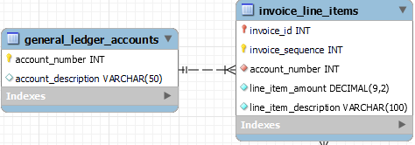  
     
   Write a SELECT statement that returns these two columns, showing the accounts that do not appear on the invoice_line_items table.

account_number The account_number column from the General_Ledger_Accounts table

account_description The account description column from the General_Ledger_Accounts table

Note that the returned account numbers have never been used.

SELECT g.account_number, account_description

FROM general_ledger_accounts g

LEFT JOIN invoice_line_items i

ON g.account_number = i.account_number

WHERE i.account_number IS NULL;

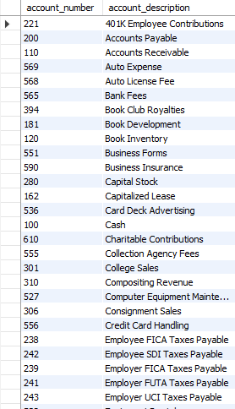

1. (5) Show two columns from the Vendors table: vendor_name and vendor_phone. If the vendor has a phone number, the vendor_phone value should be be its phone number. Otherwise, the vendor_phone value should be “No Phone.” Sort the final result set by vendor_name.

SELECT vendor_name, "No Phone" AS vendor_phone

FROM vendors

WHERE vendor_phone IS NULL

UNION

SELECT vendor_name, vendor_phone AS vendor_phone

FROM vendors

WHERE vendor_phone IS NOT NULL

ORDER BY vendor_name;

1. (5) For each vendor, show vendor name, its invoice number, invoice date, invoice id, line item amount, and line item description. Sort the result by the invoice id.

SELECT v.vendor_name, invoice_number, invoice_date, i.invoice_id, line_item_amount, line_item_description

FROM vendors v JOIN invoices i

ON v.vendor_id = i.vendor_id

JOIN invoice_line_items il

ON i.invoice_id = il.invoice_id

ORDER BY invoice_id;

1. (5) Create a table called new_terms from the terms table. Then, write an INSERT statement that adds this row to the new_terms table:

terms_id: 6terms_description: Net due 150 days

terms_due_days: 150

Then, show the result of the following query: Select * from terms;

CREATE TABLE new_terms(

terms_id INT AUTO_INCREMENT PRIMARY KEY,

terms_description varchar(255),

terms_due_date INT);

INSERT INTO new_terms(terms_id, terms_description, terms_due_date)

VALUE (6, "Net due 150 days", 150);

SELECT * FROM new_terms;

1. (5) Write an UPDATE statement that modifies the row you just added to the Terms table. This statement should change the terms_description column to “Net due 180 days”, and it should change the terms_due_days column to 180.

Then, show the result of the following query: Select * from terms;

UPDATE new_terms

SET terms_description = "Net Due In 180 Days", terms_due_date = 180

WHERE terms_id=6;

SELECT * FROM new_terms;

1. (5) Write a DELETE statement that deletes the row you added to the Terms table (that is with the terms_id 6).Then, show the result of the following query: Select * from terms;

DELETE FROM new_terms

WHERE terms_id=6;

SELECT * FROM new_terms;

1. (5) Write an UPDATE statement that modifies the Terms table. Change the terms_description column to “Net due 100 days” and the terms_due_days column to 100 for the term with an ID of 5.

Then, show the result of the following query: Select * from terms;

INSERT INTO new_terms(terms_id) VALUE (5);

UPDATE new_terms

SET terms_description = "Net Due In 100 Days", terms_due_date = 100

WHERE terms_id =5;

SELECT * FROM new_terms;

1. (5) Write a SELECT statement that returns one row for each vendor in the Invoices table that contains these columns:

The vendor_name column from the Vendors table

The sum of the invoice_total columns in the Invoices table for that vendor

SELECT vendor_name, SUM(invoice_total) AS invoice_total

FROM vendors v JOIN invoices i

ON v.vendor_id = i.vendor_id

GROUP BY vendor_name;

1. (10) Consider the following ER diagram.

1. (2) What is the relationship between vendors and general_ledger_accounts? (Show whether it is 1:1, 1:Many, Many:1 or 1:1.  
    ***Many or One : One***
2. (4) Show the account_description that has the most number invoices. What is the total invoice for the account? Show the query that finds the answer.;

Vendor with ID 123 has the most number invoices with 47 invoices.

SELECT i.vendor_id, i.account_description, MAX(total_invoice) AS total_invoice

FROM

(SELECT i.vendor_id, COUNT(*) AS total_invoice, g.account_description

FROM invoices i JOIN vendors v

ON i.vendor_id = v.vendor_id

JOIN general_ledger_accounts g

ON v.default_account_number = g.account_number

GROUP BY vendor_id

ORDER BY total_invoice DESC) i;

1. (4) Which account_description has the highest total invoice? Show the query that finds the answer.

Vendor with ID 110 has the highest invoices total with $118,982.41.

SELECT tab.vendor_id, tab.account_description, MAX(total_invoice_amt) AS total_invoice

FROM(

SELECT i.vendor_id, SUM(invoice_total) AS total_invoice_amt, g.account_description

FROM invoices i JOIN vendors v

ON i.vendor_id = v.vendor_id

JOIN general_ledger_accounts g

ON v.default_account_number = g.account_number

GROUP BY vendor_id

ORDER BY total_invoice_amt DESC) tab;



1. (10)
2. (5) Show the vendor name, line_item_description, and account number for each line items. Find vendors which use more than one account number from the result.

SELECT vendor_id, account_number, ili.line_item_description

FROM invoices i

JOIN invoice_line_items ili

ON i.invoice_id = ili.invoice_id

UNION

(SELECT vendor_id, default_account_number, vendor_name

FROM vendors)

ORDER BY vendor_id;

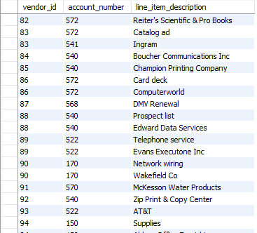

1. (5) Write a query to find out vendors which use more than one account.

SELECT tab.vendor_id, tab.account_number, tab.line_item_description

FROM (

SELECT vendor_id, account_number, ili.line_item_description

FROM invoices i

JOIN invoice_line_items ili

ON i.invoice_id = ili.invoice_id

UNION

(SELECT vendor_id, default_account_number, vendor_name

FROM vendors)

ORDER BY vendor_id

) tab

GROUP BY tab.vendor_id

HAVING COUNT(DISTINCT tab.account_number) > 1 ;

1. (10) Find a vendor that had most late payments. How many times the payment was late? Consider the payment for each invoice was late if invoice_due_date < payment_date.  
   Show the query which backs up your answer.

SELECT i.vendor_id, MAX(a.late_payment) AS number_of_late_payments

FROM invoices i JOIN (

SELECT vendor_id, COUNT(*) AS late_payment

FROM invoices

WHERE payment_date - invoice_due_date > 0

GROUP BY vendor_id) a;



1. (3) Write a query to find the average payment total for all invoices with a payment total greater than 0.  
   SELECT AVG(payment_total) AS avg_payment

FROM invoices

HAVING SUM(payment_total)>0;



1. (7) Then, write a query that shows invoice_id and its payment_total where the payment_total is greater than the average found in step (a).

SELECT i.invoice_id, i.payment_total, a.avg_payment

FROM invoices i

JOIN (SELECT AVG(payment_total) AS avg_payment

FROM invoices) a

WHERE i.payment_total > a.avg_payment

ORDER BY a.avg_payment;

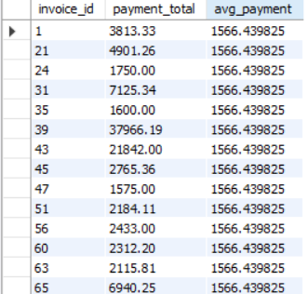

1. (10) Write a SELECT statement that returns two columns from the General_Ledger_Accounts table: account_number and account_description. Return one row for each account number that has never been assigned to any line item in the Invoice_Line_Items table. To do that, use a subquery introduced with the NOT EXISTS operator. Sort the results by the account_number column.

SELECT gen.account_number, account_description

FROM general_ledger_accounts gen

WHERE NOT EXISTS(

SELECT * FROM invoice_line_items inv

WHERE gen.account_number = inv.account_number)

ORDER BY account_number;

