Sunnyward website edit note:
Whatsapp number please put +6016 526 2894 & +6016 725 2894
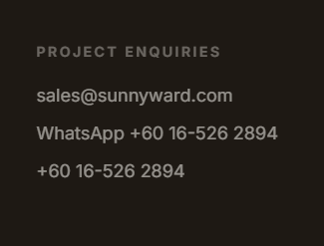

About us: please refer to the newly updated two files to re-create this page
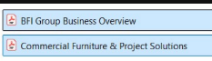

Product page: need to show all product photos and categorized it into
- Outdoor Furniture
- Office Furniture
- Project Furniture (all products not for outdoor or office purposes)

Project page:
Please only show one video for one project. DON’T show the screenshoot photo gallery

