HTBGranny Windows Machine

Web:

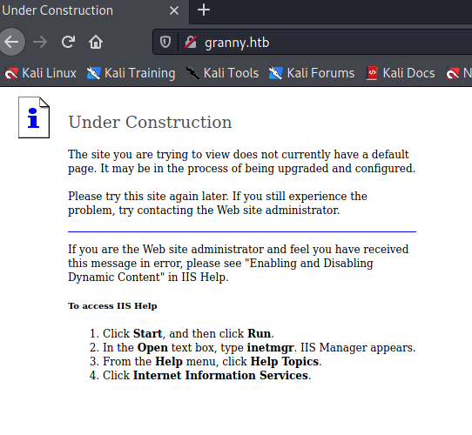

Same webpage as “grandpa” htb machine

Nmap

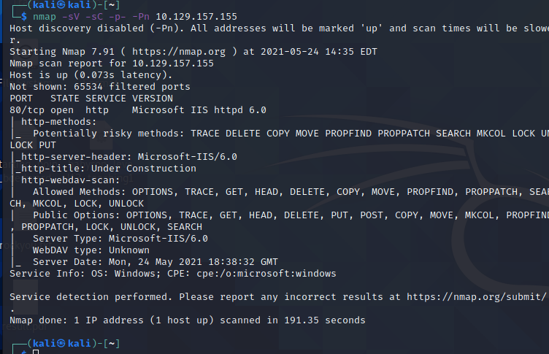

<https://github.com/g0rx/iis6-exploit-2017-CVE-2017-7269>

Same exploit as in grandpa gives us a shell:

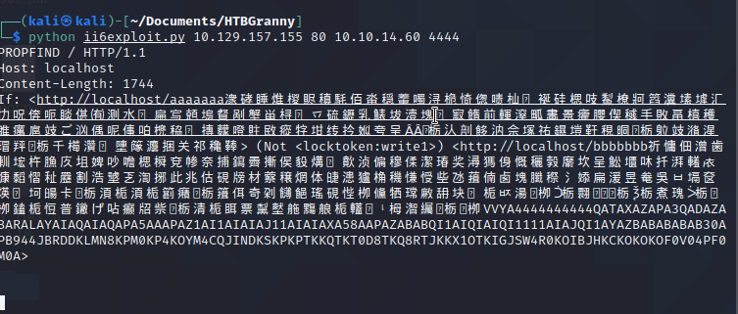

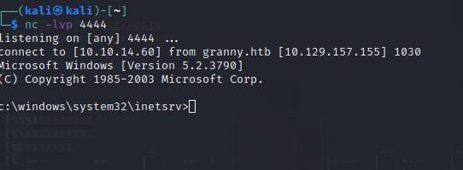

Using metasploit exploit “windows/iis/iis_webdav_scstoragepathfromurl

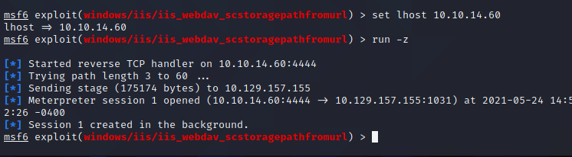

Migration:

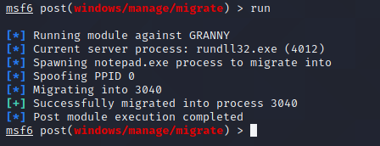

Local exploitation Suggester:

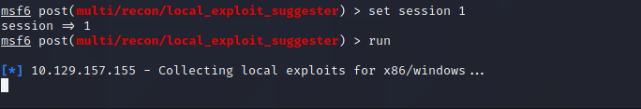

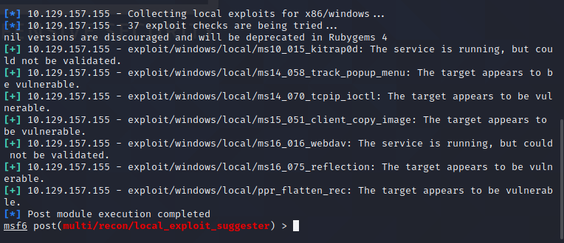

However, using ms14_058_track_popup_menu gave us a privileged shell:

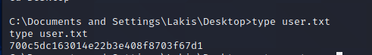

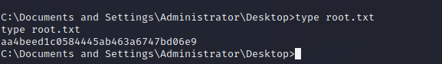

Using ms16_075_reflection gives us a shell, but it is not a privileged shell

