**Class Diagram**

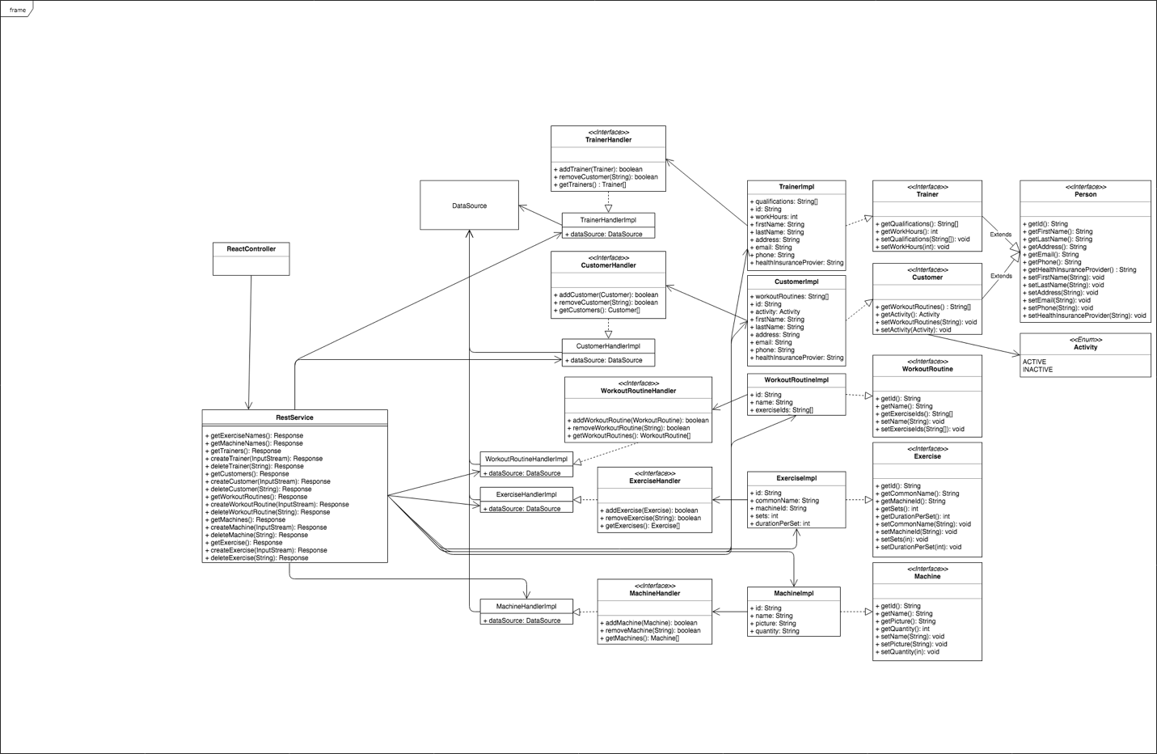

**Sequence Diagram**: Create or Update Workout Routine

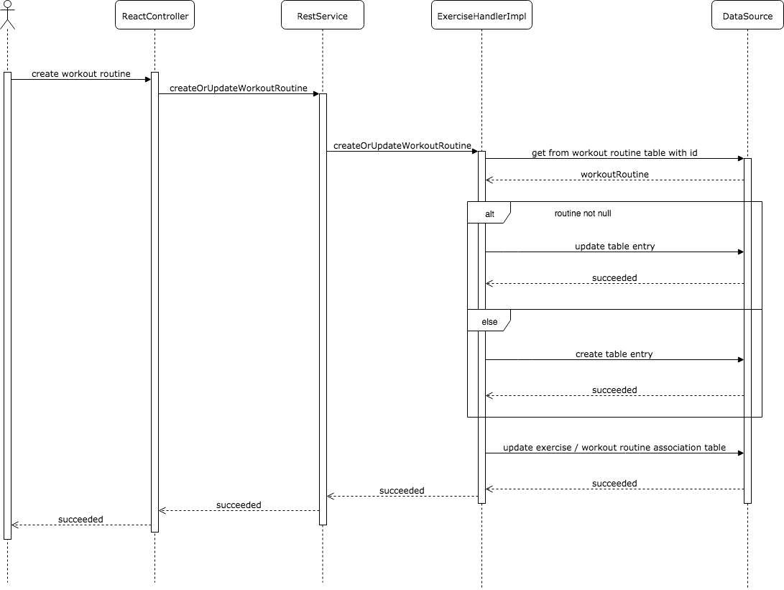

**Sequence Diagram**: Delete Exercise

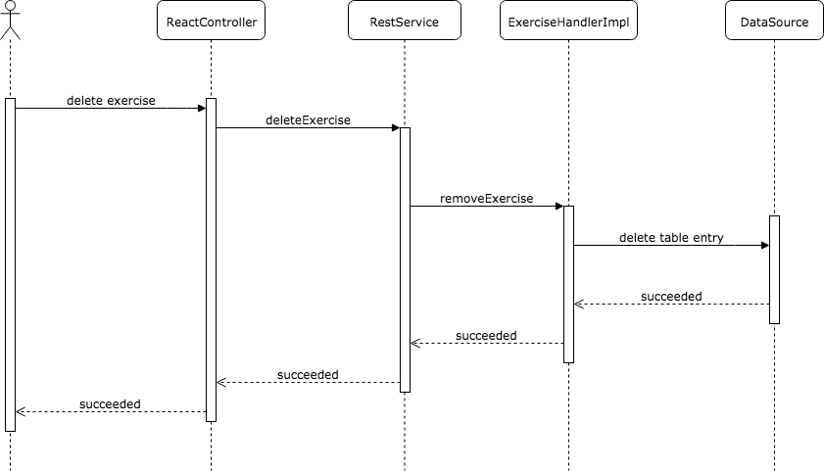

**Sequence Diagram**: Create or Update Exercise

