Gym Model: Domain Model Document

Team: Singleton

Table of contents

Domain Model 3

Person 4

Trainer 4

Trainer Tab 4

Customer 4

Customers Tab 4

Workout Routine 4

Workout Routines Tab 4

Exercises 4

Exercises Tab 4

Machine 5

Machines Tab 5

Login Pane 5

Gym System 5

# **Domain Model**

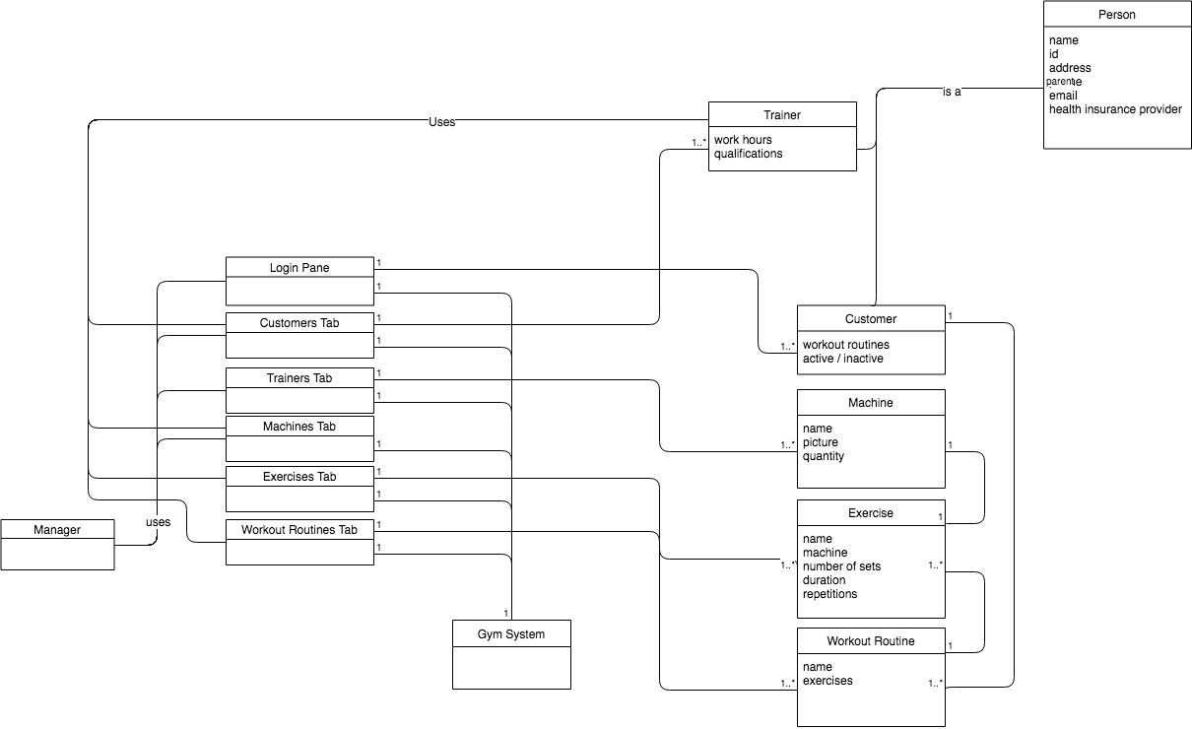Glossary

# Person

There is only one use of generalization in this domain model. Since there are many attributes that are common to both a trainer and a customer, these were extracted into a general person concept.

# Trainer

A trainer is a specialization of a person that contains additional work hours and qualifications attributes.

# Trainer Tab

The trainer tab contains all known trainers within the system (1 to many). This tab has the ability to show a single trainer to the user for manipulation.

# Customer

A customer is a specialization of a person that contains workout routines and the customer’s activity status (inactive or active).

# Customers Tab

The customers tab contains all known customers within the system (1 to many). This tab has the ability to show a single customer to the user for manipulation.

# Workout Routine

The representation of a workout routine within the system. A workout routine is assigned to a customer and contains 1 to many different exercises.

# Workout Routines Tab

The workout routines tab contains all known workout routines within the system (1 to many). This tab has the ability to show a single workout routine to the user for manipulation.

# Exercises

The representation of an exercise within the system. Each exercise has a machine associated to it.

# Exercises Tab

The exercises tab contains all known exercises within the system (1 to many). This tab has the ability to show a single exercise to the user for manipulation.

# Machine

The representation of a machine within the system. The gym can contain 1 to many different machines to be used by customers and trainers in various exercises.

# Machines Tab

The machines tab contains all known machines within the system (1 to many). This tab has the ability to show a single machine to the user for manipulation.

# Login Pane

The login pane is responsible for taking the credentials of either a trainer or manager, authenticating them with the system, and allowing the manipulation of entities within their purview.

# Gym System

The Gym System is the central mechanism for obtaining entities within the system and creating, updating and deleting them.