Assignment 2 (September 19 - 25)

1. Prove that 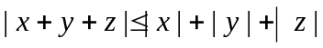 for all numbers x, y, and z.

2. Show that a convergent sequence in 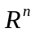 can have only one accumulation point, and therefore only one limit.

3. Show that the positive orthant
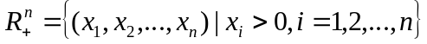
is an open subset of by finding a formula for in terms of the 's.
4. Prove that every convergent sequence in is bounded.

5. Given two sets  and  in define their sum by . Prove that if and are compact, 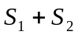 is also compact.

