# 

Undercover Books

300960704 – Rodrigo Januário da Silva

300890179 – Bruno dos Santos Demore

Table of Contents

Vision Document 2

Problem Description 2

System Capabilities 2

Business Benefits 2

Version History 3

Typography and Colours 3

Typography 3

Colours 3

Wireframes 3

Capture Section 3

# Vision Document

## Problem Description

Most libraries do not have web applications to support their system and let people access the library remotely to subscribe them, to reserve the book, to pay the late fee, or to pick the book up. Problems such as people lining inside the library either for drop off or pick up a book, or for search if a book is available, or to pay the fees for late drop off, can be seen in the library. In addition, customers can take more than 30 minutes looking for a book. Although the client has a system that covers all these areas, they lack in number of employees and computers available for customers, as well to improve and maintain the system operating.

## System Capabilities

The system will enable library clients to:

* Login to and log out from the system.
* Browse the catalog of books using search conditions.
* Order a book to borrow.
* Get a notice when a book is accessible.
* Get a notice when a book may be picked up.
* Get a notice when borrow time is close to exceed and is exceeded.
* Trace order status and number of days to return a book to the library.
* Manage customer account data.

The system will enable library staff (administrator) to:

* Login to and log out from the system.
* Manage the catalog of books.
* Manage books flow - serving books orders, pickups and returns.
* Trace delays.
* Manage cash penalties - client has a possibility to pay online using PayPal
* Manage system settings.

## Business Benefits

The purpose of the application is contribute the library staffs to manager the book and the users of the store, as well as easier way for users access their account. It also can be used to check if the book is rented, to catalog new books, to have a stored user’s database, and to remind the renter about the book drop off date.

# Version History

|  |  |
| --- | --- |
| VERSION | DESCRIPTION |
| 0.1 | Site structure and main pages set up. |

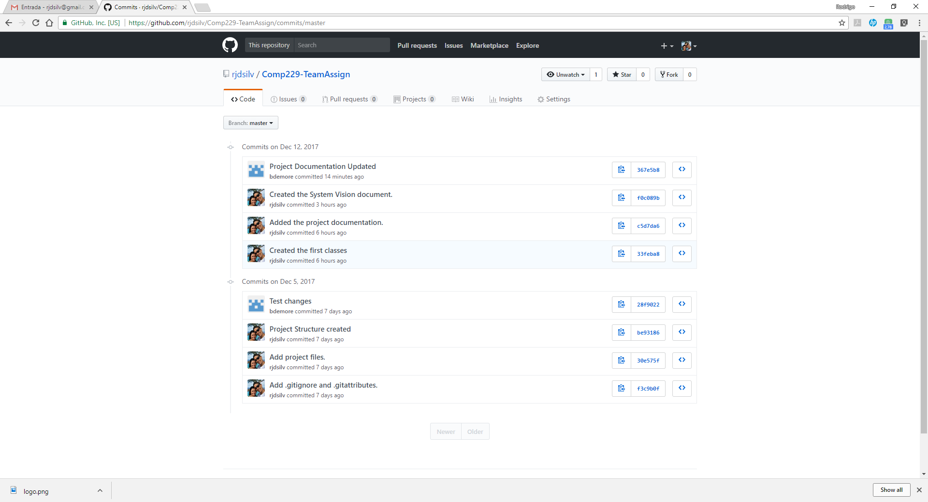

# Typography and Colours

## Typography

Not yet defined

## Colours

Not yet defined.

# Wireframes

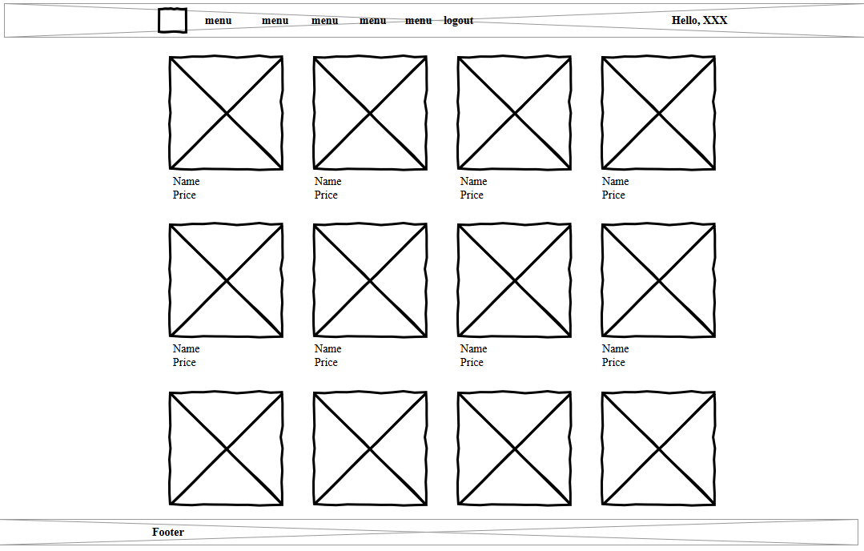

# Capture Section

Not yet constructed