Architecture_analysis

Marc LABADIE

5 juin 2018

Table of Contents

# Requierements

## Packages install

install.packages("plyr")  
install.packages("ggplot2")  
install.packages("gtable")  
install.packages("grid")  
install.packages("cowplot")  
install.packages("reshape2")  
install.packages("scales")  
install.packages("knitr")  
install.packages("tinytex")  
install.packages("dplyr")  
install.packages("lmtest")  
#install.packages("RCurl")

## Packages loading

library(plyr)  
library(ggplot2)  
library(gtable)  
library(grid)  
library(cowplot)  
library(reshape2)  
library(scales)  
library(knitr)  
library(tinytex)  
library(dplyr)  
#library(RCurl)  
library(rmarkdown)  
library(lmtest)

## Functions importing

source(file = "c:/Users/mlabadie/Documents/GitHub/strawberry/Rscript/Functions.R")

# Import and transformation of dataset

## Import dataset

**INDEX_PARAMETER :** TIME # vertex_id

**15 VARIABLES:**

* VARIABLE 1 : INT # nb_visible_leaves. No. elongated leaves (F)
* VARIABLE 2 : INT # nb_foliar_primordia No. primordia (f)
* VARIABLE 3 : INT # nb_total_leaves. Total no. leaves (F+f)
* VARIABLE 4 : INT # nb_open_flowers. No. open flowers
* VARIABLE 5 : INT # nb_aborted_flowers No. aborted flowers
* VARIABLE 6 : INT # nb_total_flowers Total no. flowers
* VARIABLE 7 : INT # vegetative_bud. No. vegetative buds (axillary vegetative bud)
* VARIABLE 8 : INT # Initiated_bud. No. initiated bud (axillary initiated bud)
* VARIABLE 9 : INT # floral_bud. No. floral buds (axillary floral bud)
* VARIABLE 10 : INT # stolons No. stolons
* VARIABLE 11 : INT # type_of_crown. Type of crown (1: primary crown, 2: extention crowns, 3: branch crown)
* VARIABLE 12 : INT # Crown_status (1: Terminal Vegetative bud (bt, stage 17, 18, 19, None), 2:Terminal bud initiated (bt, stage A), 3: Terminal floral bud(ht), 4: Inflorescence(HT), -1: rotten or aborded)
* VARIABLE 13 : INT # genotype (1: Gariguette, 2: Ciflorette, 3: Clery, 4: Capriss, 5:Darselect, 6: Cir107)
* VARIABLE 14 : INT # date (1: mid December, 2: early Junuary, 3: mid February, 4: early March, 5: early April, 6: end May/early June)
* VARIABLE 15 : INT # plant. plant index

DataSet <- read.csv(  
 "c:/Users/mlabadie/Documents/GitHub/strawberry/Rscript/Dataset.csv",   
 sep=";",na.strings = "-1")  
  
colstart<-1  
colend<-dim(DataSet)[2]-2  
  
data<-DataSet[,c(colstart:colend)]

## Dataset Class Object

str(object = data)

## 'data.frame': 1796 obs. of 16 variables:  
## $ Index : Factor w/ 17 levels "0","0-1","0-1-2",..: 1 1 1 1 1 1 1 1 1 1 ...  
## $ nb_visible_leaves : int 8 8 11 8 6 7 7 6 7 11 ...  
## $ nb_foliar_primordia: int 4 4 3 3 4 4 4 3 3 8 ...  
## $ nb_total_leaves : int 12 12 14 11 10 11 11 9 10 19 ...  
## $ nb_open_flowers : int 0 0 0 0 0 0 0 0 0 0 ...  
## $ nb_aborted_flowers : int 0 0 0 0 0 0 0 0 0 0 ...  
## $ nb_total_flowers : int 0 0 0 0 0 0 0 0 0 0 ...  
## $ vegetative_bud : int 1 4 3 6 5 3 7 1 4 3 ...  
## $ Initiated_bud : int 3 3 1 0 2 2 1 3 0 2 ...  
## $ floral_bud : int 7 4 8 5 2 5 2 4 5 10 ...  
## $ stolons : int 1 1 2 0 1 1 1 1 1 1 ...  
## $ type_of_crown : int 1 1 1 1 1 1 1 1 1 1 ...  
## $ Crown_status : int 3 3 3 3 3 3 3 3 3 3 ...  
## $ genotype : int 1 1 1 1 1 1 1 1 1 1 ...  
## $ date : int 1 1 1 1 1 1 1 1 1 2 ...  
## $ plant : int 1 2 3 4 5 6 7 8 9 1 ...

## Transformation of Class object

data$genotype<- as.factor(data$genotype)  
data$date<- as.factor(DataSet$date)  
data$Crown_status<- as.factor(DataSet$Crown_status)  
data$type_of_crown<- as.factor(DataSet$type_of_crown)

## Conversion of dataset

# Convert numerical categorical ordered value in factor values with their properties   
  
data$genotype<- factor(x = data$genotype,  
 levels = levels(x = data$genotype),  
 labels = c("Gariguette","Ciflorette","Clery","Capriss","Darselect","Cir107")  
 )  
  
data$date<- factor(x = data$date,  
 levels = levels(x = data$date),  
 labels = c("Mid-December","Early-Junuary","Mid-February","Early-March","Early-April","Early-June")  
 )  
  
data$type_of_crown<- factor(x = DataSet$type_of_crown,  
 levels = levels(x = data$type_of_crown),  
 labels = c("Primary_Crown","Extention_Crown","Branch_Crown")  
 )  
data$Crown_status<- factor(x = data$Crown_status,  
 levels = levels(x = data$Crown_status),  
 labels = c("Terminal_Vegetative_bud","Terminal_initiated_bud","Terminal_Floral_bud","Terminal_Inflorescence"))

#convert index sequence analysis in index for R analysis  
dat<-data[2:colend]  
for (i in 1:nrow(data)){   
 if (data[i,'Index']=="0"){   
 dat[i,"Index"]<- 0  
 }else if (data[i,'Index']=="0-1"){  
 dat[i,"Index"]<- 1  
 }else if (data[i,'Index']=="0-1-2"){  
 dat[i,"Index"]<- 2  
 }else if (data[i,'Index']=="0-1-2-3"){  
 dat[i,"Index"]<- 3  
 }else if (data[i,'Index']=="0-1-2-3-4"){  
 dat[i,"Index"]<- 4  
 }else if (data[i,'Index']=="0-1-2-3-4-5"){  
 dat[i,"Index"]<- 5  
 }else if (data[i,'Index']=="1"){  
 dat[i,"Index"]<- 1  
 }else if (data[i,'Index']=="1-2"){  
 dat[i,"Index"]<- 2  
 }else if (data[i,'Index']=="1-2-3"){  
 dat[i,"Index"]<- 3  
 }else if (data[i,'Index']=="1-2-3-4"){  
 dat[i,"Index"]<- 4  
 }else if (data[i,'Index']=="1-2-3-4-5"){  
 dat[i,"Index"]<- 5  
 }else if (data[i,'Index']=="2"){  
 dat[i,"Index"]<- 2  
 }else if (data[i,'Index']=="2-3"){  
 dat[i,"Index"]<- 3  
 }else if (data[i,'Index']=="2-3-4"){  
 dat[i,"Index"]<- 4  
 }else if (data[i,'Index']=="3"){  
 dat[i,"Index"]<- 3  
 }else if (data[i,'Index']=="3-4"){  
 dat[i,"Index"]<- 4  
 }else if (data[i,'Index']=="4"){  
 dat[i,"Index"]<- 4  
 }  
}  
  
dat$Index<-as.factor(x = dat$Index)  
  
#Remplacer les valeurs 0 dans la colone total flowers par NA  
dat$nb_total_flowers[dat$nb_total_flowers==0]<-NA  
  
#kable(x = dat,digits = 2,caption = "Data extract from MTG")

# Exploratory analysis

## At plant scale

## At module scale

** Extraction of data at module scale **

data_at_module_scale<-ddply(.data = dat,  
 .variables = c("genotype","Index"),  
 summarise,  
 MeanTotalLeave= mean(x = nb_total_leaves,  
 na.rm = T),  
 SdTotalLeave= sd(x = nb_total_leaves,  
 na.rm = T),  
 MeanTotalFlower= mean(x = nb_total_flowers,  
 na.rm = T),  
 SdTotalFlower= sd(x = nb_total_flowers,  
 na.rm = T),  
 MeanStolon= mean(x = stolons,  
 na.rm = T),  
 SdStolon= sd(x = stolons,  
 na.rm = T),  
 N=length(nb_total_leaves))  
  
kable(x = data_at_module_scale,caption = " Data at module scale",digits = 2)

Data at module scale

|  |  |  |  |  |  |  |  |  |
| --- | --- | --- | --- | --- | --- | --- | --- | --- |
| genotype | Index | MeanTotalLeave | SdTotalLeave | MeanTotalFlower | SdTotalFlower | MeanStolon | SdStolon | N |
| Gariguette | 0 | 10.43 | 2.35 | 18.71 | 3.70 | 0.67 | 0.75 | 54 |
| Gariguette | 1 | 3.28 | 1.28 | 8.20 | 3.25 | 0.00 | 0.00 | 94 |
| Gariguette | 2 | 3.66 | 1.55 | 6.85 | 2.41 | 0.10 | 0.65 | 62 |
| Gariguette | 3 | 2.81 | 0.51 | 6.08 | 1.61 | 0.29 | 0.56 | 21 |
| Gariguette | 4 | 2.78 | 0.44 | 5.11 | 1.17 | 1.11 | 0.78 | 9 |
| Gariguette | 5 | 3.00 | NA | 7.00 | NA | 2.00 | NA | 1 |
| Ciflorette | 0 | 7.63 | 2.57 | 10.95 | 2.76 | 1.09 | 0.96 | 54 |
| Ciflorette | 1 | 3.33 | 0.90 | 6.66 | 2.06 | 0.00 | 0.00 | 115 |
| Ciflorette | 2 | 3.60 | 1.01 | 5.95 | 1.64 | 0.00 | 0.00 | 78 |
| Ciflorette | 3 | 2.94 | 0.63 | 5.89 | 1.85 | 0.87 | 0.85 | 31 |
| Ciflorette | 4 | 3.59 | 1.54 | 6.54 | 1.20 | 1.88 | 0.78 | 17 |
| Ciflorette | 5 | 4.67 | 2.31 | 9.00 | NA | 1.33 | 0.58 | 3 |
| Clery | 0 | 8.33 | 2.97 | 13.71 | 3.34 | 1.65 | 1.25 | 54 |
| Clery | 1 | 3.09 | 1.04 | 6.34 | 2.13 | 0.01 | 0.10 | 98 |
| Clery | 2 | 3.46 | 0.78 | 4.24 | 1.46 | 0.10 | 0.35 | 63 |
| Clery | 3 | 2.94 | 0.65 | 4.35 | 1.30 | 0.38 | 0.70 | 34 |
| Clery | 4 | 2.86 | 0.77 | 3.89 | 1.17 | 0.79 | 0.70 | 14 |
| Capriss | 0 | 10.35 | 1.82 | 11.92 | 2.87 | 1.96 | 0.97 | 54 |
| Capriss | 1 | 3.43 | 1.04 | 4.28 | 1.28 | 0.00 | 0.00 | 190 |
| Capriss | 2 | 3.86 | 0.94 | 3.71 | 1.23 | 0.01 | 0.10 | 102 |
| Capriss | 3 | 2.97 | 0.71 | 3.45 | 0.74 | 0.19 | 0.40 | 31 |
| Capriss | 4 | 2.50 | 1.00 | 2.00 | 0.00 | 0.25 | 0.50 | 4 |
| Darselect | 0 | 6.11 | 2.29 | 10.50 | 4.77 | 0.94 | 1.11 | 54 |
| Darselect | 1 | 3.34 | 1.08 | 7.69 | 3.03 | 0.01 | 0.11 | 87 |
| Darselect | 2 | 2.84 | 0.96 | 5.09 | 1.27 | 0.09 | 0.34 | 57 |
| Darselect | 3 | 2.56 | 0.68 | 5.00 | 0.79 | 0.23 | 0.48 | 39 |
| Darselect | 4 | 3.00 | 2.07 | 4.33 | 0.82 | 0.62 | 1.06 | 8 |
| Darselect | 5 | 2.00 | NA | 5.00 | NA | 1.00 | NA | 1 |
| Cir107 | 0 | 9.63 | 3.29 | 16.00 | 4.20 | 1.83 | 1.33 | 54 |
| Cir107 | 1 | 3.75 | 1.61 | 8.98 | 3.46 | 0.03 | 0.25 | 154 |
| Cir107 | 2 | 3.02 | 0.94 | 6.90 | 1.90 | 0.00 | 0.00 | 110 |
| Cir107 | 3 | 3.27 | 0.71 | 5.44 | 1.50 | 0.29 | 0.56 | 41 |
| Cir107 | 4 | 3.88 | 2.10 | 5.17 | 0.98 | 1.00 | 0.76 | 8 |

### Number of Module for successive orders

tab1<- fc_dist_module_by_order(data = dat,index = "Index")  
  
kable(x = tab1,  
 caption = "No. Module by varieties for successive orders "  
 )

No. Module by varieties for successive orders

|  |  |  |  |  |  |  |  |
| --- | --- | --- | --- | --- | --- | --- | --- |
|  | 0 | 1 | 2 | 3 | 4 | 5 | Frequency |
| Gariguette | 54 | 94 | 62 | 21 | 9 | 1 | 241 |
| Ciflorette | 54 | 115 | 78 | 31 | 17 | 3 | 298 |
| Clery | 54 | 98 | 63 | 34 | 14 | 0 | 263 |
| Capriss | 54 | 190 | 102 | 31 | 4 | 0 | 381 |
| Darselect | 54 | 87 | 57 | 39 | 8 | 1 | 246 |
| Cir107 | 54 | 154 | 110 | 41 | 8 | 0 | 367 |
| Frequency | 324 | 738 | 472 | 197 | 60 | 5 | 1796 |

### Occurence of the higher order along time

* Table of distribution of higher order along time

tab2<- fc_dist_order_by_date(data = dat,  
 genotype = "Gariguette",  
 prob = "cumulative")  
kable(x = tab2,   
 caption = "Module order frequency distribution for successive date",digits = 2)

Module order frequency distribution for successive date

|  |  |  |  |  |  |  |
| --- | --- | --- | --- | --- | --- | --- |
|  | Mid-December | Early-Junuary | Mid-February | Early-March | Early-April | Early-June |
| 0 | 1 | 0.56 | 0.27 | 0.24 | 0.14 | 0.11 |
| 1 | NA | 1.00 | 1.00 | 0.68 | 0.53 | 0.37 |
| 2 | NA | NA | NA | 0.97 | 0.95 | 0.66 |
| 3 | NA | NA | NA | 1.00 | 1.00 | 0.87 |
| 4 | NA | NA | NA | NA | NA | 0.99 |
| 5 | NA | NA | NA | NA | NA | 1.00 |

* Plot visualization of distribution of higher order along time

fc_dist_order_by_date.plot(data=tab2)+  
 geom_hline(yintercept = 0.9,linetype="dashed")

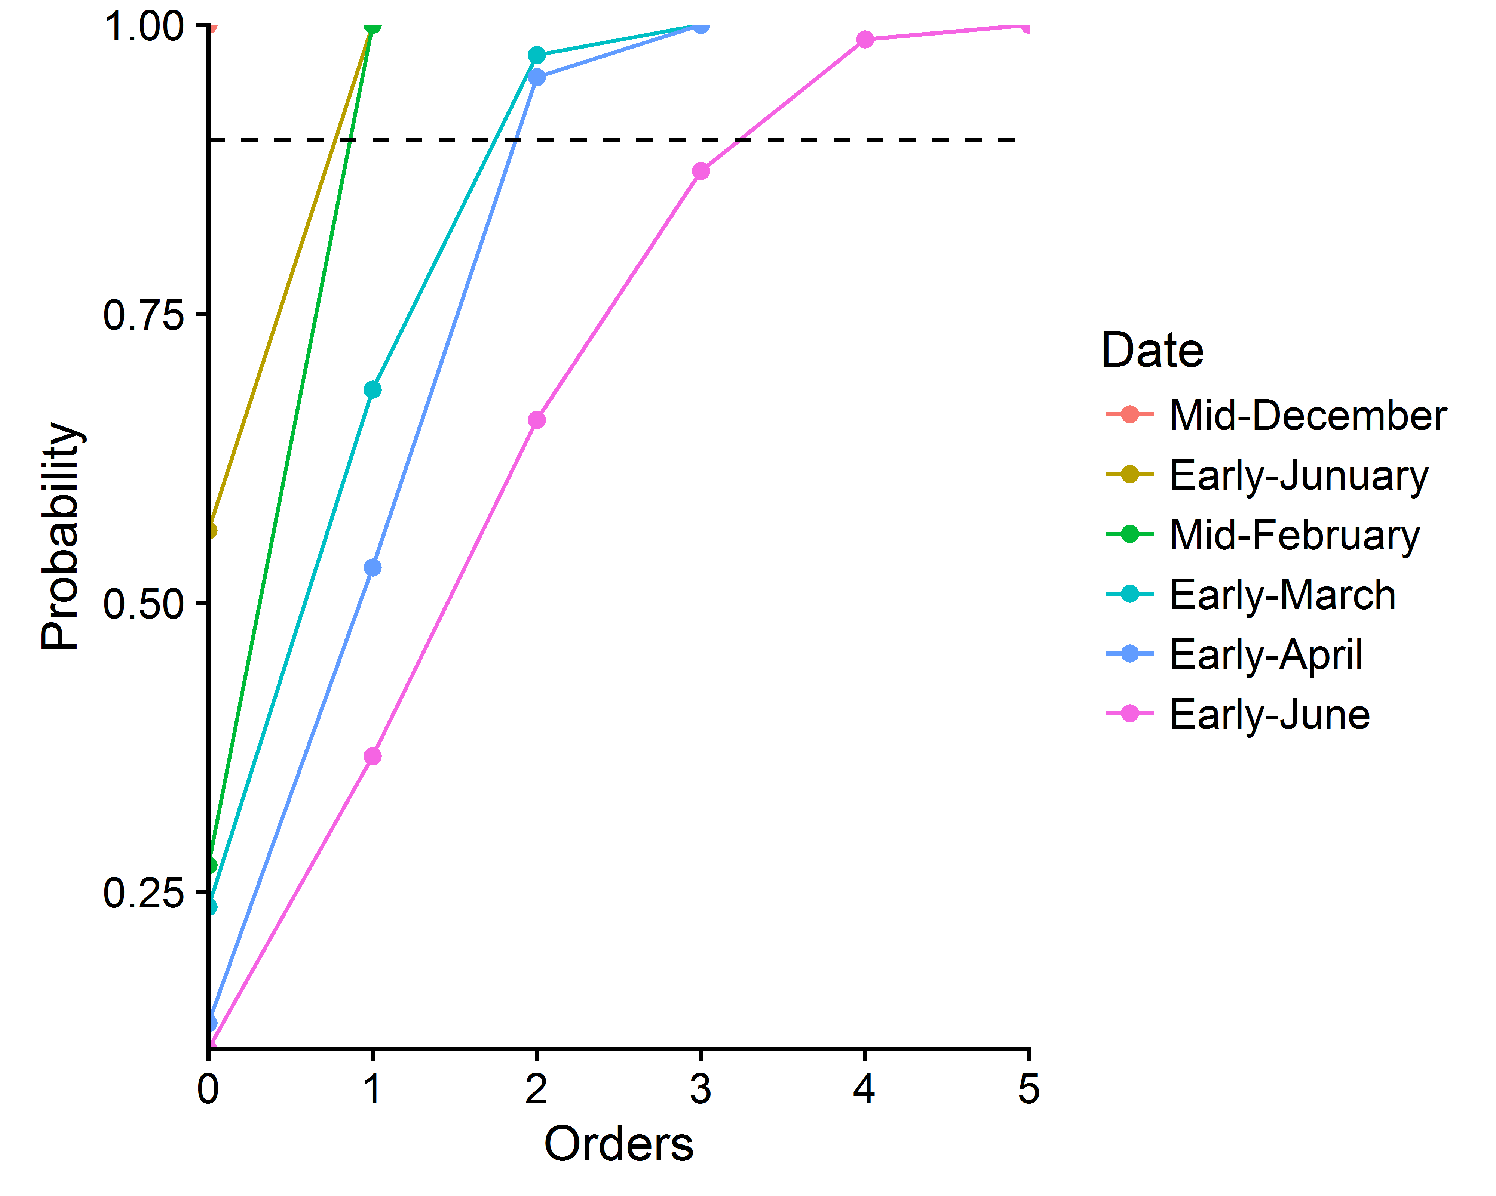

Module order frequency distribution for successive date

### Cumulative distribution of one varname for each module order

* Table of distribution of one varname according to module orders

tab3<-fc_dist_variable_by_order(data = dat,genotype = "Gariguette",varname = "nb_total_leaves",prob = "cumulative")  
  
kable(x = tab3,   
 caption = "Cumulative distribution of total no. leaves by orders",digits = 2)

Cumulative distribution of total no. leaves by orders

|  |  |  |  |  |  |  |
| --- | --- | --- | --- | --- | --- | --- |
|  | 0 | 1 | 2 | 3 | 4 | 5 |
| 1 | 0.00 | 0.01 | 0.00 | 0.00 | 0.00 | 0 |
| 2 | 0.00 | 0.31 | 0.16 | 0.24 | 0.22 | 0 |
| 3 | 0.02 | 0.68 | 0.65 | 0.95 | 1.00 | 1 |
| 4 | 0.02 | 0.82 | 0.76 | 1.00 | NA | NA |
| 5 | 0.02 | 0.91 | 0.89 | NA | NA | NA |
| 6 | 0.02 | 0.99 | 0.95 | NA | NA | NA |
| 7 | 0.04 | 1.00 | 0.97 | NA | NA | NA |
| 8 | 0.17 | 1.00 | 0.97 | NA | NA | NA |
| 9 | 0.35 | 1.00 | 1.00 | NA | NA | NA |
| 10 | 0.50 | 1.00 | NA | NA | NA | NA |
| 11 | 0.78 | 1.00 | NA | NA | NA | NA |
| 12 | 0.87 | 1.00 | NA | NA | NA | NA |
| 13 | 0.91 | 1.00 | NA | NA | NA | NA |
| 14 | 0.96 | 1.00 | NA | NA | NA | NA |
| 15 | 0.98 | 1.00 | NA | NA | NA | NA |
| 19 | 1.00 | 1.00 | NA | NA | NA | NA |

* Visualization of distribution of varname for each module orders

fc_dist_variable_by_order.plot(data = tab3)+  
 xlab("No. Leaves")+  
 ylab("Cumulative distribution function")

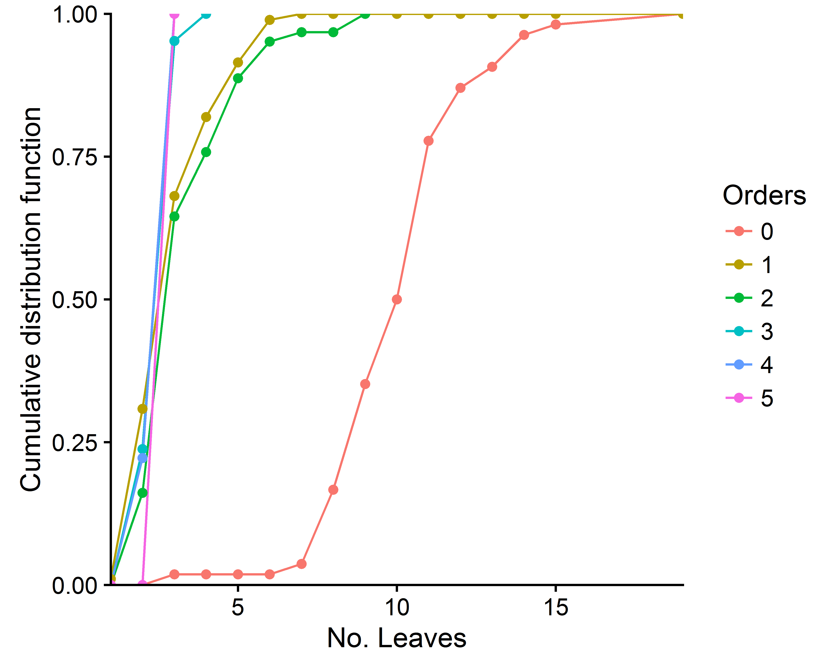

Plot distribution of XXX for each module orders

### Variable function of successive orders

In the following architectural analyses, we chose to group the highest-order modules because of the small sample size (cf. tables 1: No. Module by varieties for successive orders).

For this, we used a recursive pooling of samples from the highest order downward if sample size =< 8

* Build data according group

dat_group<-data[2:colend]  
  
  
  
for (i in 1:nrow(data)){  
 if( dat_group[i,"genotype"]=="Capriss"){  
 if (data[i,'Index']=="0"){   
 dat_group[i,"Index"]<- 0  
 }else if (data[i,'Index']=="0-1"){  
 dat_group[i,"Index"]<- 1  
 }else if (data[i,'Index']=="0-1-2"){  
 dat_group[i,"Index"]<- 2  
 }else if (data[i,'Index']=="0-1-2-3"){  
 dat_group[i,"Index"]<- 3  
 }else if (data[i,'Index']=="0-1-2-3-4"){  
 dat_group[i,"Index"]<- 3  
 }else if (data[i,'Index']=="0-1-2-3-4-5"){  
 dat_group[i,"Index"]<- 3  
 }else if (data[i,'Index']=="1"){  
 dat_group[i,"Index"]<- 1  
 }else if (data[i,'Index']=="1-2"){  
 dat_group[i,"Index"]<- 2  
 }else if (data[i,'Index']=="1-2-3"){  
 dat_group[i,"Index"]<- 3  
 }else if (data[i,'Index']=="1-2-3-4"){  
 dat_group[i,"Index"]<- 3  
 }else if (data[i,'Index']=="1-2-3-4-5"){  
 dat_group[i,"Index"]<- 3  
 }else if (data[i,'Index']=="2"){  
 dat_group[i,"Index"]<- 2  
 }else if (data[i,'Index']=="2-3"){  
 dat_group[i,"Index"]<- 3  
 }else if (data[i,'Index']=="2-3-4"){  
 dat_group[i,"Index"]<- 3  
 }else if (data[i,'Index']=="3"){  
 dat_group[i,"Index"]<- 3  
 }else if (data[i,'Index']=="3-4"){  
 dat_group[i,"Index"]<- 3  
 }else if (data[i,'Index']=="4"){  
 dat_group[i,"Index"]<- 3  
 }  
 }else  
 if (data[i,'Index']=="0"){   
 dat_group[i,"Index"]<- 0  
 }else if (data[i,'Index']=="0-1"){  
 dat_group[i,"Index"]<- 1  
 }else if (data[i,'Index']=="0-1-2"){  
 dat_group[i,"Index"]<- 2  
 }else if (data[i,'Index']=="0-1-2-3"){  
 dat_group[i,"Index"]<- 3  
 }else if (data[i,'Index']=="0-1-2-3-4"){  
 dat_group[i,"Index"]<- 4  
 }else if (data[i,'Index']=="0-1-2-3-4-5"){  
 dat_group[i,"Index"]<- 4  
 }else if (data[i,'Index']=="1"){  
 dat_group[i,"Index"]<- 1  
 }else if (data[i,'Index']=="1-2"){  
 dat_group[i,"Index"]<- 2  
 }else if (data[i,'Index']=="1-2-3"){  
 dat_group[i,"Index"]<- 3  
 }else if (data[i,'Index']=="1-2-3-4"){  
 dat_group[i,"Index"]<- 4  
 }else if (data[i,'Index']=="1-2-3-4-5"){  
 dat_group[i,"Index"]<- 4  
 }else if (data[i,'Index']=="2"){  
 dat_group[i,"Index"]<- 2  
 }else if (data[i,'Index']=="2-3"){  
 dat_group[i,"Index"]<- 3  
 }else if (data[i,'Index']=="2-3-4"){  
 dat_group[i,"Index"]<- 4  
 }else if (data[i,'Index']=="3"){  
 dat_group[i,"Index"]<- 3  
 }else if (data[i,'Index']=="3-4"){  
 dat_group[i,"Index"]<- 4  
 }else if (data[i,'Index']=="4"){  
 dat_group[i,"Index"]<- 4  
 }  
}  
  
#Remplacer les valeurs 0 dans la colone total flowers par NA  
dat_group$nb_total_flowers[dat_group$nb_total_flowers==0]<-NA  
  
dat_group$Index<-as.factor(dat_group$Index)

* check that the modules have been well grouped

tab4<- fc_dist_module_by_order(data = dat_group,index = "Index")  
kable(x = tab4,caption = "Number of modules for each successive orders after grouping for each varieties")

Number of modules for each successive orders after grouping for each varieties

|  |  |  |  |  |  |  |
| --- | --- | --- | --- | --- | --- | --- |
|  | 0 | 1 | 2 | 3 | 4 | Frequency |
| Gariguette | 54 | 94 | 62 | 21 | 10 | 241 |
| Ciflorette | 54 | 115 | 78 | 31 | 20 | 298 |
| Clery | 54 | 98 | 63 | 34 | 14 | 263 |
| Capriss | 54 | 190 | 102 | 35 | 0 | 381 |
| Darselect | 54 | 87 | 57 | 39 | 9 | 246 |
| Cir107 | 54 | 154 | 110 | 41 | 8 | 367 |
| Frequency | 324 | 738 | 472 | 201 | 61 | 1796 |

[**Hint:** Compare tab4 with tab1]

#### Recalculate data_at_module_scale after grouping

data_at_module_scale_group<-ddply(.data = dat_group,  
 .variables = c("genotype","Index"),  
 summarise,  
 MeanTotalLeave= mean(x = nb_total_leaves,  
 na.rm = T),  
 SdTotalLeave= sd(x = nb_total_leaves,  
 na.rm = T),  
 MeanTotalFlower= mean(x = nb_total_flowers,  
 na.rm = T),  
 SdTotalFlower= sd(x = nb_total_flowers,  
 na.rm = T),  
 MeanStolon= mean(x = stolons,  
 na.rm = T),  
 SdStolon= sd(x = stolons,  
 na.rm = T),  
 N=length(nb_total_leaves))  
  
kable(x = data_at_module_scale_group,caption = " Data at module scale after grouping",digits = 2)

Data at module scale after grouping

|  |  |  |  |  |  |  |  |  |
| --- | --- | --- | --- | --- | --- | --- | --- | --- |
| genotype | Index | MeanTotalLeave | SdTotalLeave | MeanTotalFlower | SdTotalFlower | MeanStolon | SdStolon | N |
| Gariguette | 0 | 10.43 | 2.35 | 18.71 | 3.70 | 0.67 | 0.75 | 54 |
| Gariguette | 1 | 3.28 | 1.28 | 8.20 | 3.25 | 0.00 | 0.00 | 94 |
| Gariguette | 2 | 3.66 | 1.55 | 6.85 | 2.41 | 0.10 | 0.65 | 62 |
| Gariguette | 3 | 2.81 | 0.51 | 6.08 | 1.61 | 0.29 | 0.56 | 21 |
| Gariguette | 4 | 2.80 | 0.42 | 5.30 | 1.25 | 1.20 | 0.79 | 10 |
| Ciflorette | 0 | 7.63 | 2.57 | 10.95 | 2.76 | 1.09 | 0.96 | 54 |
| Ciflorette | 1 | 3.33 | 0.90 | 6.66 | 2.06 | 0.00 | 0.00 | 115 |
| Ciflorette | 2 | 3.60 | 1.01 | 5.95 | 1.64 | 0.00 | 0.00 | 78 |
| Ciflorette | 3 | 2.94 | 0.63 | 5.89 | 1.85 | 0.87 | 0.85 | 31 |
| Ciflorette | 4 | 3.75 | 1.65 | 6.71 | 1.33 | 1.80 | 0.77 | 20 |
| Clery | 0 | 8.33 | 2.97 | 13.71 | 3.34 | 1.65 | 1.25 | 54 |
| Clery | 1 | 3.09 | 1.04 | 6.34 | 2.13 | 0.01 | 0.10 | 98 |
| Clery | 2 | 3.46 | 0.78 | 4.24 | 1.46 | 0.10 | 0.35 | 63 |
| Clery | 3 | 2.94 | 0.65 | 4.35 | 1.30 | 0.38 | 0.70 | 34 |
| Clery | 4 | 2.86 | 0.77 | 3.89 | 1.17 | 0.79 | 0.70 | 14 |
| Capriss | 0 | 10.35 | 1.82 | 11.92 | 2.87 | 1.96 | 0.97 | 54 |
| Capriss | 1 | 3.43 | 1.04 | 4.28 | 1.28 | 0.00 | 0.00 | 190 |
| Capriss | 2 | 3.86 | 0.94 | 3.71 | 1.23 | 0.01 | 0.10 | 102 |
| Capriss | 3 | 2.91 | 0.74 | 3.33 | 0.82 | 0.20 | 0.41 | 35 |
| Darselect | 0 | 6.11 | 2.29 | 10.50 | 4.77 | 0.94 | 1.11 | 54 |
| Darselect | 1 | 3.34 | 1.08 | 7.69 | 3.03 | 0.01 | 0.11 | 87 |
| Darselect | 2 | 2.84 | 0.96 | 5.09 | 1.27 | 0.09 | 0.34 | 57 |
| Darselect | 3 | 2.56 | 0.68 | 5.00 | 0.79 | 0.23 | 0.48 | 39 |
| Darselect | 4 | 2.89 | 1.96 | 4.43 | 0.79 | 0.67 | 1.00 | 9 |
| Cir107 | 0 | 9.63 | 3.29 | 16.00 | 4.20 | 1.83 | 1.33 | 54 |
| Cir107 | 1 | 3.75 | 1.61 | 8.98 | 3.46 | 0.03 | 0.25 | 154 |
| Cir107 | 2 | 3.02 | 0.94 | 6.90 | 1.90 | 0.00 | 0.00 | 110 |
| Cir107 | 3 | 3.27 | 0.71 | 5.44 | 1.50 | 0.29 | 0.56 | 41 |
| Cir107 | 4 | 3.88 | 2.10 | 5.17 | 0.98 | 1.00 | 0.76 | 8 |

#### Pointwise Mean of variable of modules for successive orders for each varieties

fc_pointwise_mean_variable_by_order(data = data_at_module_scale_group,varname = "MeanTotalLeave")+  
 ylab("Mean No. Leaves")+  
 ylim(2,10)

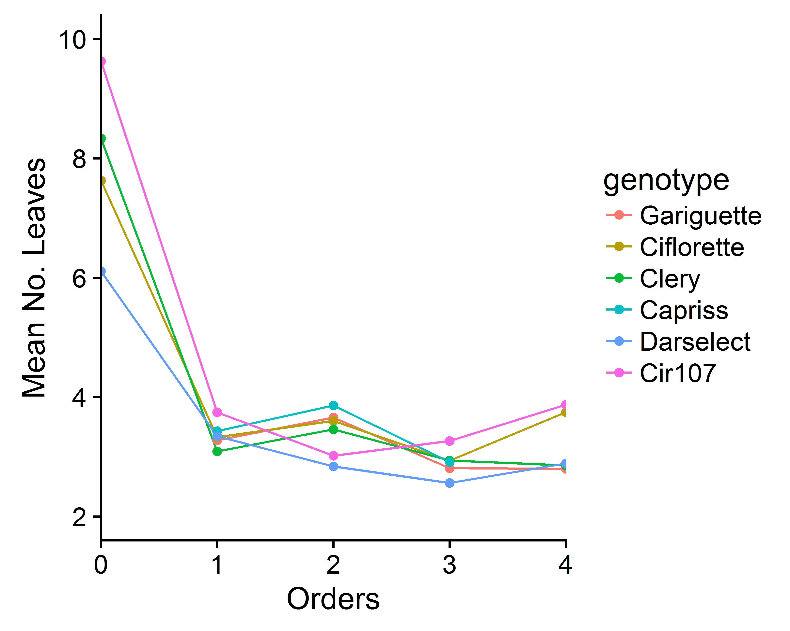

Pointwise Mean of XXX of modules for successive orders for each variety after grouping

### Comparison of variable for successive orders

Because pointwise of the mean no.leaves and mean no.flowers seems roughly constant for each varieties. In order to compare varieties we used trend linear regression, in particular we test the zero value of the slope parameter.

#### *First step:* Identification from wich module variable was roughly constant for each varieties

* **From Order 0**

Gariguette<- fc_linear_trend_reg(data = dat_group,  
 genotype = "Gariguette",  
 variable = "nb_total_leaves",  
 Index = "Index")  
  
Clery<- fc_linear_trend_reg(data = dat_group,  
 genotype = "Gariguette",  
 variable = "nb_total_leaves",  
 Index = "Index")  
  
Capriss<- fc_linear_trend_reg(data = dat_group,  
 genotype = "Capriss",  
 variable = "nb_total_leaves",  
 Index = "Index")  
  
Ciflorette<- fc_linear_trend_reg(data = dat_group,  
 genotype = "Ciflorette",  
 variable = "nb_total_leaves",  
 Index = "Index")  
  
Cir107<- fc_linear_trend_reg(data = dat_group,  
 genotype = "Cir107",  
 variable = "nb_total_leaves",  
 Index = "Index")  
  
Darselect<- fc_linear_trend_reg(data = dat_group,  
 genotype = "Darselect",  
 variable = "nb_total_leaves",  
 Index = "Index")  
  
tab5<- merge(x = Gariguette,y = Clery,all=T)  
tab5<- merge(x = tab5,y = Capriss, all=T)  
tab5<- merge(x = tab5,y = Ciflorette, all=T)  
tab5<- merge(x = tab5,y = Cir107, all=T)  
tab5<- merge(x = tab5,y = Darselect, all=T)  
  
kable(x = tab5,digits = 2,caption = "Linear trend (estimate slope and 95% confidence interval -IC95%-)")

Linear trend (estimate slope and 95% confidence interval -IC95%-)

|  |  |  |  |
| --- | --- | --- | --- |
| Genotype | Slope | IC_lower | IC_upper |
| Capriss | -1.89 | -2.15 | -1.62 |
| Ciflorette | -0.91 | -1.11 | -0.71 |
| Cir107 | -1.62 | -1.87 | -1.36 |
| Darselect | -0.96 | -1.14 | -0.78 |
| Gariguette | -2.00 | -2.32 | -1.68 |

* **From Order 1**

dat_group_from_Order1<-dat_group[!dat_group[,'Index']=="0",]  
  
Gariguette<- fc_linear_trend_reg(data = dat_group_from_Order1,  
 genotype = "Gariguette",  
 variable = "nb_total_flowers",  
 Index = "Index")  
  
Clery<- fc_linear_trend_reg(data = dat_group_from_Order1,  
 genotype = "Gariguette",  
 variable = "nb_total_flowers",  
 Index = "Index")  
  
Capriss<- fc_linear_trend_reg(data = dat_group_from_Order1,  
 genotype = "Capriss",  
 variable = "nb_total_flowers",  
 Index = "Index")  
  
Ciflorette<- fc_linear_trend_reg(data = dat_group_from_Order1,  
 genotype = "Ciflorette",  
 variable = "nb_total_flowers",  
 Index = "Index")  
  
Cir107<- fc_linear_trend_reg(data = dat_group_from_Order1,  
 genotype = "Cir107",  
 variable = "nb_total_flowers",  
 Index = "Index")  
  
Darselect<- fc_linear_trend_reg(data = dat_group_from_Order1,  
 genotype = "Darselect",  
 variable = "nb_total_flowers",  
 Index = "Index")  
  
tab6<- merge(x = Gariguette,y = Clery,all=T)  
tab6<- merge(x = tab6,y = Capriss, all=T)  
tab6<- merge(x = tab6,y = Ciflorette, all=T)  
tab6<- merge(x = tab6,y = Cir107, all=T)  
tab6<- merge(x = tab6,y = Darselect, all=T)  
  
kable(x = tab6,digits = 2,caption = "Linear trend (estimate slope and 95% confidence interval -IC95%-)")

Linear trend (estimate slope and 95% confidence interval -IC95%-)

|  |  |  |  |
| --- | --- | --- | --- |
| Genotype | Slope | IC_lower | IC_upper |
| Capriss | -0.50 | -0.75 | -0.25 |
| Ciflorette | -0.18 | -0.47 | 0.10 |
| Cir107 | -1.65 | -2.14 | -1.17 |
| Darselect | -1.31 | -1.76 | -0.87 |
| Gariguette | -1.03 | -1.55 | -0.51 |

* **From Order 2**

dat_group_from_Order2<-dat_group_from_Order1[!dat_group_from_Order1[,'Index']=="1",]  
  
Gariguette<- fc_linear_trend_reg(data = dat_group_from_Order2,  
 genotype = "Gariguette",  
 variable = "nb_total_flowers",  
 Index = "Index")  
  
Clery<- fc_linear_trend_reg(data = dat_group_from_Order2,  
 genotype = "Gariguette",  
 variable = "nb_total_flowers",  
 Index = "Index")  
  
Capriss<- fc_linear_trend_reg(data = dat_group_from_Order2,  
 genotype = "Capriss",  
 variable = "nb_total_flowers",  
 Index = "Index")  
  
Ciflorette<- fc_linear_trend_reg(data = dat_group_from_Order2,  
 genotype = "Ciflorette",  
 variable = "nb_total_flowers",  
 Index = "Index")  
  
Cir107<- fc_linear_trend_reg(data = dat_group_from_Order2,  
 genotype = "Cir107",  
 variable = "nb_total_flowers",  
 Index = "Index")  
  
Darselect<- fc_linear_trend_reg(data = dat_group_from_Order2,  
 genotype = "Darselect",  
 variable = "nb_total_flowers",  
 Index = "Index")  
  
tab7<- merge(x = Gariguette,y = Clery,all=T)  
tab7<- merge(x = tab7,y = Capriss, all=T)  
tab7<- merge(x = tab7,y = Ciflorette, all=T)  
tab7<- merge(x = tab7,y = Cir107, all=T)  
tab7<- merge(x = tab7,y = Darselect, all=T)  
  
kable(x = tab7,digits = 2,caption = "Linear trend (estimate slope and 95% confidence interval -IC95%-)")

Linear trend (estimate slope and 95% confidence interval -IC95%-)

|  |  |  |  |
| --- | --- | --- | --- |
| Genotype | Slope | IC_lower | IC_upper |
| Capriss | -0.37 | -0.94 | 0.19 |
| Ciflorette | 0.29 | -0.19 | 0.77 |
| Cir107 | -1.13 | -1.73 | -0.53 |
| Darselect | -0.25 | -0.64 | 0.14 |
| Gariguette | -0.78 | -1.49 | -0.06 |