AI-Assisted Evidence Linking: A Strategy to Improve Research Use in Polarized K-12 Education Policymaking
Bruce A. Desmarais (PI), Sarah Rajtmajer, Jessica Harden, Frederick Boehmke

Research Questions
This project addresses three interconnected research questions at the intersection of AI technology and evidence-based education policymaking:
RQ1: How do state legislators reference scientific evidence in their public communications about polarized K-12 education issues, and does the accuracy of these references differ systematically by party affiliation?
RQ2: Can AI systems reliably identify empirical claims in legislative communications, retrieve relevant scientific literature, and evaluate the degree of scientific support for those claims?
RQ3: Does providing legislators with AI-generated evidence reports improve their instrumental, conceptual, and relational use of research evidence in education policymaking?

Rationale and Significance
Education policy has become one of the most politically polarized domains in American governance. Debates over social-emotional learning (SEL), school safety measures, reading instruction methods, and educational technology increasingly divide along partisan lines, with competing claims about what "the research shows." This polarization creates both challenges and opportunities for improving research use: legislators may cite scientific evidence strategically to support predetermined positions, yet they also face genuine information asymmetries when navigating complex literatures spanning child development, educational psychology, and implementation science.
Recent advances in large language models (LLMs) and retrieval-augmented generation (RAG) create unprecedented opportunities to bridge the gap between scientific knowledge and policy discourse. These technologies can identify empirical claims in natural language, search vast scientific databases, and synthesize evidence in accessible formats. However, their application to legislative communication remains unexplored. This project develops and tests an AI-assisted evidence linking system specifically designed to improve research use in polarized contexts—a core priority of the Foundation's 2026 funding agenda.

Preliminary Data and Feasibility
We have assembled a substantial corpus of state legislative communications to establish feasibility and inform our research design. Our preliminary dataset comprises 5,131 press releases from California State Assembly members, including 4,279 from Democratic legislators and 852 from Republican legislators. This corpus provides a robust foundation for developing and validating our AI pipeline before expanding to the full 50-state sample.
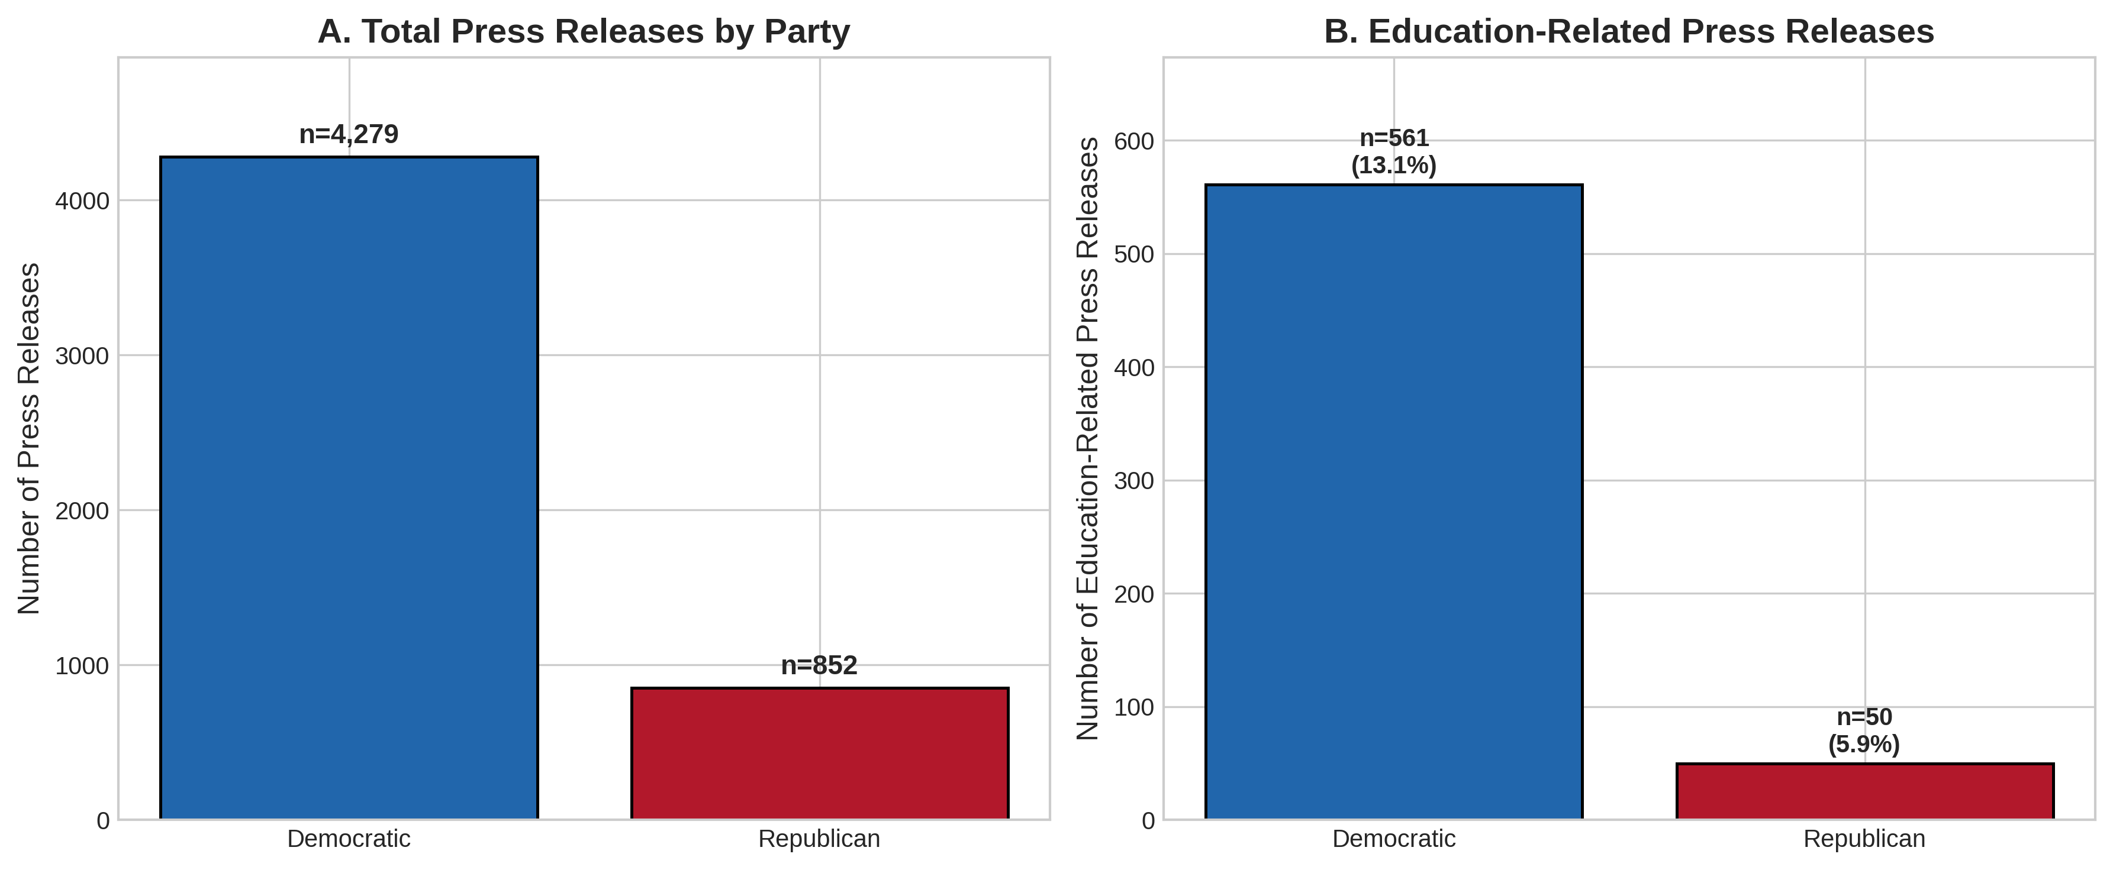
Figure 1. Corpus composition. Panel A shows total press releases by party. Panel B shows education-related press releases, with Democrats producing 561 (13.1%) and Republicans 50 (5.9%) education-focused communications.
Keyword-based filtering identified 611 education-related press releases (11.9% of the corpus). Notably, Democratic legislators devoted a significantly higher proportion of their communications to education topics (13.1%) compared to Republican legislators (5.9%), suggesting differential policy attention that our full analysis will examine in greater depth. These education-focused communications address issues central to the Foundation's interests, including school funding, teacher preparation, student mental health services, and academic standards.
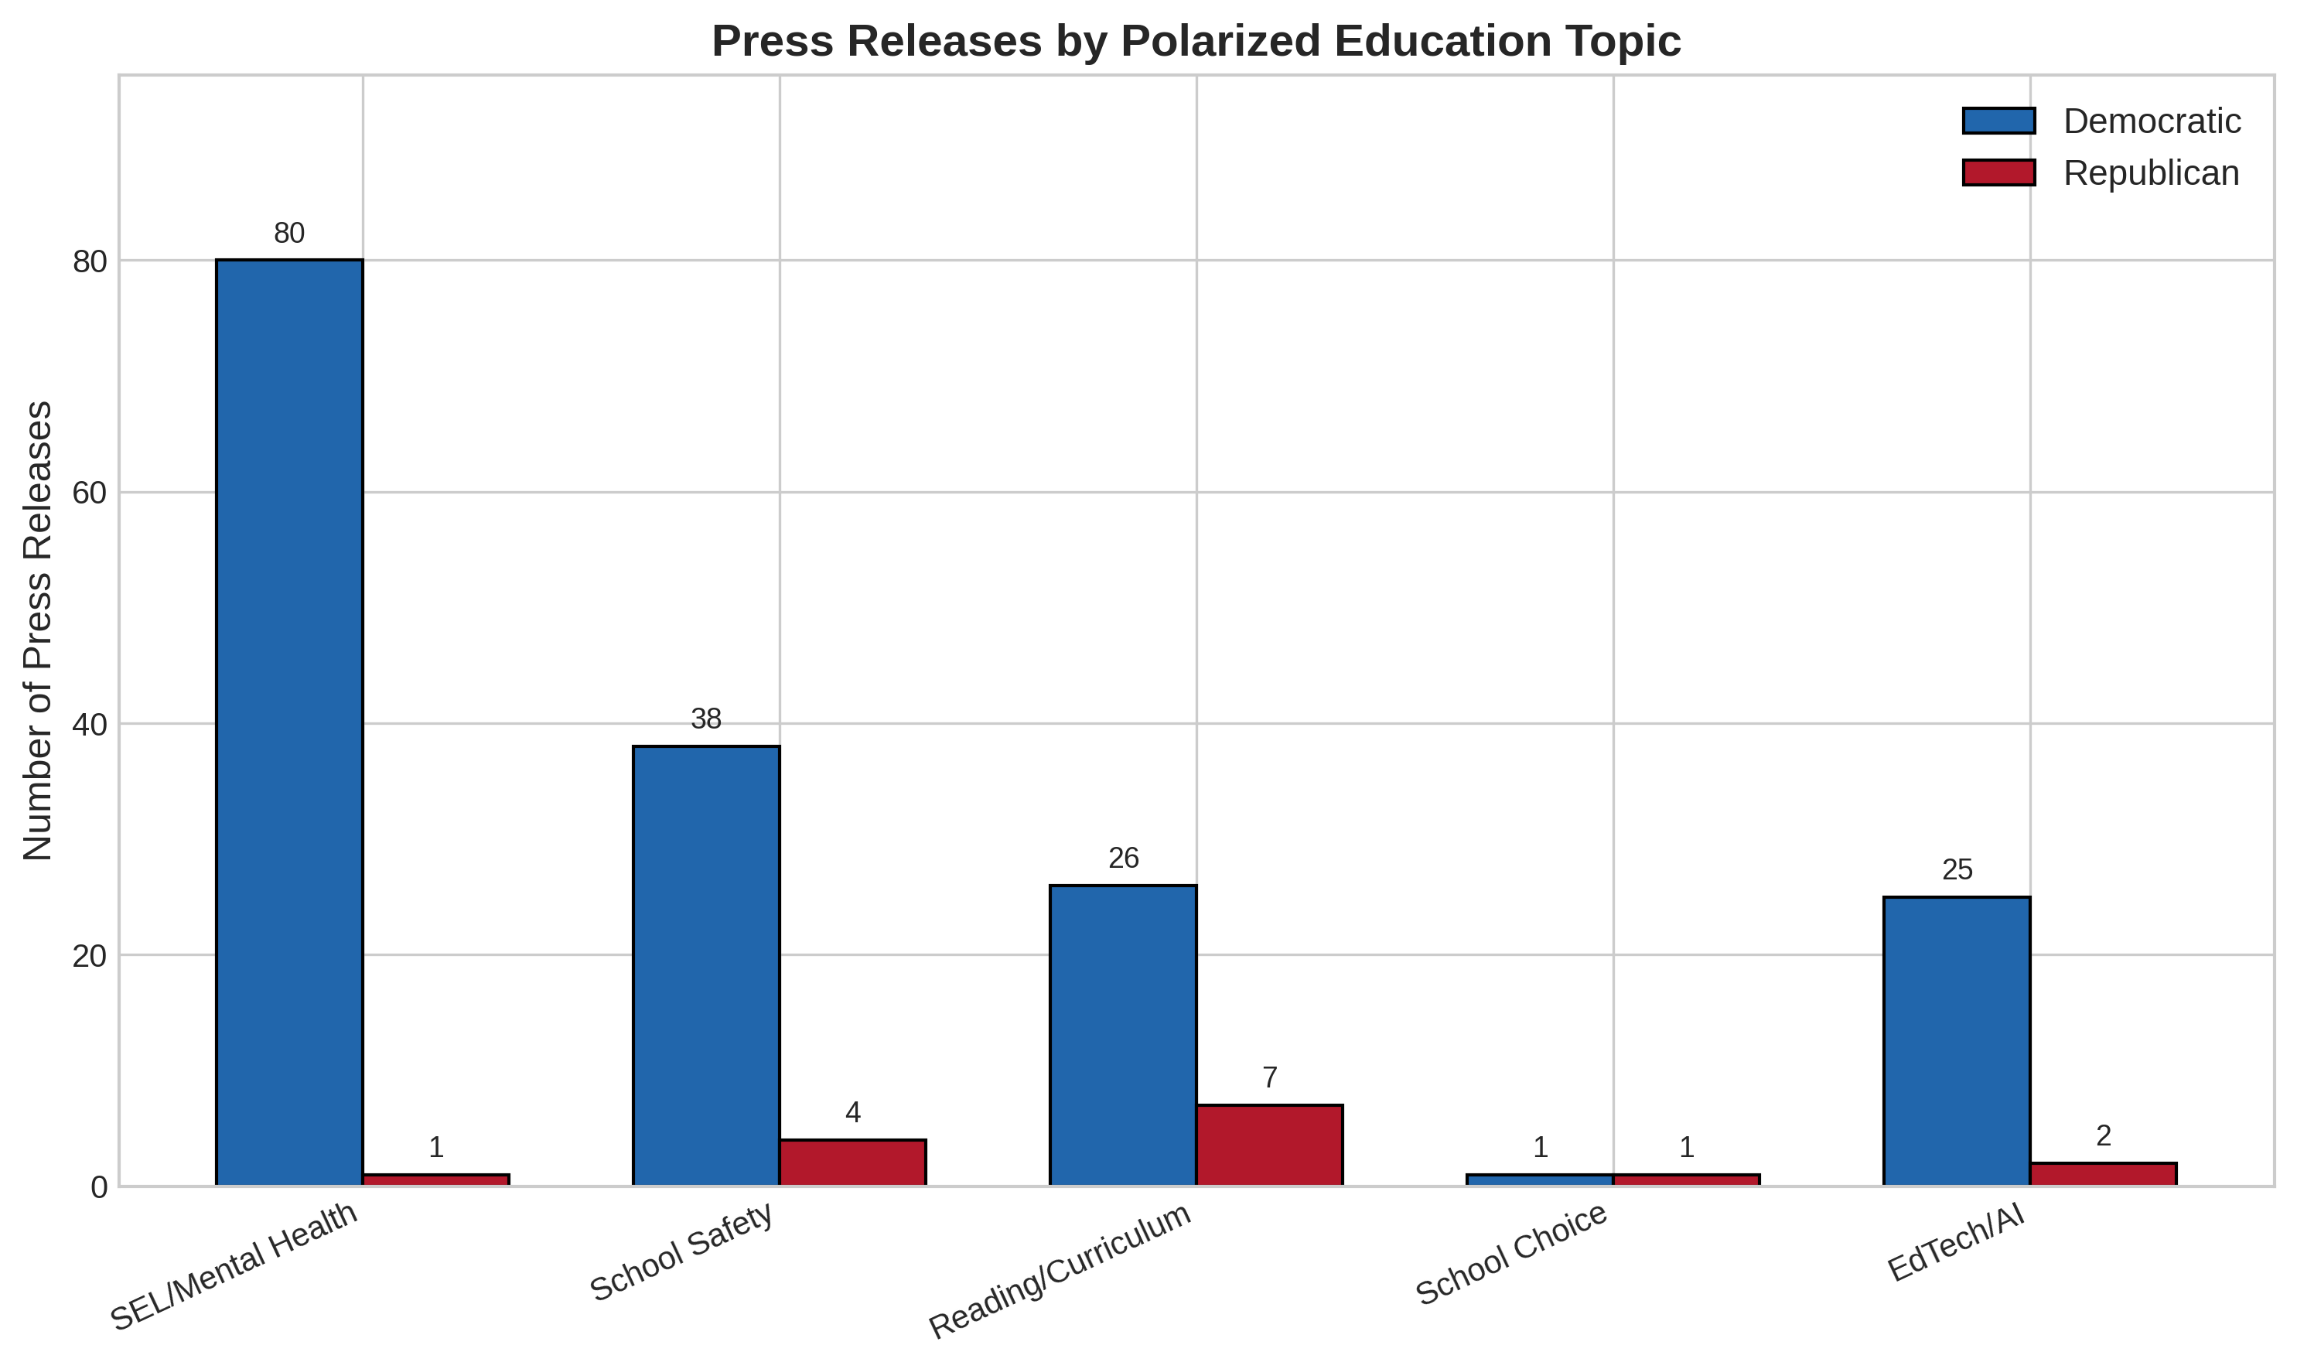
Figure 2. Distribution of press releases across polarized education topics. Democrats show substantially greater attention to SEL/mental health (n=80) and school safety (n=38), while attention to reading/curriculum issues is more comparable across parties.
Analysis of polarized topic coverage reveals striking partisan differences in policy attention. Democratic legislators produced 80 press releases addressing social-emotional learning and student mental health, compared to just 1 from Republican legislators. Similarly, school safety communications were more prevalent among Democrats (n=38) than Republicans (n=4). Reading and curriculum issues showed more balanced attention (Democrats: 26, Republicans: 7), though when normalized by total output (Figure 3), Republicans devoted a slightly higher proportion of communications to this topic (0.82% vs. 0.61%). These patterns suggest that our AI pipeline will encounter substantively different scientific claims depending on the political context—a key consideration for system validation.
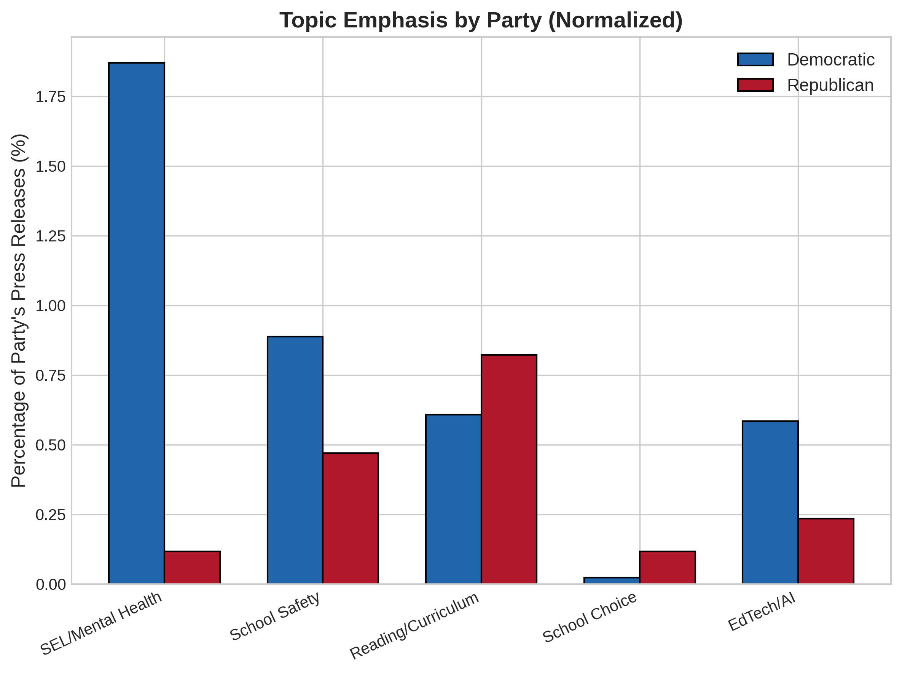
Figure 3. Topic emphasis normalized by party output. When controlling for overall communication volume, Democrats emphasize SEL/mental health 15 times more than Republicans (1.87% vs. 0.12%), while Republicans show relatively greater attention to reading/curriculum (0.82% vs. 0.61%).
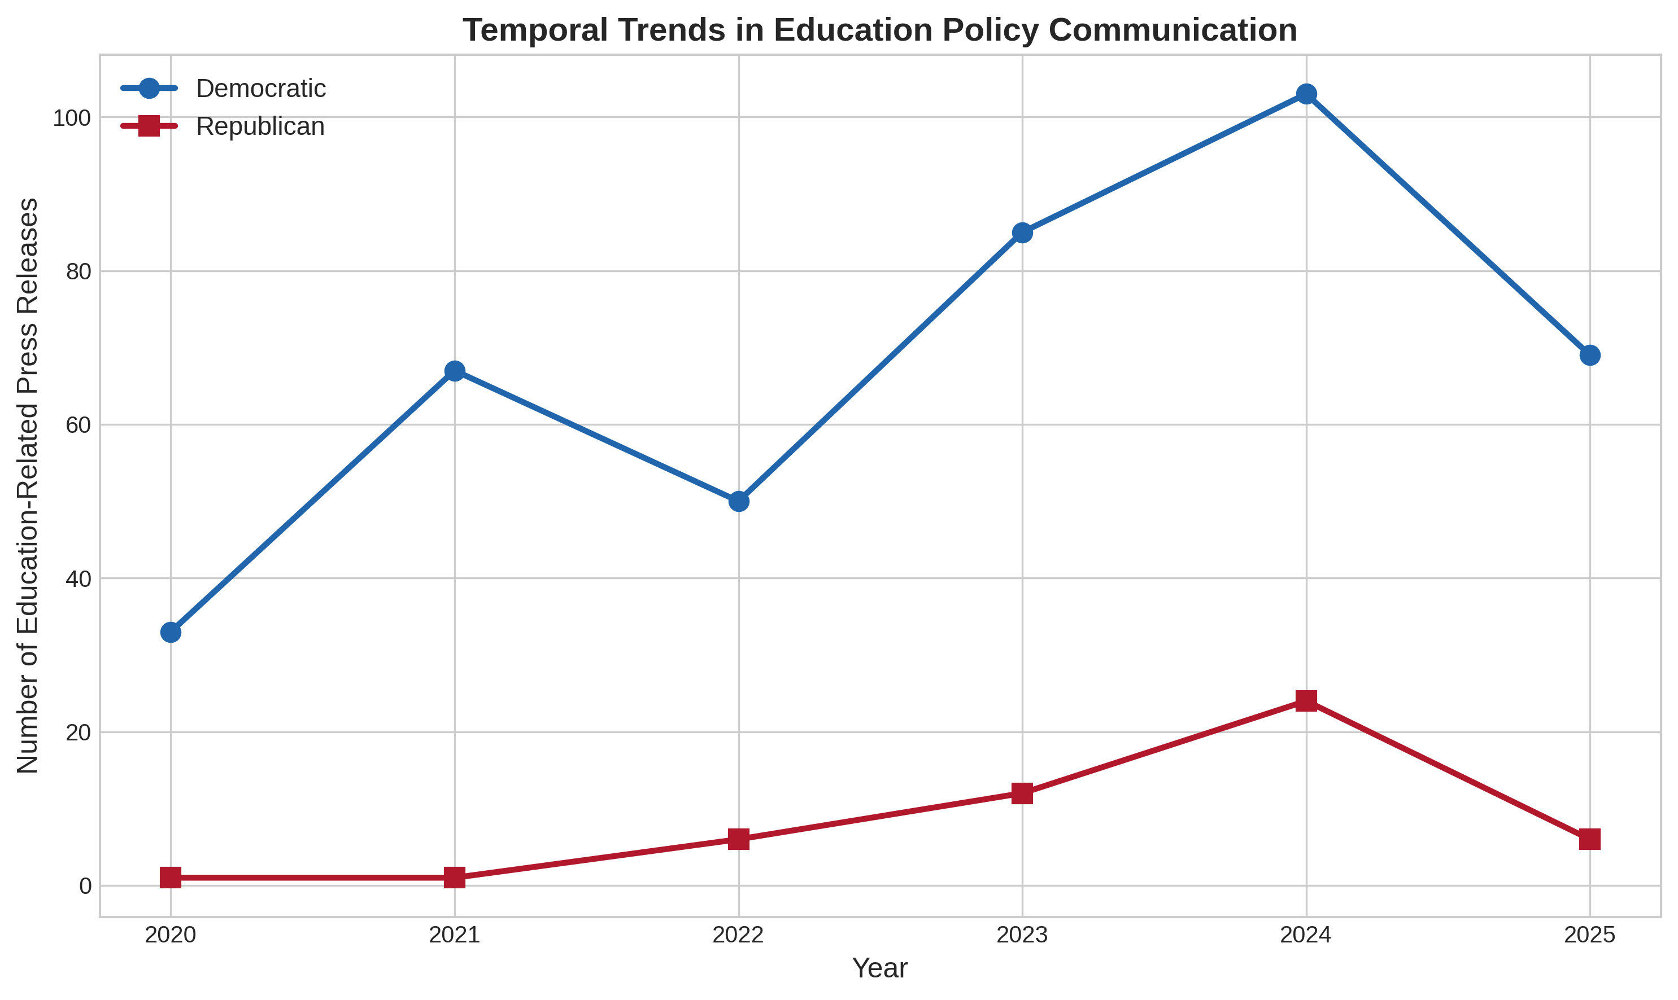
Figure 4. Temporal trends in education-related press releases (2020-2025). Both parties show increased education policy attention since 2020, with Democratic communications peaking in 2024. The post-pandemic period has intensified legislative focus on K-12 education across party lines.
Temporal analysis reveals that education policy communication has intensified substantially since 2020, likely reflecting pandemic-related disruptions to schooling and subsequent policy responses. Democratic education-focused releases grew from 33 in 2020 to 103 in 2024 before moderating to 69 in 2025 (year-to-date). Republican education communications, while fewer in absolute numbers, followed a similar trajectory with peak activity in 2024. This temporal pattern indicates heightened legislative attention to education precisely during a period of intensified polarization—underscoring the timeliness and policy relevance of our proposed research.

Theory of Change
Our theory of change posits three mechanisms through which AI-assisted evidence linking can improve research use in polarized contexts. First, by providing legislators with comprehensive, neutrally-presented evidence reports, the intervention may facilitate instrumental use—the direct application of research findings to inform specific policy decisions. Second, by exposing legislators to bodies of evidence they might not otherwise encounter, the intervention may promote conceptual use—gradual shifts in how legislators understand education issues and evaluate policy options. Third, by providing a common evidentiary foundation that transcends partisan framing, AI-generated reports may support relational use—enabling productive dialogue across political divides through shared reference points.
This framework draws on Weiss's (1979) foundational typology while incorporating contemporary insights about embedded research use in policy systems (Oliver et al., 2022). The polarized context creates both barriers and opportunities: legislators may resist evidence that challenges partisan positions, yet they also face constituent and media pressure to justify policy stances. Our design tests whether AI-assisted evidence delivery can navigate these dynamics more effectively than traditional research dissemination approaches.

Methods

Phase 1: Baseline Assessment (Months 1-12)
Building on our preliminary corpus, we will compile a comprehensive dataset of state legislative communications on education policy from all 50 states, targeting approximately 25,000 press releases over the 2020-2025 period. Our AI pipeline will process these communications through three stages: (1) LLM-based claim extraction using domain-agnostic prompting to identify verifiable scientific claims; (2) parallel search across Crossref, Semantic Scholar, and targeted web sources to retrieve potentially relevant literature; and (3) stance classification to determine whether retrieved evidence supports, refutes, or is uninformative regarding each claim. Human coders will validate a stratified sample of 500 claim-evidence pairs across parties and topics to establish reliability benchmarks.

Phase 2: Tool Development and Pilot Testing (Months 10-24)
We will refine the AI pipeline to generate accessible "Evidence Reports" summarizing the scientific consensus and areas of uncertainty for specific policy claims. These reports will present evidence in a balanced, non-partisan format designed for busy legislative professionals. We will pilot the system with 40 legislative staff members recruited through our established partnership with the National Conference of State Legislatures (NCSL), drawn from 10 states representing diverse political contexts. Participants will receive Evidence Reports on three education topics (SEL, school safety technology, reading instruction) and complete pre-post surveys measuring research use attitudes and behaviors. Semi-structured interviews with 20 participants will illuminate the mechanisms through which the tool affects (or fails to affect) evidence consideration.

Phase 3: Randomized Evaluation (Months 18-36)
The primary evaluation will employ a randomized controlled trial with 200 state legislators and senior staff members from 20 states. Treatment group participants will receive AI-generated Evidence Reports on three contentious education policy topics over a six-month period, with reports delivered through a dedicated web portal and optional email summaries. Control group participants will receive standard policy resources (bill analyses, committee reports) without AI-synthesized evidence. Randomization will be stratified by party, chamber, and state political context.

Data Analysis
Primary outcomes include: (1) accuracy of scientific citations in subsequent press releases, measured through our AI pipeline and validated by human coding; (2) self-reported research use behaviors on validated instruments; and (3) attitudes toward scientific evidence in education policy. We will employ difference-in-differences estimation to assess treatment effects, with heterogeneity analyses examining whether effects differ by party affiliation, baseline research use, or state political context. Power analysis indicates that with 200 participants and anticipated 20% attrition, we can detect moderate effects (d=0.40) for main treatment comparisons and larger effects (d=0.60) for subgroup analyses at conventional significance levels (α=0.05, power=0.80).

Expected Contributions
This project will generate three primary contributions. First, the baseline assessment will produce the most comprehensive analysis to date of how state legislators communicate about scientific evidence on education policy, with systematic comparisons across parties, states, and policy domains. Second, we will develop and validate an AI system capable of linking policy claims to scientific evidence—a tool with applications well beyond this project. Third, the randomized evaluation will provide causal evidence on whether and how AI-assisted evidence delivery can improve research use in polarized contexts, directly informing the Foundation's strategic priorities. The approximately 50 million K-12 students in U.S. public schools stand to benefit from evidence-informed policies on social-emotional learning, school safety, and instructional practice—the core topics our intervention addresses.

References
Oliver, K., Hopkins, A., Boaz, A., Guillot-Wright, S., & Cairney, P. (2022). What works to promote research-policy engagement? Evidence & Policy, 18(4), 691-713.
Weiss, C. H. (1979). The many meanings of research utilization. Public Administration Review, 39(5), 426-431.

