LAB DEMO Student class

Defining Classes

# Learning Objectives

* 1. Demonstrate how to define static methods

# Open the project

* 1. Open “StudentClassDemo” project.

# Static Keyword

* 1. Notice that unlike main we do not use the static key word in our class. Why is that?
  2. Let’s see what happens if we use the static key word with one of our instance methods. Our accessor and mutator are said to be instance methods because they are associated with each instanciated instance of the class (myStudent vs myOtherStudent in this case);

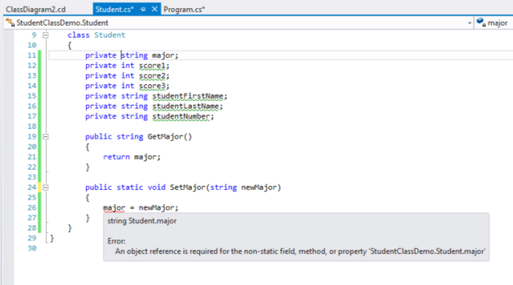

* 1. Notice we get an error. The problem is major is an instance variable. We can’t access an instance variable with a static method!
  2. Let’s change major to static as well:

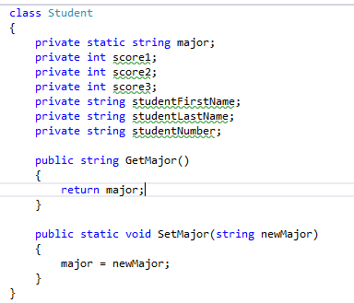

* 1. Now take a look at main:

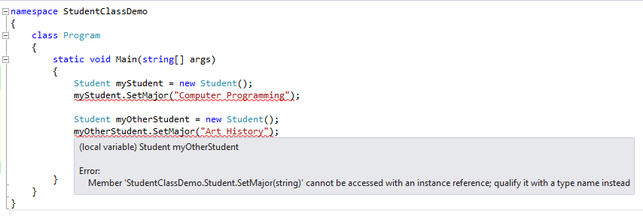

* 1. Note the error. Since we changed SetMajor to static, we can no longer access this method as instance method belonging to myStudent and myOtherStudent.
  2. Try adding a method call referenced to the class name itself:

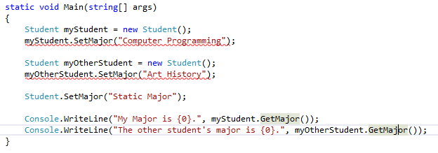

* 1. Notice that Student.SetMajor(“Static Major”) works while myStudent.SetMajor(“Computer Programming”) and myOtherStudent.SetMajor(“Art History”) doesn’t. Why is that?
  2. Static methods and fields belong to the class and are referenced using the class name:

Student.SetMajor(“Static Major”);

Class Name

* 1. Instance methods and fields belong to a particular instantiated object and are referenced using the object’s name:

Student myStudent = new Student();

myStudent.SetMajor(“Computer Programming”);

Object Name

* 1. Change the static field and method back to non-static then create a few more accessors and mutators for practice.

# Using Static Members

* 1. Static members of a class can be useful in order to store information that is common to all members in a class
  2. Create a static array to store allowable majors.

public static string[] majors = new string[] { "Programming", "Business", "Art History" };

* 1. In main use the static array to select a major for one of the students.

Console.WriteLine("Majors: ");

for(int i=0;i<Student.majors.Length;++i)

{

Console.WriteLine((i+1).ToString()+Student.majors[i]);

}

int majorIndex = int.Parse(GetInput("Major"))-1;

st.SetMajor(Student.majors[majorIndex]);

string studentNum = GetInput("Student Number");

st.SetStudentNumber(studentNum);

* 1. Try it with Ctrl-F5