Brian Detweiler

ISQA 8080

Homework 5

**Note: I used an Ant build file to compile this. See the attached build.xml.**

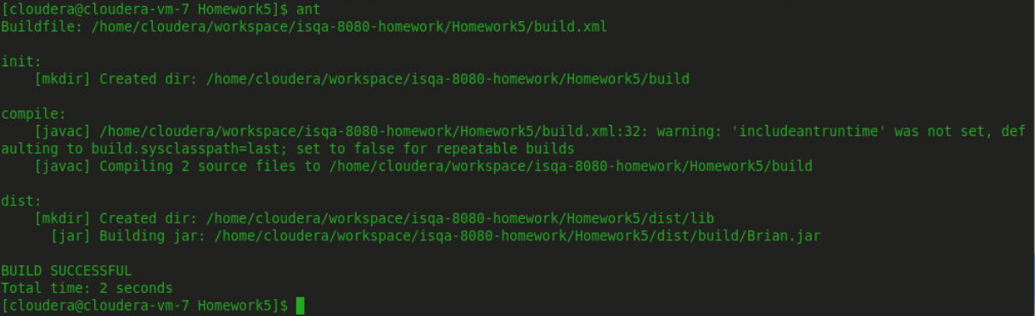

Also note, the class is packaged under **edu.unomaha.isqa8080.Brian** so be sure to give the full path if running this on your machine. I have included a **run.sh** file as well as a convenience. Make sure to run **$ chmod +x run.sh** to make it executable.

Please observe the following file structure:

* {Project Location}
  + build.xml
  + run.sh
  + src/
    - edu
      * unomaha
        + isqa8080

Brian.java

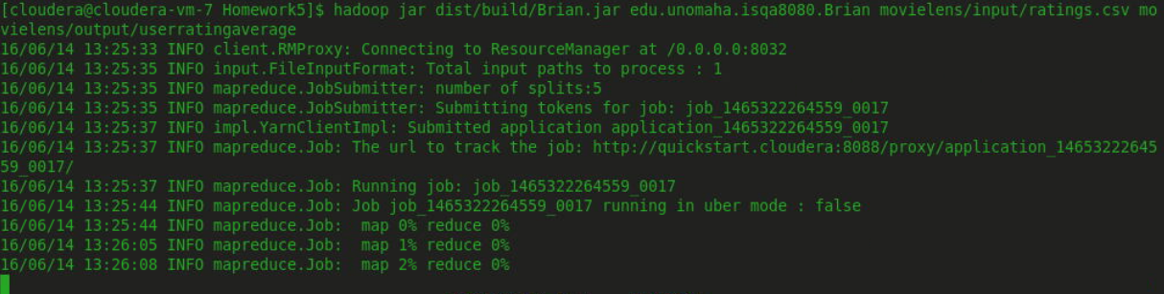

...

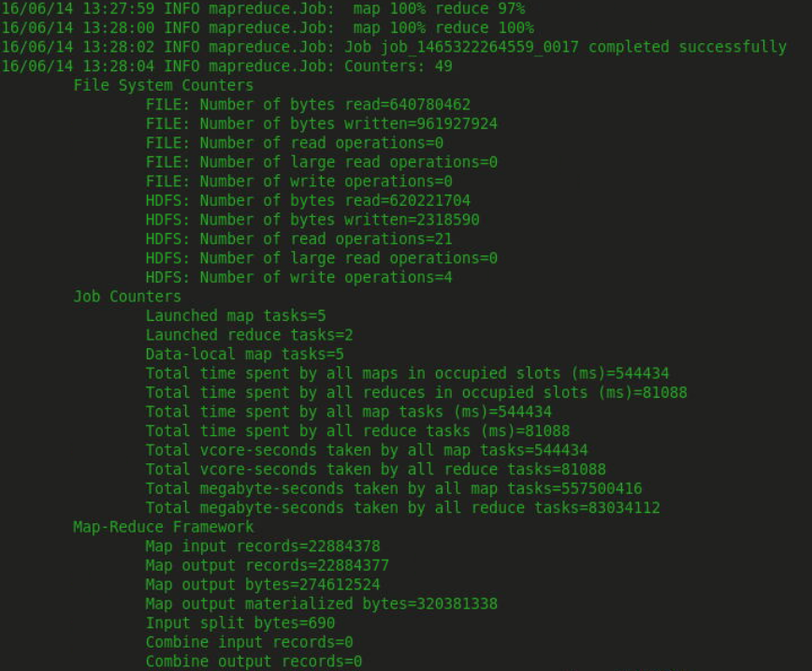

# Results

**Evens**

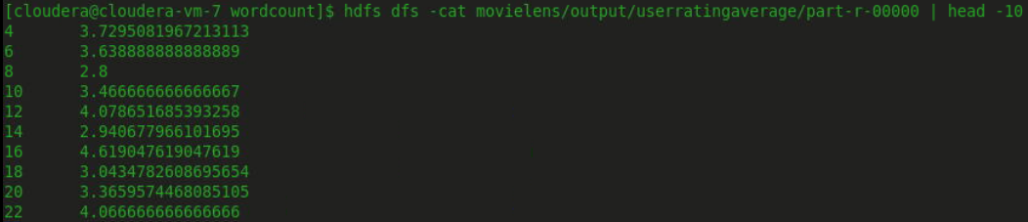

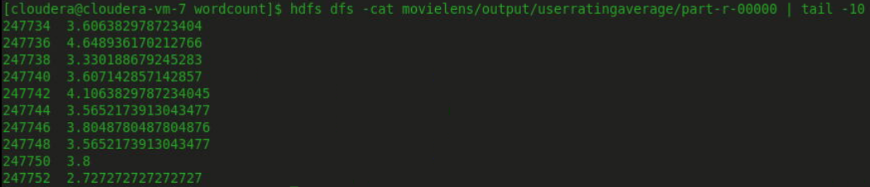

**Oddds**

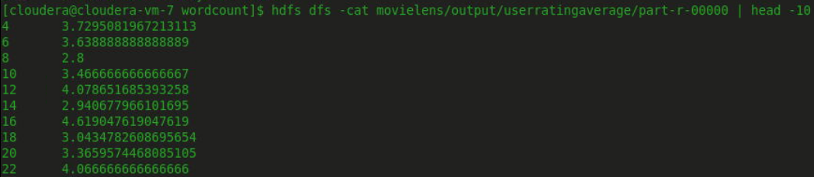

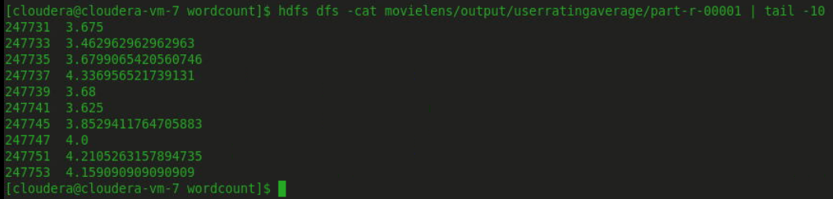

# Job Log

