Attracting Tourists: Using Airbnb Data for Entrepreneurial Insights

Business owners should always take advantage of the inherit attractions that are native to their cities. Dallas entrepreneurs capitalize on "America's Team"—the Dallas Cowboys. The Golden Gate Bridge and Silicon Valley are go-to piggybacks for money makers in San Fran. So what is it that Boston—one of America's most historic cities—can capitalize on? A look at Airbnb data from September 2016 to September 2017 can give us a few hints.

First up is the general trend in Airbnb pricing. Don't be too distracted by the price drop going into 2017. As you can see on the graph to the right, the steep drop simply mirrors a correction in the market that occurred when more people got in on the Airbnb game in Boston. The sudden decline in listings in March is also a 1-day change—likely the work of Airbnb cutting duplicate or spam listings. You can see that drop-off hardly affected pricing.

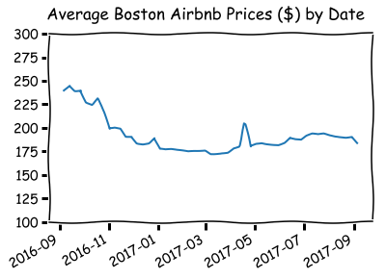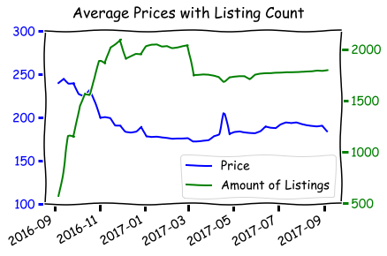

So, what insight do these timelines give us? Clearly, there's a price spike around mid to late April. What is that all about? Looking at the data, the maximum average Airbnb price in Boston (after the correction we discussed) was on April 15, 2017. The Boston Marathon was on April 17. The summer months clearly see an upward trend as well, but no single time period makes the money in tourism like the one or two days leading up to the Boston Marathon. I guess Boston entrepreneurs ought to get running!

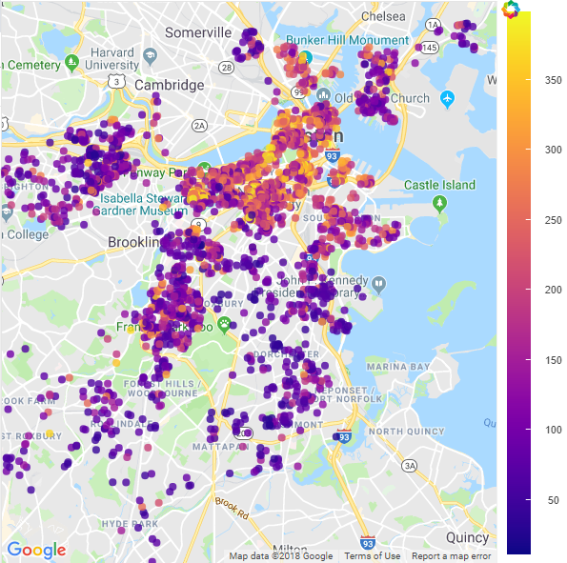

That's some of the most insightful data when it comes to tourist season, but what about location? Common sense does us good—the highest pricing and most money is in downtown. The first map demonstrates this. Those are most of the Boston Airbnb listings colored by average price.

Hardly any entrepreneur is looking to go where everybody else is already going, though. Good thing for us, Airbnb data provides some hidden insights. Instead of looking at all the data, let's look at a map with the zip codes that contain the most Airbnb listings. They're probably all close to downtown, right? Not so fast! The zip code that comes in at number two on the list of zip codes 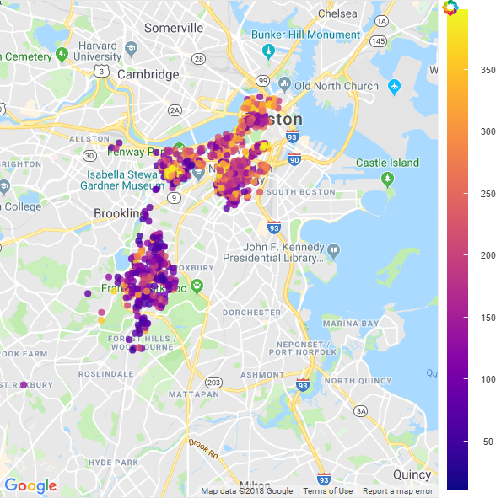with the most Airbnb listings is 02130, the Jamaica Plain/Stonybrook area. You can see it relatively far from downtown on our next map (where I've plotted all the Airbnb locations that lie in one of the top five zip codes based on total listings). It's the big clump of points south of Brookline. This zip code is also number one when it comes to the zip codes with the most Airbnb listings under $100.

So, if you're a Boston entrepreneur looking to make a quick buck off some tourists but not get lost in a crowd of downtown street marketers, the Boston Marathon is your time and Stonybrook (or just north) is your place!