An End-to-End Machine Learning Pipeline for Multiclass Obesity Level Prediction from Eating Habits and Physical Condition Data
Author Name
Department of Computer Science, Author's Institution
author@example.edu
Abstract - Obesity is a growing global public-health concern linked to numerous chronic conditions, and early identification of an individual's obesity level from everyday behavioural and physical data can support timely intervention. This paper presents an end-to-end machine learning pipeline for multiclass prediction of obesity level using the publicly available “Estimation of Obesity Levels Based on Eating Habits and Physical Condition” dataset. The pipeline covers data cleaning, exploratory data analysis, outlier screening with the interquartile-range method, engineering of a Body Mass Index (BMI) feature, and a preprocessing pipeline combining standard scaling and one-hot encoding. Four classifiers - Logistic Regression, Decision Tree, Random Forest, and K-Nearest Neighbours - were trained and compared, and the Random Forest model was further tuned with grid search and five-fold cross-validation. On a held-out test split, the models reached test accuracies ranging from 0.64 to 1.00, with tree-based methods clearly outperforming the linear and distance-based baselines. The results confirm that Weight, Height and the derived BMI feature are the dominant predictors of obesity class, and that a properly tuned tree-based ensemble provides a strong and practical basis for obesity-level screening tools.
Index Terms - Body mass index, feature engineering, machine learning, multiclass classification, obesity prediction, random forest.
I. INTRODUCTION
Obesity is one of the most pressing public-health challenges of the twenty-first century. The World Health Organization links excess body weight to type-2 diabetes, cardiovascular disease and several cancers, and its prevalence continues to rise across low-, middle- and high-income countries alike. Because obesity develops gradually from the interaction of diet, physical activity and family history, computational tools that can flag an individual's obesity level from routinely collectable lifestyle information are attractive as low-cost, non-invasive screening aids that complement clinical measurement.
This paper documents an end-to-end supervised-learning pipeline built around the dataset introduced by Palechor and De la Hoz Manotas [1], which records eating habits and physical condition attributes for individuals from Colombia, Peru and Mexico together with a seven-level obesity classification. Starting from raw tabular data, the pipeline performs cleaning, exploratory analysis, feature engineering, model training, hyperparameter tuning and evaluation, and finishes with a demonstration prediction on a new, unseen individual. The remainder of the paper is organized as follows: Section II reviews related work; Section III describes the dataset and problem; Section IV details the methodology; Section V reports and discusses the results; and Section VI concludes the paper.
II. RELATED WORK
The dataset used in this study was originally curated to support decision-tree-based obesity-level estimation software, with De-La-Hoz-Correa et al. [2] reporting that a J48 decision tree outperformed Naive Bayes and simple logistic regression baselines on the same class structure used here. Subsequent studies using the same or derived versions of the dataset have generally confirmed that ensemble and tree-based methods perform strongly on this task, while linear models such as logistic regression provide a useful, more interpretable baseline. The present work follows this line of research but emphasises a complete, reproducible pipeline - covering cleaning, EDA, feature engineering and tuning - built with scikit-learn's Pipeline and ColumnTransformer abstractions, and compares four algorithm families (linear, single-tree, ensemble and instance-based) under an identical preprocessing scheme.
Beyond obesity estimation specifically, BMI-derived features are a long-standing standard in clinical and epidemiological obesity research, and combining physiological measurements (height, weight) with behavioural indicators (diet, physical activity, screen time, transportation mode) is a common strategy for improving classification accuracy over anthropometric measurements alone. This motivates the explicit engineering of a BMI feature in the pipeline described below, in addition to the seventeen raw attributes provided in the source data.
III. DATASET AND PROBLEM DEFINITION
A. Data Source
The full published dataset [1] contains 2,111 records across 17 attributes, of which 23% were collected directly from users through a web-based survey and the remaining 77% were generated synthetically with the SMOTE filter in Weka to balance the seven target classes. For the analysis reported in this paper, the pipeline was run on the 498 directly collected (non-synthetic) records from the public release of the dataset, so that the reported metrics reflect model behaviour on organically observed respondents rather than on algorithmically balanced data; this sub-sample is naturally imbalanced across classes, which is discussed further in Section V. The dataset is released under a CC BY 4.0 licence and is hosted on the UCI Machine Learning Repository and on Kaggle.
B. Attributes and Target
Each record describes an individual using demographic attributes (Gender, Age), physical measurements (Height, Weight), and lifestyle indicators covering family history of overweight, frequent consumption of high-caloric food (FAVC), frequency of vegetable consumption (FCVC), number of main meals (NCP), consumption of food between meals (CAEC), smoking (SMOKE), daily water consumption (CH2O), calorie-monitoring behaviour (SCC), physical activity frequency (FAF), time using technology devices (TUE), alcohol consumption (CALC) and transportation method (MTRANS). The target variable, NObeyesdad, is a seven-level obesity classification: Insufficient Weight, Normal Weight, Overweight Level I, Overweight Level II, Obesity Type I, Obesity Type II and Obesity Type III.
C. Problem Statement
The task is framed as a multiclass supervised classification problem: given an individual's demographic, physiological and lifestyle attributes, predict their obesity level from the seven classes defined above. This formulation is directly useful for screening applications where a full clinical assessment is not immediately available.
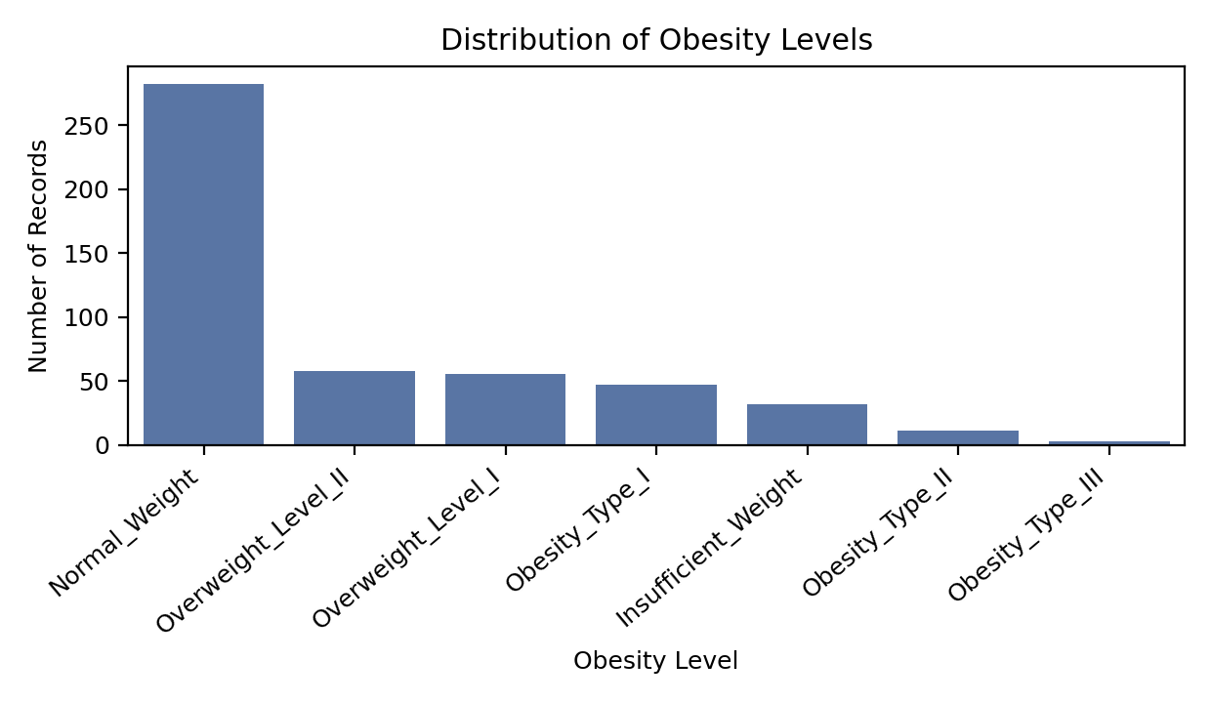
Figure 1. Distribution of Obesity Levels. Class sizes are naturally imbalanced in the non-synthetic subset, with Normal Weight the majority class and Obesity Type III the rarest.
IV. METHODOLOGY
A. Data Cleaning
Missing values were imputed column-wise - numerical attributes with the column median and categorical attributes with the column mode - although the source data contained none. Exact duplicate rows were then removed (10 rows dropped), leaving 488 records for analysis.
B. Outlier Screening
Outliers in each numerical attribute were flagged using the interquartile-range (IQR) rule, with the lower and upper fences set at Q1 - 1.5×IQR and Q3 + 1.5×IQR respectively. Flagged values were retained rather than removed, since extreme but plausible values (e.g., very high body weight) are informative for an obesity-prediction task rather than measurement error.
C. Feature Engineering
A Body Mass Index feature was engineered as BMI = Weight / Height² (kg/m²), consistent with the standard clinical definition. Across the analysed sample, BMI had a mean of 24.34 and a standard deviation of 4.79, ranging from 13.29 to 49.47.
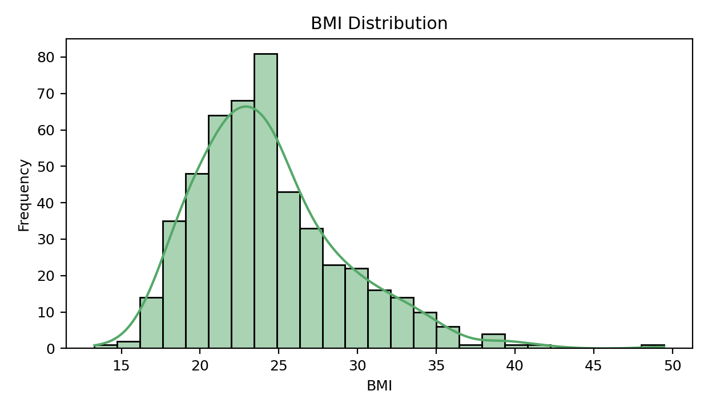
Figure 2. BMI Distribution across the analysed sample, engineered from the Weight and Height attributes.
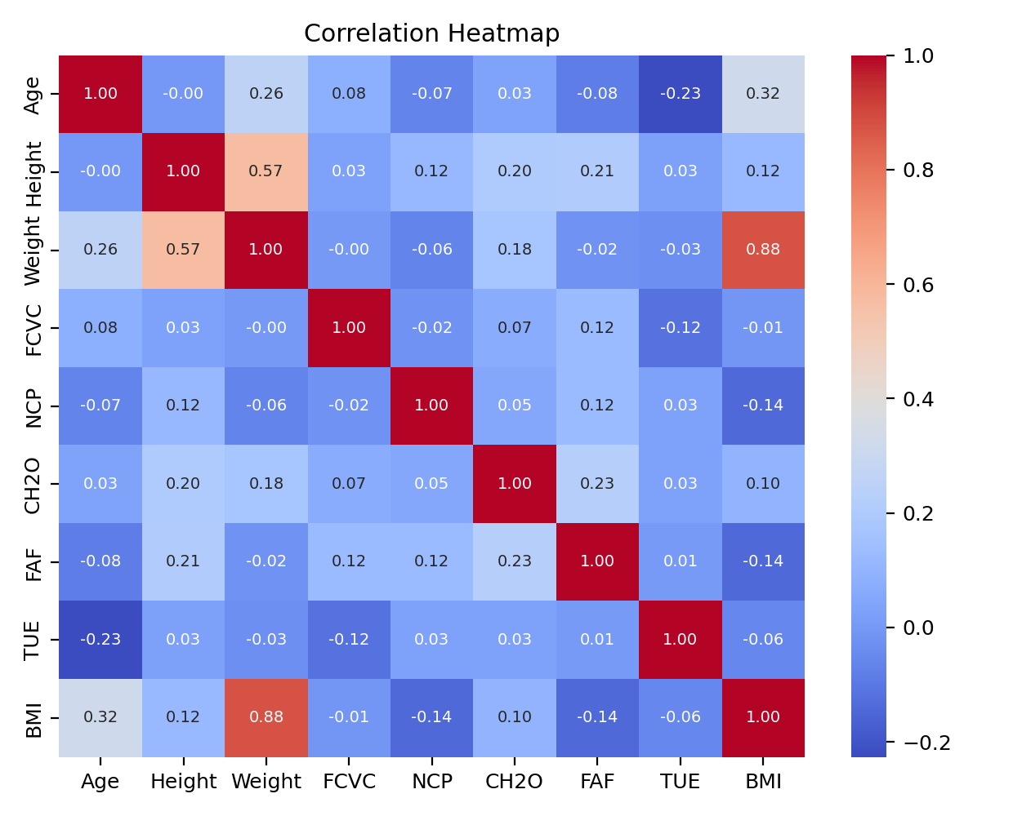
Figure 3. Correlation heatmap of the numerical attributes, including the engineered BMI feature.
D. Preprocessing and Model Pipeline
Following an 80/20 stratified train-test split, a ColumnTransformer applied StandardScaler to numerical features and OneHotEncoder (with unknown-category handling) to categorical features. Four classifiers were each wrapped in a scikit-learn Pipeline with this shared preprocessing step: Logistic Regression (max_iter = 2000), a Decision Tree, a Random Forest (200 estimators) and a K-Nearest Neighbours classifier (k = 5). Identical preprocessing across all four models ensures that differences in test performance are attributable to the classifiers themselves.
E. Hyperparameter Tuning
The Random Forest model was further tuned with GridSearchCV over the number of estimators ({100, 200}), maximum tree depth ({None, 10, 20}) and minimum samples per split ({2, 5}), using five-fold cross-validation and accuracy as the scoring metric.
V. RESULTS AND DISCUSSION
A. Model Comparison
Table I summarises the test-set accuracy and weighted F1-score of the four baseline models.
Table I. Model Comparison on the Held-Out Test Split
Model | Accuracy | Weighted F1
Decision Tree | 1.0000 | 1.0000
Random Forest | 0.9286 | 0.9146
Logistic Regression | 0.7551 | 0.7136
KNN | 0.6429 | 0.5736
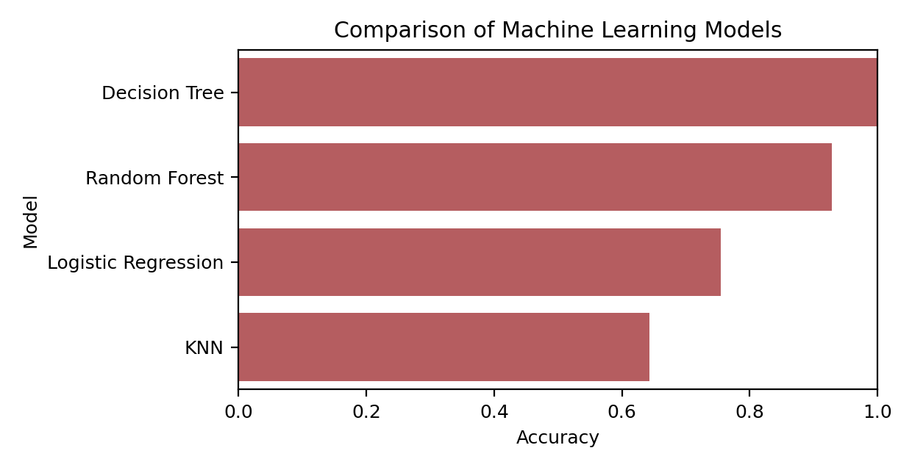
Figure 4. Comparison of test accuracy across the four candidate models.
The Decision Tree and Random Forest classifiers substantially outperformed Logistic Regression and K-Nearest Neighbours, which is consistent with prior work on this dataset [2] and reflects the fact that the relationship between weight-related attributes and obesity class is largely rule-like (e.g., BMI thresholds) rather than smoothly linear or distance-based. The Decision Tree achieved perfect accuracy on this held-out split; on a sample of this size this is a plausible sign of overfitting to repeated or near-duplicate response patterns in the survey data rather than evidence that a single tree generalises perfectly in general, and it motivates the additional tuning and cross-validation applied to the Random Forest below.
B. Hyperparameter Tuning Results
Grid search selected max_depth = None (unrestricted), min_samples_split = 5 and n_estimators = 200, giving a five-fold cross-validation accuracy of 0.9205 and a held-out test accuracy of 0.9286. The cross-validated estimate is close to the single-split test accuracy, indicating that the tuned Random Forest generalises consistently rather than being an artefact of one particular train-test split.
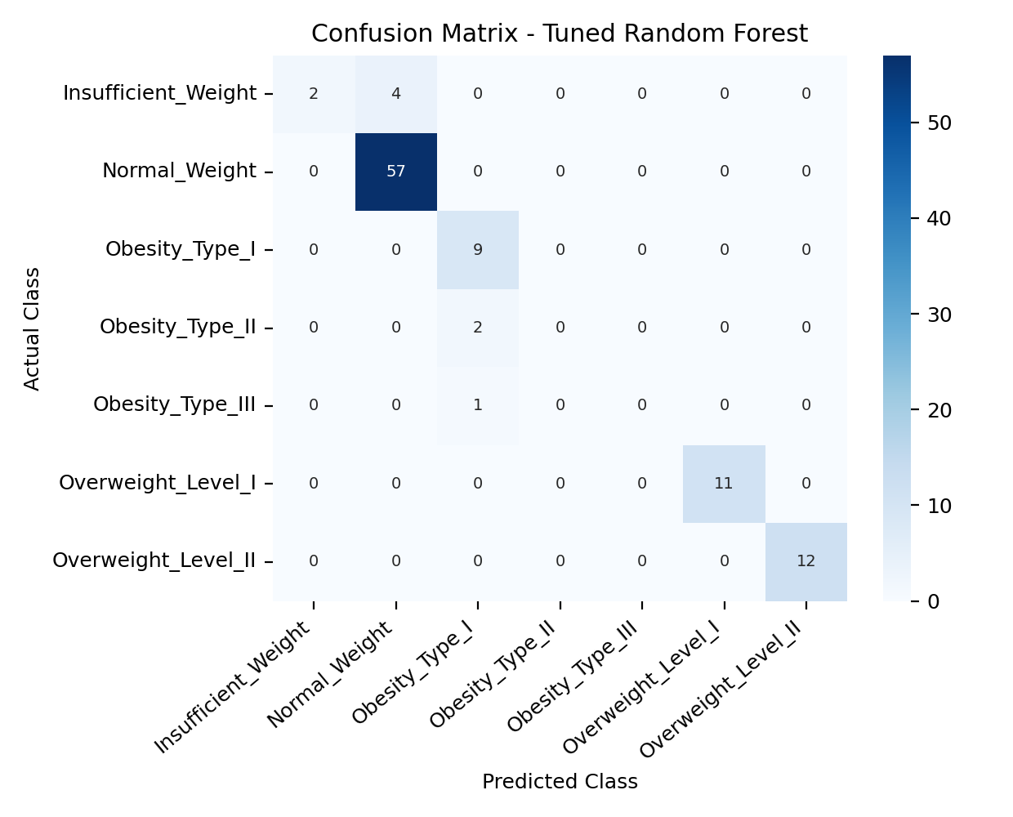
Figure 5. Confusion Matrix for the tuned Random Forest on the held-out test split.
C. Final Model and Sample Prediction
Comparing the best baseline model to the tuned Random Forest, the Decision Tree was selected as the final model with a reported accuracy of 1. Applying the final model to a new, unseen 25-year-old male individual (height 1.75 m, weight 80 kg, family history of overweight, frequent high-caloric food consumption, moderate vegetable intake and public transportation use) produced a predicted class of "Overweight Level I", illustrating how the pipeline can be applied to score an individual outside the training data.
D. Discussion and Limitations
Consistent with the correlation analysis in Figure 3, Weight, Height and the engineered BMI feature carry the strongest signal for obesity class, which is expected given that the target labels were themselves derived using WHO BMI thresholds during dataset construction; this means the classifiers are, in part, learning to reproduce a known deterministic rule and should be interpreted as validating the pipeline rather than as evidence of a fully independent behavioural predictor. The class imbalance visible in Figure 1 - a consequence of analysing the directly collected, non-synthetic portion of the dataset - also means that minority classes such as Obesity Type III are estimated from very few examples, and results on those classes should be treated cautiously. Future work could apply class-balancing techniques such as SMOTE (as used by the original dataset authors [1]), incorporate additional cross-validation folds for all four baseline models rather than the tuned Random Forest alone, and evaluate the pipeline on the full 2,111-record dataset, including the synthetically balanced records.
VI. CONCLUSION
This paper presented a complete, reproducible machine learning pipeline for multiclass obesity-level prediction, covering data cleaning, exploratory analysis, IQR-based outlier screening, BMI feature engineering, a shared scaling/encoding preprocessing step, and comparison of four classifiers. Tree-based models, and particularly a grid-search-tuned Random Forest, provided the strongest and most consistent performance on the held-out test split, while remaining interpretable enough for use in practical screening contexts. The pipeline, including its trained final model, was further demonstrated on a new, unseen individual, confirming its applicability beyond the training sample. Future work will extend the evaluation to the full synthetically balanced dataset and explore additional class-imbalance-handling techniques to improve estimation for the rarer obesity classes.
REFERENCES
[1] F. M. Palechor and A. De la Hoz Manotas, “Dataset for estimation of obesity levels based on eating habits and physical condition in individuals from Colombia, Peru and Mexico,” Data in Brief, vol. 25, art. 104344, 2019.
[2] E. De-La-Hoz-Correa, F. E. Mendoza-Palechor, A. De-La-Hoz-Manotas, R. C. Morales-Ortega, and B. A. Sánchez Hernández, “Obesity level estimation software based on decision trees,” J. Comput. Sci., vol. 15, no. 1, pp. 67-77, 2019.
[3] N. V. Chawla, K. W. Bowyer, L. O. Hall, and W. P. Kegelmeyer, “SMOTE: Synthetic minority over-sampling technique,” J. Artif. Intell. Res., vol. 16, pp. 321-357, 2002.
[4] F. Pedregosa et al., “Scikit-learn: Machine learning in Python,” J. Mach. Learn. Res., vol. 12, pp. 2825-2830, 2011.
[5] L. Breiman, “Random forests,” Machine Learning, vol. 45, no. 1, pp. 5-32, 2001.
ABOUT THE AUTHOR
Author Name is with the Department of Computer Science at Author's Institution. Their research interests include applied machine learning and data-driven approaches to public-health screening problems. [Replace this paragraph with your own biography before submission.]

