How To: Install antivirus software

1. A free option for antivirus software is AVG. You can find it by searching ‘avg antivirus’.

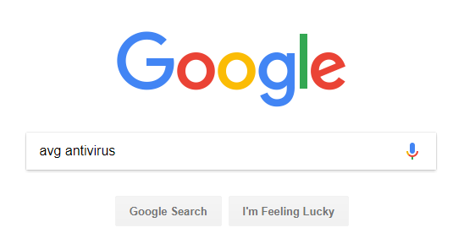

1. This is the link that you want to click on.

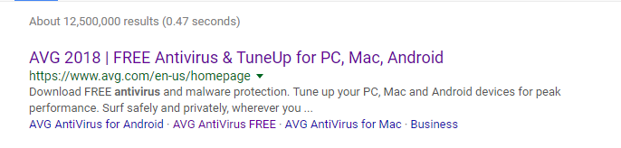

1. There is a free download option, or there is a paid subscription that you can do.



1. Hit the download button and allow it to install.