Supporting Information for:
Stereoisomerization of human constitutive androstane receptor agonist CITCO
Benjamin Diethelm-Varelaª, Anmol Kumarª, Caitlin Lynch^{b}, Gregory H. Imler^{c}, Jeffrey R. Deschamps^{c}, Yue Li^{d}, Menghang Xia^{b}, Alexander D. MacKerell Jr.ª, and Fengtian Xue*ª

ªDepartment of Pharmaceutical Sciences, University of Maryland School of Pharmacy, 20 Penn Street, Baltimore, Maryland 21201, United States
^{b}National Center for Advancing Translational Sciences, National Institutes of Health, Bethesda, Maryland 20892-3375, United States
^{c}Naval Research Laboratory, Code 6930, 4555 Overlook Avenue, Washington, D.C. 20375, United States
^{d}Department of Chemistry and Biochemistry, University of Maryland College Park, College Park, Maryland, 20740, USA

Studies on the stereoselectivity in the synthesis of CITCO
Scheme S2. Synthesis of CITCO
Reagents and conditions: (a) EtOH, reflux, 24, 80% (b) i) POCl3, DMF, rt, 3 h., ii) KOH, H2O, reflux, overnight, 95% (c) EtOH, AcOH, 70 °C, 16 h, 40%
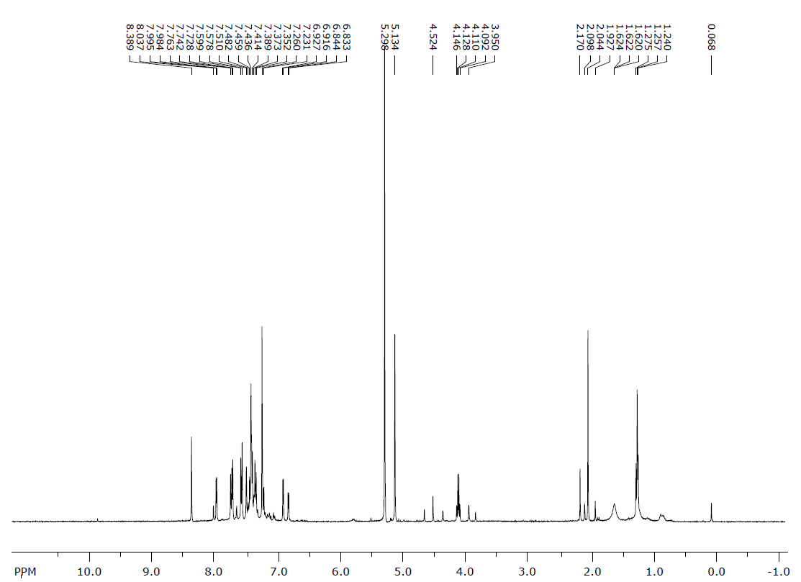
Figure S1. ¹H-NMR spectrum of a crude CITCO sample, immediately after synthesis. For spectra of purified CITCO stereoisomers refer to figs. S8-S13
Table S1. Synthetic study of the stereoselectivity of various CITCO-like imines and oximes ª

Z | Y | R | Yield (%) | Stereoselectivity
S | CH₂ | 3,4-diCl-Bn | 72 | Single isomer detected
S | O | H | 57 | Single isomer detected ^{b}
S | O | n-propyl | 57 | Single isomer detected
O | O | 3,4-diCl-Bn | 26 | 85%:15% E/Z mixture ^{c}
ª All reactions were performed in ethanol at 70°C using 5 equivalents of acetic acid
^{b} Product rapidly isomerizes. Stereoselectivity determined by NMR analysis of the crude product
^{c} Proportion estimated from NMR signal intensity ratios in the crude product spectrum
Scheme S2. Observed deformylation side-reaction on the CITCO synthesis
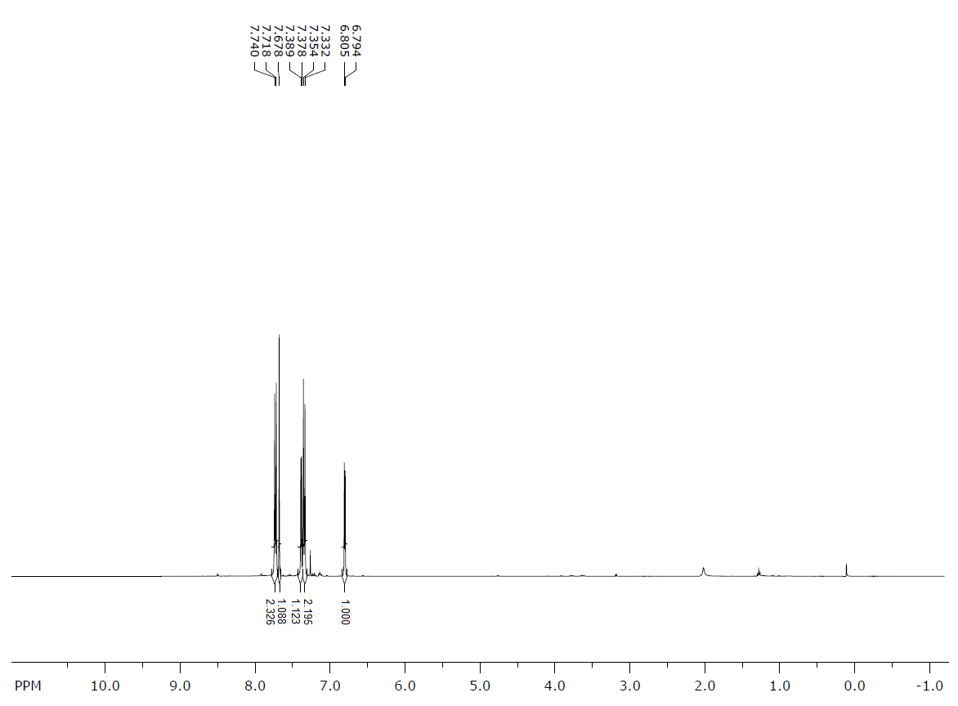
Figure S2. ¹H-NMR spectrum of the purified deformylation byproduct
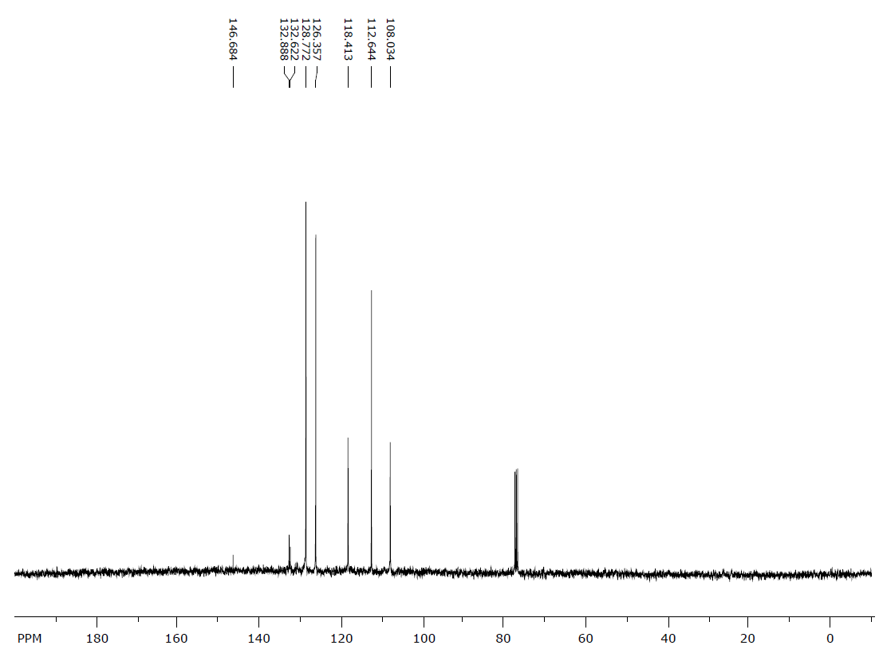
Figure S3. ¹³C-NMR spectrum of the purified deformylation byproduct

Studies on the stereoisomerization of CITCO
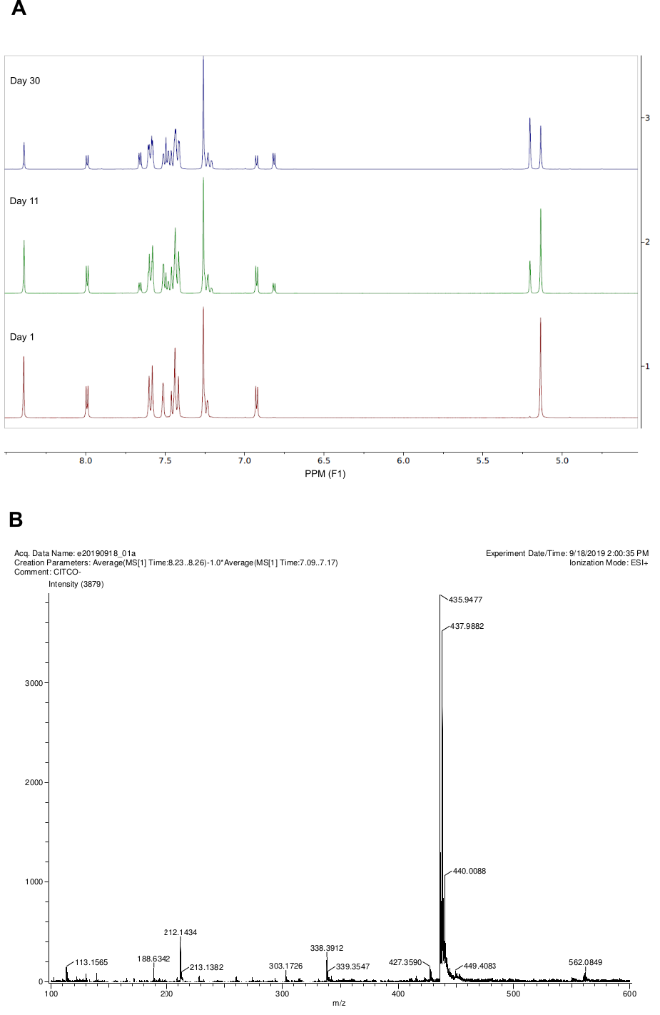
Figure S4. A: ¹H-NMR spectrum of a purified CITCO sample, re-acquired over time. B: HRMS spectrum of a purified CITCO sample. Samples with different NMR compositions show indistinguishable MS spectra
Figure S5. Isomerization kinetics of E-CITCO (16 mM) in different solvent systems. Freshly–purified E-CITCO was dissolved in either CDCl3 (red) or DMSO-d6 (magenta), and 1H-NMR spectra were recorded over time at room temperature. The proportion of each isomer was estimated by the ratio of their NMR signals’ intensities. To gain mechanistic insights, additional samples for NMR kinetic studies were prepared by dissolving CITCO in CDCl3 with the addition of either: 2% D2O by volume (cyan), 4% D2O by volume (blue), 1 equiv. of TEA (orange), or 1 equiv. of TFA (green)
Scheme S3. A: Nucleophilic catalysis mechanism for the stereoisomerization of imines and related compounds. B: Protonation-rotation mechanism for the stereoisomerization of imines and related compounds
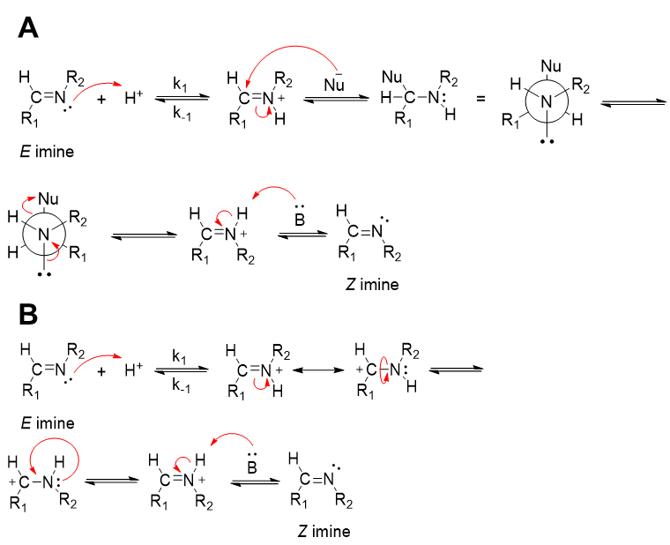
Figure S6. Isomerization kinetics of CITCO at different concentrations. Full time range of experiments is shown

¹H, ¹³C NMR, NOESY and HRMS Spectra of novel compounds
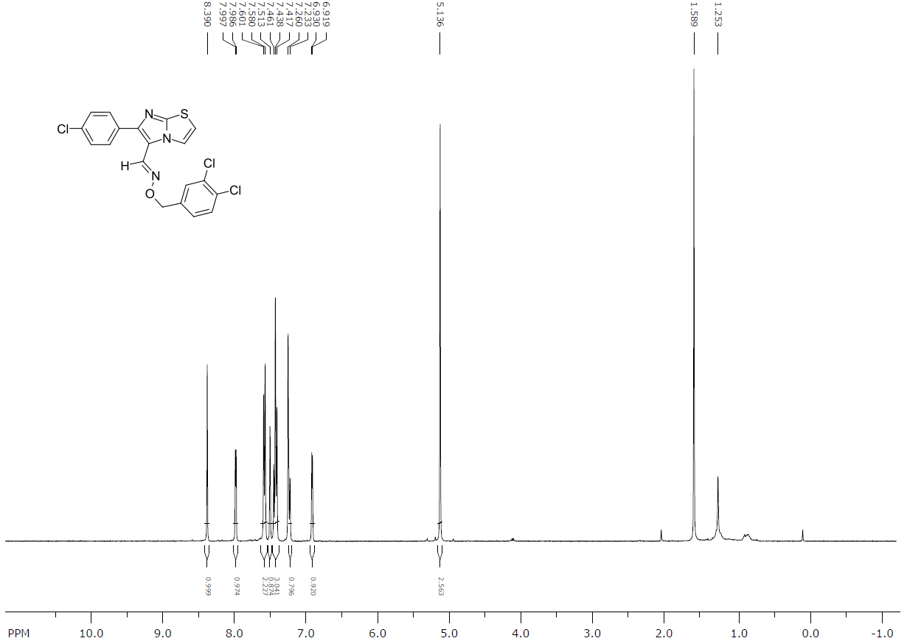
Figure S7. ¹H-NMR spectrum of (E)-6-(4-chlorophenyl)imidazo[2,1-b]thiazole-3-carbaldehyde O-(3,4-dichlorobenzyl) oxime (E-CITCO) in CDCl₃
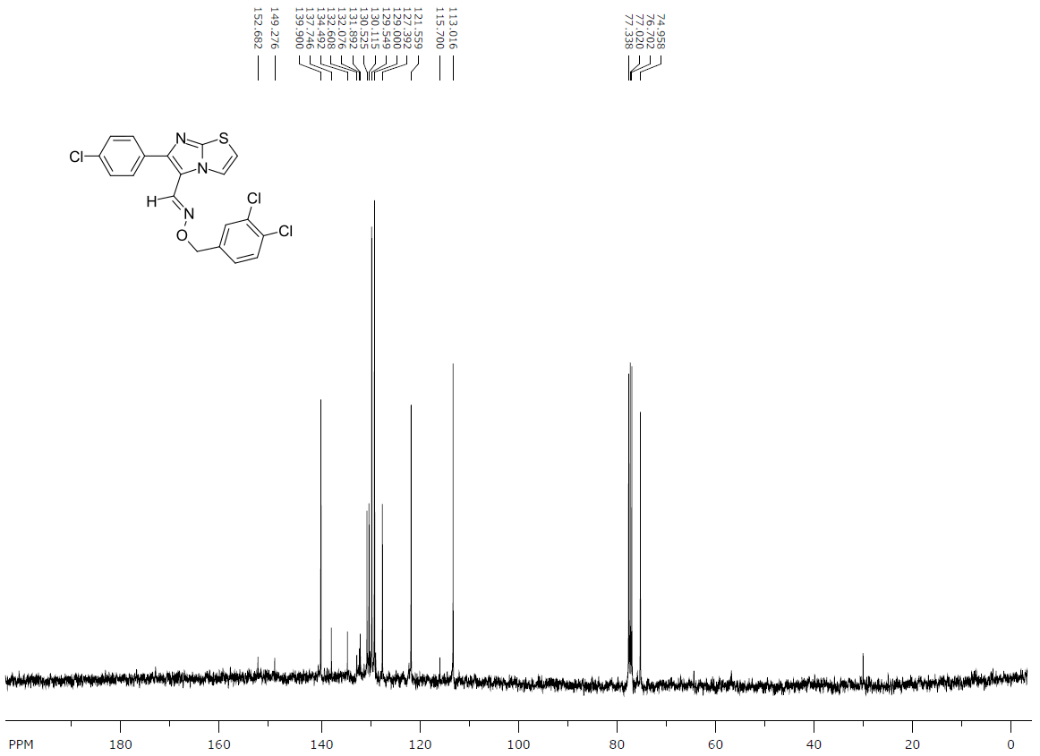
Figure S8. ¹³C-NMR spectrum of (E)-6-(4-chlorophenyl)imidazo[2,1-b]thiazole-3-carbaldehyde O-(3,4-dichlorobenzyl) oxime (E-CITCO) in CDCl₃
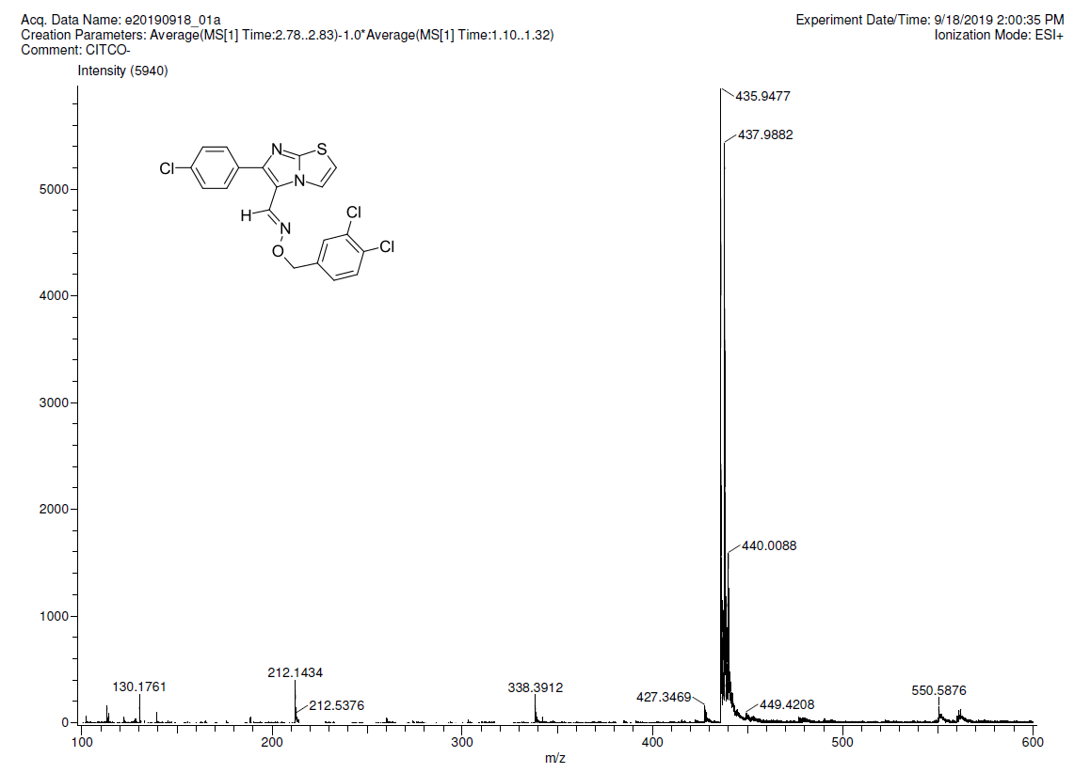
Figure S9. HRMS spectrum of (E)-6-(4-chlorophenyl)imidazo[2,1-b]thiazole-3-carbaldehyde O-(3,4-dichlorobenzyl) oxime (E-CITCO)
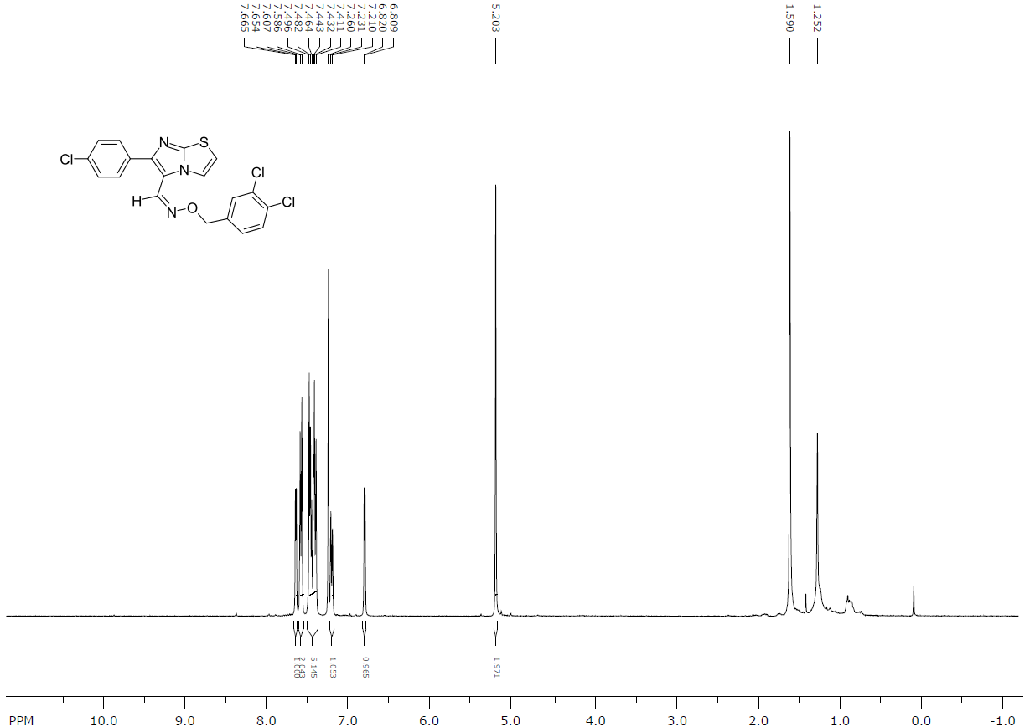
Figure S10. ¹H-NMR spectrum of (Z)-6-(4-chlorophenyl)imidazo[2,1-b]thiazole-3-carbaldehyde O-(3,4-dichlorobenzyl) oxime (Z-CITCO) in CDCl₃
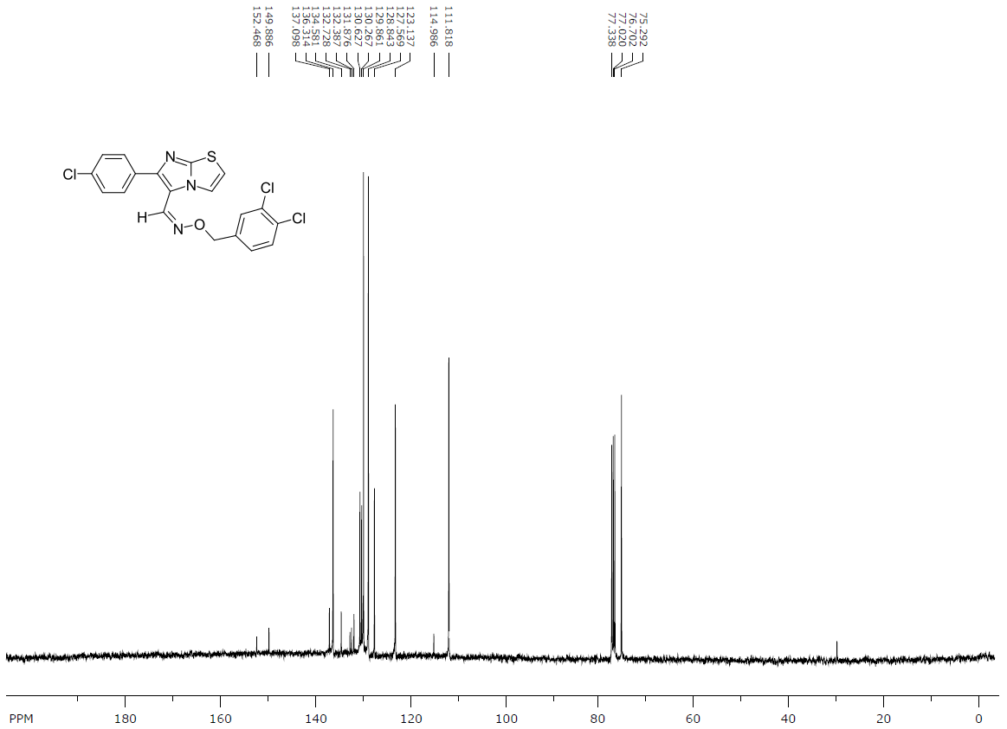
Figure S11. ¹³C-NMR spectrum of (Z)-6-(4-chlorophenyl)imidazo[2,1-b]thiazole-3-carbaldehyde O-(3,4-dichlorobenzyl) oxime (Z-CITCO) in CDCl₃
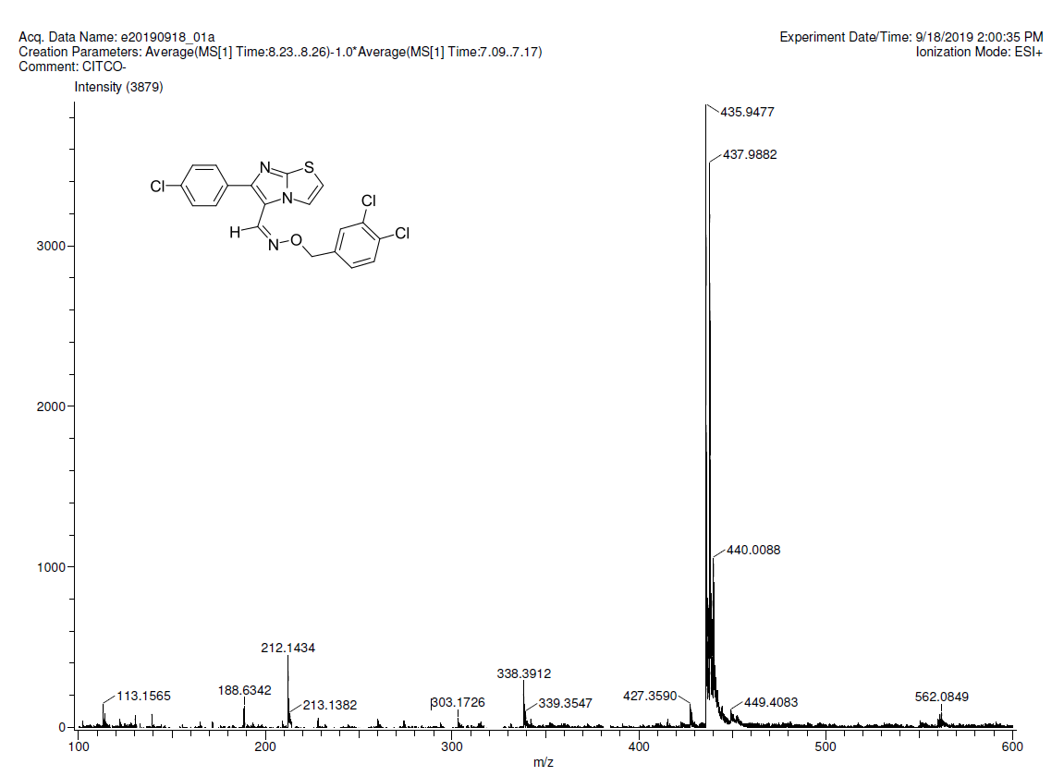
Figure S12. HRMS spectrum of (Z)-6-(4-chlorophenyl)imidazo[2,1-b]thiazole-3-carbaldehyde O-(3,4-dichlorobenzyl) oxime (Z-CITCO)
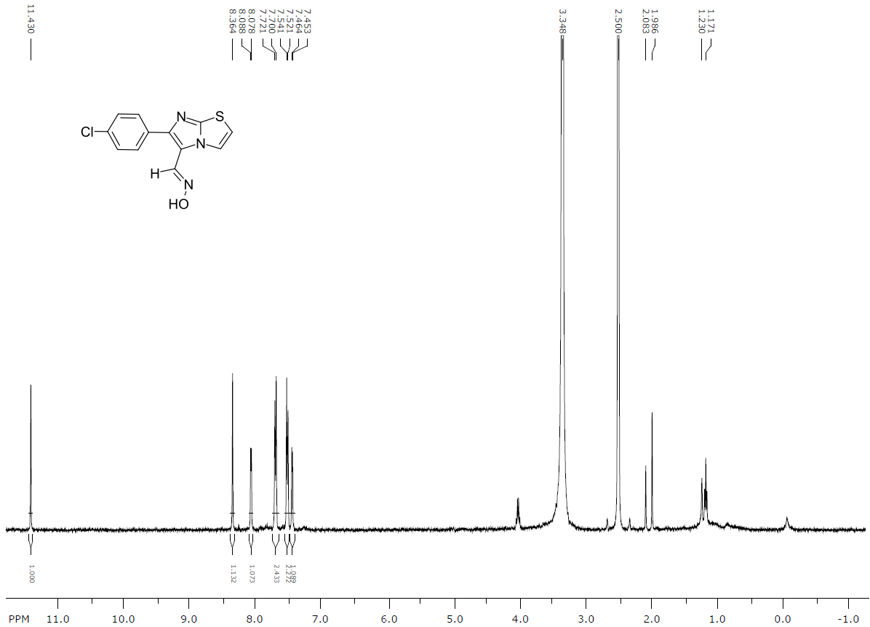
Figure S13. ¹H-NMR spectrum of 6-(4-chlorophenyl)imidazo[2,1-b]thiazole-5-carbaldehyde oxime in DMSO-d₆
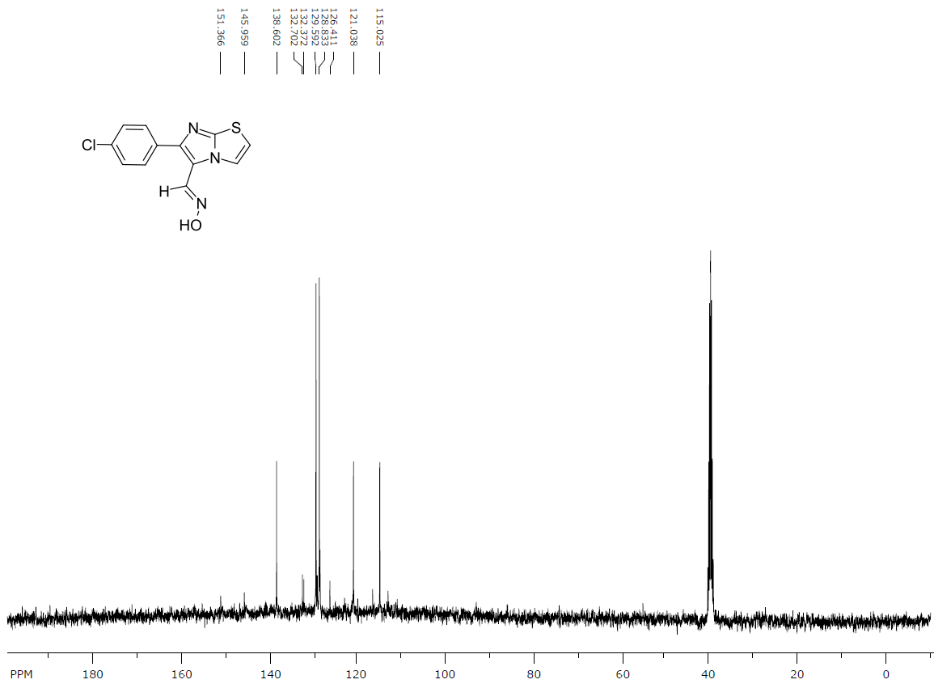
Figure S14. ¹³C-NMR spectrum of 6-(4-chlorophenyl)imidazo[2,1-b]thiazole-5-carbaldehyde oxime in DMSO-d₆
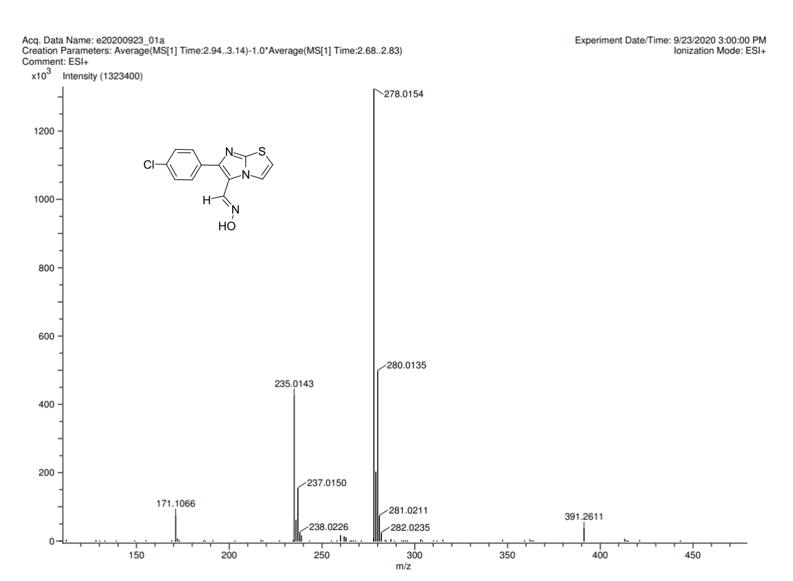
Figure S15. HRMS spectrum of 6-(4-chlorophenyl)imidazo[2,1-b]thiazole-5-carbaldehyde oxime
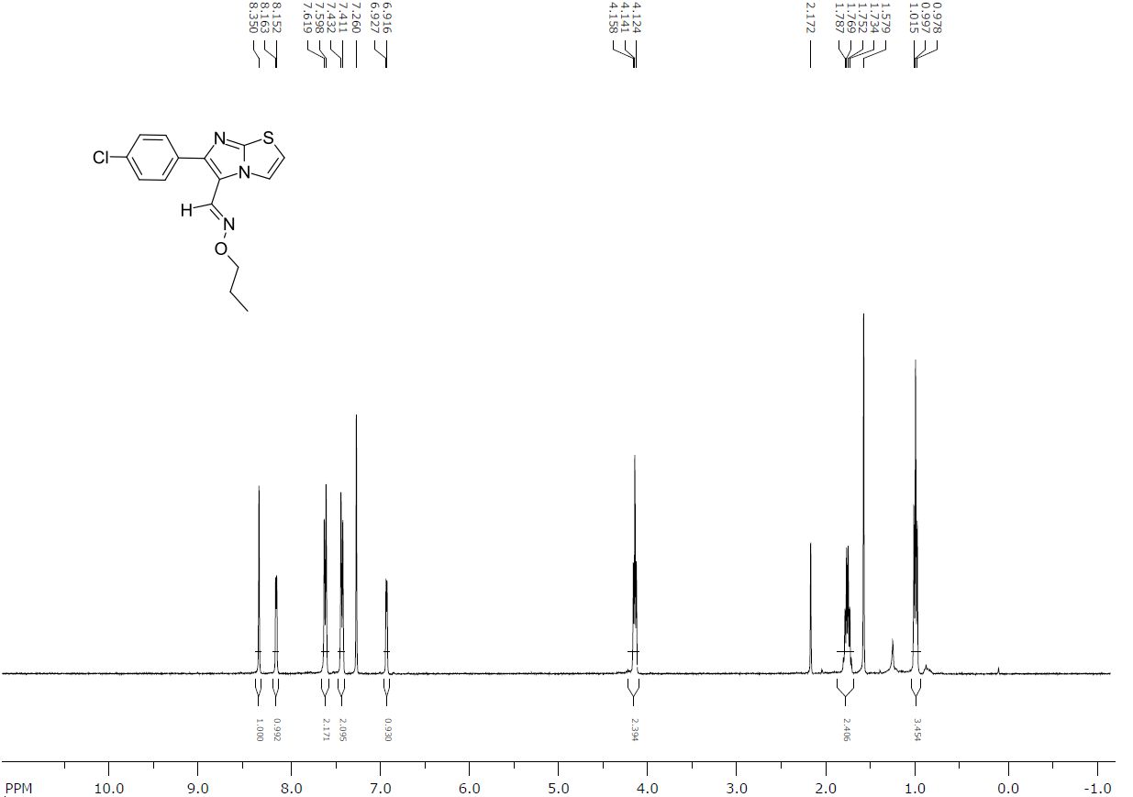
Figure S16. ¹H-NMR spectrum of 6-(4-chlorophenyl)imidazo[2,1-b]thiazole-5-carbaldehyde O-propyl oxime in CDCl₃
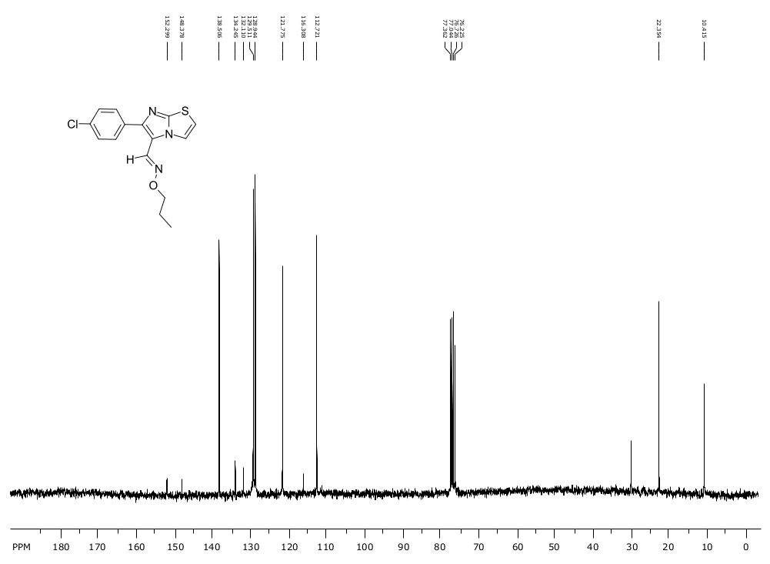
Figure S17. ¹³C-NMR spectrum of 6-(4-chlorophenyl)imidazo[2,1-b]thiazole-5-carbaldehyde O-propyl oxime in CDCl₃
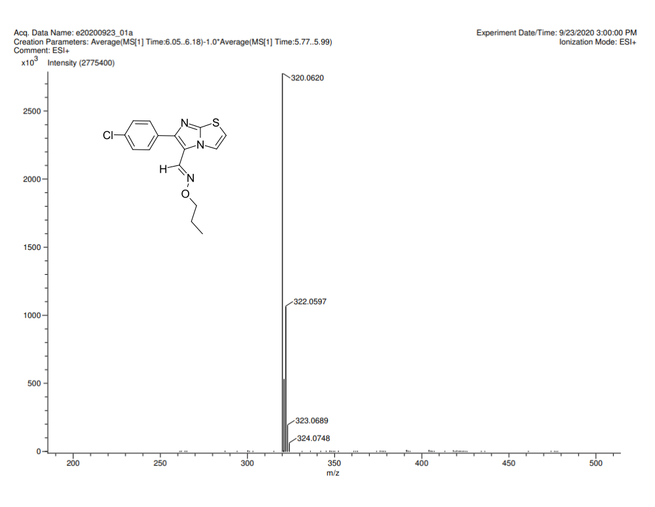
Figure S18. HRMS spectrum of 6-(4-chlorophenyl)imidazo[2,1-b]thiazole-5-carbaldehyde O-propyl oxime
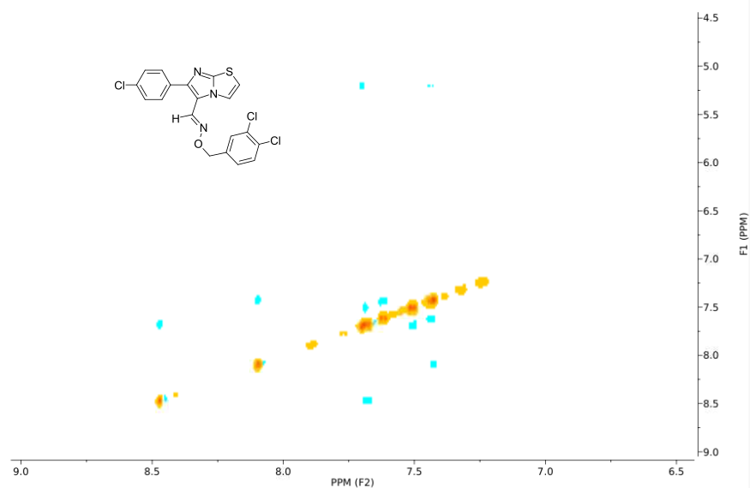
Figure S19. NOESY spectrum of E-CITCO acquired in a DMSO-d₆-D₂O 9:1 mixture
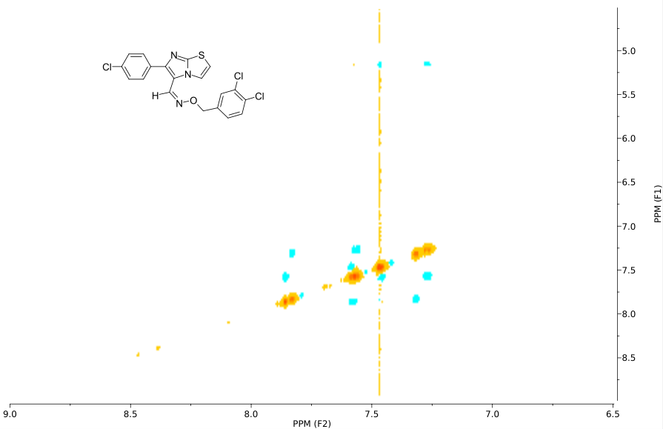
Figure S20. NOESY spectrum of Z-CITCO acquired in a DMSO-d₆-D₂O 9:1 mixture
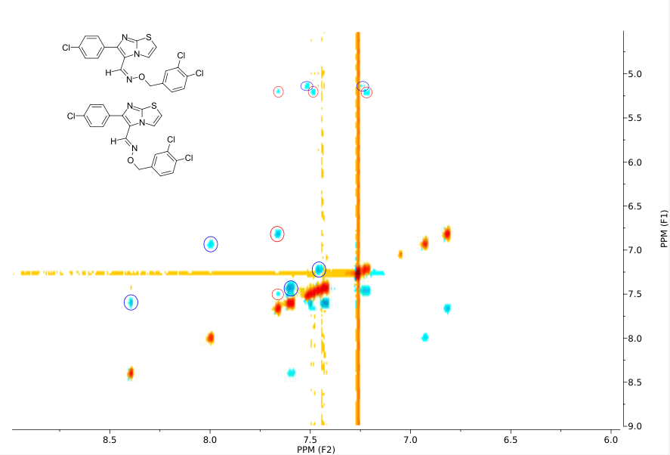
Figure S21. NOESY spectrum of a mixture of CITCO isomers acquired in CDCl₃. Blue circles: E-CITCO crosspeaks. Red circles: Z-CITCO crosspeaks

