SYNAPSESCM – PROCUREMENT COST INTELLIGENCE
Turning Procurement Data into Cost Visibility and Smarter Purchasing Decisions
Abstract
Procurement cost management is an important aspect of supply chain operations, as purchasing decisions directly influence the overall cost of an organization. This project, “SynapseSCM – Procurement Cost Intelligence,” focuses on developing a Power BI-based dashboard for analyzing procurement-related costs from supplier, product, purchasing, and market perspectives. The project uses internal procurement datasets along with supporting external data related to currency exchange rates, crude oil, copper prices, interest rates, and Producer Price Index. The data was examined and prepared by identifying missing values, duplicate records, inconsistent formats, invalid numeric values, and other data quality issues. Excel and Power Query were used for data cleaning and transformation, while Power BI and DAX were used for data modeling, KPI calculation, and dashboard development. The dashboard presents procurement spend, quantity ordered, unit cost, discounts, savings, freight cost, supplier ratings, supplier status, product-level costs, and relevant market indicators through interactive KPIs, charts, filters, and navigation. The developed dashboard provides a consolidated view of procurement information and helps identify major cost contributors, compare suppliers and products, monitor procurement expenditure, and understand external factors that may influence purchasing costs. The project demonstrates the practical use of business data analysis and visualization techniques for improving procurement cost visibility and supporting informed purchasing decisions.

TABLE OF CONTENTS

S/No | Contents
1 | Introduction
2 | Problem Statement
3 | Business Objectives
4 | Dataset Information
5 | Data Understanding
6 | Data Cleaning
7 | Exploratory Data Analysis
8 | Dashboard Development
9 | Key Insights
10 | Business Recommendations
11 | Limitations
12 | Future Scope
13 | Conclusion
14 | References
15 | Appendixx

1. Introduction
Data analytics is an important part of modern business operations because organizations generate large amounts of data through their daily activities. Sales, purchasing, suppliers, products, inventory, transportation, and financial activities all produce information that can be analyzed to understand business performance. Data analytics helps convert raw data into useful information by identifying patterns, comparing values, measuring performance, and finding areas that require attention. Data visualization makes these findings easier to understand through charts, tables, KPIs, and interactive reports.
Procurement is one of the important areas where data analysis can support business decisions. Procurement involves purchasing products and materials from suppliers, and each transaction may contain information such as supplier, product, quantity, unit cost, purchase order value, discount, freight cost, payment terms, and dates. When the number of suppliers and transactions increases, it becomes difficult to review this information manually. It may also be difficult to identify which suppliers, products, or categories contribute the most to procurement expenditure. A structured data analysis approach can provide better visibility into these costs.
The SynapseSCM – Procurement Cost Intelligence project was developed to analyze procurement-related information and present it through an interactive Power BI dashboard. The project focuses on the Procurement Cost Intelligence domain. Its main purpose is to provide a consolidated view of procurement expenditure, supplier contribution, product costs, discounts, savings, freight costs, and supporting market information. The project uses Power BI as the main reporting platform, with Excel and Power Query used for data preparation and DAX used for calculations and KPIs.
The project uses internal procurement information related to suppliers, products, orders, purchase transactions, and other business activities. Supporting external information such as currency exchange rates, crude oil prices, copper prices, interest rates, and Producer Price Index data is also included to provide additional market context. These external indicators help in reviewing procurement costs alongside changes in the wider market.
Before creating the dashboard, the datasets were examined to understand their structure and quality. Several data quality issues were identified, including missing values, duplicate records, inconsistent text values, different date formats, invalid numeric values, blank fields, and unwanted symbols in some columns. These issues were reviewed and cleaned using Excel and Power Query. The cleaned data was then prepared for analysis in Power BI.
A structured data model was created using fact and dimension tables. Supplier, product, and date information were connected with procurement transactions through appropriate relationships. This model allows procurement data to be analyzed by supplier, product, country, category, and date. DAX measures were created for important indicators such as total procurement spend, active suppliers, active supplier percentage, total discount value, total savings, average unit cost, average freight cost, and quantity ordered.
The Power BI dashboard is organized into different analytical pages within the same Procurement Cost Intelligence project. The Procurement Overview page provides a high-level view of procurement activity. The Procurement Spend Analysis page focuses on cost-related information such as procurement spend, discounts, savings, unit cost, freight cost, and quantity ordered. The Supplier Intelligence page examines supplier contribution, supplier ratings, status, country, and payment terms. The Product Intelligence page provides product-level analysis of quantities, costs, categories, and procurement values.
Interactive filters are provided to allow users to examine the information according to their requirements. Depending on the page, users can filter by supplier, country, supplier rating group, status, payment terms, product, category, and date. Different visualizations are used according to the type of analysis, including KPI cards, bar charts, column charts, line charts, donut charts, scatter charts, maps, and other suitable visuals.
The main purpose of the dashboard is to improve procurement cost visibility. For example, suppliers with high procurement expenditure can be reviewed for pricing and purchasing conditions, while products with high unit costs or procurement values can be examined for possible cost-saving opportunities. Discounts, savings, and freight costs can also be reviewed together with procurement expenditure to obtain a clearer understanding of purchasing costs.
Overall, the SynapseSCM – Procurement Cost Intelligence project demonstrates the practical use of data analytics, data preparation, data modeling, DAX calculations, and Power BI visualization in procurement. The dashboard brings procurement information into one report and provides different views for analyzing spending, suppliers, products, and market conditions. It can support regular procurement monitoring, cost comparison, supplier review, and informed purchasing decisions.

2. Problem Statement
The procurement data contains information about suppliers, products, purchase orders, quantities, costs, discounts, freight, and deliveries, but it is difficult to understand all this information from separate datasets. It is not easy to identify which suppliers and products contribute the highest procurement cost. Tracking discounts, savings, unit costs, and freight costs also requires manual checking. Supplier ratings and status need to be considered while reviewing procurement spending. Changes in external factors such as currency rates and commodity prices may also affect procurement costs. Therefore, a simple and organized dashboard is needed to bring the information together, analyze the major cost areas, and help users understand procurement spending and make better purchasing decisions.
3. Business Objectives
The main objective of the SynapseSCM – Procurement Cost Intelligence project is to analyze procurement-related data and provide a clear view of purchasing costs, supplier performance, product costs, and related market information. The analysis is intended to help understand where procurement expenditure is concentrated and identify areas where better cost control and purchasing decisions may be possible.
3.1 Business Objectives
- Analyze the total procurement expenditure and understand the major components contributing to procurement cost.
- Identify suppliers with high procurement spending and compare their contribution to overall procurement expenditure.
- Analyze products and product categories that account for a significant portion of procurement spending.
- Examine unit cost, quantity ordered, discounts, savings, and freight costs to understand the major cost drivers.
- Evaluate suppliers using available information such as supplier rating, status, country, and payment terms.
- Use external market indicators such as exchange rates, crude oil prices, copper prices, interest rates, and PPI to provide additional context for procurement cost analysis.
- Develop an interactive Power BI dashboard that allows users to analyze procurement information using KPIs, charts, filters, and different analytical pages.
3.2 Business Questions
The analysis is designed to answer the following six key business questions:
1. Which suppliers contribute the highest procurement expenditure, and what factors are associated with these costs?
2. Which products and procurement categories account for the largest share of procurement spending?
3. How has procurement spending changed over time, and which periods show significant changes in expenditure?
4. How do unit cost, quantity ordered, discounts, savings, and freight costs contribute to the overall procurement cost?
5. How do supplier characteristics such as rating, status, country, and payment terms relate to procurement spending?
6. How do external market indicators such as exchange rates, crude oil, copper prices, interest rates, and PPI provide additional context for changes in procurement costs?
4. Dataset Information
The SynapseSCM – Procurement Cost Intelligence project uses datasets collected from internal business records and external sources. These datasets were selected to support procurement cost, supplier, product, and market-related analysis. The data was reviewed, cleaned, transformed, and prepared before being used in Power BI.
Datasets Used
- Orders Dataset – Contains order-level information used to understand purchasing transactions and order activity.
- Order Details Dataset – Contains product-level details such as quantity, price, and other information related to individual orders.
- Sales Target Dataset – Contains target values used for comparing actual business performance with planned targets.
- Suppliers Dataset – Contains supplier details such as supplier name, country, rating, status, and payment terms.
- Products Dataset – Contains product information used for product-level procurement and cost analysis.
- Purchase Orders Dataset – Contains purchase order information such as order value, quantity, unit cost, discounts, and procurement-related costs.
- Shipment Dataset – Contains shipment information used to examine shipment status and delivery-related procurement activities.
- Currency Exchange Rate Dataset – Contains exchange-rate information used to provide market context for procurement costs involving different currencies.
- Copper Price Dataset – Contains copper price information used to monitor changes in a commodity that can influence material-related procurement costs.
- Crude Oil Price Dataset – Contains crude oil price information used to provide context for transportation and energy-related cost changes.
- Interest Rate Dataset – Contains interest-rate information used as an external economic indicator for procurement and business cost analysis.
- Producer Price Index (PPI) Dataset – Contains producer price information used to understand changes in the prices of goods and production-related costs.
File | Purpose | Records
Suppliers.xlsx | Supplier Master Data | 1,000
Products.xlsx | Product Master Data | 5,000
Inventory.xlsx | Inventory Stock Data | 50,000
Warehouses.xlsx | Warehouse Master Data | 50
Purchase_Orders.xlsx | Procurement Transaction Data | 20,000
Shipments.xlsx | Shipment & Logistics Data | 15,000
ExchangeRates.xlsx | Currency Exchange Rates | 166
Copper.xlsx | Copper Market Prices | 252
CrudeOil.xlsx | Crude Oil Market Prices | 252
InterestRates.xlsx | Federal Interest Rates | 864
ProducerPriceIndex.xlsx | Producer Price Index (PPI) | 1,362

5. Data Understanding
Objective
The objective of this stage was to profile the internal ERP datasets and external market datasets in Excel before performing data cleaning and transformation in Power Query. The datasets were examined to understand their structure, data types, completeness, consistency, and potential data quality issues. The identified issues and the actions taken during data preparation were documented for reference.
Tasks
- Opened and reviewed all available datasets.
- Checked row and column counts.
- Identified missing and blank values.
- Checked for duplicate records.
- Validated date formats.
- Checked column data types.
- Identified invalid, negative, and unusual numeric values.
- Checked inconsistent text and categorical values.
- Documented observations and corrective actions.

Data Quality Report
Issue | Column | Count | Action Taken
Missing Values | SupplierRating | 71 | Replaced missing values with 0.
Missing Values | FacilityManager | 6 | Replaced blank values with "Unknown".
Duplicate Records | SupplierID, PO_Number, SupplierName | 56 | Retained the first valid record and removed duplicate occurrences.
Invalid Date Format | OrderDate, ShipDate, ExpectedDeliveryDate | 6,222 | Standardized all date values into a consistent date format.
Blank Values | Country, ReorderPoint | 1,076 | Replaced blank values using the appropriate validated values available in the dataset.
Blank Values | ActualDeliveryDate | Business Scenario | Replaced blank values where applicable based on the available shipment information and delivery status.
Invalid Numeric Values | BaseFreightCost | 148 | Replaced the invalid/missing value using the median of valid values.
Missing Financial Values | UnitCost, TotalPOValue | 2 | Replaced missing values with 0.
Invalid Numeric Values | BaseUnitCost_USD | 34 | Replaced negative values using the median of valid values.
Invalid Numeric Values | QuantityAvailable | Business Rule | Recalculated using QuantityOnHand − QuantityAllocated.
Currency Symbols / Units | Currency-related numeric fields | Variable | Removed currency symbols such as $ and ₹ and unit text, then converted the values to numeric format.
Inconsistent Text Values | Status, Carrier, TransportMode, PaymentTerms, Currency | 7,428 | Standardized inconsistent text values into consistent formats.

6. Data Cleaning
The data cleaning stage was carried out after the initial data understanding and quality assessment. The purpose of this stage was to improve the consistency, completeness, and usability of the datasets before loading the prepared data into Power BI. The identified issues were addressed using Excel and Power Query based on the nature of each field and the requirements of the procurement analysis.
The following cleaning activities were performed:
- Missing and blank values were identified and reviewed across the datasets to determine the appropriate treatment for each field.
- Missing supplier rating values were replaced with 0 where a numeric value was required for supplier analysis.
- Blank categorical values were replaced with meaningful values such as "Unknown" where the actual value was not available.
- Duplicate records were identified and removed based on relevant identifying fields such as SupplierID, PO_Number, and SupplierName, while retaining the first valid record.
- Date fields were standardized so that OrderDate, ShipDate, ExpectedDeliveryDate, and other relevant date columns followed a consistent date format.
- Data types were corrected for numerical, date, text, and categorical columns to ensure that each field could be used correctly in calculations and visualizations.
- Invalid and negative numeric values were reviewed and corrected in procurement-related fields such as unit cost, freight cost, and other financial measures.
- Missing financial values were replaced where required, ensuring that procurement calculations did not contain unintended blank values.
- Freight cost values were checked and corrected where missing or invalid entries were identified.
- Quantity-related values were validated using business rules, including recalculation of available quantity where required from related quantity fields.
- Currency symbols and unit text were removed from numeric fields, allowing financial and quantity values to be converted into proper numeric data types.
- Inconsistent text values were standardized for fields such as Status, Carrier, TransportMode, PaymentTerms, and Currency.
- Column names and field formats were standardized to maintain consistency across the datasets and make them easier to use during data modeling.
- Unnecessary rows and invalid records were reviewed and removed where they did not contain useful information for the analysis.
- The cleaned datasets were validated again after transformation to confirm that the major data quality issues identified during the initial assessment had been addressed.

7. Feature Engineering(Calculated Columns)
Feature engineering was performed to create additional analytical fields from the existing procurement data. These fields were created to make supplier, product, procurement cost, and performance analysis easier in Power BI. In addition to calculated columns, DAX measures were created for KPI calculations and dashboard reporting.
The calculated columns were mainly used for classification and grouping, while measures were used for dynamic calculations that respond to filters and slicers.

7.1 Calculated Columns

1. Supplier Rating Group
The supplier rating was grouped into categories so that suppliers could be compared more easily.
Supplier Rating Group =
SWITCH(
TRUE(),
Dim_Suppliers[SupplierRating] >= 4, "High Rated",
Dim_Suppliers[SupplierRating] >= 3, "Medium Rated",
"Low Rated"
)
Purpose: Used to compare high-, medium-, and low-rated suppliers in charts and filters.

2. Supplier Status Group
Supplier status was classified into a simple business category.
Supplier Status Group =
IF(
Dim_Suppliers[Status] = "Active",
"Active",
"Inactive"
)
Purpose: Used to analyze the active and inactive supplier base.

3. Procurement Cost Category
Procurement spending can be grouped into cost bands for easier comparison.
Procurement Cost Category =
SWITCH(
TRUE(),
Fact_Purchase_Orders[TotalPOValue] >= 100000, "High Cost",
Fact_Purchase_Orders[TotalPOValue] >= 50000, "Medium Cost",
"Low Cost"
)
Purpose: Helps identify high-value and low-value purchase orders.

4. Unit Cost Category
Unit costs were grouped into categories to support product cost comparison.
Unit Cost Category =
SWITCH(
TRUE(),
Fact_Purchase_Orders[UnitCost] >= 1000, "High Unit Cost",
Fact_Purchase_Orders[UnitCost] >= 500, "Medium Unit Cost",
"Low Unit Cost"
)
Purpose: Used to identify products or purchase transactions with relatively high unit costs.

5. Purchase Quantity Category
Purchase quantities were classified into different ranges.
Purchase Quantity Category =
SWITCH(
TRUE(),
Fact_Purchase_Orders[Quantity] >= 1000, "High Quantity",
Fact_Purchase_Orders[Quantity] >= 500, "Medium Quantity",
"Low Quantity"
)
Purpose: Helps compare purchasing activity based on order quantity.

6. Delivery Status Group
Shipment or delivery status can be grouped into broader categories.
Delivery Status Group =
SWITCH(
TRUE(),
Fact_Shipments[Status] = "Delivered", "Delivered",
Fact_Shipments[Status] = "In Transit", "In Transit",
"Other"
)
Purpose: Used to simplify shipment-status analysis in the dashboard.

7. Order Year
A year column can be extracted from the procurement order date.
Order Year =
YEAR(Fact_Purchase_Orders[OrderDate])
Purpose: Used for yearly procurement analysis.

8. Order Month
A month name can be created for monthly analysis.
Order Month =
FORMAT(Fact_Purchase_Orders[OrderDate], "MMM")
Purpose: Used for monthly procurement trend analysis.
For proper chronological sorting, a separate month number can also be created:
Order Month Number =
MONTH(Fact_Purchase_Orders[OrderDate])

9. Procurement Year-Month
A year-month field can be created for time-based analysis.
Procurement Year Month =
FORMAT(Fact_Purchase_Orders[OrderDate], "YYYY-MM")
Purpose: Used to identify procurement spending patterns across months and years.

7.2 Calculated Measures
Measures were created using DAX to calculate the main procurement KPIs dynamically. Unlike calculated columns, these measures respond to filters, slicers, supplier selections, product selections, and date selections in the dashboard.

1. Total Procurement Spend
Total Procurement Spend =
SUM(Fact_Purchase_Orders[TotalPOValue])
Purpose: Calculates the total value of procurement transactions.

2. Total Purchase Orders
Total Purchase Orders =
COUNTROWS(Fact_Purchase_Orders)
Purpose: Shows the total number of purchase order records.

3. Total Suppliers
Total Suppliers =
DISTINCTCOUNT(Dim_Suppliers[SupplierID])
Purpose: Shows the number of unique suppliers.

4. Active Suppliers
Active Suppliers =
CALCULATE(
DISTINCTCOUNT(Dim_Suppliers[SupplierID]),
Dim_Suppliers[Status] = "Active"
)
Purpose: Shows the number of currently active suppliers.

5. Active Supplier %
Active Supplier % =
DIVIDE(
[Active Suppliers],
[Total Suppliers],
0
)
Purpose: Measures the percentage of suppliers that are currently active.

6. High Rated Suppliers
High Rated Suppliers =
CALCULATE(
DISTINCTCOUNT(Dim_Suppliers[SupplierID]),
Dim_Suppliers[SupplierRating] >= 4,
Dim_Suppliers[Status] = "Active"
)
Purpose: Identifies active suppliers with a rating of 4 or above.

7. Total Procurement Quantity
Total Procurement Quantity =
SUM(Fact_Purchase_Orders[Quantity])
Purpose: Shows the total quantity purchased.

8. Average Unit Cost
Average Unit Cost =
AVERAGE(Fact_Purchase_Orders[UnitCost])
Purpose: Shows the average cost per purchased unit.

9. Total Freight Cost
Total Freight Cost =
SUM(Fact_Purchase_Orders[BaseFreightCost])
Purpose: Measures the total freight cost associated with procurement.

10. Total Discount
If your dataset contains a discount amount:
Total Discount =
SUM(Fact_Purchase_Orders[DiscountAmount])
Purpose: Shows the total discount received on procurement transactions.

11. Total Savings
If savings are available as a separate field:
Total Savings =
SUM(Fact_Purchase_Orders[Savings])
Purpose: Measures the total savings generated through procurement transactions.

12. Average Procurement Order Value
Average Procurement Order Value =
DIVIDE(
[Total Procurement Spend],
[Total Purchase Orders],
0
)
Purpose: Shows the average procurement value per purchase order.

13. Procurement Spend per Supplier
Procurement Spend per Supplier =
DIVIDE(
[Total Procurement Spend],
[Total Suppliers],
0
)
Purpose: Shows the average procurement expenditure associated with each supplier.

14. Supplier Procurement Spend Contribution %
Supplier Procurement Spend Contribution % =
DIVIDE(
[Total Procurement Spend],
CALCULATE(
[Total Procurement Spend],
ALL(Dim_Suppliers[SupplierName])
),
0
)
Purpose: Shows how much each supplier contributes to the overall procurement expenditure.

15. Procurement Spend Previous Year
Procurement Spend LY =
CALCULATE(
[Total Procurement Spend],
SAMEPERIODLASTYEAR('Date Dimension'[Date])
)
Purpose: Compares current procurement spending with the corresponding previous-year period.

16. Procurement Spend YoY Growth %
Procurement Spend YoY Growth % =
DIVIDE(
[Total Procurement Spend] - [Procurement Spend LY],
[Procurement Spend LY],
0
)
Purpose: Shows the percentage increase or decrease in procurement spending compared with the previous year.

7.3 KPI Target Measures
Where KPI visuals require targets, separate target measures were created.

Active Supplier Target
Active Supplier Target =
IF(
NOT ISBLANK([Active Supplier %]),
0.90,
BLANK()
)
Target: 90%

Procurement Spend Target
For a previous-period comparison:
Procurement Spend Target =
IF(
NOT ISBLANK([Total Procurement Spend]),
[Procurement Spend LY],
BLANK()
)
Purpose: Provides a comparison value for the current procurement spend against the previous year's corresponding period.

High Rated Supplier Target
High Rated Supplier Target =
IF(
NOT ISBLANK([High Rated Suppliers]),
[Total Suppliers] * 0.50,
BLANK()
)
Purpose: Provides a benchmark based on 50% of the supplier base.
8. Exploratory Data Analysis (EDA)
Exploratory Data Analysis was performed to understand the structure, distribution, relationships, categories, trends, and unusual observations present in the procurement datasets. The analysis was carried out in a structured sequence using dataset overview, descriptive statistics, distribution analysis, categorical analysis, correlation analysis, time-series analysis, missing-value analysis, and outlier detection. The results obtained during these stages were reviewed before proceeding with dashboard development.
8.1 Dataset Overview
The datasets were initially reviewed to understand their size, structure, number of records, number of columns, field names, and the type of information available in each dataset. This stage provided an overall understanding of the data before detailed analysis was performed.
Place your Dataset Overview output here.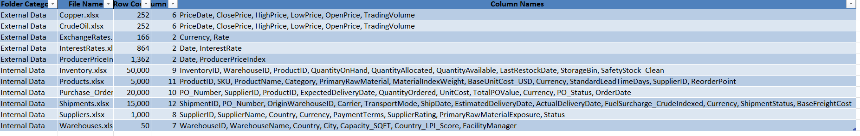 Figure 8.1 – Dataset Overview
8.2 Descriptive Statistics
Descriptive statistics were calculated for relevant numerical fields to understand the central values and variation in the procurement data. Measures such as count, minimum, maximum, mean, median, and standard deviation were examined for fields such as procurement value, quantity, unit cost, freight cost, and other numerical variables.
Dataset : Product
Column1 | Count | Minimum | Maximum | Average | Median | Standard Deviation
MaterialIndexWeight | 5000 | 0.2 | 0.8 | 0.54 | 0.65 | 0.21
BaseUnitCost_USD | 5000 | 6.76 | 3198.12 | 1608.97 | 1627.74 | 923.45
StandardLeadTimeDays | 5000 | -10 | 90 | 44.12 | 45 | 27.34
ReorderPoint | 5000 | 0 | 500 | 271.12 | 250 | 204.38
Dataset : Suppliers
Column1 | Count | Minimum | Maximum | Average | Median | Standard Deviation
SupplierRating | 1000 | 0 | 5 | 3.37 | 3.53 | 1.22
Dataset : Inventory
Column1 | Count | Minimum | Maximum | Average | Median | Standard Deviation
QuantityOnHand | 50000 | 0 | 35000 | 17117.46 | 17131 | 10318.04
QuantityAllocated | 50000 | 0 | 7500 | 3747.49 | 3748 | 2159.61
QuantityAvailable | 50000 | 0 | 34904 | 14070.44 | 13334.5 | 9606.95
SafetyStock_Clean | 50000 | 250 | 1000 | 515.58 | 500 | 308.99
Dateset : Warehouses
Column1 | Count | Minimum | Maximum | Average | Median | Standard Deviation
Capacity_SQFT | 50 | 379186 | 653816 | 481992.7 | 452237 | 98623.43
Country_LPI_Score | 50 | 3.8 | 4.2 | 3.98 | 3.9 | 0.15
Dataset : Purchase_Orders
Column1 | Count | Minimum | Maximum | Average | Median | Standard Deviation
QuantityOrdered | 20000 | -500 | 15000 | 7276.42 | 7310 | 4462.59
UnitCost | 20000 | 0 | 2500 | 1163.06 | 1147.46 | 762.67
TotalPOValue | 20000 | 0 | 36993572 | 8786523 | 6346646 | 8270526.94
Dataset : Shipments
Column1 | Count | Minimum | Maximum | Average | Median | Standard Deviation
FuelSurcharge_CrudeIndexed | 15000 | 62.97 | 8515.04 | 2905.56 | 2663.2 | 1880.84
BaseFreightCost | 15000 | 0 | 24497.32 | 11672.67 | 11515.4 | 7320.63
Dataset : EchangeRates
Column1 | Count | Minimum | Maximum | Average | Median | Standard Deviation
Rate | 166 | 0.02 | 1364235 | 9796.06 | 22.76 | 106050.97
Dataset : Copper
Column1 | Count | Minimum | Maximum | Average | Median | Standard Deviation
ClosePrice | 252 | 4.33 | 6.65 | 5.53 | 5.73 | 0.63
HighPrice | 252 | 4.4 | 6.65 | 5.57 | 5.75 | 0.64
LowPrice | 252 | 4.32 | 6.63 | 5.48 | 5.63 | 0.63
OpenPrice | 252 | 4.39 | 6.65 | 5.53 | 5.68 | 0.64
TradingVolume | 252 | 0 | 41200 | 1797.32 | 948.5 | 4247.14
Dateset : CrudeOil
Column1 | Count | Minimum | Maximum | Average | Median | Standard Deviation
PriceDate | 252 | 45862 | 46227 | 46044.04 | 46044.5 | 106.44
ClosePrice | 252 | 55.27 | 112.95 | 72.93 | 64.72 | 15.82
HighPrice | 252 | 56.7 | 119.48 | 74.72 | 65.47 | 17.06
LowPrice | 252 | 54.98 | 109.2 | 71.17 | 63.64 | 14.6
OpenPrice | 252 | 55.23 | 112.96 | 73.02 | 64.65 | 15.91
TradingVolume | 252 | 0 | 1107193 | 292620.99 | 271966.5 | 147608.56
Dataset : Interest_Rates
Column1 | Count | Minimum | Maximum | Average | Median | Standard Deviation
InterestRate | 864 | 0.05 | 19.1 | 4.6 | 4.26 | 3.53
8.3 Distribution Analysis
Distribution analysis was performed to understand how numerical variables were spread across the datasets. Histograms and related summaries were used to examine procurement values, quantities, unit costs, freight costs, and other relevant numerical fields. This analysis helped identify concentration, variation, and unusual patterns in the data.
Purchase_Orders_TotalPOValue
Shows the distribution of total purchase order values.
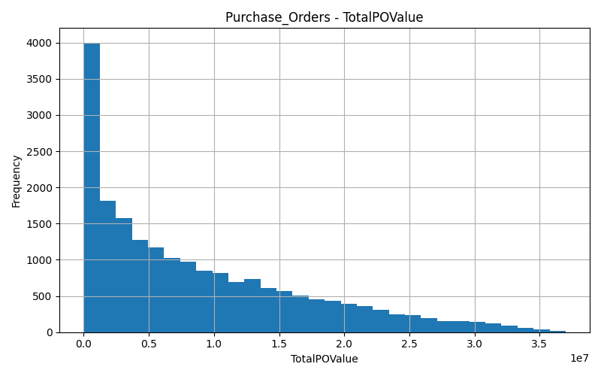
Figure: Distribution of Total Procurement Value
2. Purchase_Orders_UnitCost
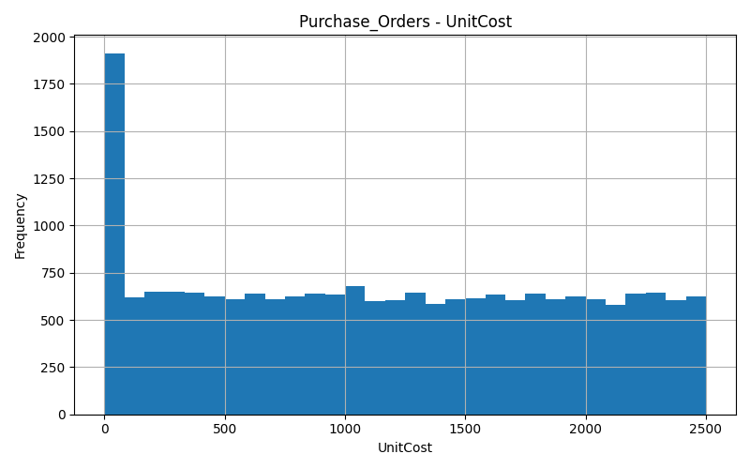
Figure: Distribution of Procurement Unit Cost
3.Shipments_BaseFreightCost
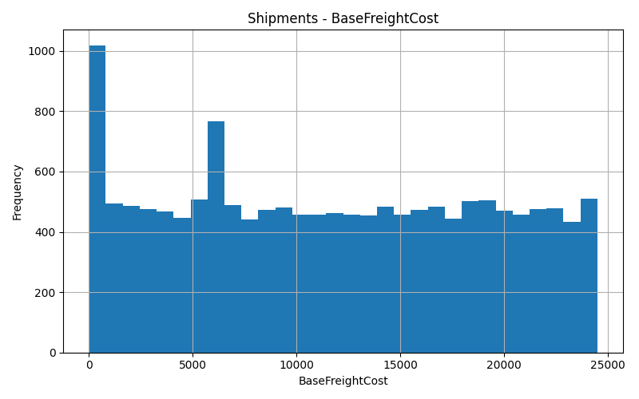
Figure: Distribution of Base Freight Cost
8.4 Categorical Analysis
Categorical analysis was performed to understand the composition of the procurement data across different groups. Supplier status, supplier rating groups, countries, product categories, currencies, payment terms, shipment status, and other categorical fields were examined where applicable. This analysis helped identify the major groups within the supplier and procurement datasets and provided a basis for comparing procurement activity across categories.

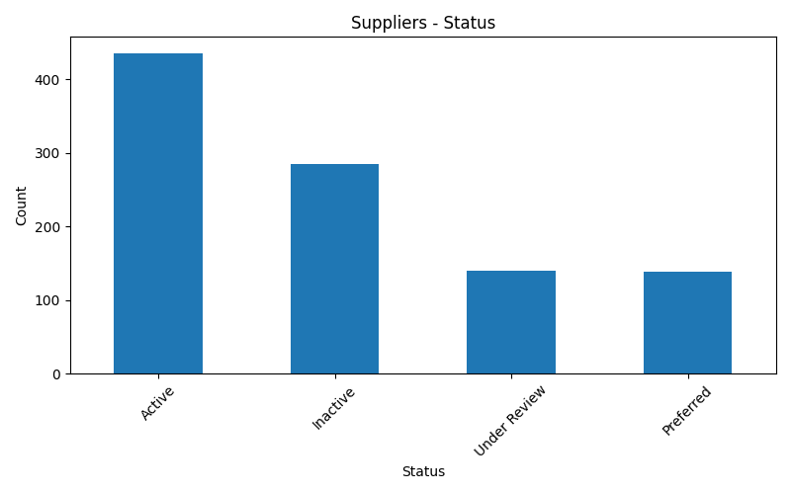
8.5 Correlation Analysis
Correlation analysis was performed to examine relationships between relevant numerical variables. The analysis was used to understand whether changes in one variable were associated with changes in another variable. Procurement-related variables such as quantity, unit cost, procurement value, freight cost, and other available numerical measures were compared where appropriate.
The correlation results were used only to identify relationships in the data and were not treated as evidence of a direct cause-and-effect relationship.
Product coreleation :
Column1 | MaterialIndexWeight | BaseUnitCost_USD | StandardLeadTimeDays | ReorderPoint
MaterialIndexWeight | 1 | -0.011609008 | 0.015749251 | -0.002902646
BaseUnitCost_USD | -0.011609008 | 1 | 0.000813471 | 0.004595234
StandardLeadTimeDays | 0.015749251 | 0.000813471 | 1 | 0.01346381
ReorderPoint | -0.002902646 | 0.004595234 | 0.01346381 | 1
Inventory coreleation:
Column1 | QuantityOnHand | QuantityAllocated | QuantityAvailable | SafetyStock_Clean
QuantityOnHand | 1 | -0.007961864 | 0.965025444 | -0.00785073
QuantityAllocated | -0.007961864 | 1 | -0.174606472 | 0.000824223
QuantityAvailable | 0.965025444 | -0.174606472 | 1 | -0.008910169
SafetyStock_Clean | -0.00785073 | 0.000824223 | -0.008910169 | 1
8.6 Time Series Analysis
Time series analysis was performed using date-related procurement information to understand how procurement activity and costs changed over time. Monthly, quarterly, or yearly patterns were examined depending on the available data. This helped identify periods with higher or lower procurement activity and changes in procurement expenditure.
Copper Price Trend:
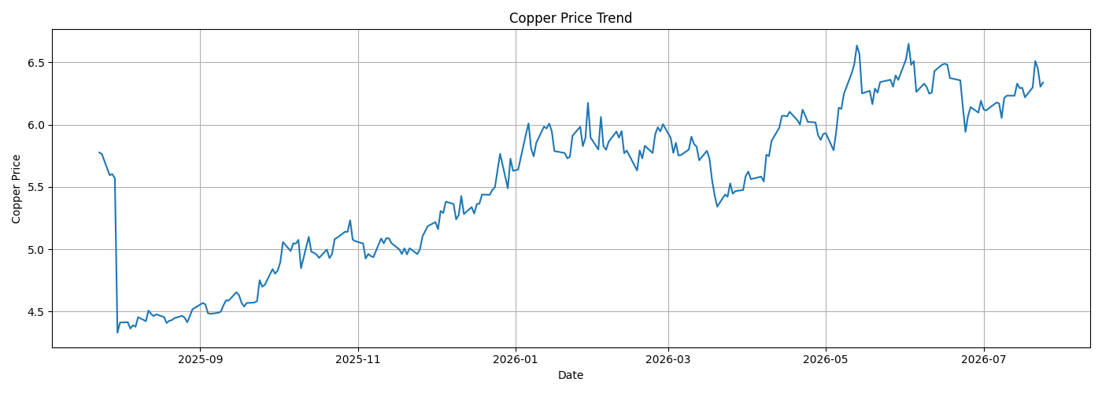
Figure – Procurement Cost Trend Over Time

Monthly Procurement Spend :
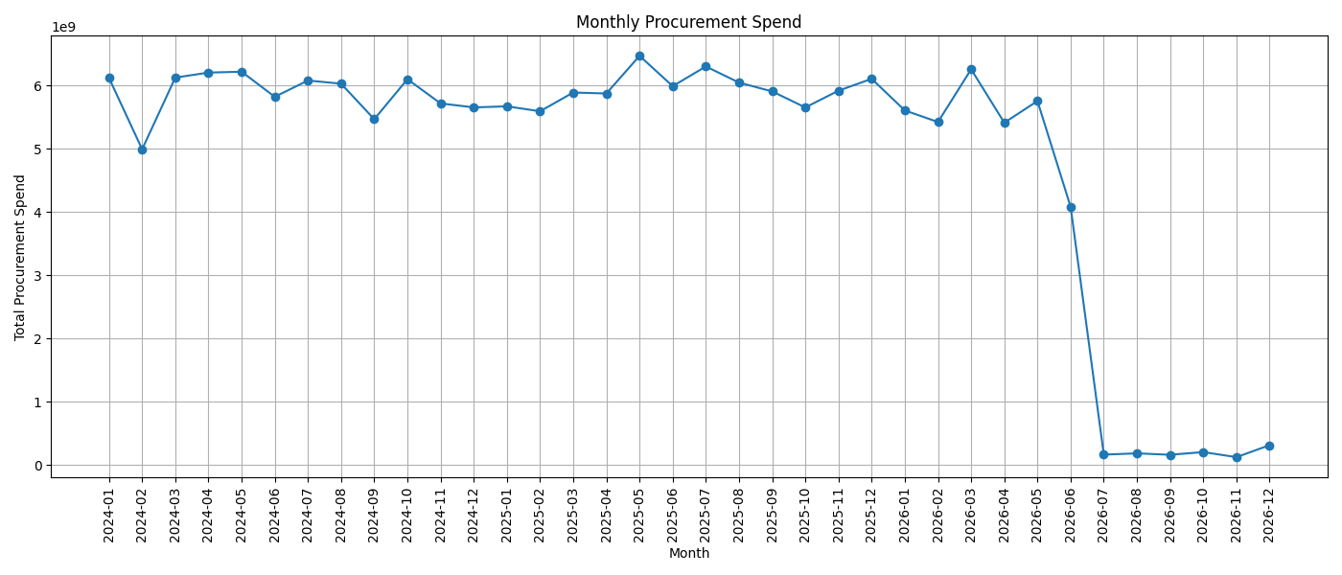
Figure – Procurement Activity Trend Over Time
8.7 Missing Value Analysis
Missing value analysis was performed to identify fields containing blank or missing entries. The results were reviewed to determine the extent of missing information and to decide the appropriate treatment during the data cleaning stage.
The missing-value findings were compared with the data quality assessment before the datasets were prepared for Power Query and Power BI.
8.8 Outlier Detection
Outlier detection was performed to identify unusually high or low observations in the numerical procurement fields. The analysis helped identify values that required further examination during data cleaning, particularly in financial, quantity, freight, and cost-related fields.
The identified observations were reviewed before deciding whether they represented genuine business values or required correction.

Outlier Report:
Column | Minimum | Maxi  mum | Lower Limit | Upper Limit | Outlier Count
QuantityOnHand | 0 | 35000 | -18734 | 53010 | 0
QuantityAllocated | 0 | 7500 | -3716 | 11204 | 0
QuantityAvailable | 0 | 34904 | -20855.5 | 48294.5 | 0
SafetyStock_Clean | 250 | 1000 | -875 | 2125 | 0

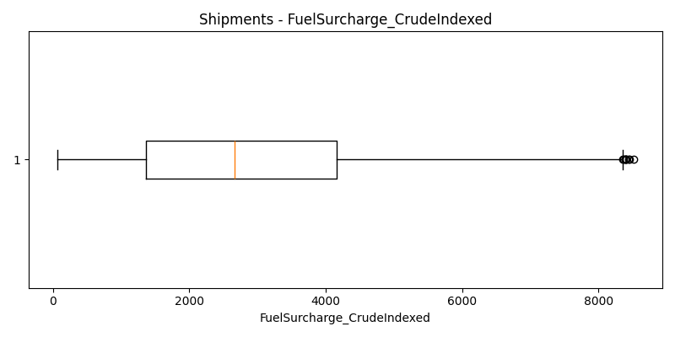
Figure – Outlier Detection in Procurement Data
8.9 Summary of EDA
The EDA process provided an overall understanding of the procurement datasets before dashboard development. The analysis covered the dataset structure, numerical characteristics, distributions, categorical composition, relationships between variables, changes over time, missing values, and unusual observations. The findings from these stages were used to support the subsequent data cleaning, transformation, modeling, and visualization activiti
9. Dashboard Design
The Procurement Cost Intelligence dashboard was developed in Power BI to provide a consolidated view of procurement expenditure, supplier-related costs, product costs, and external market indicators. The dashboard uses KPI cards, charts, slicers, and interactive visual elements to allow users to examine procurement information from different perspectives.

Visualizations Used
Visualization | Purpose
KPI Cards | Display important procurement measures such as total procurement spend, total suppliers, active suppliers, and average procurement value.
Column Chart | Compare procurement spending across products, suppliers, categories, or time periods.
Clustered Bar Chart | Compare suppliers or products based on procurement cost and other measures.
Stacked Column Chart | Show the composition of procurement values across different supplier or product groups.
Line Chart | Display procurement cost and market-related trends over time.
Donut Chart | Show the proportion of suppliers by rating group, status, or other categorical classifications.
Scatter Chart | Examine relationships between procurement variables such as quantity, unit cost, lead time, or supplier rating.
Treemap | Show the relative contribution of products or categories to procurement expenditure.
Map | Display supplier distribution based on country where applicable.
Histogram / Distribution Chart | Examine the distribution of procurement value, unit cost, and freight cost during exploratory analysis.
Table / Matrix | Provide detailed supplier, product, procurement, and cost-level information.
Slicers | Allow users to filter the dashboard based on supplier, product, country, rating, status, date, and other relevant fields.

Dashboard KPIs
The main KPIs used in the dashboard include:
- Total Procurement Spend
- Total Purchase Orders
- Total Suppliers
- Active Suppliers
- Active Supplier %
- Average Procurement Order Value
- Average Unit Cost
- Total Procurement Quantity
- Total Freight Cost
- Total Discount / Savings, where applicable
- Procurement Spend YoY Growth %
These KPIs provide a quick summary of procurement performance before the user moves to detailed analysis.
9.1 Dashboard Pages
Page 1 – Procurement Overview
The first page provides an executive-level summary of the overall procurement position. It presents the major procurement KPIs, spending trends, category distribution, supplier contribution, payment terms, geographic distribution, and product purchasing activity.
Main Components
- Total Procurement Spend
- Total Purchase Orders
- Active Suppliers
- Products Procured
- Average Purchase Order Value
- YoY Spend Growth %
- Procurement Spend Trend
- Procurement Spend by Category
- Payment Terms Distribution
- Top Suppliers by Procurement Activity
- Procurement Spend by Country
- Top Products by Quantity
- On-Time Delivery %
- Average Lead Time
- Average Supplier Rating
- High Rated Suppliers
- Cost Variance
Filters
- Year
- Procurement Category
- Supplier
- Country
- Shipment Status
Purpose
To provide management with a quick overview of procurement expenditure, supplier activity, purchasing trends, and major procurement performance indicators.
Page 2 – Procurement Spend Analysis
The second page focuses specifically on procurement expenditure and provides a detailed breakdown of spending patterns across time, categories, payment terms, currencies, and procurement costs.
Main Components
- Procurement Spend
- Average Unit Cost
- Average Purchase Order Value
- Average Freight Cost
- Total Discount Value
- Cost Variance %
- Monthly Procurement Spend Trend
- Procurement Spend by Category
- Purchase Orders vs Procurement Spend
- Average Unit Cost by Category
- Average Purchase Order Value by Payment Terms
- Currency Distribution of Procurement Spend
- Total Quantity Ordered
- Total Savings / Discount Value
- Cost per Unit
- Discount %
Filters
- Year
- Procurement Category
- Supplier
- Currency
- Payment Terms
Purpose
To identify how procurement expenditure is distributed, determine the major cost-contributing categories and suppliers, and examine changes in procurement spending over time.
Page 3 – Supplier Cost Analysis
The third page focuses on supplier-related expenditure, supplier performance, supplier ratings, and supplier coverage.
Main Components
- Total Suppliers
- Active Suppliers
- High Rated Suppliers
- Average Supplier Rating
- On-Time Delivery %
- Active Supplier %
- Supplier Procurement Spend
- Supplier Rating Distribution
- Spend Mix by Payment Terms and Supplier Rating
- Procurement Spend Contribution by Supplier Rating
- Supplier Rating Group Spend Ranking Over Time
- Supplier Rating vs Procurement Spend
- Supplier Coverage by Country and Payment Terms
Filters
- Supplier Name
- Country
- Supplier Rating Group
- Status
- Payment Terms
- Date
Purpose
To identify major suppliers, compare supplier-related expenditure, evaluate supplier ratings and delivery performance, and understand how supplier characteristics are associated with procurement spending.
Page 4 – Product Cost Analysis
The fourth page focuses on product-level procurement expenditure, purchasing demand, reorder requirements, and inventory availability.
Main Components
- Total Products
- Total Quantity Ordered
- Total Inventory on Hand
- Average Reorder Point
- Average Material Index Weight
- Total Product Procurement Value
- Average Purchase Order Value
- Procurement Value Contribution by Category
- Product Demand vs Reorder Point
- Inventory Availability Mix by Category
- Category Ranking by Procurement Value Over Time
- Reorder Point Distribution
- Product / Category Matrix
Filters
- Product Category
- Product Name
- Raw Material
- Warehouse
- Date
- Supplier, where applicable
Purpose
To identify products and categories that contribute significantly to procurement expenditure, examine purchasing demand, and understand the relationship between demand, reorder points, and inventory availability.
Page 5 – Market Intelligence
The fifth page provides external market information that supports the analysis of procurement costs. It does not represent a separate project domain; instead, it provides additional market context for understanding changes in procurement-related costs.
Main Components
- Average Producer Price Index (PPI)
- Average Copper Price
- Average Crude Oil Price
- Average Exchange Rate
- Average Interest Rate
- PPI Trend
- Copper Price Trend
- Crude Oil Price Trend
- Exchange Rate Trend
- Interest Rate Trend
Filters
- Date
- Year
- Month
- Currency
- Market Indicator
Purpose
To provide external market context that can be considered alongside procurement spending and cost trends. Changes in material prices, crude oil prices, exchange rates, interest rates, and producer prices can provide additional context when reviewing movements in procurement costs.
9.2 Dashboard (Visualization)
1.Procurement Overview Dashboard
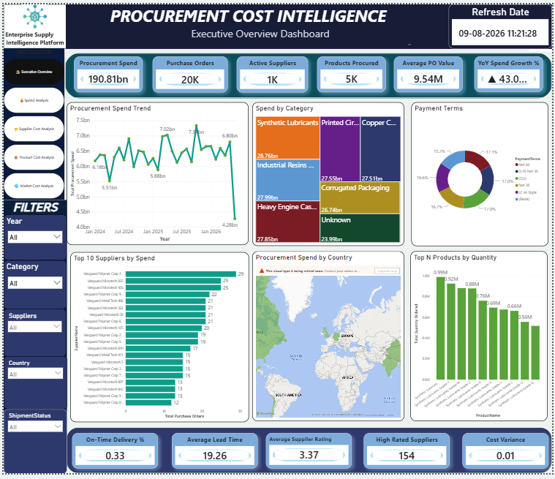
Figure 9.1 – Procurement Overview Dashboard
This page provides a consolidated view of the overall procurement position.It presents key procurement KPIs, spending trends, supplier contribution, and category-level analysis.The page also provides information on payment terms, countries, products, and delivery performance. It helps users quickly understand the overall procurement activity and cost position.

2.Procurement Spend Analysis Dashboard
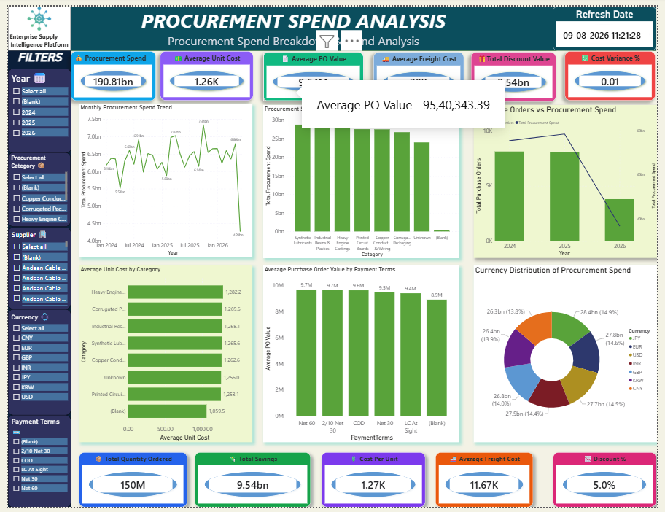
Figure 9.2 – Procurement Spend Analysis Dashboard

This page focuses on detailed procurement spending and cost patterns. It shows procurement spend trends, category-wise spending, unit costs, freight costs, and purchase order values. The visuals help identify major spending areas and differences in procurement costs .Interactive filters allow users to examine spending based on different business dimensions.

3.Supplier Cost Analysis Dashboard
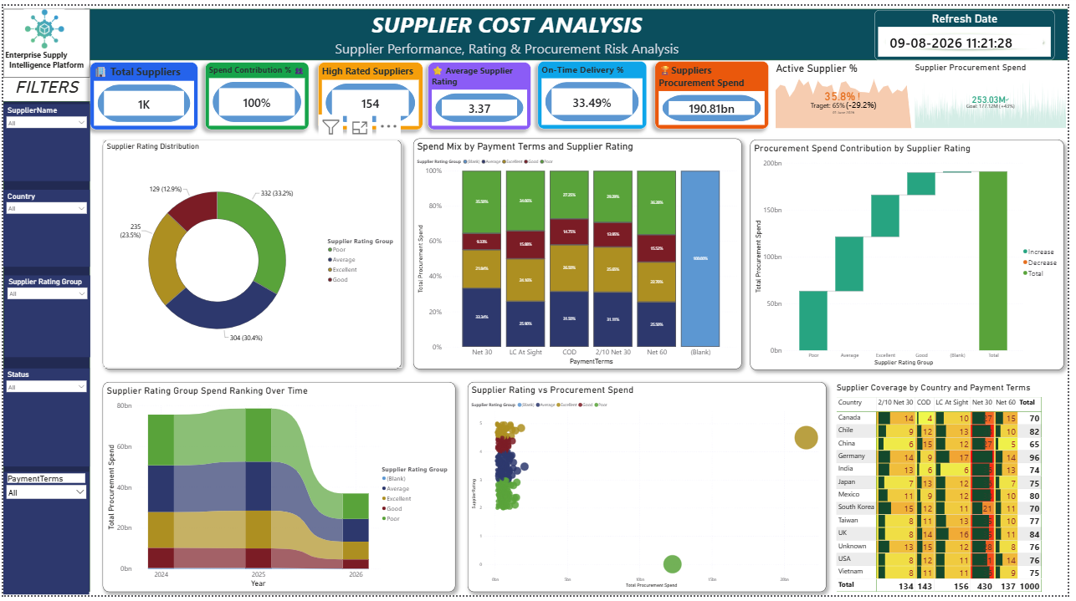
Figure 9.3 – Supplier Cost Analysis Dashboard
This page analyzes suppliers based on procurement spending, ratings, status, and related performance measures.It compares supplier contributions to procurement expenditure and shows supplier rating distributions.Country and payment-term analysis provides additional information about the supplier base.The page helps identify important suppliers and understand their contribution to procurement costs.

4.Product Cost Analysis Dashboard
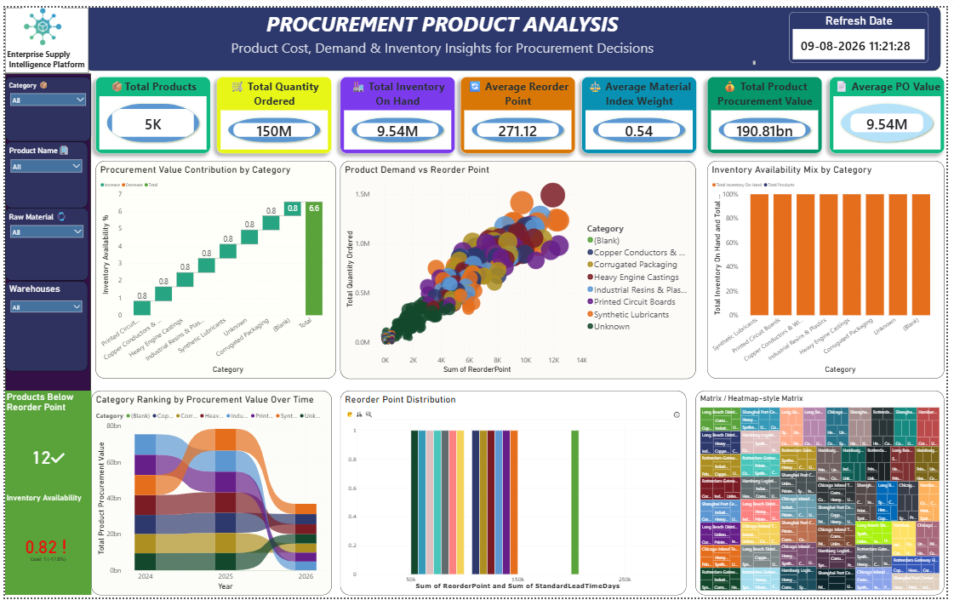
Figure 9.4 – Product Cost Analysis Dashboard
This page provides product-level analysis of procurement expenditure, quantity, and inventory information.It compares product categories based on procurement value and purchasing demand. The analysis also examines reorder points and inventory availability across categories.It helps identify high-value products and areas requiring closer cost and inventory monitoring.

5.Market Analysis Dashboard
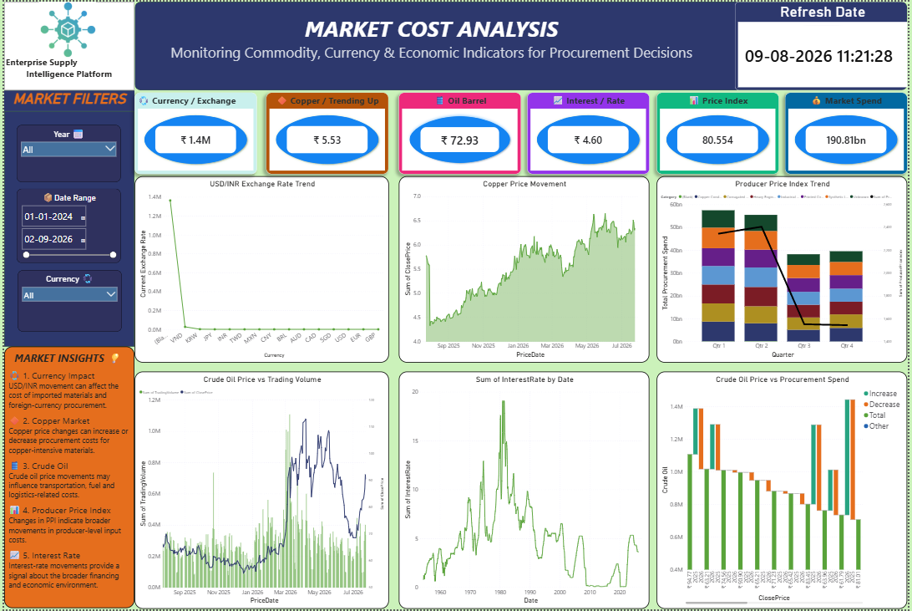
Figure 9.5 – Market Intelligence Dashboard
This page presents external market indicators that provide additional context for procurement cost analysis. It includes PPI, copper prices, crude oil prices, exchange rates, and interest rates. Trend charts show how these indicators change over the selected period. The information supports the interpretation of changes in procurement costs and market conditions.

10. Key Findings
- Some suppliers have higher spending than others and contribute more to total procurement cost.
- Supplier ratings are different, and spending also changes between high-, medium-, and low-rated suppliers.
- Some product categories have higher spending than other categories.
- Procurement spending changes over time, with some months having higher spending than others.
- Unit costs are different across products, showing variation in purchasing prices.
- Freight costs add to procurement expenses and vary between transactions.
- Payment terms show different spending patterns across suppliers.
- The number of active and inactive suppliers is different, giving a clear view of the current supplier base.
- Some products have higher demand and reorder requirements, which can help with inventory planning.
- Market factors such as PPI, copper, crude oil, exchange rates, and interest rates change over time and provide useful information when reviewing procurement costs.
- The original data contained quality issues such as missing values, duplicates, incorrect dates, and inconsistent values, which were cleaned before analysis.
- The Power BI dashboard brings the main procurement information together and makes it easier to compare suppliers, products, spending, and costs.
11 . Business Insights
- Focus on high-spending suppliers:
Suppliers contributing the highest procurement spend should be reviewed regularly to identify opportunities for better pricing and negotiation.
- Review high-cost products and categories:
Products and categories with higher procurement costs should be monitored to control unnecessary spending.
- Compare supplier cost with supplier rating:
Suppliers with high spending but lower ratings may require closer performance review before future purchasing decisions.
- Monitor monthly spending:
Large changes in monthly procurement spending should be reviewed to understand the reason for increases or decreases.
- Control unit costs:
Products with higher unit costs should be compared with similar products and suppliers to identify possible cost-saving opportunities.
- Monitor freight expenses:
Suppliers or shipments with higher freight costs should be reviewed to identify better transportation options.
- Use payment terms during supplier evaluation:
Payment terms can be considered along with price and supplier performance when comparing suppliers.
- Monitor inactive suppliers:
Inactive suppliers should be reviewed to determine whether they are still required or can be removed from the active supplier list.
- Improve inventory planning:
Products with high demand and low available inventory should receive greater attention to avoid stock shortages.
- Consider market conditions when reviewing costs:
Changes in PPI, copper, crude oil, exchange rates, and interest rates can be considered when reviewing changes in procurement costs.
- Use supplier and product comparisons for negotiations:
Procurement teams can compare suppliers and products using the dashboard before making purchasing or negotiation decisions.
- Regularly monitor procurement KPIs:
Tracking procurement spend, supplier activity, unit cost, freight cost, and other KPIs regularly can help identify cost changes early.
12. Recommendations
- Focus on high-spending suppliers
Regularly review suppliers that contribute the highest procurement spend and negotiate better prices, discounts, and payment terms where possible.
- Control high-cost products and categories
Identify products and categories with high procurement values and review their prices, quantities, and supplier options to reduce unnecessary expenditure.
- Monitor supplier performance and ratings
Compare supplier ratings, delivery performance, and procurement spend together before making future purchasing decisions.
- Reduce freight and related costs
Review transactions with high freight costs and evaluate alternative suppliers or transportation options to control additional procurement expenses.
- Improve inventory and purchasing planning
Use product demand, inventory levels, and reorder points to plan purchases more effectively and avoid both stock shortages and unnecessary excess inventory.
- Track market conditions while reviewing procurement costs
Monitor PPI, copper, crude oil, exchange rates, and interest rates alongside procurement spending to understand external factors that may influence purchasing costs.
13. Business Impact
- Better Procurement Cost Control
The dashboard helps identify high-spending suppliers, products, categories, and other major cost areas.
- Improved Supplier Management
Supplier spending, ratings, status, and performance can be viewed together, supporting better supplier evaluation.
- Reduced Procurement Expenses
High unit costs, freight costs, and expensive procurement categories can be identified for review and cost reduction.
- Better Purchasing and Inventory Planning
Product demand, reorder points, and inventory information help support more effective purchasing decisions.
- Faster Management Decisions
Important procurement information is available in one dashboard instead of being reviewed across multiple separate files.
- Better Understanding of Cost Changes
External indicators such as PPI, copper, crude oil, exchange rates, and interest rates provide additional context when reviewing changes in procurement costs.
14. Challenges Faced
- Data Quality Issues
The datasets contained missing values, duplicate records, incorrect date formats, negative values, and inconsistent entries that required careful checking and correction.
- Handling Different Data Formats
The datasets contained different formats for dates, currencies, units, and numerical values, which had to be standardized before analysis.
- Managing Multiple Datasets
Combining supplier, product, inventory, purchase order, shipment, and external market datasets required proper understanding of their relationships.
- Creating the Data Model
Establishing the correct relationships between fact and dimension tables was important to ensure that calculations and dashboard visuals returned accurate results.
- Developing Accurate DAX Measures
Creating measures for procurement spend, supplier counts, active supplier percentage, average costs, targets, and year-over-year changes required careful validation.
- Designing Useful Dashboard Visuals
Selecting appropriate KPIs, charts, filters, and layouts while keeping the dashboard clear and easy to understand was another challenge.
- Validating Dashboard Results
KPI values and chart results had to be compared with the underlying data to identify incorrect measures, blank results, and calculation issues before finalizing the dashboard.
15. Limitations
- Limited Data Period
The analysis is based on the available time period in the collected datasets. Longer-term data may provide a better view of procurement trends.
- Data Availability
Some procurement and supplier fields were limited by the information available in the source datasets.
- External Market Data Limitations
Market indicators such as PPI, copper, crude oil, exchange rates, and interest rates provide supporting context, but they do not directly explain every change in procurement cost.
- Data Cleaning Requirements
The original datasets contained missing, duplicate, inconsistent, and invalid values. Although these were addressed during cleaning, the quality of the final analysis depends on the accuracy of the available source data.
- Dashboard Dependency on Available Data
The insights and KPIs shown in Power BI are limited to the fields and records available in the connected datasets.
- No Direct Causal Analysis
The dashboard identifies spending patterns and relationships between procurement variables, but it does not establish that one factor directly causes a change in another.
- Manual Data Refresh
Where source data is updated manually, the dashboard requires a refresh to reflect the latest available information.

16. Future Scope
The current project focuses on Procurement Cost Intelligence. The following areas can be developed as future extensions to expand the project into a broader supply-chain intelligence platform:
- Supplier Intelligence
The project can be extended with detailed supplier performance, supplier risk, delivery reliability, and supplier comparison analysis.
- Product Intelligence
Future development can include deeper analysis of product demand, product costs, purchasing patterns, and product-level performance.
- Inventory Intelligence
Inventory monitoring can be expanded with stock-level analysis, safety stock calculations, reorder planning, and inventory forecasting.
- Logistics Intelligence
A logistics module can be added to analyze shipments, transportation costs, delivery performance, freight expenses, and logistics efficiency.
- Advanced Market Intelligence
The market analysis can be expanded to study the impact of PPI, copper prices, crude oil prices, exchange rates, and interest rates on procurement costs.
The Procurement Cost Intelligence project was developed to provide a clear view of procurement spending and related cost factors. The project involved collecting, understanding, cleaning, and transforming procurement and supporting market datasets before developing the Power BI dashboard.
17 . Conclusion
The final dashboard provides separate views for Procurement Overview, Procurement Spend Analysis, Supplier Cost Analysis, Product Cost Analysis, and Market Intelligence. These pages help users examine procurement expenditure, supplier contribution, product costs, purchasing trends, and external market conditions from different perspectives.
The analysis identified important areas such as high-spending suppliers, high-cost products and categories, variations in unit and freight costs, supplier performance, and changes in procurement spending over time. External market indicators such as PPI, copper prices, crude oil prices, exchange rates, and interest rates provide additional context when reviewing procurement cost changes.
Overall, the project demonstrates how properly prepared data and Power BI reporting can bring procurement information together in one place and support better cost monitoring, supplier evaluation, purchasing planning, and business decision-making.
18. References
[1] Microsoft, “Power BI documentation,” Microsoft Learn. [Online]. Available: https://learn.microsoft.com/power-bi/. [Accessed: Aug. 9, 2026].
[2] Microsoft, “Power Query documentation,” Microsoft Learn. [Online]. Available: https://learn.microsoft.com/power-query/. [Accessed: Aug. 9, 2026].
[3] Microsoft, “Data Analysis Expressions (DAX) reference,” Microsoft Learn. [Online]. Available: https://learn.microsoft.com/dax/. [Accessed: Aug. 9, 2026].
[4] Federal Reserve Bank of St. Louis, “Federal Reserve Economic Data (FRED),” Federal Reserve Bank of St. Louis. [Online]. Available: https://fred.stlouisfed.org/. [Accessed: Aug. 9, 2026].
[5] Yahoo, “Yahoo Finance,” Yahoo. [Online]. Available: https://finance.yahoo.com/. [Accessed: Aug. 9, 2026]

Appendix
The appendix contains supporting materials used during the development and analysis of the Procurement Cost Intelligence project.
Appendix A – Dataset Details
- Suppliers dataset
- Products dataset
- Inventory dataset
- Warehouses dataset
- Purchase Orders dataset
- Shipments dataset
- Exchange Rates dataset
- Copper price dataset
- Crude Oil price dataset
- Interest Rates dataset
- Producer Price Index dataset
Appendix B – Data Quality Assessment
- Data quality checklist
- Missing-value analysis
- Duplicate-record analysis
- Date-format validation
- Numeric-value validation
- Text standardization records
Appendix C – Data Cleaning
- Excel data-cleaning outputs
- Power Query transformations
- Data-type corrections
- Missing-value treatment
- Duplicate removal
- Standardization activities
Appendix D – Exploratory Data Analysis
- Dataset overview
- Descriptive statistics
- Distribution analysis
- Categorical analysis
- Correlation analysis
- Time-series analysis
- Missing-value analysis
- Outlier analysis
Appendix E – Data Model
- Power BI model view
- Fact and dimension tables
- Table relationships
- Data model structure
Appendix F – DAX Measures
- Procurement KPI measures
- Supplier KPI measures
- Product and inventory measures
- Cost measures
- Target measures
- Time-intelligence measures
Appendix G – Dashboard Screenshots
- Procurement Overview
- Procurement Spend Analysis
- Supplier Cost Analysis
- Product Cost Analysis
- Market Intelligence
Appendix H – Additional Supporting Outputs
- KPI validation
- Chart outputs
- Filter and slicer configurations
- Additional analysis results

