University of Washington

iSchool Info 340

# Final

In this Final, you will plan, document, and implement a database used in an application being created by another development team.

The purposed application consists of a simple internal windows application that handles the act of scheduling appointments between patients and doctors.

This application allows a use to:

* Search for existing patients
* Add a new patient
* Search for doctor
* Select a clinic
* Select a date and time

Your job is the design a database for the application. You will need:

* A development documentation with Excel (I've provided a starter file)
* An ERD
* A SQL database script (tables, constraints, views, stored procedures)
* An Import of sample data (Use <https://www.mockaroo.com/>)
* One or more reporting views
* A backup of the database with sample data
* One or more Excel reports
* One or more Report Builder reports
* One or more PowerBI reports
* A formal project document with Word (I've provided a starter file)

## Application Flow

1. User looks up an existing patient (If patient cannot be found a new record can be created).

2. User selects a doctor (or clinic)

3. User selects a clinic (or doctor)

4. User selects a date and time for the appointment

5. User Creates the appointment (or updates appointment or delete appointment)

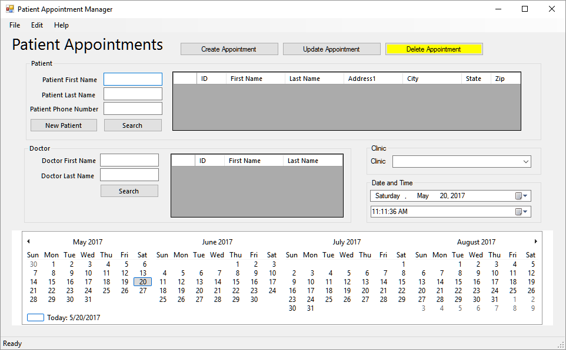

## Database Design

You need to design a database based on what you have learned about the application. This will be a prototype, so expect there to be issue that you will have to resolve or note. When you find issues, or have question for the Application team, you need to note these for discussion once your prototype design is complete.

Please remember to use normalization, constraints, and abstraction layers. Each table needs a view showing the table's data and an insert, update, and delete stored procedure. All stored procedures must have explicit transactions and error handling. Let's, put this code at the bottom of the SQL Import script.

Example:

<all the code you use to import some starting data into your DB>

...

Exec pMyInsSprocT1

Exec pMyUpdSproc T1

Exec pMyDelSproc T1

Select * from vMyView T1

Exec pMyInsSproc T2

Exec pMyUpdSproc T2

Exec pMyDelSproc T2

Select * from vMyView T2

## Flow of Project

I suggest you perform the final in the following order.

1. Create a development documentation with Excel
2. Create an ERD
3. Create a SQL database script
4. Create an Import of sample data
5. Create one or more reporting views
6. Create a backup of the database with sample data
7. Create one or more Excel reports
8. Create one or more Report Builder reports
9. Create one or more PowerBI reports
10. Create a formal project document with Word
11. Create Lessons Learned Document

## Project Artifacts

You need to turn in the **developer document** in Excel, the **ERD**, the **SQL script** that creates the database, the **SQL Import script** that fills your database with sample data, the **backup file**, the **Excel, Report Builder and PowerBI Reports**, and a formal **project document** that details the current database design.

**Write a one-page report on what you learned in this class**

Write a paper that outlines what you have learned in this class. This helps both you and I to understand your progress in this class. You may be surprised to see how this process also solidifies what you have learned (or at least other students have told me it does!) There is no need to make this an exhaustive coverage of what you did, so make the paper to about a single page of text and it will be fine.

Here is an overview of what we covered:

* Module 01 - Database Design
  + In this module, you learned about databases; why they exist, what types are common, and how they are created
* Module 02 - Enhancing a Database
  + In this module, we looked at adding objects to a database to enhance its usability and consistency
* Module 03 - Writing SQL Code
  + In this module, we looked at how you create SQL code, batches, and scripts
* Module 04 - Views and Store Procedures
  + In this module, we looked at how you create SQL views and stored procedures
* Module 05 - Error Handling and Transaction Processing
  + In this module, we looked at how you create error handling and transaction processing in your stored procedures
* Midterm
  + In this Midterm, you planned and documented a database used in a departmental application be created by another development team
* Module 06 - Data Driven Applications
  + In this module, we looked at how to create applications that work with your database
* Module 07 - Data Warehousing and Reporting Structures
  + In this module, we looked at how to create a data warehouse database and why you would want to
* Module 08 - Database Administration
  + In this module, we looked at common tasks performed by database administrators (Security, Backup, Replication, and Distribution technologies)

**Note**: This is a college level class and I expect college level writing and formatting. It does not have to be perfect, but if you turn in a blob of text without a header or citing it will cost you.

If it has been awhile since you learned about this, here are a couple of web pages you should look at. There are many, many, sites that will give you more information, but these include the basics you need to know:

1. <https://blog.udemy.com/college-essay-format/>
2. <https://owl.english.purdue.edu/owl/resource/747/02/>

You will place all the files a single folder called Patient Appointments Project and then zip the contents into a single file. You will next upload this file to Canvas as you would any other assignment.

# You are done with the Final!