**目 录**

**Catalog**

1. 经典服务器结构Classic server architecture 1

1.1. 服务构成Services 1

1.2. 单机环境Single machine environment 2

1.3. 分布式环境 distributed environment 2

2. 源码结构Source code structure 3

2.1. 五个zip包 5 zip packages 3

2.2. beiqi-home-master.zip 3

2.3. beiqi-service-master.zip 4

2.4. beiqi-web-master.zip 4

2.5. beiqi-geoip.zip 5

2.6. SQL.zip 5

3. 参考reference 6

3.1. Reference 6

## 经典服务器结构Classic server architecture

### 1.1. 服务构成Services

|  |  |  |
| --- | --- | --- |
| **服务Service** | **典型端口 Typical port** | **描述 Describe** |
| MySQL | 3306 | 推荐8.0以上版本  Recommend using version 8.0 or above |
| Redis | 6379 | 推荐使用5.0以上版本  Recommend using version 5.0 or above  缓存服务 It’s a cache service |
| Back-end API Service | 8080 | 一个SpringBoot application，使用Java8环境。它的功能是为给管理面板提供Web API。 A SpringBoot App，Use Java 8.  Its function is to provide the Web API to the management panels. |
| Front-end API Service | 8080 | 一个SpringBoot application，使用Java8环境。它的功能是为给网站提供Web API。 A SpringBoot App，Use Java 8.  Its function is to provide the Web API to the website. |
| Management Panel Service | 80 | 这是一个纯静态的WebApp。  This is a purely static WebApp. |
| Website Service | 80 | 这是一个纯静态的Website。  This is a purely static Website. |
| Geo-IP service | 80 | 它提供一个API接口，将IP地址转换成国家和城市。  It provides an API interface to convert IP addresses into countries and cities. |
| Gateway Service | 80/443 | 它使用反向代理将“后端服务”、“管理面板服务”、“网站服务”暴露给互联网。它是一个nginx。  It uses a reverse proxy to expose "Back-end Service", "Management Panel Service" and "Website Services" to the Internet.Normally it is an nginx. |

### 1.2. 单机环境Single machine environment

如果你只有一台服务器，系统结构可以是这样的：

If you only have single server, the system structure can be as follows:

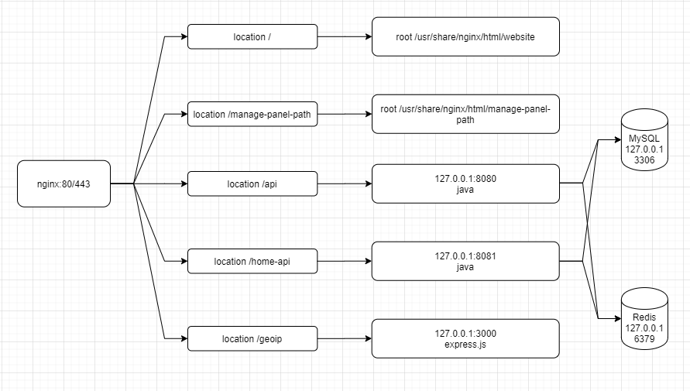

### 1.3. 分布式环境 distributed environment

如果你想部署在多台服务器上，系统结构可以是这样的：

If you want to deploy on multiple servers, the system architecture can be as follows:

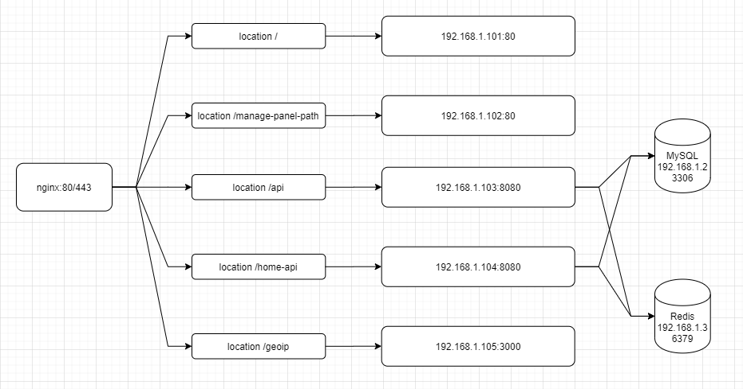

## 源码结构Source code structure

### 2.1. 五个zip包 5 zip packages

|  |  |  |
| --- | --- | --- |
| **zip** | **服务Service** | **开发环境和框架** |
| beiqi-home-master.zip | Website Service | Base：Node16/18  Framework：Nuxt.js 2 + Vue.js 2 |
| beiqi-service-master.zip | Back-end API Service  Front-end API Service | Base：JDK 8  Framework：RuoYi-Vue 3.4.0 |
| beiqi-web-master.zip | Management Panel Service | Base：Node 16/18  Framework: Ruoyi-Vue 3.4.0 |
| beiqi-geoip.zip | Geo-IP service | Base：Node 16  Framework: Express.js |
| SQL.zip | - | MySQL: 8.0+ |

### 2.2. beiqi-home-master.zip

**简介 Abstract：**

它是一个典型的Nuxt2.js的项目，开发者可以仔细阅读Nuxt官网来了解其功能和原理。

It is a typical “Nuxt2.js” project, and developers can read the Nuxt website carefully to understand its features and principles.

**可配置项目 Configurable items：**

绝大多数可配置项目存在于./nuxt.config.js文件中，其中你需要注意以下几项配置：

Most of the configurable items are found in the /nuxt.config.js file, where you need to pay attention to the following configurations:

1. facebook广告分析的基础代码ID ，在`head.script[1].innerHTML`；

Facebook analysis ID, in `head.script[1].innerHTML` ;

1. 开发过程中使用API代理（为了解决开发环境的跨域问题） ，在`proxy.*`;

API proxy during development (to solve the cross-domain problem in the dev environment), in `proxy.*`;

除此之外，你还需要注意GTag（Google分析）ID的配置项目，它在`plugins/gtag.js`文件中。

In addition, you need to pay attention to the configuration item of the GTag (Google analysis) ID, which is in the `plugins/gtag.js` file.

**最佳实践 Best practice：**

我们使用`npm run dev`来启动开发环境;

We use `npm run dev` to start the development environment;

我们使用`npm run generate`在本地生成编译结果，文件存放与dist目录，我们将dist目录中的文件通过FTP上传到服务器;

We use `npm run generate` to generate the compilation results locally, and the files are stored in the dist directory. We upload the files in the dist directory to the server through FTP;

记得备份旧的文件；

Remember to back up the old files;

也不要忘记刷新CDN缓存；

Don't forget to refresh the CDN ;

### 2.3. beiqi-service-master.zip

**简介 Abstract：**

它是一个典型的Ruoyi-Vue项目（https://github.com/yangzongzhuan/RuoYi-Vue），这个zip中只包含了Java相关代码，Vue相关的代码我们放在了beiqi-web-master.zip中。

It is a typical “Ruoyi-Vue” project (https://github.com/yangzongzhuan/RuoYi-Vue), which only contains the Java related code in this zip, and we put the Vue related code in the `beiqi-web-master.zip`.

请仔细阅读Ruoyi-Vue的文档来了解其功能和原理。

Please read the “Rooyi-Vue” documentation carefully to understand its functions and principles.

**可配置项目 Configurable items：**

可供修改的配置项目有以下几个文件：

The following files contain configuration items that can be modified:

ruoyi-admin\src\main\resources\application-*.yml

ruoyi-web\src\main\resources\application-*.yml

经典的配置项包括：MySQL、Redis、Email的账户和密码；

Classic configuration items include: MySQL, Redis, Email account and password;

还要注意Also note:

1、token secret，in `token.*`；

2、文件上传的存放路径，在`ruoyi.profile`; The storage path for uploaded files in `ruoyi.profile`;

3、UFO/FDFS（如果你想启用这些功能的话 If you want to enable these features）；

4、druid控制台的账户和密码 The account and password for the Druid console；

5、just-auth secret（如果你想开启第三方登录功能的话If you want to turn on the third-party login function）；

6、email.test-drive 配置项表示客户预约试驾留下的资料将会被转发到指定的电子邮箱地址The configuration option indicates that the information left by the customer's reservation for a test drive will be forwarded to the specified email address；

**最佳实践 Best practice：**

我们使用maven来编译项目，在./ruoyi-admin/ 和 ./ruoyi-web/分别编译；

We use Maven to compile the project, and compile `./ruoyi-admin/` and `./ruoyi-web/` respectively;

我们会把jar文件上传到服务器，杀死旧的java程序并启动新的java程序；

We upload the jar file to the server, kill the old java program and start the new java program;

记得备份旧的文件；

Remember to back up the old files;

### 2.4. beiqi-web-master.zip

**简介 Abstract：**

它是一个典型的Ruoyi-Vue项目的Vue部分（https://github.com/yangzongzhuan/RuoYi-Vue）。

It is the Vue part of a typical Ruoyi-Vue project（https://github.com/yangzongzhuan/RuoYi-Vue）.

请仔细阅读Ruoyi-Vue的文档来了解其功能和原理。

Please read the “Rooyi-Vue” documentation carefully to understand its functions and principles.

**可配置项目 Configurable items：**

可供修改的配置项目有以下几个文件：

The following files contain configuration items that can be modified:

vue.config.js

.env.*.yml

在vue.config.js中你需要特别注意一个配置项叫做”**publicPath**”，它表示你如何访问到你的Management Panel 。比如它默认的配置是'/manage-panel-path/'，这代表着你可以通过 “https://YOU-DOMAIN/manage-panel-path/”来访问Management Panel。如果你要修改它，请使用vscode全局的搜索'/manage-panel-path/'并替换，它最好是一个随机字符串以保证安全。除此之外，你还要修改nginx或者网关的规则，我们在deploy/nginx.conf有个示例供你参考。

In vue.config.js you need to pay special attention to a configuration item called publicPath, which means how you access your Management Panel. For example, its default configuration is '/ manage-panel-path /', which means that you can access Management Panel through "https: / / YOU-DOMAI N/manage-panel-path /"."If you want to modify it, use vscode global search '/ manage-panel-path /' and replace it, preferably a random string for security. In addition, you also have to modify the rules of nginx or gateway, we have a sample in deploy/nginx.conf for your reference.

**最佳实践 Best practice：**

我们使用npm run dev来启动开发环境；

We use npm run dev to start the development environment;

我们使用npm run build:prod来编译项目，编译结果在dist目录；

We use npm run build: prod to compile the project and compile the results in the dist directory;

我们将dist目录中的文件通过FTP上传到服务器；

We upload the files in the dist directory to the server via FTP;

记得备份旧的文件；

Remember to back up the old files;

也不要忘记刷新CDN缓存；

Don't forget to refresh the CDN ;

### 2.5. beiqi-geoip.zip

它是一个非常简单的Express.js程序，我们这里不花费过多的墨水。

It is a very simple Express.js program, and we don't spend too much ink here.

### 2.6. SQL.zip

它是Java程序所依赖的数据库SQL文件，你只需要把它用navicat导入到你的MySQL数据库即可。

It is a SQL file of the database that Java programs depend on. You just need to import it into your MySQL database using navicat.

## 参考reference

### Reference

<https://doc.ruoyi.vip/ruoyi-vue/>

<https://github.com/yangzongzhuan/RuoYi-Vue>

<https://v2.nuxt.com/>