Static Route

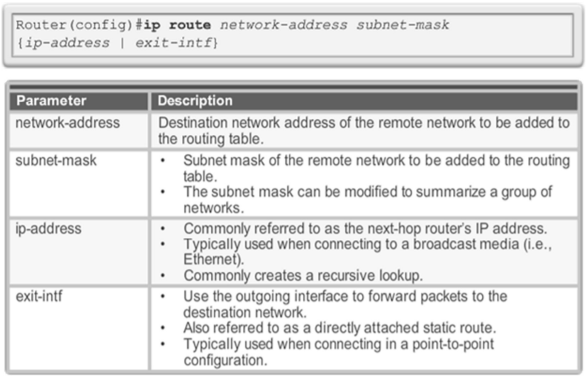

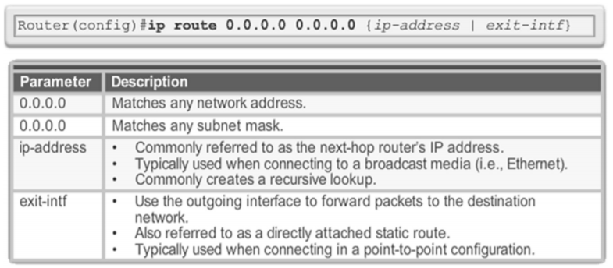Default Route

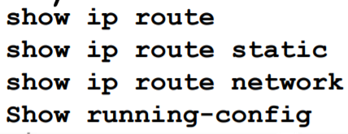

RIPv1 (Auto Summarization)

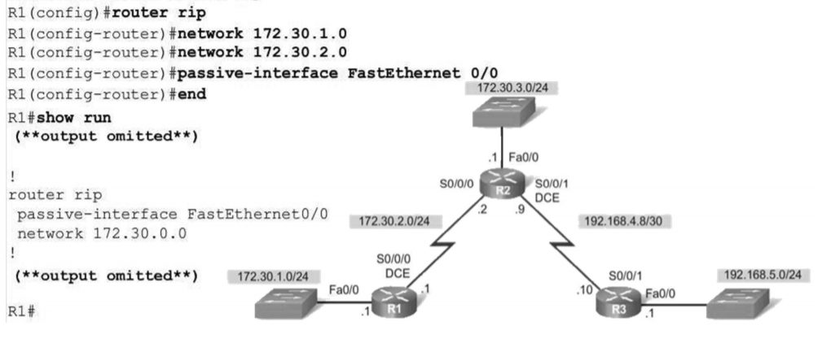

RIP update : 

RIPv2 ( network = สายที่ออกจาก router )

router rip

version 2

network 192.168.1.80 {Subnet mask}

network 192.168.1.0 {Subnet mask}

network 192.168.1.32 {Subnet mask}

passive-interface fa0/0.10

passive-interface fa0/0.20

no auto-summary

Standard ACL :

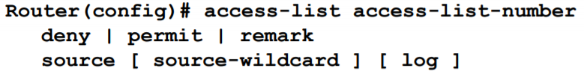

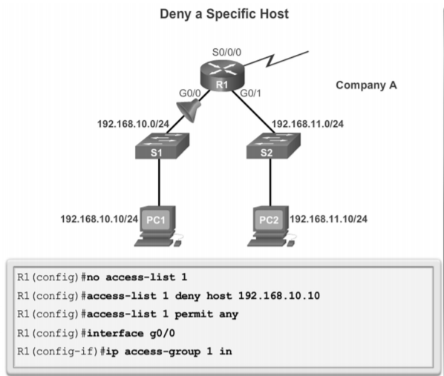

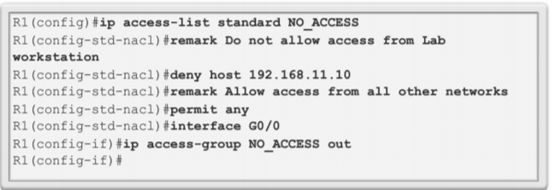

Extended ACL :

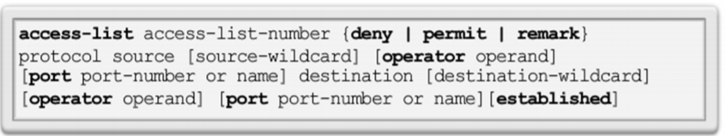

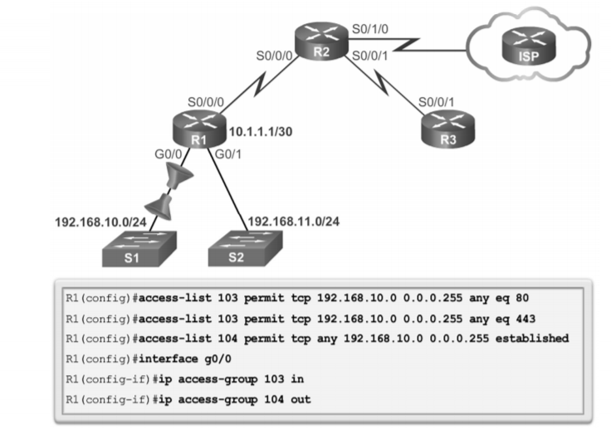

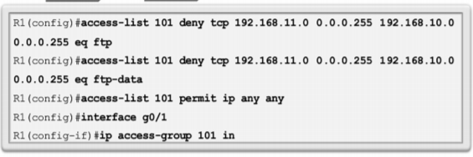

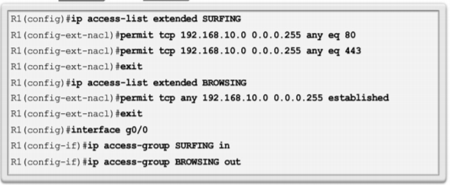

OSPF :

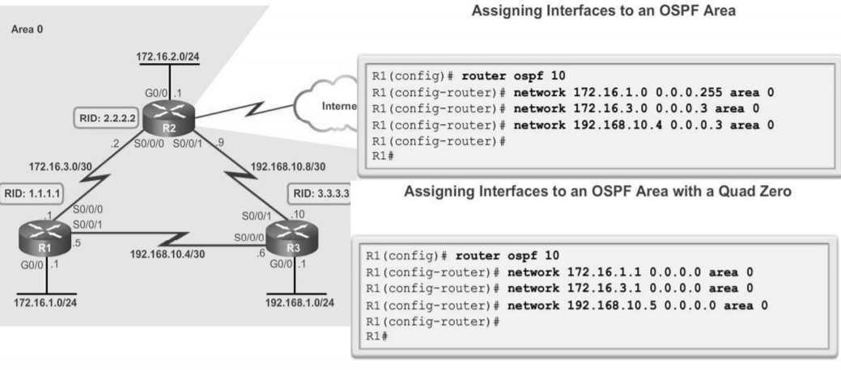





ดู Bandwidth = 

DHCP :

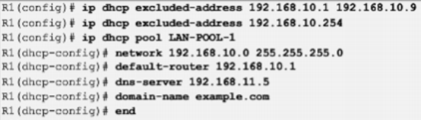

Switch :

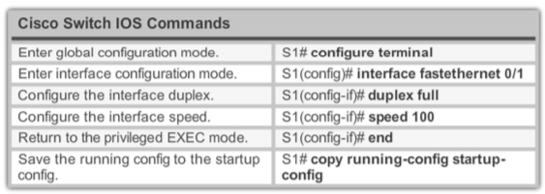

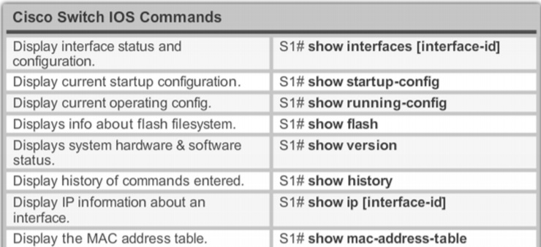

Sw with SSH

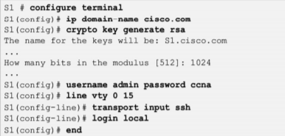

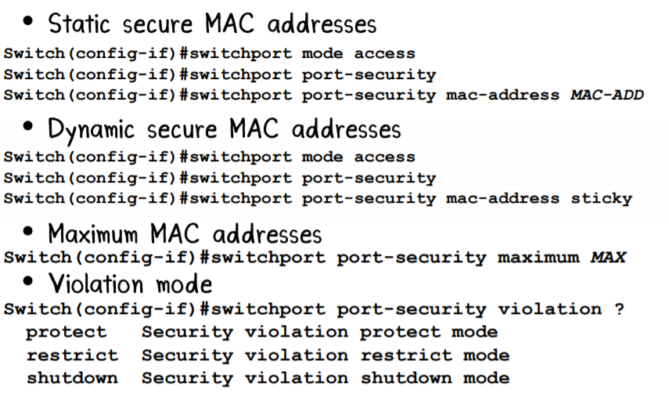 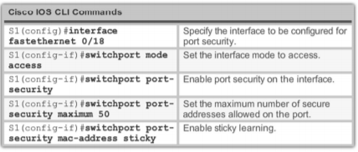

Spanning Tree

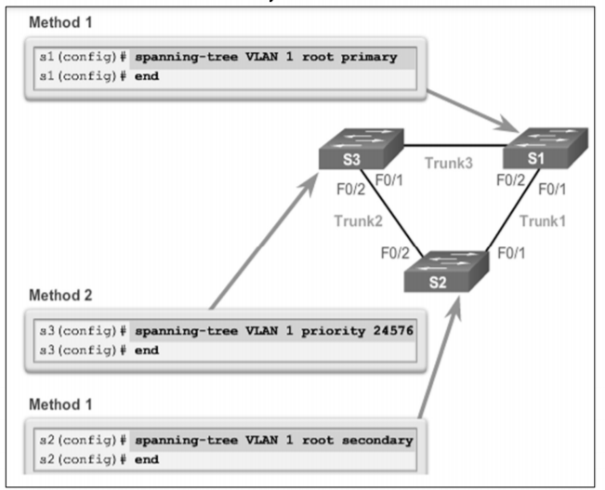



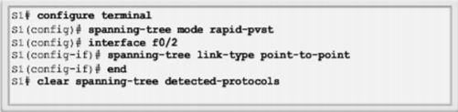

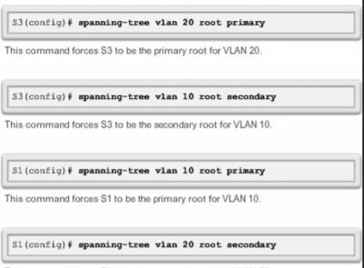

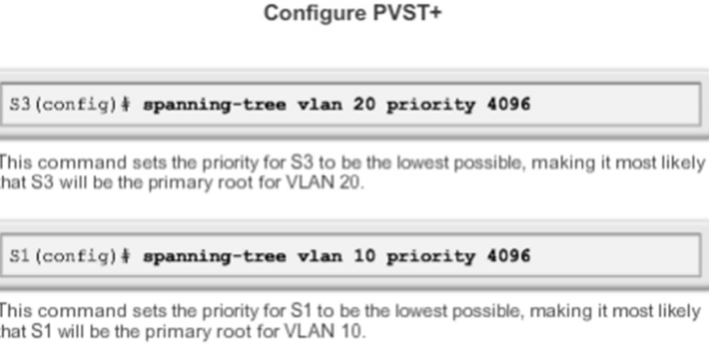

VLAN

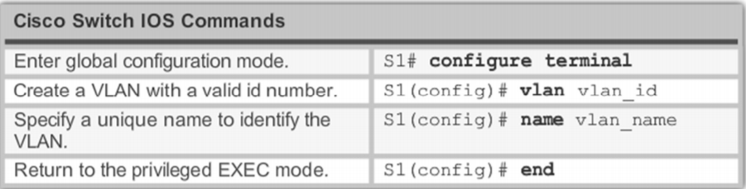

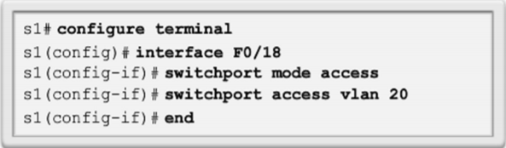

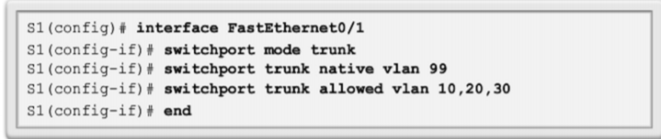

Inter-VLAN

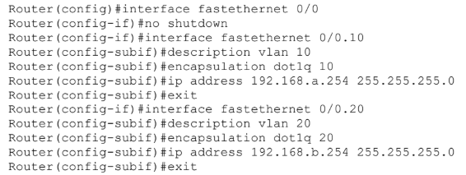

VTP

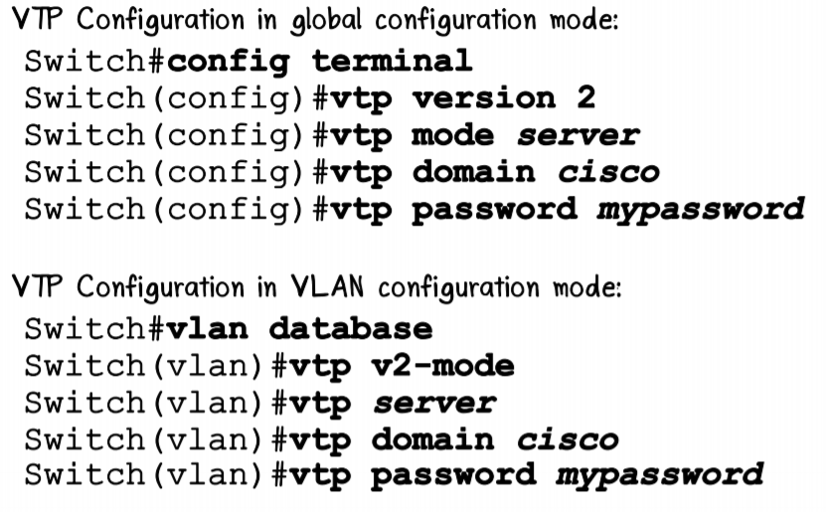





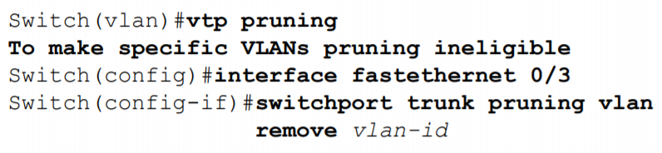

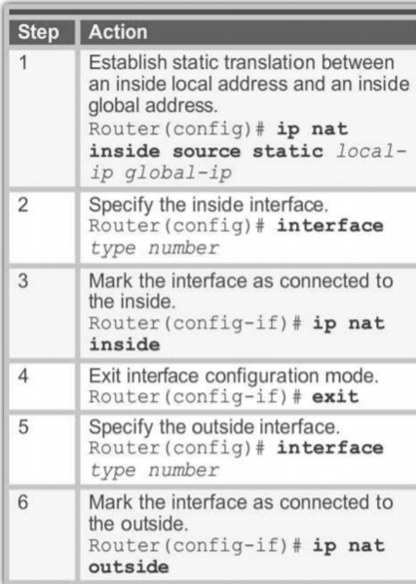Static NAT

ip nat inside source static 192.168.1.11 161.246.1.101

ip nat inside source static 192.168.1.12 161.246.1.102

ip nat inside source static 192.168.2.11 161.246.1.103

ip nat inside source static 192.168.2.12 161.246.1.104

int fa0/0.10

ip nat inside

exit

int fa0/0.20

ip nat inside

exit

int se0/0

ip nat outside

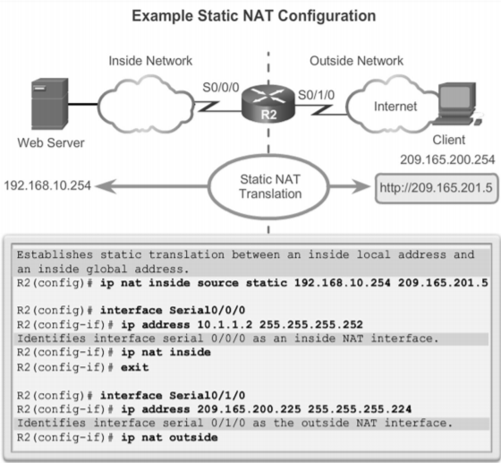



Dynamic NAT

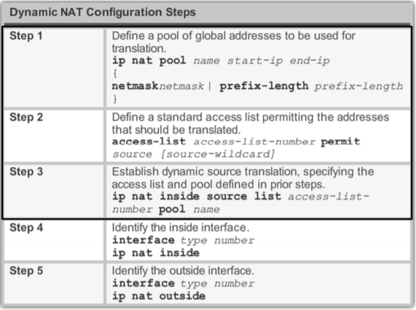

PAT

conf t

ip nat pool net 161.246.1.101 161.246.1.103 netmask 255.255.255.0

access-list 1 permit 192.168.1.0 0.0.0.255

access-list 1 permit 192.168.2.0 0.0.0.255

ip nat inside source list 1 pool net overload

end

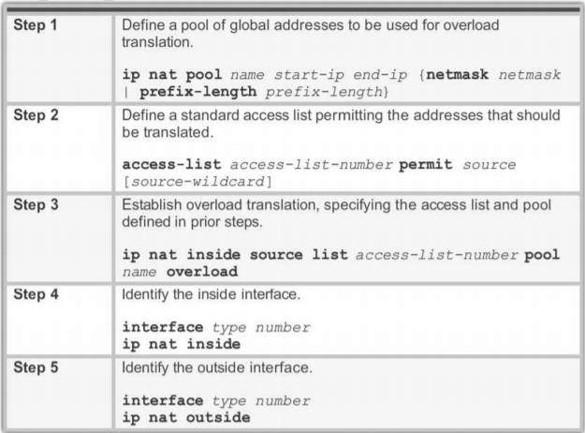

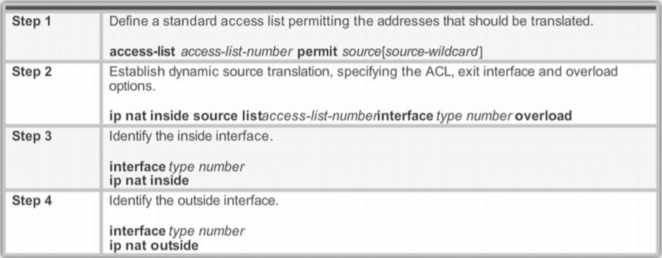

EIGRP

conf t

router eigrp 100

eigrp router-id 1.1.1.1

network 192.168.1.80

network 192.168.1.76

network 192.168.1.56

no auto-summary

end

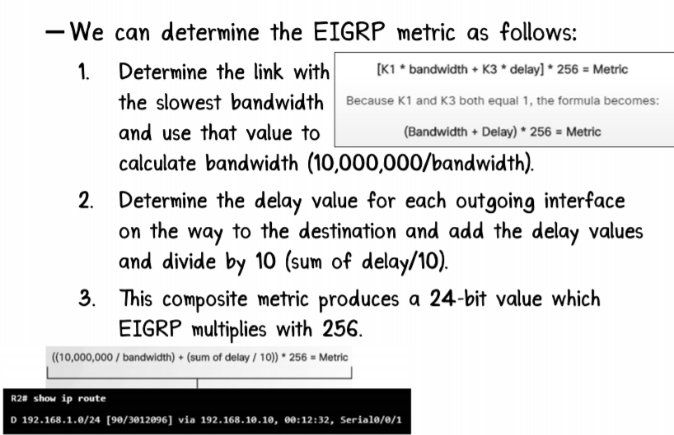

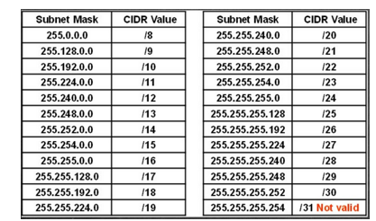

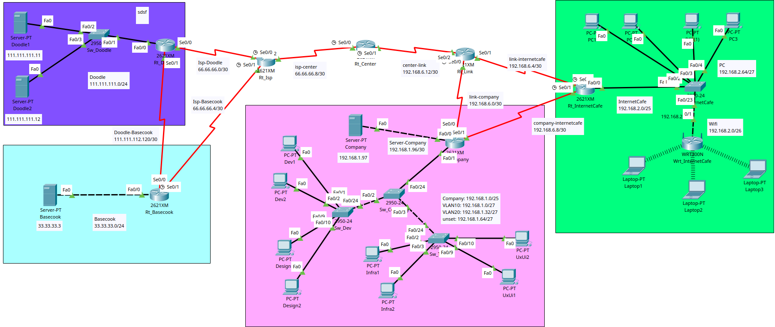

**Sw_Doodle**

|  |
| --- |
| en  vlan database  vlan 10 name Doodle  exit  conf t  hostname Sw_Doodle  int range f0/1-3  sw mo ac  sw ac v 10 |

**Rt_Doodle**

|  |
| --- |
| en  conf t  hostname Rt_Doodle  int f0/0  ip add 111.111.111.1 255.255.255.0  no sh  int s0/0  ip add 66.66.66.2 255.255.255.252  no sh  int s0/1  ip add 111.111.112.121 255.255.255.252  no sh  ip route 33.33.33.0 255.255.255.0 s0/1  router eigrp 100  no auto-summary  network 111.111.111.0  network 66.66.66.0  ip address 192.168.2.73 255.255.255.252  clock rate 56000  no shutdown  exit |

**Rt_Basecook**

|  |
| --- |
| en  conf t  hostname Rt_Basecook  int f0/0  ip add 33.33.33.1 255.255.255.0  no sh  int s0/0  ip add 66.66.66.6 255.255.255.252  no sh  int s0/1  ip add 111.111.112.122 255.255.255.252  no sh  ip route 111.111.111.0 255.255.255.0 s0/1  router eigrp 100  no auto-summary  network 33.33.33.0  network 66.66.66.4 |

**Rt_Isp**

|  |
| --- |
| en  conf t  hostname Rt_Isp  int s0/0  ip add 66.66.66.1 255.255.255.252  no sh  int s0/1  ip add 66.66.66.5 255.255.255.252  no sh  int s0/2  ip add 66.66.66.9 255.255.255.252  no sh  router eigrp 100  no auto-summary  network 66.66.66.0  network 66.66.66.4  network 66.66.66.8 |

**Rt_Center**

|  |
| --- |
| en  conf t  hostname Rt_Center  int s0/0  ip add 66.66.66.10 255.255.255.252  no sh  int s0/1  ip add 192.168.6.14 255.255.255.252  no sh  router eigrp 100  redistribute ospf 100 metric 1000 100 255 1 1500  network 66.66.66.8  router ospf 100  log-adjacency-changes  redistribute eigrp 100 metric 1 subnets  network 192.168.6.12 0.0.0.3 area 0 |

**Rt_Company**

|  |
| --- |
| en  conf t  hostname Rt_Company  int f0/1  no sh  int f0/1.10  description Vlan-Dev  en do 10  ip add 192.168.1.30 255.255.255.224  int f0/1.20  description Vlan-Design  en do 20  ip add 192.168.1.62 255.255.255.224  int s0/0  ip add 192.168.6.2 255.255.255.252  no sh  int s0/1  ip add 192.168.6.9 255.255.255.252  no sh  int f0/0  ip add 192.168.1.98 255.255.255.252  no sh  router ospf 100  network 192.168.6.0 0.0.0.3 area 0  network 192.168.6.8 0.0.0.3 area 0  network 192.168.1.96 0.0.0.3 area 0 |

**Sw_Company**

|  |
| --- |
| en  vlan database  vlan 10 name Dev  vlan 20 name Design  exit  conf t  hostname Sw_Company  vtp do vtp  vtp mo t  vtp ve 2  int f0/2  sw mo tr  int f0/3  sw mo tr |

**Sw_Dev**

|  |
| --- |
| en  vlan database  vlan 10 name Dev  vlan 20 name Design  exit  conf t  hostname Sw_Dev  vtp do vtp  vtp mo s  vtp ve 2  int f0/24  sw mo tr  no sh  int range f0/1-8  sw mo ac  sw ac v 10  int range f0/9-15  sw mo ac  sw ac v 20 |

**Sw_Tech**

|  |
| --- |
| en  vlan database  vlan 10 name Infra  vlan 20 name UxUi  exit  conf t  hostname Sw_Tech  vtp do vtp  vtp mo c  vtp ve 2  int f0/24  sw mo tr  no sh  int range f0/1-8  sw mo ac  sw ac v 10  int range f0/9-15  sw mo ac  sw ac v 20 |

**Rt_InternetCafe**

|  |
| --- |
| en  conf t  hostname Rt_InternetCafe  int s0/0  ip add 192.168.6.6 255.255.255.252  no sh  int s0/1  ip add 192.168.6.10 255.255.255.252  no sh  int f0/0  ip add 192.168.2.126 255.255.255.128  no sh  router ospf 100  network 192.168.6.4 0.0.0.3 area 0  network 192.168.6.8 0.0.0.3 area 0  network 192.168.2.0 0.0.0.127 area 0 |

**Sw_InternetCafe**

|  |
| --- |
| en  conf t  hostname Sw_InternetCafe  int f0/24  no sh |

**Wrt_InternetCafe**

|  |
| --- |
| IP Address 192.168.2.126  Network: 192.168.2.0/26  Subnet Mask 255.255.255.128  SSID: InternetCafe  WPA2-PSK: InternetCafe |
| StartIp: 192.168.2.1  EndIp: 192.168.2.62 |

**Rt_Link**

|  |
| --- |
| en  conf t  hostname Rt_Isp  int s0/0  ip add 192.168.6.1 255.255.255.252  no sh  int s0/1  ip add 192.168.6.5 255.255.255.252  no sh  int s0/2  ip add 66.66.66.62 255.255.255.252  no sh  ip route 192.168.6.0 255.255.255.252 66.66.66.61  ip route 192.168.6.4 255.255.255.252 66.66.66.61  router ospf 100  redistribute static subnets  network 192.168.6.0 0.0.0.3 area 0  network 192.168.6.4 0.0.0.3 area 0 |